Name :Sumeet Chendke Roll no: 273

Experiment no7: Display servertime using digital clock.

Code:

<!DOCTYPE html>

<html>

<head>

    <title>Digital Clock</title>

    <style>

        body {

            font-family: Arial, sans-serif;

            background: #000;

            color: #0f0;

            text-align: center;

            font-size: 48px;

            margin-top: 20%;

        }

    </style>

</head>

<body>

<?php

// Get the current server time

date_default_timezone_set('UTC'); // Change to your timezone if needed

$serverTime = date("H:i:s");

?>

<div id="clock"><?php echo $serverTime; ?></div>

<script>

    function updateClock() {

        const clock = document.getElementById('clock');

        let time = new Date();

        clock.innerHTML = time.toLocaleTimeString();

    }

    setInterval(updateClock, 1000);

</script>

</body>

</html>

Output:

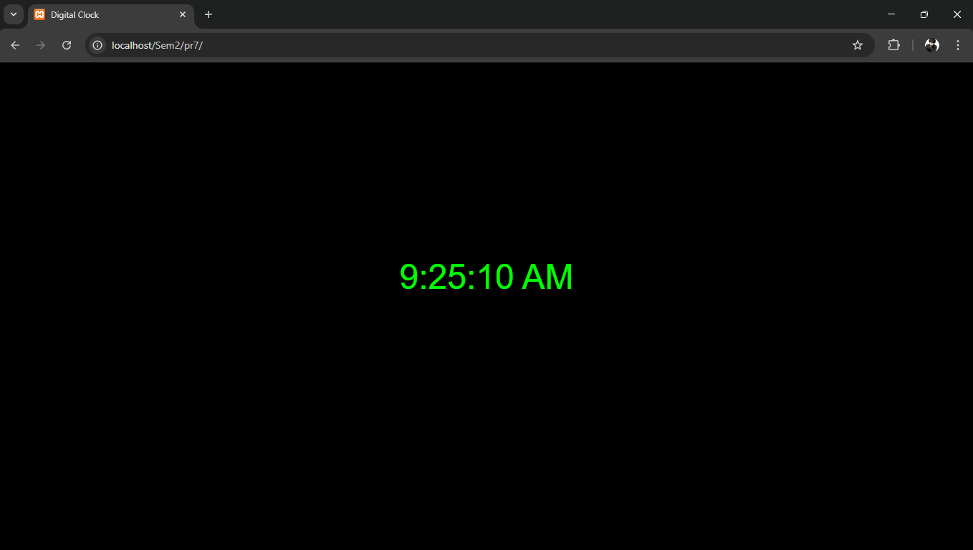

Name: Ritesh Doibale Roll no:274

Experiment no8: Write a PHP program to implement sign-In and Sign-out functionality.

Login.php

<?php

session_start();

// Dummy credentials

$valid_username = 'admin';

$valid_password = '12345';

// Handle form submission

if ($_SERVER['REQUEST_METHOD'] === 'POST') {

    $username = $_POST['username'] ?? '';

    $password = $_POST['password'] ?? '';

    if ($username === $valid_username && $password === $valid_password) {

        $_SESSION['user'] = $username;

        header('Location: welcome.php');

        exit;

    } else {

        $error = "Invalid username or password!";

    }

}

?>

<!DOCTYPE html>

<html>

<head>

    <title>Sign-In</title>

</head>

<body>

    <h2>Login</h2>

    <?php if (!empty($error)) echo "<p style='color:red;'>$error</p>"; ?>

    <form method="post" action="login.php">

        Username: <input type="text" name="username" required><br><br>

        Password: <input type="password" name="password" required><br><br>

        <button type="submit">Sign In</button>

    </form>

</body>

</html>

Welcome.php

<?php

session_start();

if (!isset($_SESSION['user'])) {

    header('Location: login.php');

    exit;

}

?>

<!DOCTYPE html>

<html>

<head>

    <title>Welcome</title>

</head>

<body>

    <h2>Welcome, <?php echo htmlspecialchars($_SESSION['user']); ?>!</h2>

    <p><a href="logout.php">Sign Out</a></p>

</body>

</html>

Logout.php

<?php

session_start();

session_unset();

session_destroy();

header('Location: login.php');

exit;

Output:

