**Assignment**

**Case Study**

The Butler Financing company runs a mortgage brokerage business that matches lenders and borrowers. The table below lists some of the data that Butler maintains on its borrowers and lenders. The data are stored in a spreadsheet that must be manually updated for each new borrower, lender or mortgage. This updating is error-prone, which has harmed the business. In addition, the spreadsheet has to be sorted in many different ways to retrieve the necessary data.

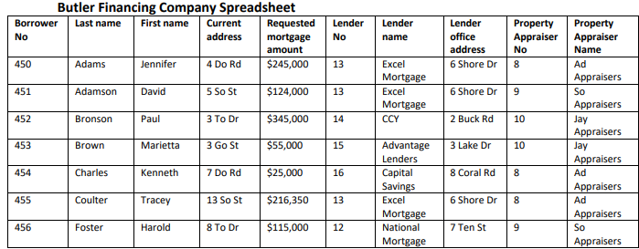

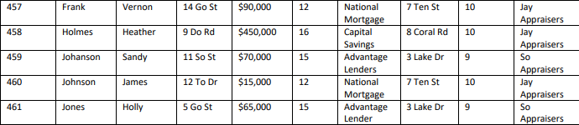

**Justification of the use of database**

Microsoft Excel is a Spreadsheet application, which is used to manage the data in tabular form. It is very easy to filter, sort and arrange the data in excel. We can build charts, macros, graphs etc.

Microsoft Access is primarily a database program used to collect, manipulate and sort data. Access is used as part of the RDBMS (Relational Database Management System). It Consists tables, queries, forms, reports, modules and macros. It provides data structure and normalisation through multiple tables. It provides data referential and integrity.

However, they both handle tabular data but their scopes are very much different from each other. Some of the comparisons are as follows –

1. It is very easy to perform sorting and filtering on large amount of data through database as compared to spreadsheets.
2. The storage capacity of Access is also more as compared to excel as it is built for manipulating databases.
3. It is easy to build multiple relational model in Access.

**Database Design: E-R Diagram**

Entity Relationship Diagram is a diagram, which helps the user to identify the major entities involved in the system scope and the relationships among these entities. It is a kind of structural diagram, which helps in designing the database for the system. An E-R Diagram contains specialized symbols and connectors, which has its own meanings. In Other words, it can be used as a blueprint for database designers for implementing data.

It has three main concepts -

a. Entities - Anything physical or an event in enterprise that needs to be represented in the database can be termed as an Entity. For example - employee, machine, course, sale etc. It is represented as rounded rectangle in E-R models.

b. Attributes - Attributes are the one who defines the property or characteristics of an entity. They also known as columns and shown as ellipse. Some of the entity attributes are primary key and foreign key.

c. Relationships - Relationships between two entities defines that how the entities are connected to each other. There are three types of relationships –

1. One-to-one – A One-to-one relationship defined as when instance of an entity is related to single instances of other entity.

2. One-to-many – A One-to-many relationship defined as when instance of an entity is related to many instances of other entity.

3. Many-to-many - A Many-to-many relationship defined as when instance of an entity is related to many instances of other entity and vice versa.

There are two main tables Borrower and Lender. Borrower_No is the primary key for borrower table and Borrower_No is foreign key for lender table.

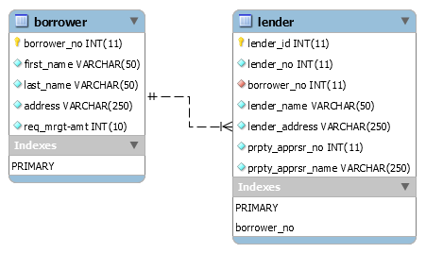

**Microsoft Access files**

**Access Database**

Microsoft Access Database containing all the Tables, Queries, Forms and Reports.



**Tables**

**Borrower**

Below is the Borrower table in Access. Borrower_no is the primary key for this table, which helps in uniquely identifying the records. Primary key is mandatory to make relation with other table.

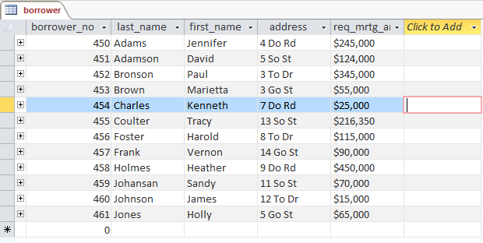

**Lender**

Below is the Lender table in Access. Borrower_no is the foreign key for this table, which will be matched, with the primary key of other table if we need to fetch the common records from both the tables.

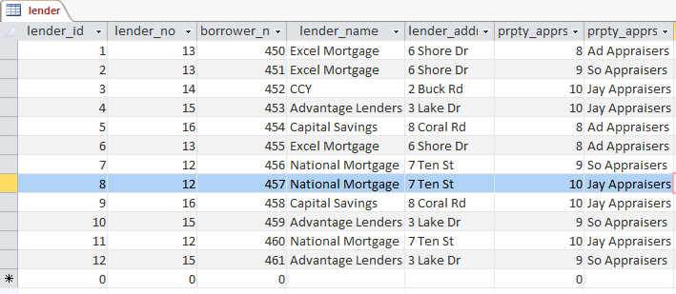

**Relationship between Tables**

Below image depicts the relationship between borrower and lender table. Both the table are related to each other with the common column borrower_no which is the primary key for the borrower table.

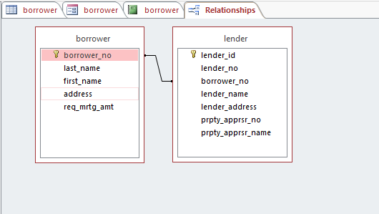

**Queries**

Queries are the mechanism to retrieve the data from the tables in RDBMS system. We can retrieve the data from the table with different criteria as per our need. Below is the resultant data from both tables based on the common key match i.e. borrower_no.

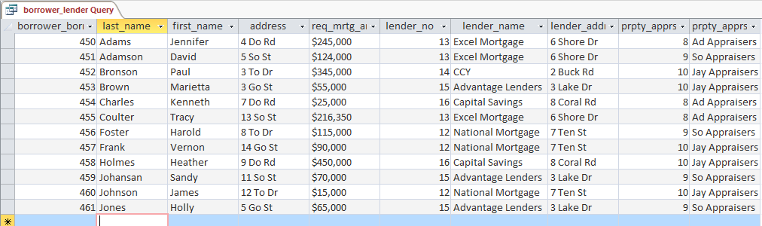

Attached is the excel representation of the query result.



**Forms**

**Borrower**

Below is the screenshot of Form representation of borrower table.

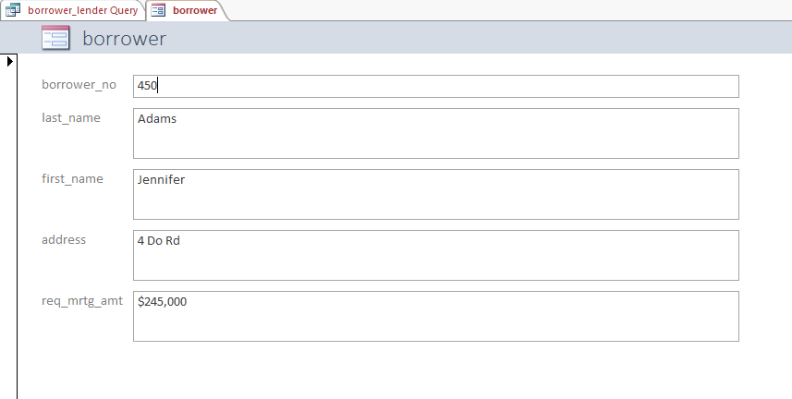

**Lender**

Below is the screenshot of Form representation of lender table.

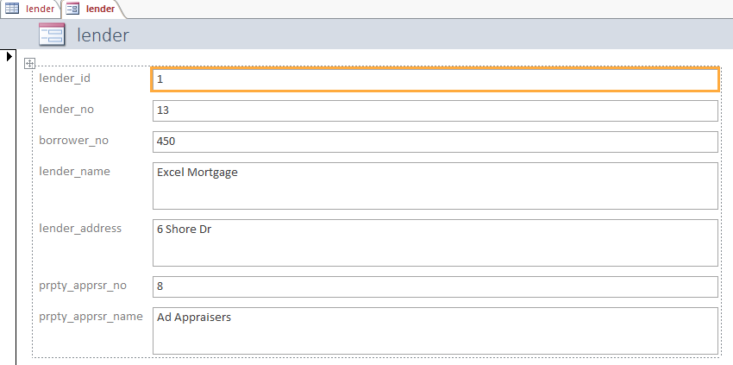

**Form for Results**

Attached the exported form for the resultant query



**Reports**

**Borrower**

Below is the screenshot of Reports representation of borrower table.

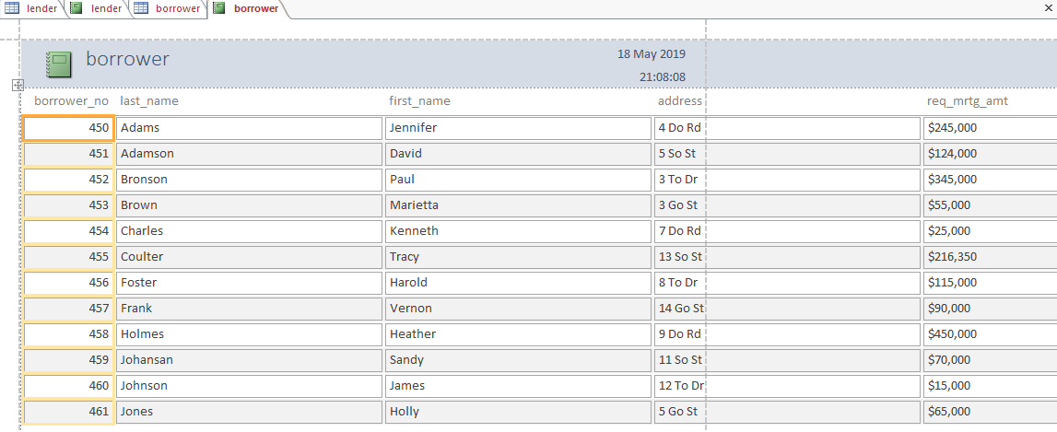

**Lender**

Below is the screenshot of Reports representation of lender table.

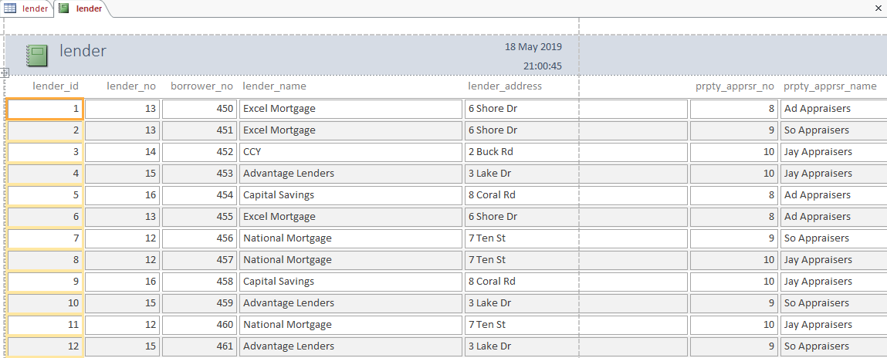

**Report for Result**

Attached the exported form for the resultant query

