**CS 650 Software Engineering Process**

**Project Proposal**

**Theater Ticket System**

**9/24/2014**

**Team D Project Team Members:**

Andy Kesterson

Samantha Knight

Sumeet Kore

Rashad Madyun

Anthony Morse

# Scope

The Theater Ticket application manages the different tasks involved with handling ticket sales to all events and associated venues. Customer service agents interact with the Theater Ticket application to handle sales to customers either by telephone or in person. The customer service agent handles reservations for reserved seating and for general admission. Once the customer service agent has entered the reservation information into the system, a database stores the information for future use. The database stores customer name and address information, seat choices, special needs information, payment information, and whether the customer is a season ticket buyer or an individual ticket buyer.

The Level 0 Use Case diagram is presented in Figure 1. In creating this diagram, several assumptions were made. The customer only interacts with the customer service agent. The customer service agent provides the interaction between the Theater Ticket system and the database.

Figure 1- Level 0 Use Case Diagram

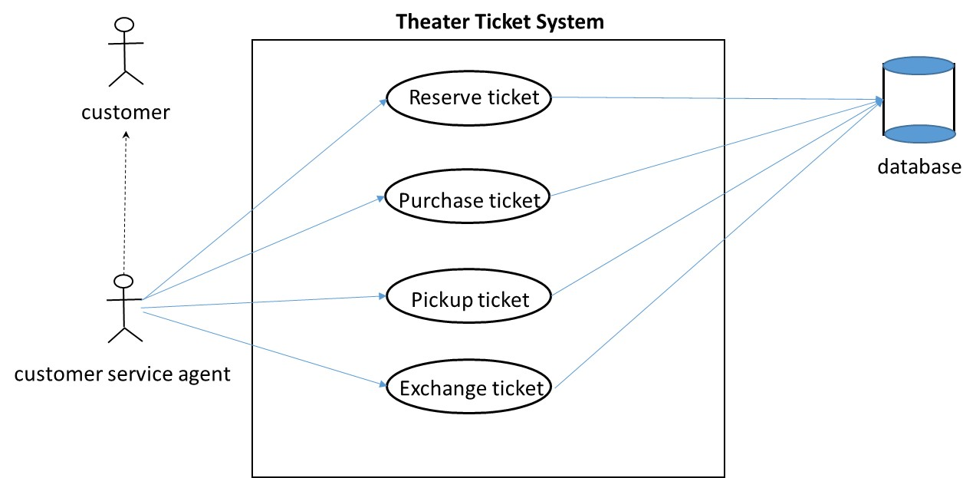

Some of the analysis classes derived from this diagram include the ticket, the event, the venue, the customer, and the customer service agent.

Several assumptions about the system were identified:

1. The system is up and running.
2. Tickets are available.
3. There is a working telephone line.
4. There are customer service agents available to work telephone lines and event lines.
5. The customer uses a valid form of payment.
6. There is a third party payment system available.
7. Operating Systems are compatible.

A constraint was identified. The Theater Ticket system software must operate on a typical Windows machine that can be used both at the organization’s office and at the ticket booth before the event.

The team has decided to meet on Tuesdays and Wednesdays at 7:00 pm at the university. The team will also use Angel and uah email to communicate during the semester. The team has tentatively identified a plan as follows:

1. Identify the Customer requirements.
2. Refine the Level 0 Use Case diagram.
3. Develop use case descriptions based on the Level 0 Use Case diagram.
4. Develop activity diagrams from the use case descriptions.
5. Develop sequence diagrams from the activity diagrams.
6. Derive software requirements from the previous activities.
7. Develop any other artifacts as required by the professor.
8. Perform reviews on a regular basis (TBD).
9. Take meeting minutes for every meeting which will become part of the project paper.
10. Note lessons learned during the course of the semester and add to the project paper.

The team has decided to use git hub for source control of documentation and UMLET as the uml tool. We may attempt to use jira for task tracking.