**MRT Information Management GmbH**



Title

Sub-title

List of contents

1.1 Doc_Rev_LOV_Migration.exe 3

1.2 Steps to follow: 3

|  |  |  |  |
| --- | --- | --- | --- |
| Revision History | | | |
| **Date** | **Version** | **Description** | **Author** |
| 08.03.2016 | 1.0 | Document creation | Rahul Katare |

## Doc_Rev_LOV_Migration.exe

## Steps to follow:

1. Place the **Doc_Rev_LOV_Migration_Data.csv** file in the same directory where the .exe is placed

2)Open TC_Command_prompt, Browse to this directory where .exe is placed from the **Binaries\exe** folder and Press Enter(no input parameters have to be given).

3)Till this counter keeps running means utility is running.

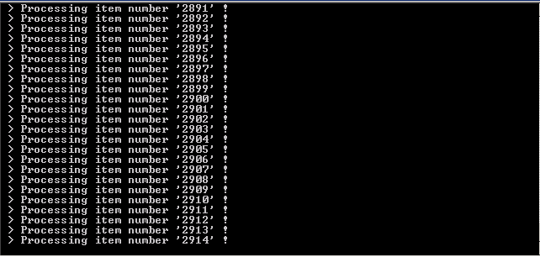

4)When this counter stops means utility has done processing.

5)Go to Doc_Rev_LOV_Migration.exe674bae0.syslog in **%temp%** folder and see for any errors.if not we have processed all the elements successfully as per condition.

6)Two files will be generated UIDvalue.csv and Unprocessed_Combinations.csv at the end of utility processing.

7)These files can be found in the folder where the exe is placed.

8)Send the generated file to Hanspeter.