**MRT Information Management GmbH**



Title

Sub-title

List of contents

1.1 Processed_DocitemRev_Report.exe 3

1.2 Steps to follow: 3

|  |  |  |  |
| --- | --- | --- | --- |
| Revision History | | | |
| **Date** | **Version** | **Description** | **Author** |
| 08.03.2016 | 1.0 | Document creation | Rahul Katare |

## Processed_DocitemRev_Report.exe

## Steps to follow:

1. Place the **UIDvalue.csv and Doc_Rev_LOV_Migration_Data.csv** file in the same directory where the .exe is placed

2)You need to fire below sql to get uids. This sql has be executed on each site before executing utility.

e.g. if you planning to execute this exe on central site, then you need to fire this query on central site from sql developer, then export all records into **UIDvalue.csv** (don’t change file name, keep this file where exe also present) file. This csv file will be input to our exe. This csv is site specific.

**select puid from pbt7_documentrevision;**

**Note 1:**Remove the first entry named as PUID and delete the last blank line in generated UIDvalue.csv file.

**Note 2:**Remove if nay double quotes from UID values in generated UIDvalue.csv file.

1. Open TC_Command_prompt, Browse to this directory where .exe is placed from the **Binaries\exe** folder and Press Enter(no input parameters have to be given).

2)Till this counter keeps running means utility is running.

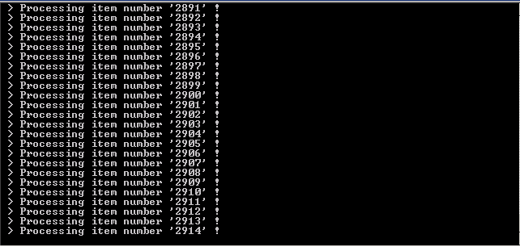

1. When this counter stops means utility has done processing.
2. Go to Processed_DocitemRev_Report.exe674bae0.syslog in **%temp%** folder and see for any errors.if not we have processed all the elements successfully as per condition.
3. Two files will be generated Processed_Combinations.csv and Unprocessed_Combinations.csv at the end of utility processing.
4. These files can be found in the folder where the exe is placed.

7)Send the generated file to Hanspeter.