

Document classification

Utility to migrate old document revisions as per LOV mapping

Document Classification

22.05.2017 – Siemens BT

# Vortrag

This migration utility will update new attribute LOV values as per excel file recived from customer. Need to run tis utility for each site. Seperate batch provided for the same. Make sure that input data is present in database before starting this utility.

# Doc_Rev_LOV_Migration.exe

## Steps to follow:

1. Run the following command to register tables in database from SQL command prompt or SQL developer to create data tables.

Central Site

CREATE TABLE **infodba.Doc_Rev_LOV_Migration_Central** ( Primary_UID VARCHAR(16),bt7_documentClass VARCHAR(50), bt7_documentSubClass VARCHAR(50), bt7_documentSNType VARCHAR(50));

Follow the below mentioned steps to import excel into database once above table is created

1. Click on filter button a pop up will appear , fill the table name that you have registered above.

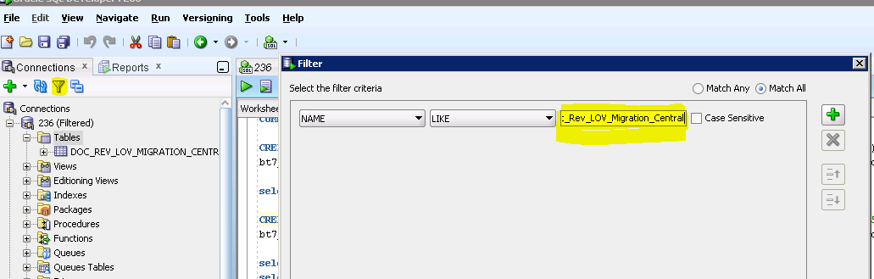

1. We can find the table under ‘Tables’

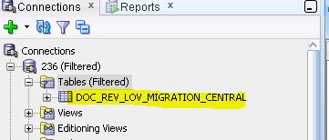

1. Right click on table name and select ‘import data’ option a screen will appear

as below Browse to the location where excel is placed. In our case will be placed in the same folder where exe is placed.

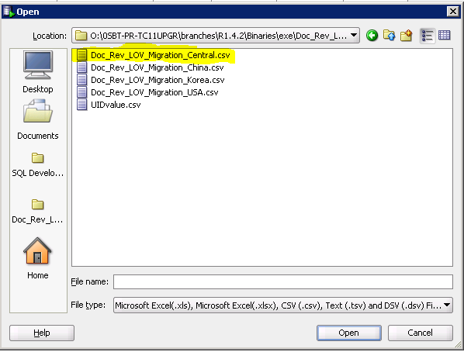

1. Check format and click next

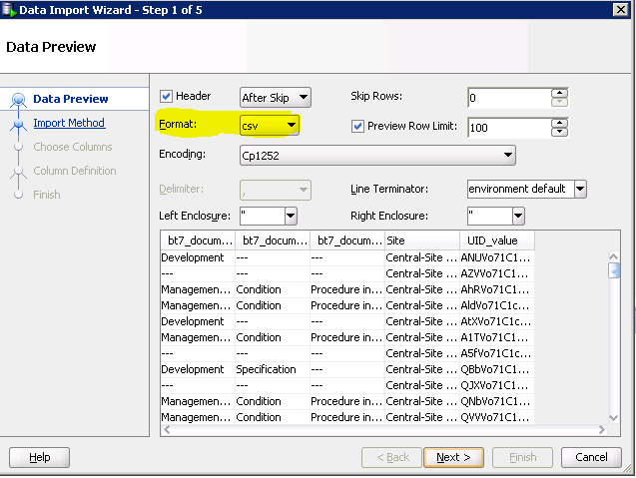

1. Click Next

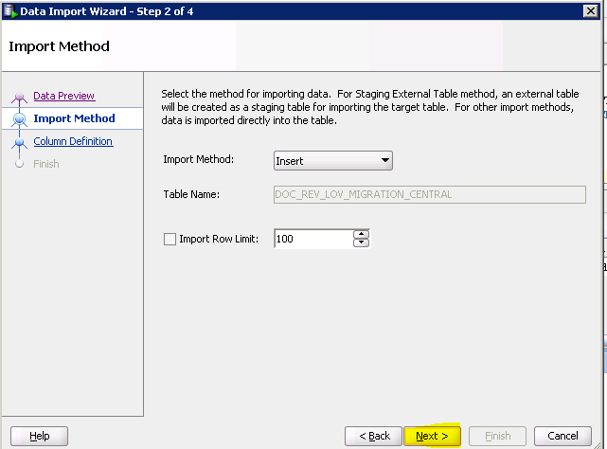

1. Select the unwanted columns from below and push them to left side. Maintain the columns order

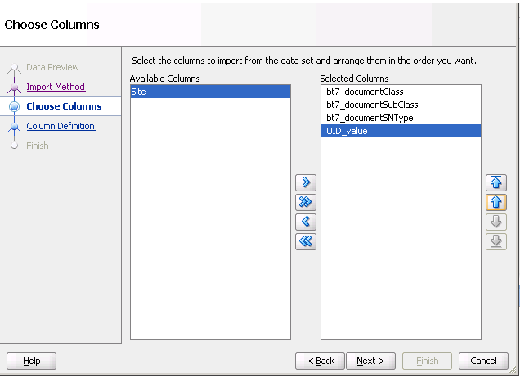

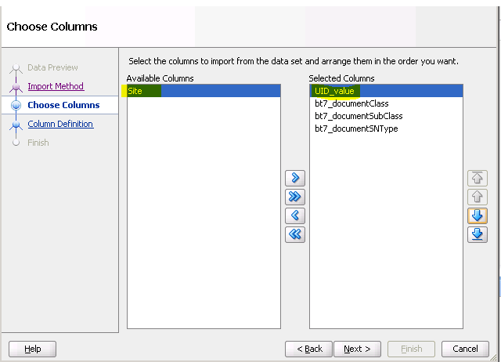

1. Select match by name and make sure below mapping is fulfilled then click next

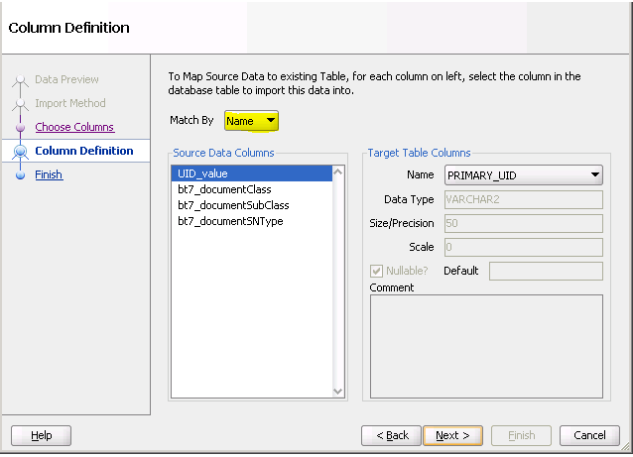

|  |  |
| --- | --- |
| **Excel Attribute** | **Table Attribute Mapping** |
| UID_value | PRIMARY_UID |
| Bt7_documentClass | BT7_DOCUMENTCLASS |
| Bt7_documentSubClass | BT7_DOCUMENTSUBCLASS |
| Bt7_documentSNType | BT7_DOCUMENTSNTYPE |

1. Click Finish excel will start importing.

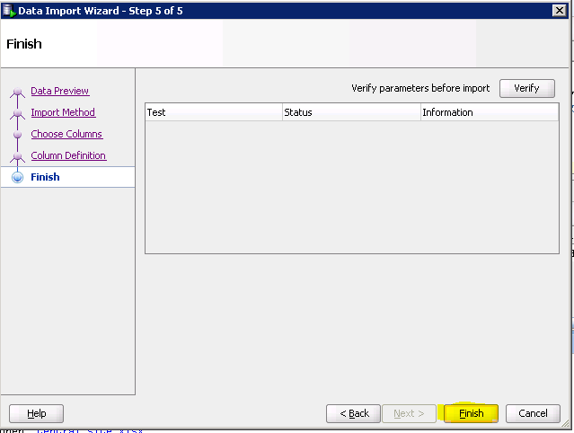

**Follow the same steps for other sites also**.

* 1. **USA**

CREATE TABLE infodba.**Doc_Rev_LOV_Migration_USA**( Primary_UID VARCHAR(16), bt7_documentClass VARCHAR(50), bt7_documentSubClass VARCHAR(50), bt7_documentSNType VARCHAR(50));

* 1. **China**

CREATE TABLE infodba.**Doc_Rev_LOV_Migration_China**( Primary_UID VARCHAR(16), bt7_documentClass VARCHAR(50), bt7_documentSubClass VARCHAR(50), bt7_documentSNType VARCHAR(50));

* 1. **Korea**

CREATE TABLE infodba.**Doc_Rev_LOV_Migration_Korea**( Primary_UID VARCHAR(16), bt7_documentClass VARCHAR(50), bt7_documentSubClass VARCHAR(50), bt7_documentSNType VARCHAR(50));

2) run SQL's from attached text file to update lov values. this sql will take 1h to complete



