**After installing AWC patch 3.2 if we require certain command icons to be displayed**

Then we need to install that feature seperately.As in Below example

We need below command icon to be displayed in AWC web client.



Select below feature in Active Workspace ->Client->**Classification** to display above icon

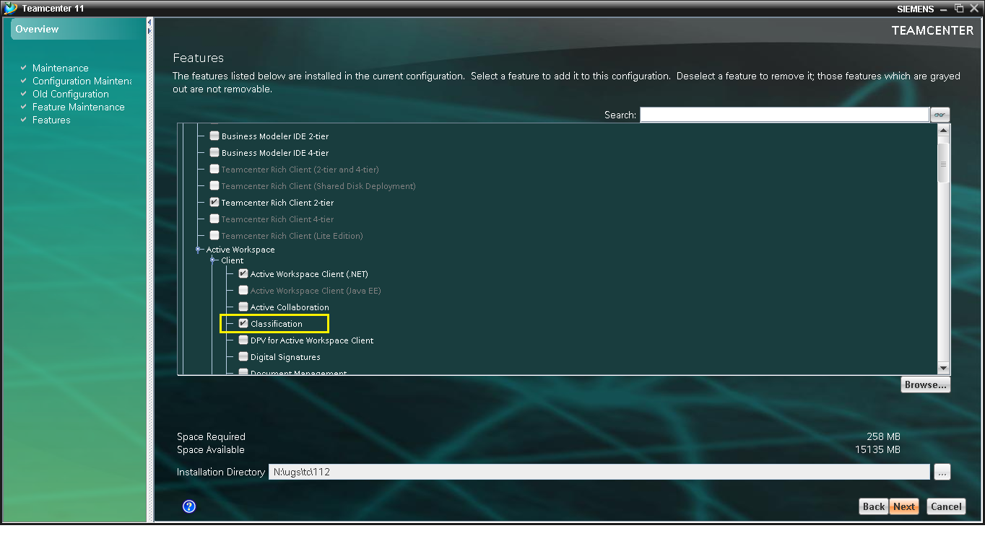

Also make sure **ICS_AW_enable_classification** preference is set to true.

This icon displays in AWC like this

