**AIM:** How to Create ACL: EPM Open with Checkout?

**SOLUTION:**

Before importing **CC Request** Workflow. Create the ACL "**EPM Open with Checkout**" using **Access Manager**.

Step1: Go to Access Manager, with Group\Role "**infodba\dba**" combination.

Step2: In the Access Manager, fill ACL Named as "**EPM Open with Checkout**", click on Create a New Named ACL.

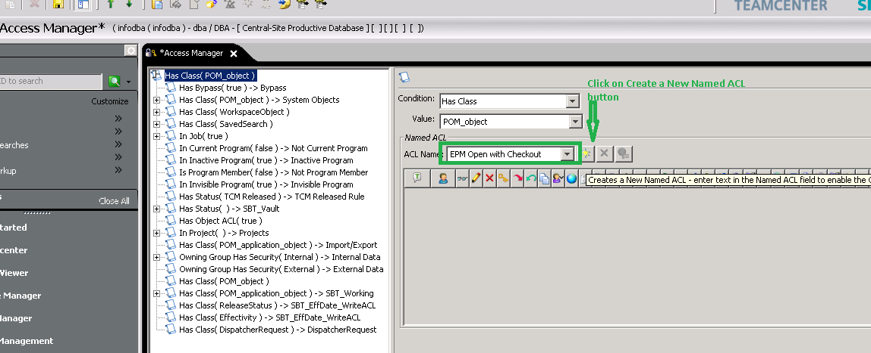

Step 3: Then click on **"+"** button on Right Hand side, do the modification as shown below:

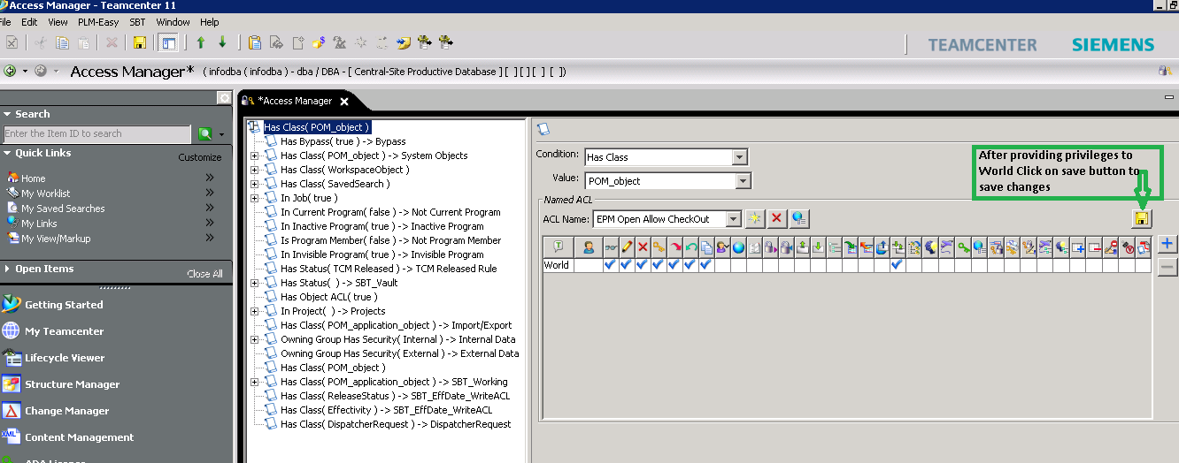

Step 4: Then click on Save button at the tool bar of Access Manager level.

**To Confirm ACL Created:**

Select at any node of ACL Tree and chek newly added ACL Rule " EPM Open with Checkout " in the ACL Name LOV List.

**NOTE:**

Follow this for all Multi-Sites including CSE.