For Jar Compared results:

1. No Jars are modified by us in TC11.2.3.1 for IMM.

Upgrade to TcVis_1123_win64:

1. Extract "TcVis_1123_win64" from "%svn%\trunk\MRT\TC11.2.3_Patch_1\Patches\TcVis_1123".

2. Run "Teamcenter_Visualization_11_2_3_win64.msi" from the extracted "TcVis_1123_win64".

3. Select shown value from lov of "Base"

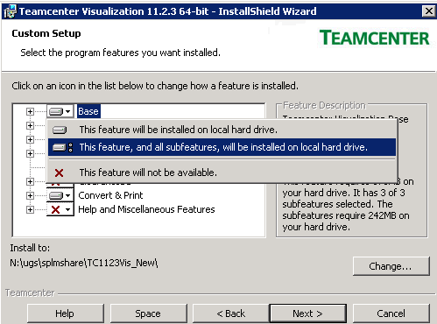

and same for "Convert & Print":

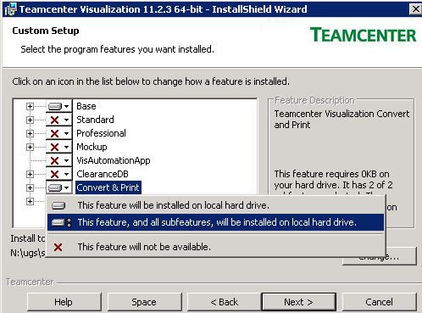

Change the Install to path for Tc1123 to any new desired location:

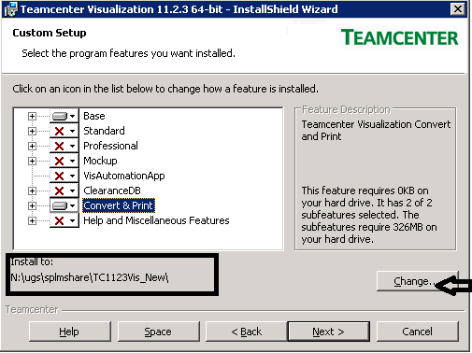

Click on next and select the desired language.

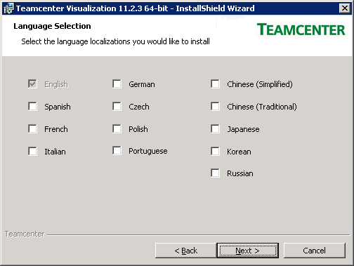

Again click on next

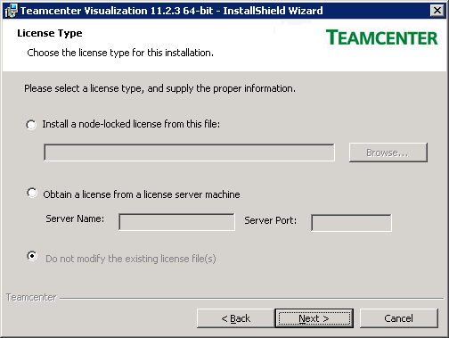

Click next and install.

After installation update TC_Vis location into "**appendcpath.bat**" inside dispatcher @ "N:\ugs\tc11\11_disp\Module\Translators"

set TCVIS_ROOT_DIR=N:\ugs\splmshare\TC1123Vis_New

set TCVIS_BIN_DIR=%TCVIS_ROOT_DIR%\VVCP

and replace file "vvcp.ini" inside VVCP location from svn

Open Command Prompt and change directory uptill patches "%svn%\trunk\MRT\TC11.2.3_Patch_1\Patches\ TcVis_1123" and then to install the installation on Windows

**TcVis_11231_win64.exe** file. This is a self-installing executable. It will install in the proper location automatically. To run the patch silently with no user interaction, run the .exe with a "-ai" option (think "Auto-Install")

E.g. **TcVis_11231_win64.exe -ai**

