**MRT Information Management GmbH**



SBT Teamcenter IMM-NX Configuration

List of contents

1. IMM 3

1.1 Prerequisite 3

1.2 Deploying IMM TEM Package 3

1.3 Deploying Portal plugins 8

1.3.1 Run the deploy script 8

|  |  |  |  |
| --- | --- | --- | --- |
| Revision History | | | |
| **Date** | **Version** | **Description** | **Author** |
| 27.05.2016 | 1.0 | Document creation | Nagesh |
|  |  |  |  |

# IMM

## Prerequisite

Below are listed down the prerequisite before starting IMM Configuration

* Make sure Materia management is installed

## Deploying IMM TEM Package

* Start **tem.bat**
* In the Maintenance panel, select **Configuration Manager** and click **Next**.

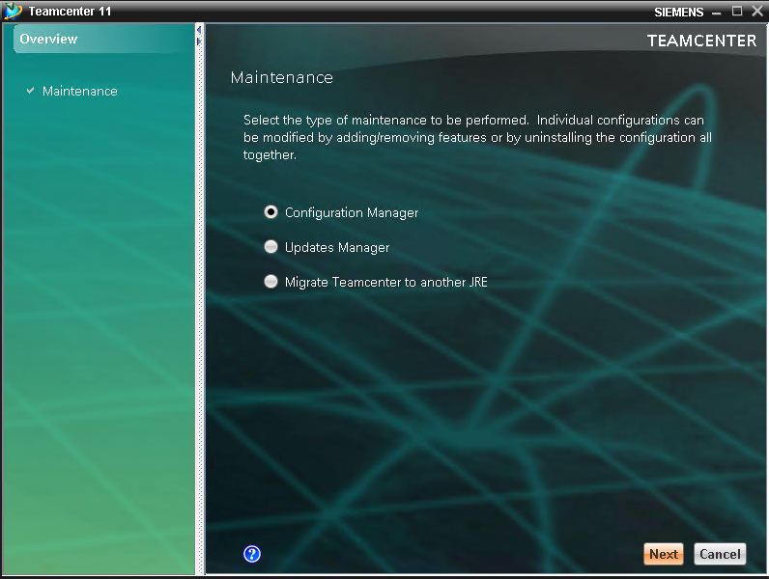

* In the **Configuration Maintenance** panel, select **Perform Maintenance on an existing configuration** and click **Next**

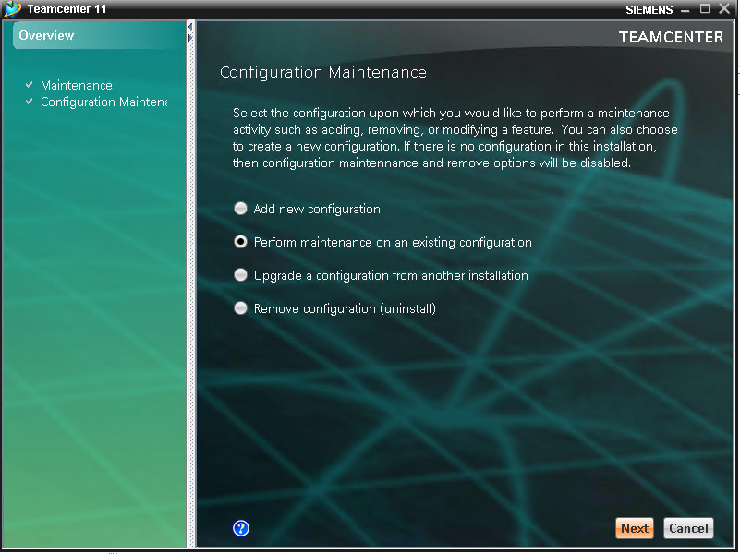

* In the next panel proceed with **Next** if the correct installation is already selected

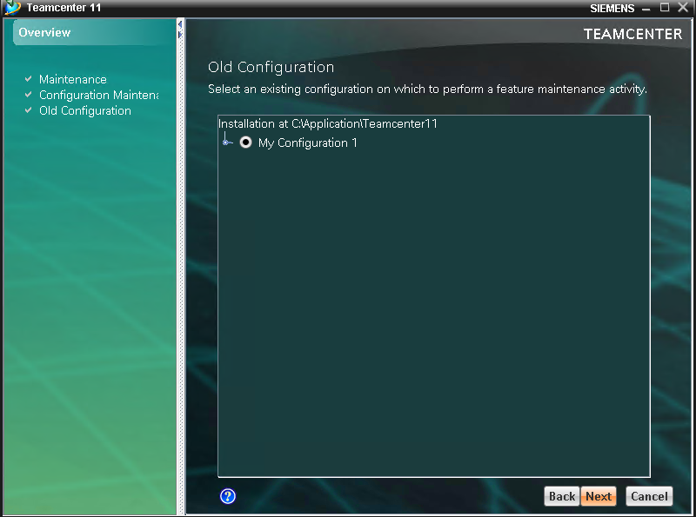

* Select **Update Database** and click Next

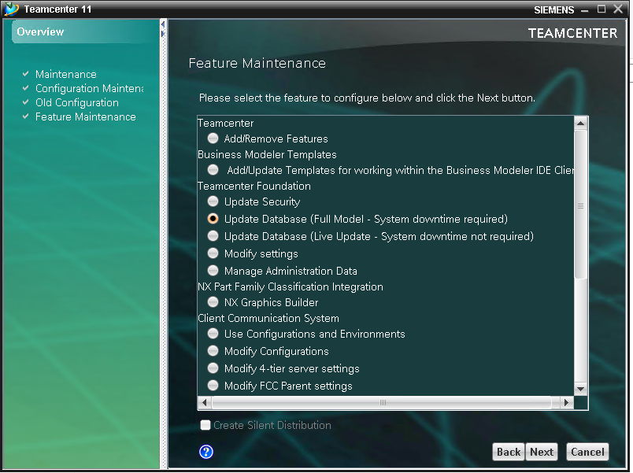

* In the **Update Database** panel, click Browse and **select** from the IMM installation package the IMM_installables/**Teamcenter/Server/feature_materialmgmt.xml** file and press **Next**

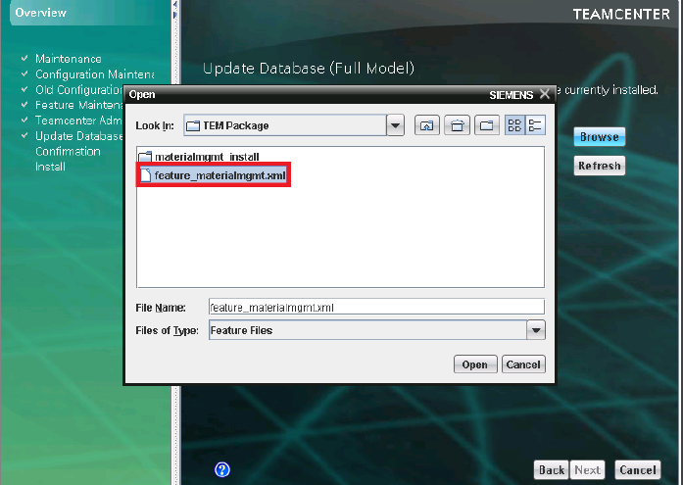

* In the **Confirmation** panel, click **Start**.

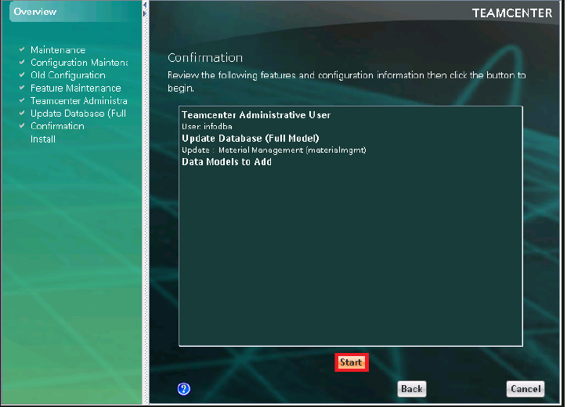

## Deploying Portal plugins

### Run the deploy script

* Open **TC command prompt** of the target system to run the installation script.
* Change the directory to **Teamcenter\Portal** then execute the script **Copy_plugins_to_portal.cmd**
* The plugins will be copied from. **/plugins** to **TC_ROOT/portal/plugins**

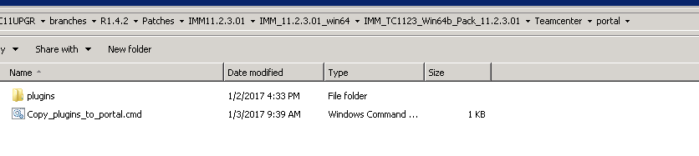

* After copying the plugins to the target path, run %TC_ROOT%\portal\registry\genregxml.bat