**Upgrade to TcVis_1123_win64:**

1. Extract "TcVis_1123_win64" from SVN

"0SBT-PR-TC11UPGR\branches\R1.4.2\Patches\TcVis_1123".

1. Run "**Teamcenter_Visualization_11_2_3_win64.msi**" from the extracted "TcVis_1123_win64".
2. Select shown value from lov of "Base"

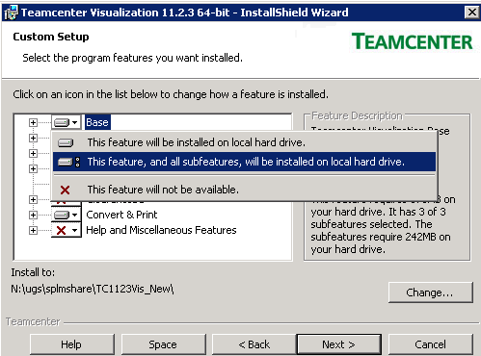

* 1. and samilarly for "Convert & Print":

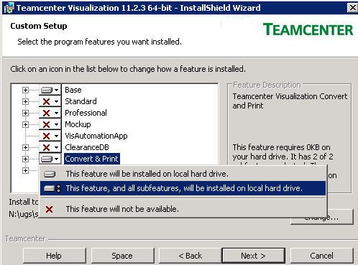

1. Change the Install to path for Tc1123 to any new desired location:

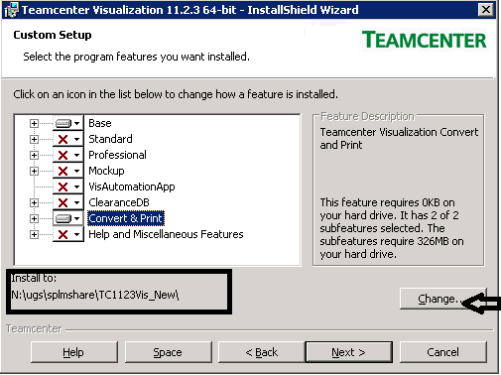

1. Click on next and select the desired language.

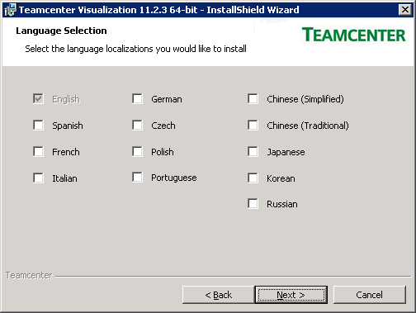

1. Again click on next

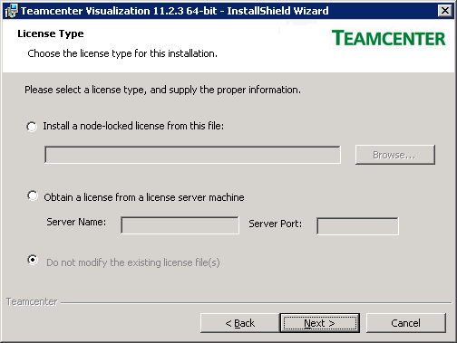

1. Click next and install.
2. After installation update TC_Vis location into "**appendcpath.bat**" inside dispatcher @ "N:\ugs\tc11\11_disp\Module\Translators"
   * set **TCVIS_ROOT_DIR**=**N:\ugs\splmshare\TC1123Vis_New** (same as one provided at Step 4)
   * set **TCVIS_BIN_DIR**=**%TCVIS_ROOT_DIR%\VVCP**

and replace file "**vvcp.ini**" inside VVCPlocation from svn "0SBT-PR-TC11UPGR/branches/R1.4.2/Configuration/TcVis/VVCP/vvcp.ini"

1. Open Command Prompt and change directory uptill patches SVN "0SBT-PR-TC11UPGR\branches\R1.4.2\Patches\TcVis_1123" and then to install the installation on Windows
   1. **TcVis_11231_win64.exe** file. This is a self-installing executable. It will install in the proper location automatically. To run the patch silently with no user interaction, run the .exe with a "-ai" option (think "Auto-Install")

E.g. **TcVis_11231_win64.exe -ai**

