CISCO–AICTE VIRTUAL INTERNSHIP PROGRAM 2026
CYBER SECURITY PROJECT REPORT
Secure Hybrid Datacenter and Public Cloud Network Architecture

Particular | Details
Student Name | Sumeeth Goud Matoori
College | Marwadi Education Foundation's Group of Institutions
Domain | Cyber Security
Project Type | Individual
AICTE Registration Number | STU69d13dce4a8af1775320526
Submission Date | 30 August 2026
Submitted as part of the Cisco–AICTE Virtual Internship Program 2026

1. Introduction
I prepared this project as an individual Cyber Security project for the Cisco–AICTE Virtual Internship Program 2026. The project is based on the given problem statement about securing a hybrid environment in which enterprise applications use services from both a private datacenter and a public cloud.
The problem statement explains that modern applications are often hybrid and that data has to leave the private datacenter to reach the public cloud. Therefore, strong network security and segmentation are required. It also highlights the importance of cloud security controls such as AWS Security Groups and IAM, and the need to prevent an attack on one application from spreading to other applications, VPCs or the enterprise network.
To understand and demonstrate these requirements practically, I designed and configured a small hybrid network in Cisco Packet Tracer. I divided the private network into separate VLANs, configured inter-VLAN routing, applied ACLs for access control, created a private-datacenter-to-cloud connection, and added a separate cloud application network. I also prepared an IAM and Security Group design that can be used if the same architecture is implemented on AWS.

2. Problem Statement
The given problem asks me to design a secure hybrid datacenter network architecture that supports applications connecting to or using services between a private datacenter and a public cloud. The design must provide strong network security and segmentation because traffic has to move between the private datacenter and public cloud.
The problem also asks how IAM should function, what type of Security Groups should be used, and how applications can be segmented in VPCs so that a compromise of one application does not easily spread to other applications, VPCs or the enterprise network.

3. Aim
To design and implement a secure hybrid datacenter and public cloud network using Cisco Packet Tracer, with VLAN segmentation, inter-VLAN routing, ACL-based access control, controlled private-to-cloud connectivity, and a cloud security design based on IAM and Security Groups.

4. Objectives
To understand the security requirements of a hybrid private-datacenter and public-cloud environment.
To divide the enterprise network into separate VLANs for Faculty, Admin, Servers and Guest users.
To configure router-on-a-stick for communication between required VLANs.
To configure trunk links between the switches and the router.
To use extended ACLs to control access to sensitive servers.
To establish a routed connection between the private datacenter and cloud router.
To create a separate network for a cloud-hosted application.
To configure static routes for communication between the private and cloud networks.
To test both permitted and restricted communication.
To design IAM roles and cloud Security Groups according to least privilege and workload isolation.

5. Scope of the Project
The practical scope of my project is a Packet Tracer simulation of a secure hybrid environment. The private side contains user VLANs and application/database servers. The cloud side contains a cloud router and a separate cloud application network. Security is demonstrated through VLAN segmentation, ACLs and routing controls.
The AWS IAM and Security Group portion is a design representation rather than a live AWS deployment. I included it because the original problem statement specifically requires consideration of IAM, Security Groups and VPC segmentation.

6. Technologies and Devices Used
Item | Use in My Project
Cisco Packet Tracer | Designing, configuring and testing the network
R1-DataCenter | Private datacenter router, inter-VLAN routing and ACL enforcement
R2-Cloud | Cloud-side routing and cloud application connectivity
SW1-Core | Core switch, VLAN creation and trunking
SW2-Server | Server-side switching
PC-Faculty1 | Faculty traffic and security testing
PC-Admin | Administrative traffic testing
PC-Guest | Guest restriction testing
APP-Server | Private application server
DB-Server | Private database server
CLOUD-APP | Cloud application simulation
VLANs | Network segmentation
Extended ACLs | Traffic filtering
Static Routing | Private datacenter to cloud reachability

7. Proposed Network Architecture
I designed the network with a private datacenter side and a cloud side. The private datacenter is connected to R1, while R1 is connected to R2 through a separate point-to-point network. R2 provides connectivity to the cloud application network.
The logical structure of my design is:
Faculty/Admin/Guest/Servers → SW1-Core → R1-DataCenter → R1–R2 WAN → R2-Cloud → CLOUD-APP
[Insert Figure 1 here: Final Packet Tracer topology screenshot.]

8. VLAN Design
VLAN ID | Name | Network | Purpose
10 | FACULTY | 192.168.10.0/24 | Faculty users
20 | ADMIN | 192.168.20.0/24 | Administrative users
30 | SERVERS | 192.168.30.0/24 | Private application and database servers
40 | GUEST | 192.168.40.0/24 | Guest users with restricted access
I used VLANs because users with different responsibilities should not remain in one common broadcast domain. Separating Faculty, Admin, Servers and Guests also gives me a clear location to apply access control policies.

9. IP Addressing
Device / Interface | IP Address | Subnet Mask | Purpose
R1 G0/0.10 | 192.168.10.1 | 255.255.255.0 | Faculty gateway
R1 G0/0.20 | 192.168.20.1 | 255.255.255.0 | Admin gateway
R1 G0/0.30 | 192.168.30.1 | 255.255.255.0 | Server gateway
R1 G0/0.40 | 192.168.40.1 | 255.255.255.0 | Guest gateway
R1 G0/1 | 192.168.50.1 | 255.255.255.252 | R1–R2 WAN
R2 G0/0 | 192.168.50.2 | 255.255.255.252 | R1–R2 WAN
R2 G0/1 | 203.0.113.1 | 255.255.255.252 | Public-cloud side
R2 G0/2 | 172.16.10.1 | 255.255.255.0 | Cloud application gateway
APP-Server | 192.168.30.10 | 255.255.255.0 | Private application
DB-Server | 192.168.30.20 | 255.255.255.0 | Private database
CLOUD-APP | 172.16.10.10 | 255.255.255.0 | Cloud application

10. Switch Configuration and Trunking
I configured SW1-Core as the main switch for the user VLANs and connected it to R1 using a trunk link. The connection between SW1-Core and SW2-Server was also configured as a trunk so that the required VLAN traffic could be carried between the switching devices.
On R1, the physical interface G0/0 carries the VLAN traffic using 802.1Q subinterfaces. This is the router-on-a-stick method.
[Insert Figure 2 here: SW1 'show interfaces trunk' output.]

11. Inter-VLAN Routing
I configured the following R1 subinterfaces. Each subinterface acts as the default gateway for its VLAN.
Subinterface | VLAN | Gateway
G0/0.10 | 10 | 192.168.10.1
G0/0.20 | 20 | 192.168.20.1
G0/0.30 | 30 | 192.168.30.1
G0/0.40 | 40 | 192.168.40.1
After configuration, I verified that all four subinterfaces were up/up. I then tested connectivity between the Faculty network and the server network.

12. ACL-Based Security
The main security feature of my Packet Tracer implementation is the use of extended ACLs. I created separate ACL policies for Faculty and Guest traffic and applied them inbound on the appropriate VLAN subinterfaces.

12.1 Faculty Security Policy
Faculty users are allowed to use the application server and cloud application, but direct access to the database server is blocked. This prevents normal Faculty traffic from directly reaching a sensitive database resource.

12.2 Guest Security Policy
Guest users are treated as untrusted users. They are blocked from the private application server, private database server and cloud application.
Source | Destination | Action
Faculty | 192.168.30.10 APP | ALLOW
Faculty | 192.168.30.20 DB | DENY
Faculty | 172.16.10.10 CLOUD-APP | ALLOW
Admin | 192.168.30.10 APP | ALLOW
Admin | 192.168.30.20 DB | ALLOW
Admin | 172.16.10.10 CLOUD-APP | ALLOW
Guest | 192.168.30.10 APP | DENY
Guest | 192.168.30.20 DB | DENY
Guest | 172.16.10.10 CLOUD-APP | DENY
[Insert Figure 3 here: R1 'show access-lists' output.]

13. Private Datacenter to Cloud Connectivity
I created a separate point-to-point connection between R1 and R2. R1 uses 192.168.50.1 and R2 uses 192.168.50.2 with a /30 network. This keeps the WAN connection separate from the internal VLAN networks.
On R2, I configured G0/2 as the cloud application network gateway 172.16.10.1/24. The CLOUD-APP server was configured as 172.16.10.10/24 with 172.16.10.1 as its default gateway.
I added a static route on R1 for 172.16.10.0/24 through 192.168.50.2. I also added return routes on R2 for the private VLAN networks through 192.168.50.1.
After routing was configured, I tested R1 to CLOUD-APP and obtained 100% success. This confirmed that the private datacenter router could reach the cloud application network.
[Insert Figure 4 here: R1-to-R2 successful ping and cloud application ping.]

14. Cloud IAM Design
The problem statement requires IAM to be considered as part of the cloud security design. For my proposed AWS implementation, I would use role-based access and the principle of least privilege. I would avoid giving every user administrator permissions.
Role | Responsibilities | Access Level
Cloud Administrator | Manage overall cloud resources | High / administrative
Network Administrator | Manage VPC, routes and Security Groups | Network-focused
Application Administrator | Manage application resources | Application-focused
Database Administrator | Manage database resources | Database-focused
Faculty User | Use approved teaching/application services | Limited
Guest User | Use only permitted external services | Very limited
The important point is that permissions should be based on the job requirement. A Faculty user should not receive database administration permissions, and a Guest user should not receive internal management permissions.

15. AWS VPC and Security Group Design
If the design is implemented in AWS, I would place workloads in separate logical subnets and use Security Groups around the application tiers. The database should not be directly exposed to the Internet.
Security Group | Main Rule / Purpose
SG-Web | Allow only required HTTP/HTTPS traffic to the web-facing service.
SG-App | Allow application traffic only from approved sources.
SG-Database | Allow database traffic only from the application tier and approved administrative access.
This design creates another security layer in addition to the Packet Tracer ACLs. The application tier can communicate with the database when required, while general users and Internet traffic do not receive direct database access.

16. Application Segmentation and Attack Containment
One of the main requirements of the problem is to reduce the chance of an attack spreading from one application to other applications, VPCs or the enterprise network. I addressed this by separating user VLANs, server resources and the cloud application network.
Guest users are separated from trusted Admin and Faculty networks.
The database is placed in the Server VLAN instead of the user VLANs.
Faculty users cannot directly access the database through the Faculty ACL.
Guest users cannot directly access the private application, database or cloud application.
The cloud application is placed in a separate 172.16.10.0/24 network.
The R1–R2 WAN connection uses a separate 192.168.50.0/30 network.
In a real AWS deployment, separate VPC/subnet boundaries and Security Groups would provide additional workload isolation.

17. Testing and Results
I tested the network after completing the configuration. I used ping tests to verify both connectivity and security restrictions. The following are the final results obtained from the completed project.
Test Case | Expected | Final Result
Faculty → Gateway 192.168.10.1 | Allowed | PASS
Faculty → APP 192.168.30.10 | Allowed | PASS
Faculty → DB 192.168.30.20 | Blocked | PASS
Faculty → CLOUD-APP 172.16.10.10 | Allowed | PASS
Admin → APP | Allowed | PASS
Admin → DB | Allowed | PASS
Admin → CLOUD-APP | Allowed | PASS
Guest → APP | Blocked | PASS
Guest → DB | Blocked | PASS
Guest → CLOUD-APP | Blocked | PASS
R1 → R2 192.168.50.2 | Allowed | 100% success
R1 → CLOUD-APP 172.16.10.10 | Allowed | 100% success
During testing, some first ping attempts could show a timeout because Packet Tracer devices may first learn ARP information. I repeated the tests to verify the actual connectivity result.

18. Challenges Faced and How I Solved Them
While implementing the project, I faced a few configuration and troubleshooting issues. Solving these issues helped me understand the network rather than only copying commands.
Challenge | How I Solved It
Identifying the correct router interface | Used show cdp neighbors and show ip interface brief to identify connected interfaces.
R1–R2 link was not working | Checked both routers, corrected the interface/IP placement and verified both ends were up/up.
ACL was applied to the wrong VLAN interface | Used show ip interface to identify the inbound ACL and corrected the subinterface assignment.
Guest ACL was not applied | Applied GUEST-SECURITY inbound on G0/0.40 and verified it.
Private-to-cloud ping initially failed | Added the required static route on R1 and return routes on R2.
First ping sometimes failed | Repeated the ping after ARP learning and checked the overall result.

19. My Individual Contribution
I completed this project individually. I was responsible for the complete design, configuration, troubleshooting and testing of the Packet Tracer implementation.
I studied the given hybrid cloud security problem and planned the network structure.
I created the private datacenter topology with users, switches, routers and servers.
I created and configured VLANs for Faculty, Admin, Servers and Guest users.
I configured trunk links and router-on-a-stick inter-VLAN routing.
I assigned IP addresses and verified interface status.
I created and applied Faculty and Guest extended ACLs.
I tested allowed and blocked traffic to verify the security policy.
I configured the R1–R2 routed connection.
I configured the cloud application network and CLOUD-APP server.
I added static routes between the private and cloud networks.
I verified private-datacenter-to-cloud connectivity.
I prepared the IAM, VPC segmentation and Security Group design.
I documented the final results and prepared this report.

20. Overall Network Architecture
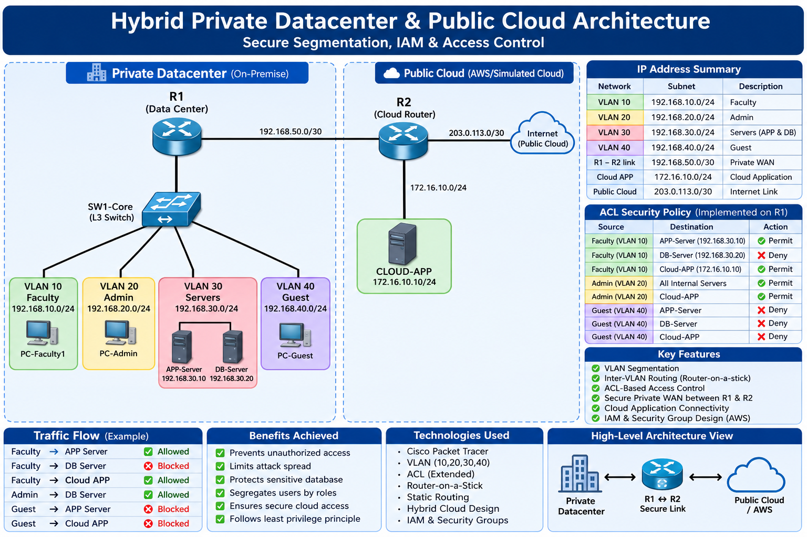
Figure 01: Secure hybrid network architecture.

21. Result
The project was successfully implemented and tested in Cisco Packet Tracer. The final network provides segmentation between Faculty, Admin, Server and Guest users. Inter-VLAN routing works through R1, and ACLs successfully restrict unauthorized access to protected resources.
The private datacenter is also connected to the cloud side through R1 and R2, and R1 successfully reaches the CLOUD-APP network. The final security policy allows required users to reach required services while blocking direct access from Guest users and blocking direct Faculty access to the database.

22. Conclusion
Through this project, I learned how network segmentation and access control can be used to secure a hybrid environment. I used VLANs to separate different types of users and servers, router-on-a-stick to provide controlled inter-VLAN routing, and extended ACLs to restrict traffic based on source and destination.
I also implemented a separate routed connection between the private datacenter and the cloud side. The cloud application was placed on a separate network, and static routes were used to provide controlled communication between the two environments.
The IAM and Security Group design extends the same security principles to a cloud environment. By using least privilege, workload segmentation and restricted database access, the design can reduce the impact of a compromise and prevent unnecessary movement across the network.

23. Future Scope
Implement the design on an actual AWS VPC with public and private subnets.
Use AWS IAM roles and policies with least-privilege permissions.
Use Security Groups and Network ACLs for layered cloud security.
Use a site-to-site VPN or dedicated private connectivity between the datacenter and cloud.
Add centralized logging, monitoring and alerting.
Use vulnerability scanning and continuous security assessment.
Deploy applications using containers/Kubernetes with network policies.
Add redundancy, backup and disaster-recovery mechanisms for production use.

24. SDG Justification
This project can be related to Sustainable Development Goal 9 (Industry, Innovation and Infrastructure). Secure networking is an important part of reliable digital infrastructure. The project demonstrates how segmentation, access control and secure hybrid connectivity can be used to build a more dependable digital environment.

