# Table content

1. **Project Goal**
2. **Project Objectives**
3. **Project Scope**

* **Project in Scope**
* **Target Language Platform**
* **Target Audience**
* **Out of Scope**

1. **Project Deliverable**

* **Analysis Document**
* **Design Documents**
* **User Documentation**
* **Quality Plan**
* **Project Executive**

1. **Resources**
2. **Project Milestone**
3. **Project Schedule**

# Project Proposal

# Project Introduction and Overview

Addy want a website that can add cars for here small trading business. She wants to keep the track of the cars. She a weather app in the website that will show the weather of any location

|  |  |
| --- | --- |
| **NAME** | Addy |
| **CONTACT** | 0226372183 |
| **ADDRESS** | 12A Northshore , Auckland |
| **E-MAIL** | john@gmail.com |

# Project Description

## Project Need

* Need a database to store the data
* Need a full working crud function

Online web api to show the weather

## Goals and Objectives

The main goal of the website is to keep track of the cars that addy are taking and make a weather app

The website allows following features: -

* Can add, update or delta a car.
* Can search the weather of the any city
* Can have the access to the salary of the employee.

## Languages used: -

* .Net framework
* C Sharp
* ASP.net
* Bootstrap
* MYSQL

## Target Audience

In the first pilot software, the target audience is: -

* Client: - the main target audience is Addy and her clients that will use the website to keep the track of the car that come up for trading

## Out of Scope: -

* Can add search page to search the car
* Can put the sort function.

## Project Deliverable: -

## Analysis Document: -

**Wireframe of About**

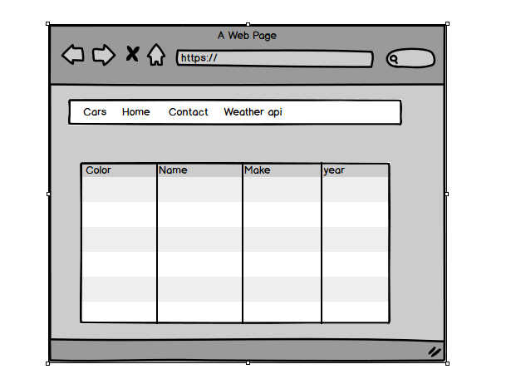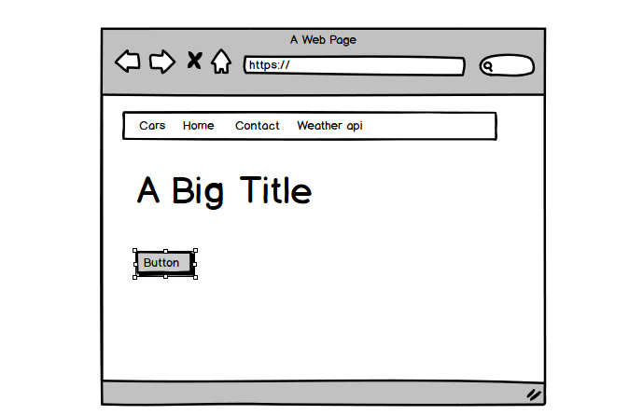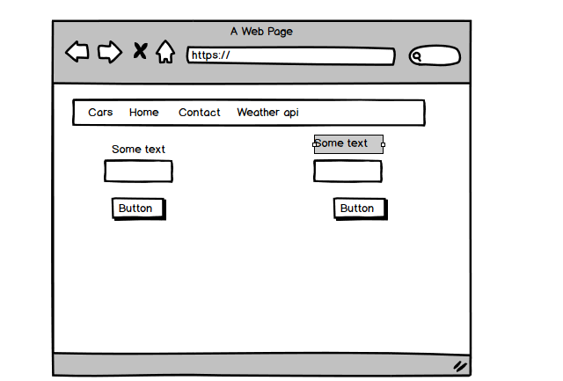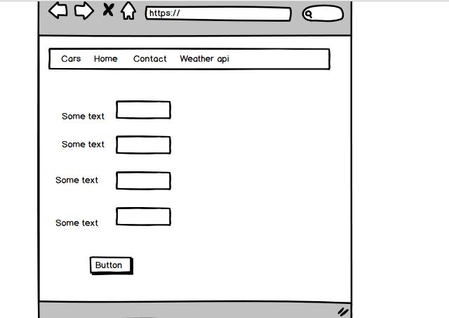

## Design Document: -

**Below are the mock-ups of given project**

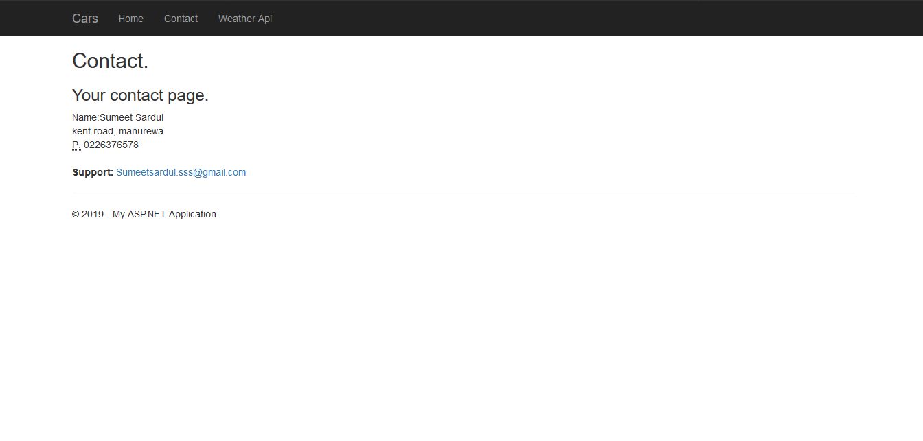

**This is the contact page**

This is just the simple contact page so user can contact the support if there is any error

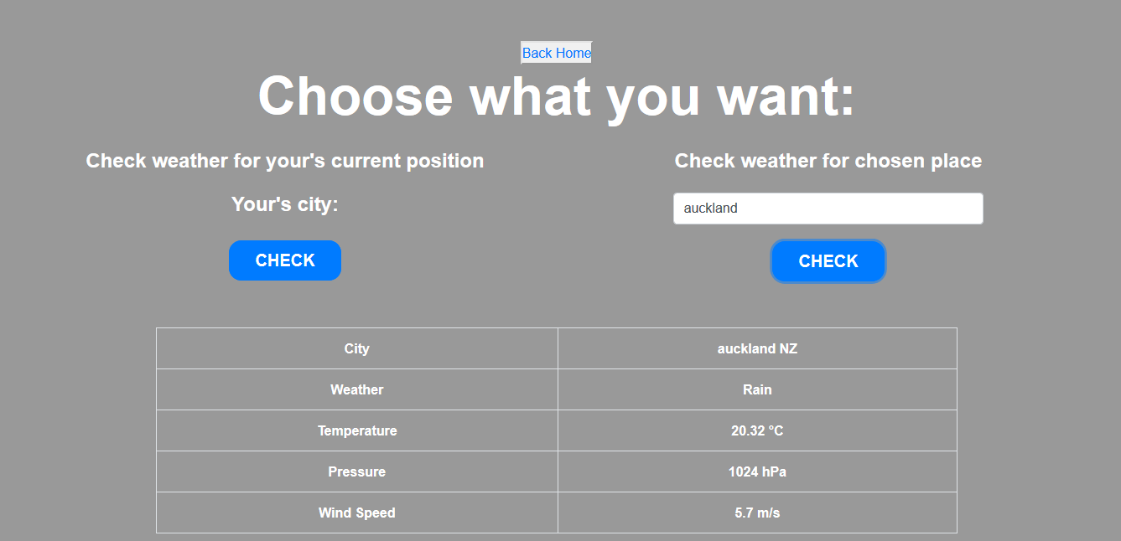

**WeatheApi**

This is the page where you can search the weather of any city and get the accurate result

It is done by implementing the api open weather

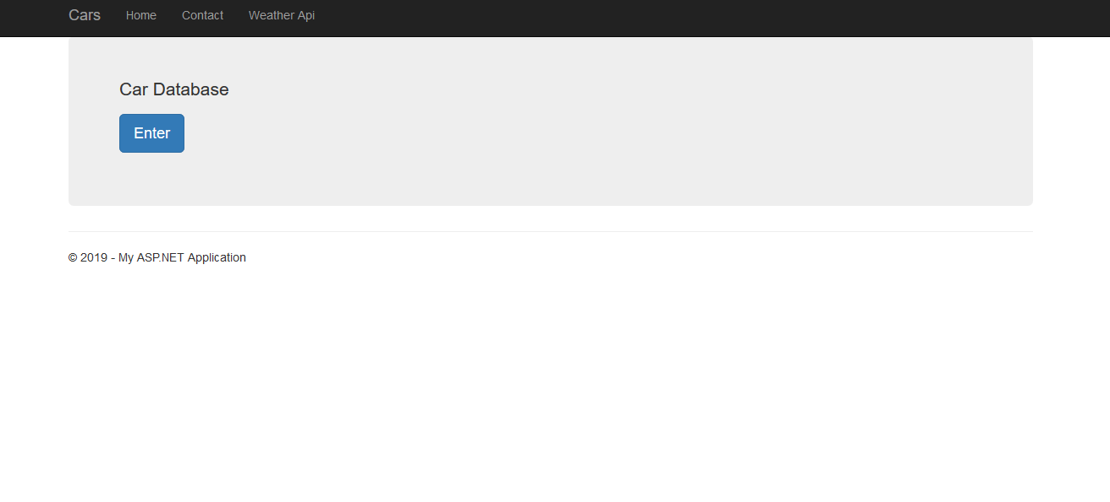

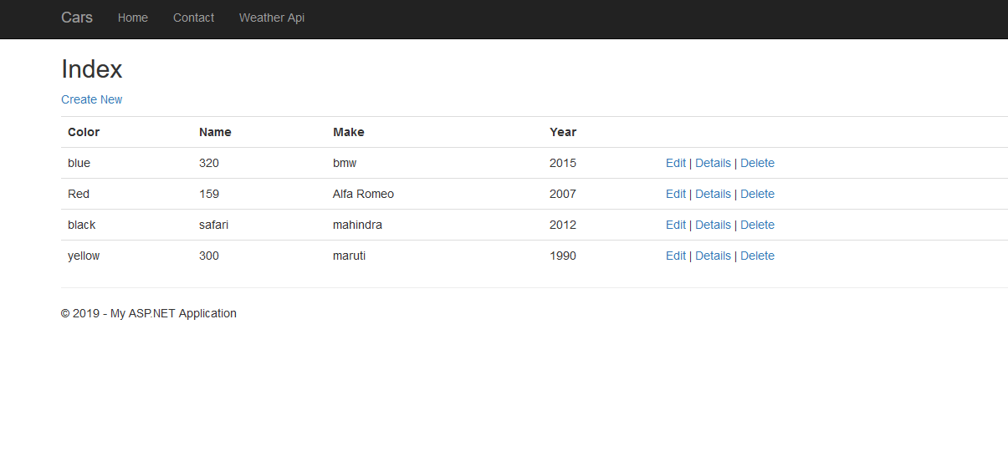

**Main data grid page**

This is the main data gird page here the data of every car is shown that is in the database

Base the car u add will be automatically update here

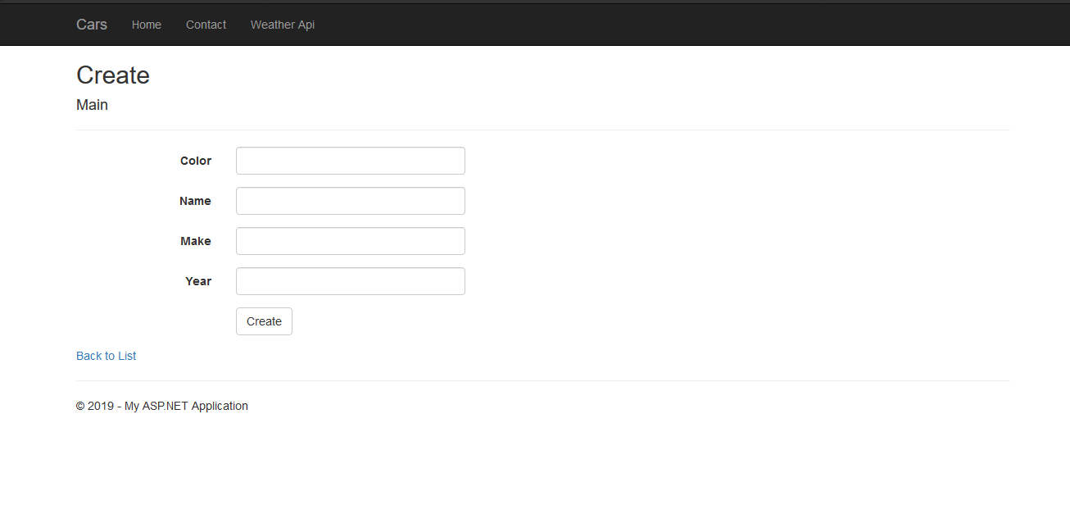

**Create page**

From this page you can add the car by filling the text boxes and clicking of the create button. after you click on the create button the data will be added to the main data grid.

## Quality Plan: -

|  |  |  |  |  |  |
| --- | --- | --- | --- | --- | --- |
| Step NO | Test Step | Input Data | Expected Result | Actual Result | Test Step Result |
| 1 | add New car | accord | The car should be added to the database | As Expected | Pass |
| 2 | Edit Button | Change accord to civic | Changes in information should appear on the main data grid | As Expected | Pass |
| 3 | Delete button | civic | civic should be  deleted | As Expected | Pass |
| 4 | Weather search | auckland | The weather of auckland should appear | As Expected | Pass |

## Project executive summary: -

**Hardware: -**

* Windows 10
* Intel core processor i5
* 8GB RAM

**Software: -**

* Visual Studio 2017
* Microsoft SQL

**Languages: -**

* C Sharp
* jQuery
* ASP.Net
* SQL

## Resources: -

Requirements Required to complete this project are as follow:

* PC must have RAM of 8GB.
* Windows used should be Windows 10.
* At least Intel i5 Processor should be used.
* Visual Studio 2017 is Required for the coding.
* Microsoft SQL is required for establishing the database and for the connection between visual studio and database.
* C#, jQuery, bootstrap, HTML, NETFramwork, ASP, all of them should be used.

## Project Milestone: -

|  |  |
| --- | --- |
| **WORK** | **DAY** |
| Database | 12 April to 14 April |
| Controller | 15 April to 20April |
| Front End | 21 April to 25 April |
| Back End Coding | 26 April to 28 April |
| Documentation | 28 April to 30 April |

## Project Schedule: -

|  |  |
| --- | --- |
| **WORK** | **HOURS** |
| **Database** | **8 hours** |
| **Controller** | **12 hours** |
| **Front End** | **13 hours** |
| **Back End Coding** | **14 hours** |
| **Documentation** | **2 hours** |