A. P. SHAH INSTITUTE OF TECHNOLOGY
INTELLIGENT PDF RESEARCH ASSISTANT
Intelligent Document Retrieval and Question Answering Using Hybrid RAG

Submitted in partial fulfilment of the requirements of the degree of
BACHELOR OF ENGINEERING
IN
COMPUTER ENGINEERING
by
Sumeet Gupta - 23102083
Saad Ansari - 23102075
Sumukh Bhagwat - 23102074
Kunal Bankar - 23102132

Guide: Dr. Rushikesh Nikam
Department of Computer Engineering
A. P. SHAH INSTITUTE OF TECHNOLOGY, THANE
2026-2027

CERTIFICATE
This is to certify that the project entitled “Intelligent PDF Research Assistant: Intelligent Document Retrieval and Question Answering Using Hybrid RAG” is a bonafide work of the project group “Sumeet Gupta (23102083), Saad Ansari (23102075), Sumukh Bhagwat (23102074), Kunal Bankar (23102132)” submitted to the University of Mumbai in partial fulfilment of the requirement for the award of the degree of Bachelor of Engineering in Computer Engineering.

Project Guide | Project Coordinator
____________________ | ____________________
Dr. Rushikesh Nikam | Dr. Rushikesh Nikam

Head of Department | Principal
____________________ | ____________________
Dr. Sachin Malave | Dr. Uttam Kolekar

PROJECT REPORT APPROVAL FOR B.E.
This project report entitled “Intelligent PDF Research Assistant: Intelligent Document Retrieval and Question Answering Using Hybrid RAG” by the project group is approved for the degree of Bachelor of Engineering in Computer Engineering, 2026-27.

Examiner Name | Signature
1. ____________________ | ____________________
2. ____________________ | ____________________

Date: ____________________
Place: ____________________

DECLARATION
We declare that this written submission represents our ideas in our own words and where others’ ideas or words have been included, we have adequately cited and referenced the original sources. We also declare that we have adhered to all principles of academic honesty and integrity and have not misrepresented, fabricated or falsified any idea, data, fact or source in this submission. We understand that any violation of the above may result in disciplinary action by the Institute.
______________________________
Sumeet Gupta - 23102083
______________________________
Saad Ansari - 23102075
______________________________
Sumukh Bhagwat - 23102074
______________________________
Kunal Bankar - 23102132
Date: ____________________

ABSTRACT
Research material is frequently distributed as lengthy PDF documents such as technical manuals, academic notes, project reports and reference documents. Locating a precise answer across several PDFs requires repeated manual reading, while a generic conversational system may return an answer that is not supported by the uploaded material. The Intelligent PDF Research Assistant is a document-based question-answering system that enables users to upload PDFs and ask questions in natural language.
The system extracts clean page-level text from PDFs, creates sentence-aware and section-aware chunks, and builds both semantic and keyword retrieval indexes. Dense vector retrieval uses Sentence Transformers with FAISS, while BM25 supports exact-term retrieval. Hybrid mode combines the two ranked lists using reciprocal-rank fusion and applies cross-encoder reranking before answer generation. The final response is grounded in selected document passages and displays the corresponding document name and page number. The application also supports document summaries, query expansion using WordNet and phrase aliases, and a browser extension that applies the same retrieval pipeline to readable webpage text.
The project is implemented with Python, Streamlit and FastAPI. It demonstrates a practical and transparent approach to PDF-based information access: users can compare retrieval modes, inspect sources and obtain a clear missing-evidence response when the uploaded documents do not contain an answer.
Keywords: PDF Processing, Hybrid Retrieval, BM25, Vector Search, FAISS, Reranking, Retrieval-Augmented Generation, Grounded Answers, Source Citation.

ACKNOWLEDGEMENT
We express our sincere gratitude to our project guide, Dr. Rushikesh Nikam, for valuable guidance, encouragement and constructive suggestions during the development of this project. We also thank the Department of Computer Engineering, A. P. Shah Institute of Technology, for providing the academic environment and resources required for this work. Finally, we thank our classmates, friends and family members for their support throughout the project.

CONTENTS
Chapter 1 Introduction 1
1.1 Background 1
1.2 Motivation 2
1.3 Overview of the Proposed Project 2
1.4 Aim and Scope 3
1.5 Significant Contributions 3
1.6 Alignment with Sustainable Development Goals 4
Chapter 2 Literature Survey 6
Chapter 3 Limitation of Existing System 10
Chapter 4 Problem Statement Objectives and Scope 12
Chapter 5 Proposed System 15
Chapter 6 Experimental Setup and Testing 23
Chapter 7 Project Plan 26
Chapter 8 Expected Outcome 28
Chapter 9 Project Cost Analysis 30
References 32

LIST OF FIGURES
Figure 5.1 System architecture
Figure 5.2 PDF ingestion and indexing workflow
Figure 5.3 Question answering workflow
Figure 5.4 User use-case model
Figure 5.5 Example grounded-answer screen
Figure 5.6 Example detailed-answer screen
Figure 7.1 Gantt chart of the project plan
LIST OF TABLES
Table 2.1 Comparison of document question-answering approaches
Table 5.1 Main application components
Table 5.2 Technology stack
Table 6.1 Evaluation parameters
Table 7.1 Phase-wise project plan
Table 9.1 Estimated project cost

ABBREVIATIONS
Abbreviation | Expansion
AI | Artificial Intelligence
API | Application Programming Interface
BM25 | Best Matching 25
FAISS | Facebook AI Similarity Search
LLM | Large Language Model
NLP | Natural Language Processing
PDF | Portable Document Format
RAG | Retrieval-Augmented Generation
RRF | Reciprocal Rank Fusion
UI | User Interface

CHAPTER 1
INTRODUCTION

1.1 Background
Digital libraries, institutional repositories and organisations store a large volume of knowledge in Portable Document Format (PDF) files. PDF is convenient for preserving layout, but it is not convenient when a reader needs one exact fact from many pages. The reader must repeatedly open documents, identify possible keywords, scan pages and compare passages. This process becomes slow when several reports or manuals are involved.
Traditional keyword search is useful when the reader already knows the exact vocabulary contained in a document. It is less effective when the same idea is written with different words. A document question-answering system can reduce this gap by retrieving relevant passages and presenting the information in a direct answer. Retrieval-augmented generation (RAG) uses retrieved source context to help keep an answer related to the supplied material.

1.2 Motivation
The project is motivated by the need to search long PDF documents efficiently while retaining traceability. Students and professionals need answers quickly, but they also need to verify them. An answer is more dependable when the system shows the document name and page number of the supporting material.
A second motivation is that no single retrieval approach works equally well for every question. Exact technical terms are handled effectively by lexical search, while paraphrased questions benefit from semantic search. The proposed system therefore provides Vector Search, BM25 Search and Hybrid Search modes.

1.3 Overview of the Proposed Project
The Intelligent PDF Research Assistant is a Python application with a Streamlit interface and FastAPI service. Users upload one or more PDFs, select document settings and ask questions through a chat interface. The backend extracts page text, creates chunks, builds vector and BM25 indexes, ranks candidate passages and generates an answer from the selected context. Source information is returned with the answer.

1.4 Aim and Scope
The aim is to develop an interactive PDF research assistant that retrieves information from uploaded PDFs and produces understandable, source-linked answers. The implemented scope includes PDF ingestion, page-level extraction, chunking, Vector/BM25/Hybrid retrieval, reranking, summary requests, source citations, FastAPI endpoints, Streamlit interaction and a webpage assistant extension. It does not include OCR for scanned documents, persistent multi-user storage, authentication, cloud deployment or a research-paper comparison feature.

1.5 Significant Contributions
- A practical hybrid retrieval pipeline that combines semantic vector search and BM25 lexical search.
- Sentence-aware and section-aware chunking that retains document and page metadata.
- Reciprocal-rank fusion and cross-encoder reranking for selecting useful evidence.
- Grounded answers with document/page citations and clear responses when evidence is missing.
- Query expansion using WordNet and phrase aliases, document summary handling, and browser-page ingestion through the same pipeline.

1.6 Alignment with Sustainable Development Goals SDGs
The project aligns with SDG 4, SDG 9 and SDG 16. SDG 4 is supported by making educational PDFs easier to explore through natural-language questions, summaries and traceable sources. SDG 9 is supported by the use of modern information-retrieval components including embeddings, FAISS, BM25, reranking and web APIs. SDG 16 is supported by source-linked answers and the deliberate refusal to fabricate an answer when adequate evidence is unavailable.

CHAPTER 2
LITERATURE SURVEY

2.1 PDF Processing and Text Extraction
PDF text extraction is a necessary first step in a document question-answering system. Text-based PDFs contain page content that can be extracted for indexing, although line breaks and spacing may need cleaning. PyMuPDF provides page-level text extraction and page metadata. The project cleans whitespace and repairs common hyphenated line breaks before chunking text.

2.2 Lexical Retrieval Using BM25
BM25 is a widely used probabilistic ranking method for information retrieval. It scores passages according to query-term frequency, document length and the rarity of matching terms. Its main strength is exact lexical matching: it can retrieve a passage containing a precise technical term that may be weakened in a purely semantic representation.

2.3 Dense Vector Retrieval
Dense retrieval represents text as numerical embeddings. Query and passage embeddings can be compared using similarity measures, which helps find related content when the question uses wording different from the document. The project uses Sentence Transformers to create embeddings and FAISS for similarity search over the indexed chunk vectors.

2.4 Hybrid Retrieval and Reranking
Hybrid retrieval combines lexical and semantic strengths. In this project, ranked result lists from FAISS and BM25 are merged through reciprocal-rank fusion. A cross-encoder then evaluates query-passage pairs and reranks the candidates. This two-stage approach first obtains broad coverage and then focuses on relevance for the final answer context.

2.5 Retrieval-Augmented Generation and Citations
RAG uses retrieved text as context for answer generation. The project instructs the language model to use only the supplied context; when no LLM credential is configured, it uses a grounded extractive response. The system also keeps document name and page number metadata so that the user can inspect the original source.

2.6 Query Understanding and Summary Requests
Different users may describe the same requirement in different words. Query expansion improves retrieval by retaining the original question and adding controlled phrase aliases and WordNet synonyms. The implementation maps expressions such as “pros and cons” to “advantages, disadvantages, benefits and drawbacks”. It also detects summary requests and selects ordered, document-wide context instead of using only standard question retrieval.

2.7 Comparison of Approaches
Criterion | Manual search | BM25 | Vector search | Proposed hybrid system
Interaction | Open and read pages | Enter exact terms | Ask a query | Ask a natural-language question
Matching | Human interpretation | Lexical match | Semantic similarity | Lexical and semantic match
Answer | Reader prepares answer | Ranked passages | Ranked passages | Grounded answer with sources
Traceability | Direct page checking | Depends on interface | Depends on interface | Document name and page shown

Table 2.1: Comparison of document question-answering approaches

2.8 Research Gaps Identified
The review identifies a practical gap between manual document search and trustworthy conversational access to document content. Keyword-only search does not reliably handle paraphrases, while generic chat systems may not cite the supplied PDFs. The project addresses this gap through a selectable hybrid pipeline, section-aware context selection, source citations and missing-evidence handling. The project does not claim a comparison feature for research papers; its input is general PDF content and readable webpage text.

CHAPTER 3
LIMITATION OF EXISTING SYSTEM
- Manual reading is slow when several lengthy PDFs must be consulted.
- Keyword-only retrieval can miss relevant passages when a question is phrased differently from the document.
- Semantic search alone can miss exact terms, rare vocabulary and abbreviations.
- Generic chatbots can produce text without a verifiable connection to the user’s documents.
- Many tools do not provide document and page citations with their answers.
- Unstructured chunks may combine unrelated topics and reduce answer relevance.
- A missing API key or provider failure can interrupt answer generation unless the system has a grounded fallback.
The proposed system addresses these limitations through multi-PDF ingestion, page-level metadata, sentence and section-aware chunking, selectable retrieval modes, hybrid fusion, reranking, grounded context and source display. Its limitations are stated clearly: it currently supports text-extractable PDFs, keeps indexes in memory, and requires configured provider credentials for generated prose.

CHAPTER 4
PROBLEM STATEMENT OBJECTIVES AND SCOPE

4.1 Problem Statement
Users who need answers from multiple PDF documents spend significant time finding relevant passages and interpreting them manually. Basic keyword search may not understand natural-language phrasing, while general language models may answer without using the supplied documents. A system is required to retrieve relevant PDF content, prepare a direct answer and display source references for verification.

4.2 Objectives
- Develop a user-friendly interface for uploading and managing PDF documents.
- Extract clean page-level PDF text and divide it into meaningful chunks for retrieval.
- Implement Vector Search, BM25 Search and Hybrid Search modes.
- Fuse hybrid results and rerank candidates before producing an answer.
- Generate or extract grounded answers and show document/page citations.
- Support document summaries and query expansion with WordNet and phrase aliases.
- Provide FastAPI endpoints and a browser extension for readable webpage content.
- Test PDF extraction, chunking, retrieval, citations, query understanding and summary logic.

4.3 Scope
The project supports one or more text-extractable PDF files, browser-extracted page text, natural-language questions, selected retrieval modes, summary requests and source display. The Streamlit UI supports document upload, chunk settings, retrieval selection, model provider selection, document status and chat. The FastAPI service supports health checks, PDF upload, queries, clearing documents and isolated browser sessions. The current scope excludes OCR, mobile applications, user accounts, persistent cloud storage, multilingual document processing and research-paper comparison.

CHAPTER 5
PROPOSED SYSTEM

5.1 System Architecture
The application uses a layered architecture. The user interacts with the Streamlit interface or browser extension. The ResearchAssistant coordinates document processing, index rebuilding and answer selection. Retrieval combines FAISS vector search, BM25 retrieval, hybrid fusion and cross-encoder reranking. The answer service uses a configured Groq/OpenAI provider when credentials are available, otherwise it returns a grounded extractive response. Every selected context item retains source metadata.
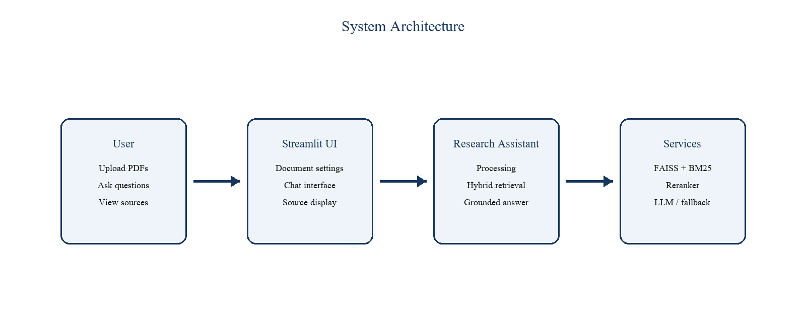
Figure 5.1: System architecture of the Intelligent PDF Research Assistant

5.2 PDF Ingestion and Indexing
Uploaded PDFs are saved to the data directory and passed to the assistant. PyMuPDF extracts page text; cleaning removes unnecessary whitespace and joins words split across PDF line breaks. The chunker preserves sentence boundaries and uses overlap to retain context. When question-style content is detected, it avoids mixing separate question/answer sections. The assistant embeds chunks, builds a FAISS index and builds a BM25 index over the same content.
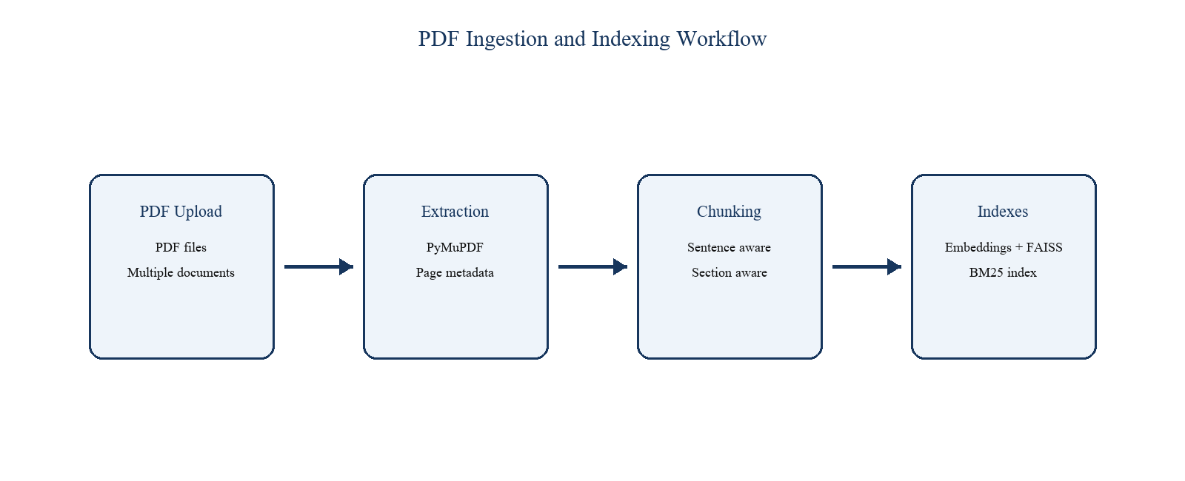
Figure 5.2: PDF ingestion and indexing workflow

5.3 Retrieval and Answer Workflow
For Vector Search, one or more query variants are encoded and searched against FAISS. For BM25 Search, the expanded query is scored against the lexical index. Hybrid Search runs both methods and combines ranks using reciprocal-rank fusion. Candidate passages are reranked by a cross-encoder. The most relevant section is selected, a bounded answer context is built and the answer service returns a response with source citations.
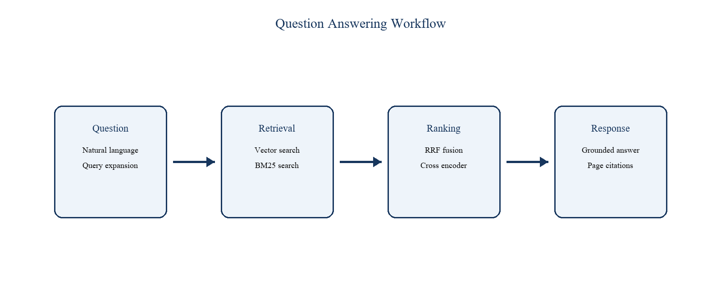
Figure 5.3: Question answering and source display workflow

5.4 User Use Cases
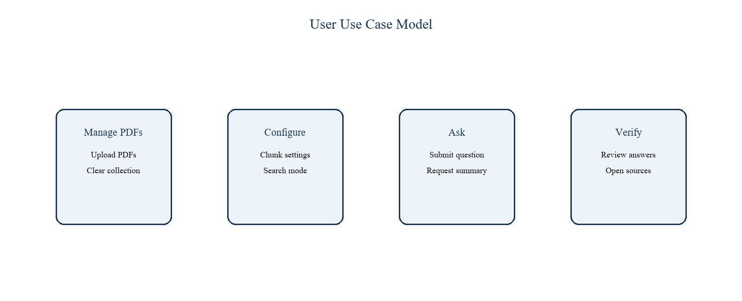
Figure 5.4: User use-case model
Component | Implemented responsibility
Streamlit UI | PDF upload, chunk configuration, retrieval and model selection, chat, source display and document clearing.
PDF processor | Page extraction, text cleaning and page metadata preservation.
Chunker | Sentence-aware chunks, overlap and question-section separation.
Retrievers | FAISS vector retrieval, BM25 lexical retrieval and reciprocal-rank fusion.
Reranker | Cross-encoder scoring of query-passage pairs.
LLM service | Grounded answer/summary generation and extractive handling when credentials are missing.
FastAPI and extension | Endpoints for PDF/browser content and isolated webpage assistant sessions.

Table 5.1: Main application components

5.5 User Interface and Source Display
The interface presents a question, assistant answer and source section. Answers are intended to remain grounded in retrieved content, while source information lets the user return to the original document. The following screens illustrate the answer-oriented interaction; the final interface should show the document/page sources returned by the system.
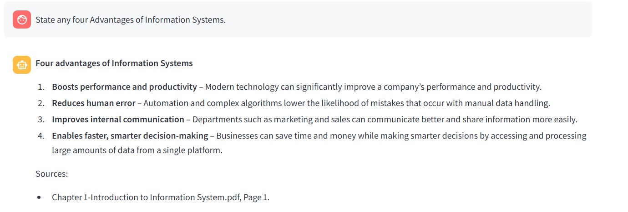
Figure 5.5: Example grounded-answer interface
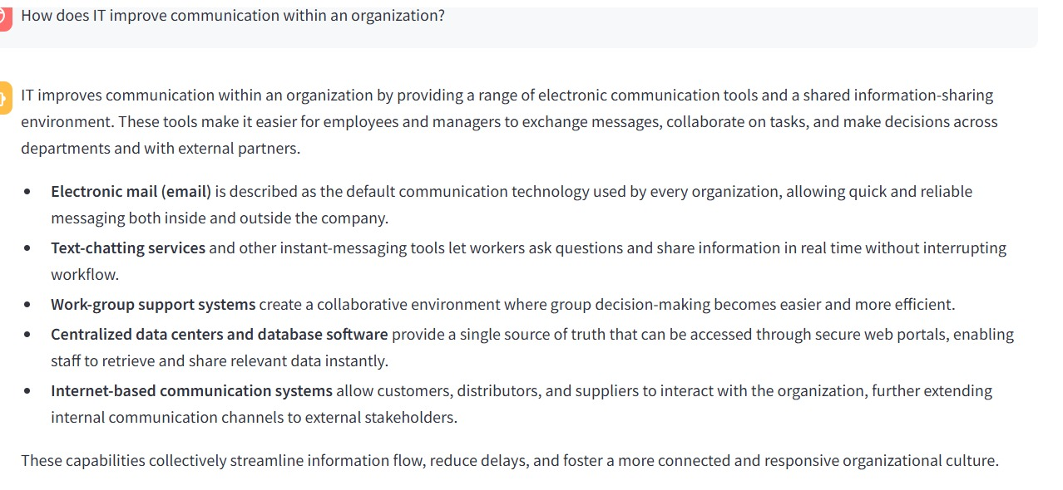
Figure 5.6: Example detailed-answer interface

5.6 Browser Page Assistant
The implemented Manifest V3 browser extension creates a movable Research Assistant bubble on ordinary webpages. It supports asking about the page, summarising the page and explaining selected text. Readable text is extracted from the page and sent to an isolated FastAPI session. That session uses the same chunking, embedding, BM25 retrieval, hybrid fusion, reranking and answer-generation pipeline as the PDF assistant. The extension does not include a research-paper comparison feature.

5.7 Technology Stack
Layer | Technology | Use
Language | Python | Application and backend implementation
UI | Streamlit | PDF upload, settings, chat and sources
API | FastAPI and Uvicorn | PDF/browser endpoints
PDF processing | PyMuPDF | Extract and clean page text
Embedding and vector index | Sentence Transformers and FAISS | Semantic retrieval
Lexical retrieval | rank-bm25 | Exact-term retrieval
Reranking | MS MARCO MiniLM cross-encoder | Query-passage relevance ranking
Query understanding | NLTK and WordNet | Controlled vocabulary expansion
Testing | pytest | Automated unit tests

Table 5.2: Technology stack

CHAPTER 6
EXPERIMENTAL SETUP AND TESTING

6.1 Input Data and Configuration
The application accepts PDF files through the Streamlit uploader. The default chunk size is 900 characters and default chunk overlap is 120 characters; the UI permits chunk size from 300 to 2000 and overlap from 50 to 300. The default retrieval mode is Hybrid Search. The embedding model is BAAI/bge-small-en-v1.5, and the reranker configuration uses cross-encoder/ms-marco-MiniLM-L-6-v2 on CPU.

6.2 Test Coverage
The repository contains automated tests for the implemented logic. Tests check sentence-safe chunking, splitting long text, question-section separation, PDF page extraction, citation creation, reciprocal-rank fusion, vector query variants, query expansion, summary request detection, context selection, relevant-section selection and LLM error handling. These checks provide repeatable validation of individual components; they do not replace a large user study.

6.3 Evaluation Parameters
Aspect | Parameter | Purpose
Retrieval relevance | Recall@K | Checks whether relevant evidence appears among the first K results.
Ranking quality | MRR | Measures the rank of the first relevant result.
Precision | Precision@K | Measures the proportion of retrieved results that are relevant.
Efficiency | Latency | Records time required for retrieval/reranking.
Traceability | Document/page correctness | Checks displayed sources against original PDF pages.
Robustness | Unit-test outcome | Checks expected behaviour for normal and error cases.

Table 6.1: Evaluation parameters

6.4 Evaluation Setup
An evaluation script builds a sample research PDF, indexes it and runs a prepared set of questions through BM25, Vector Search, Hybrid Search and Hybrid Search plus reranking. It calculates Recall@50, Precision@50, MRR and latency. The report does not claim numerical benchmark results because final values depend on the environment, installed models and execution conditions. The script provides a repeatable way to record results before final submission.

6.5 Software and Hardware
The project requires Python with the packages listed in requirements.txt. It can run on a general-purpose computer with CPU support for the embedding and reranking models. A valid Groq or OpenAI key is needed only for LLM-generated prose. If a provider key is absent, the application displays a configuration warning and uses the implemented grounded extractive response path.

CHAPTER 7
PROJECT PLAN
The work was arranged as an incremental six-week implementation cycle. Each stage produced a usable component and informed the next stage.
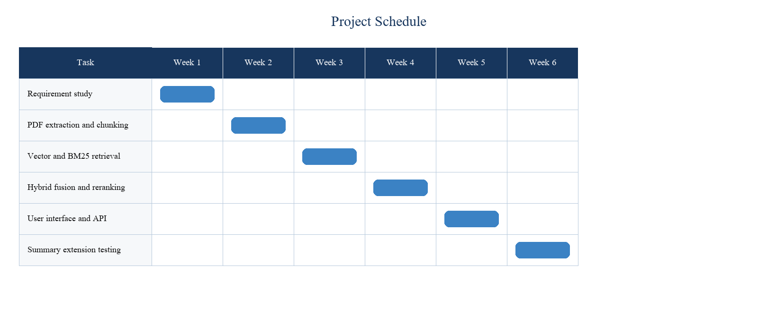
Figure 7.1: Gantt chart of the first-semester project plan
Week | Activity | Deliverable
1 | Requirement study and problem definition | Objectives, architecture outline and technology selection
2 | PDF extraction and chunking | Clean page text, metadata and section-aware chunks
3 | Semantic and lexical retrieval | FAISS vector index and BM25 retrieval
4 | Hybrid ranking and grounding | RRF fusion, reranking and citations
5 | User interface and API | Streamlit workflow and FastAPI endpoints
6 | Supporting functionality and tests | WordNet expansion, summaries, extension, evaluation setup and tests

Table 7.1: Phase-wise project plan

CHAPTER 8
EXPECTED OUTCOME
- A working application for uploading one or more text-based PDF documents.
- A document list that shows document name, page count, chunk count and processing status.
- Sentence-aware and section-aware chunking with retained page metadata.
- Vector Search, BM25 Search and Hybrid Search modes.
- Hybrid fusion and cross-encoder reranking of candidate passages.
- Question answers grounded in selected context with document/page source citations.
- Document summary requests and WordNet/phrase-based query expansion.
- FastAPI endpoints and a browser-page assistant for readable webpage text.
- Automated tests and a repeatable retrieval evaluation setup.
The expected outcome is a transparent tool for navigating information in supplied documents. Its value comes from helping users locate relevant passages while retaining a route back to the source. The system does not claim to replace critical reading or provide unsupported information outside its retrieved context.

CHAPTER 9
PROJECT COST ANALYSIS

9.1 Estimated Project Cost
The project uses open-source Python libraries and existing student hardware for local demonstration. The main variable cost is optional LLM API usage. When an API key is unavailable, the implemented grounded extractive path avoids generation-token cost.
Item | Basis | Estimated cost INR
Development hardware | Existing student laptop or desktop | 0
Open-source libraries | Python, Streamlit, PyMuPDF, FAISS and related packages | 0
Development tools | Existing editor and Git tooling | 0
LLM API use | Limited testing; depends on provider usage | 0 to 3,000
Internet | Existing connection | 0
Hosting | Local demonstration; optional | 0 to 3,000
Printing and binding | Report copies | 1,000 to 2,000
Contingency | Small allowance | 500 to 1,000

Table 9.1: Estimated project cost

9.2 Cost Interpretation
The direct cash cost can remain low because the core retrieval pipeline uses local CPU models and open-source libraries. API and hosting expenses vary according to use. The main academic investment is the team’s development and testing effort rather than software licensing.

REFERENCES
[1] P. Lewis et al., “Retrieval-Augmented Generation for Knowledge-Intensive NLP Tasks,” NeurIPS, 2020.
[2] K. Johnson, M. Douze and H. Jegou, “Billion-scale similarity search with GPUs,” IEEE Transactions on Big Data, 2019.
[3] N. Reimers and I. Gurevych, “Sentence-BERT: Sentence Embeddings using Siamese BERT-Networks,” EMNLP-IJCNLP, 2019.
[4] S. Robertson and H. Zaragoza, “The Probabilistic Relevance Framework: BM25 and Beyond,” Foundations and Trends in Information Retrieval, 2009.
[5] G. V. Cormack, C. L. A. Clarke and S. Buettcher, “Reciprocal Rank Fusion Outperforms Condorcet and Individual Rank Learning Methods,” SIGIR, 2009.
[6] R. Nogueira and K. Cho, “Passage Re-ranking with BERT,” arXiv:1901.04085, 2019.
[7] PyMuPDF Documentation. Available: https://pymupdf.readthedocs.io/
[8] Streamlit Documentation. Available: https://docs.streamlit.io/
[9] Sentence Transformers Documentation. Available: https://www.sbert.net/
[10] FAISS Documentation. Available: https://faiss.ai/
[11] rank-bm25 Python package. Available: https://pypi.org/project/rank-bm25/
[12] NLTK Documentation. Available: https://www.nltk.org/
[13] FastAPI Documentation. Available: https://fastapi.tiangolo.com/

