Workflow / Architecture :-
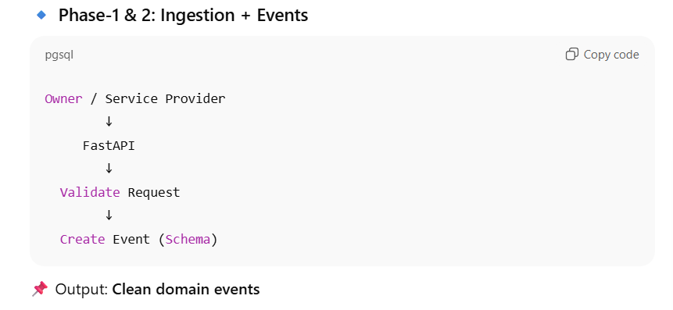
Phase-1 & 2: Ingestion + Events

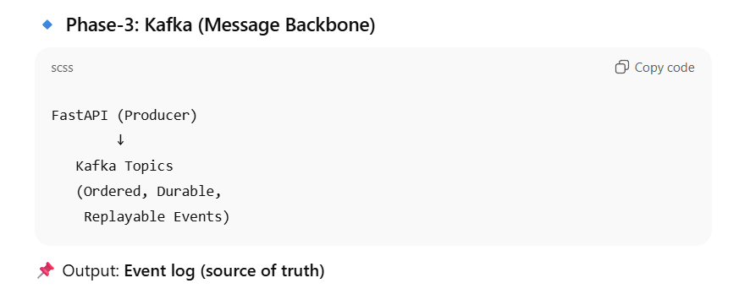
Phase-3: Kafka (Message Backbone)

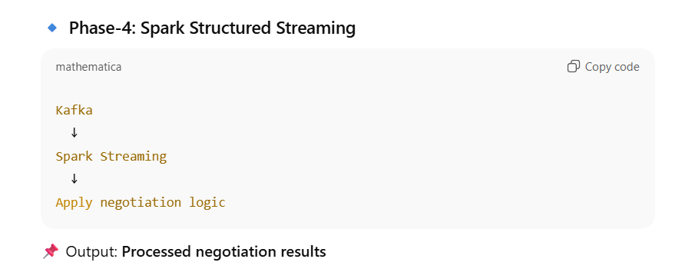
Phase-4: Spark Structured Streaming

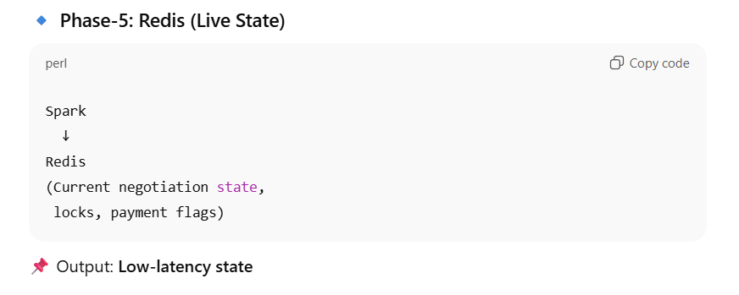
Phase-5: Redis (Live State)

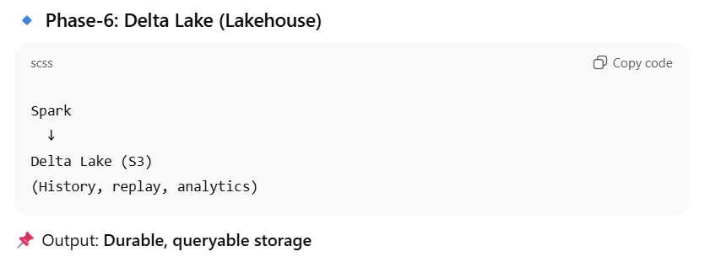
Phase-6: Delta Lake (Lakehouse)

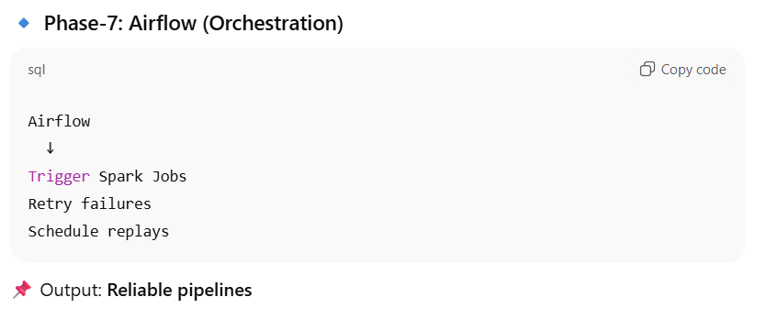
Phase-7: Airflow (Orchestration)

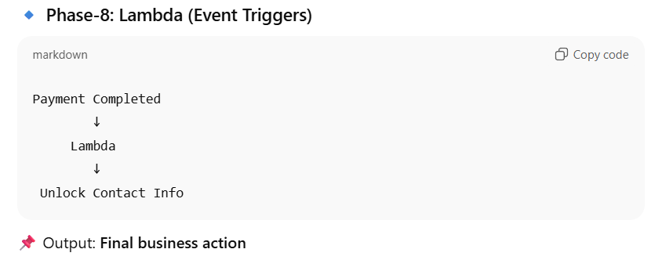
Phase-8: Lambda (Event Triggers)

FULL FLOW
User (Owner / Provider)
|
v
FastAPI
(Validate + Create Event)
|
v
Kafka
(Buffer + Order + Replay)
|
v
Spark Structured Streaming
(Business Logic)
|
+--------> Redis (Live State)
|
v
Delta Lake (S3)
(History / Analytics)
|
v
Airflow
(Schedule / Retry)
|
v
AWS Lambda
(Contact Unlock)

