CarCraft — Project Visual Documentation
1. CarCraft Home Page
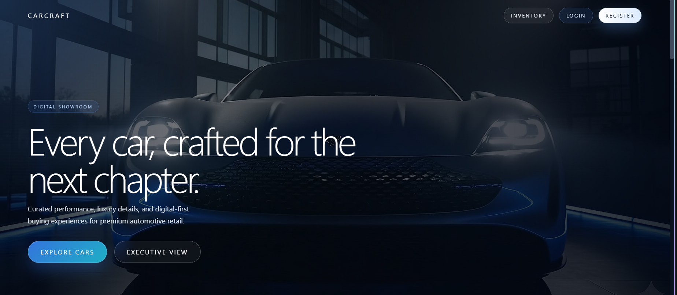
2. Premium Vehicle Inventory and Filters
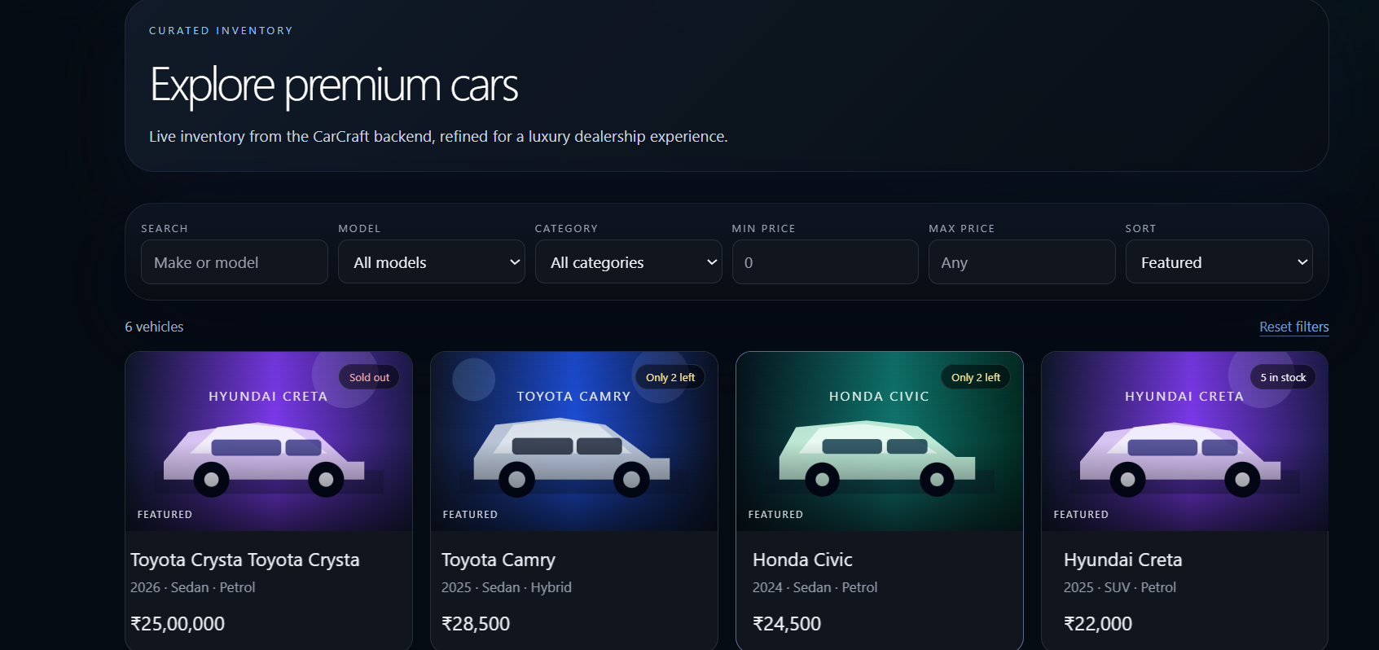
3. Luxury Standards and About Section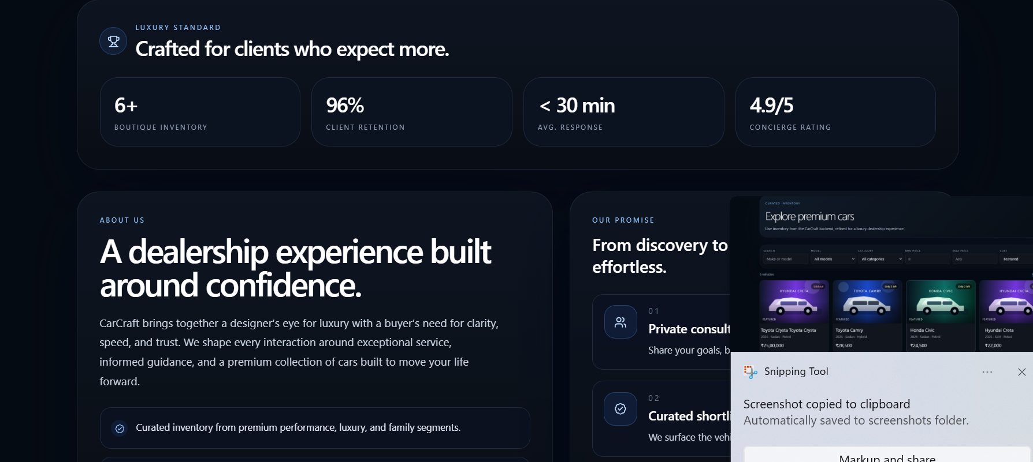
4. Customer Registration Page
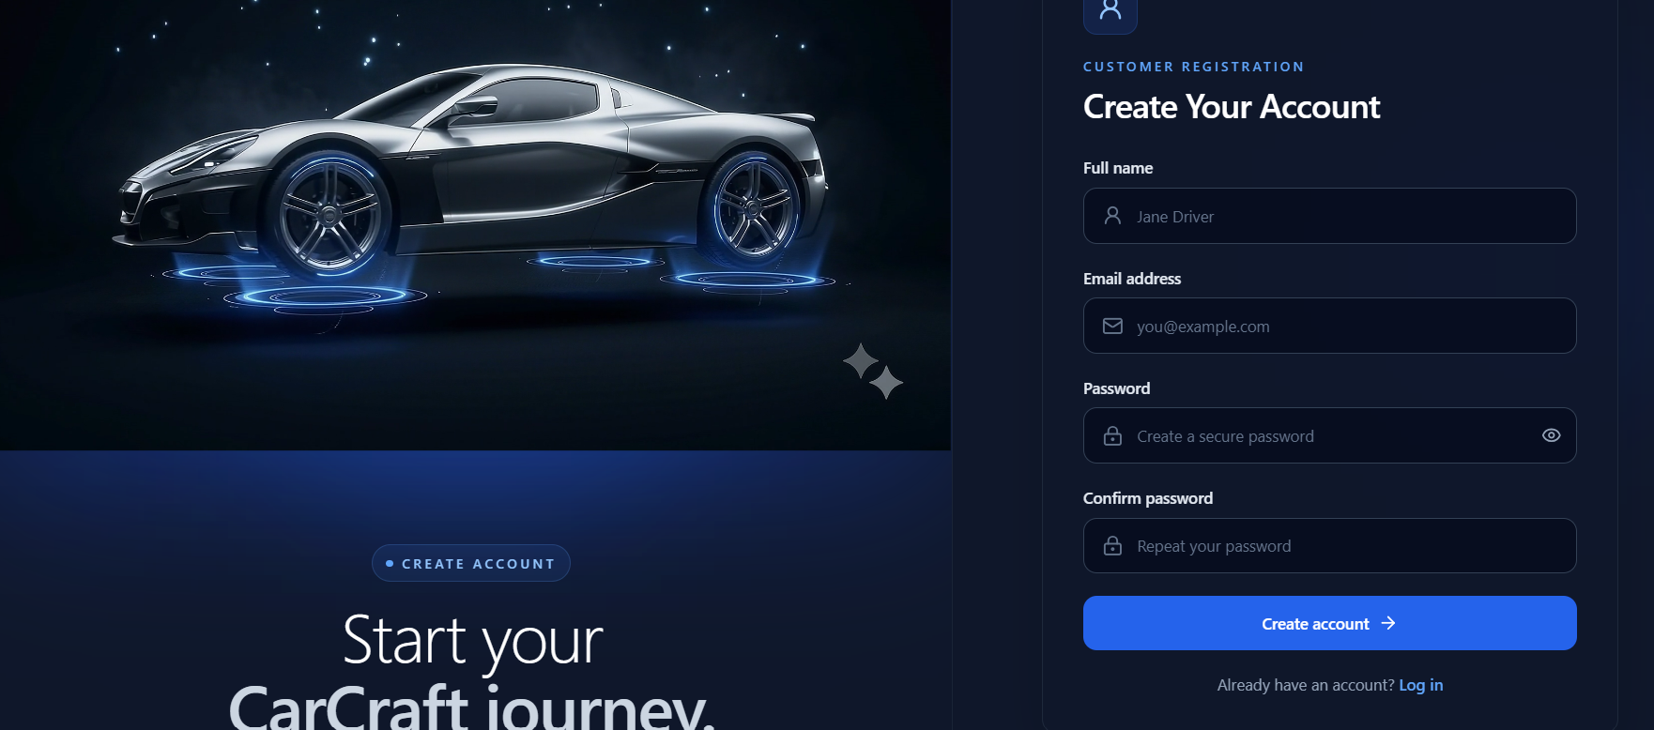

5. Customer Login Page
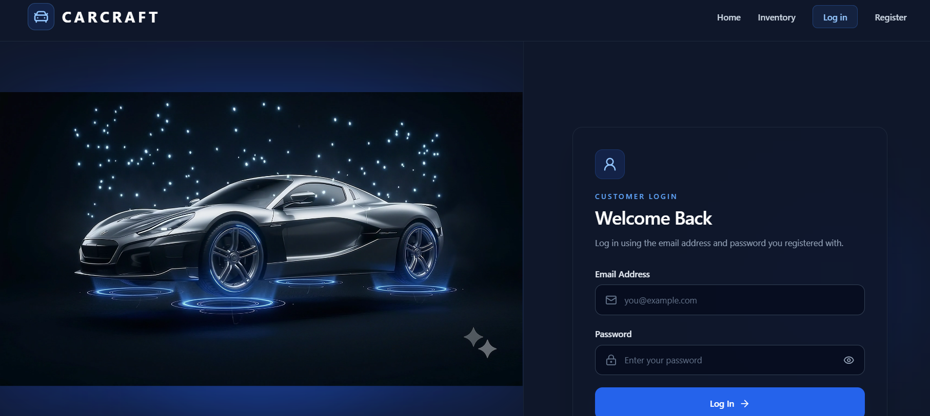
6. Customer Dashboard Overview
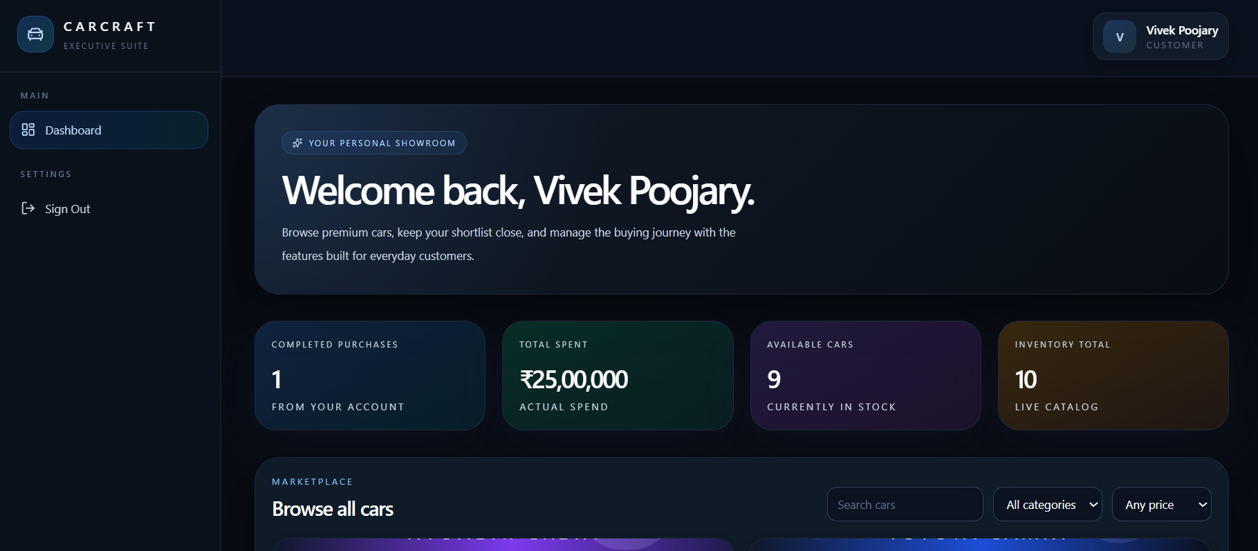
7. Customer Dashboard — Vehicle Marketplace
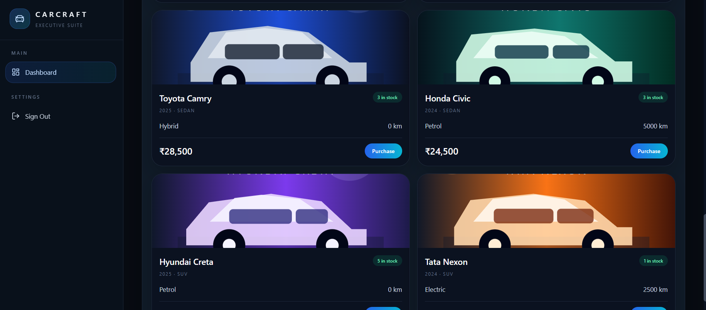
8. Admin Dashboard Overview
