Massachusetts Open Checkbook
Vendor Contract & SDO Commitment Analysis

ALY 6980 — Capstone Project
Exploratory Data Analysis Report
February 2026

List of questions
- BQ1: Top IT Sector Companies by SDO Commitment %
- BQ2: Average SDO Commitment % by Procurement Category
- BQ3: Distribution of Vendors Across Procurement Categories
- BQ4: Top Contract Sub-Categories by Vendor Count
- BQ5: National vs Local Company Presence by Industry
- BQ6: SDO Commitment Distribution & Outlier Detection
- BQ7: SDO Coverage Rate — Valid vs Missing
- BQ8: Correlation: Vendor Count vs Average SDO
- BQ9: Industry Diversity — National vs Local vs SGC Target
- BQ10: IT Sector Vendor Concentration
- BQ11: Sector Analysis: Company Density by Industry

BQ1: Which companies in the IT sector (ITE, ITS, ITT) have the best SDO commitment percentage?
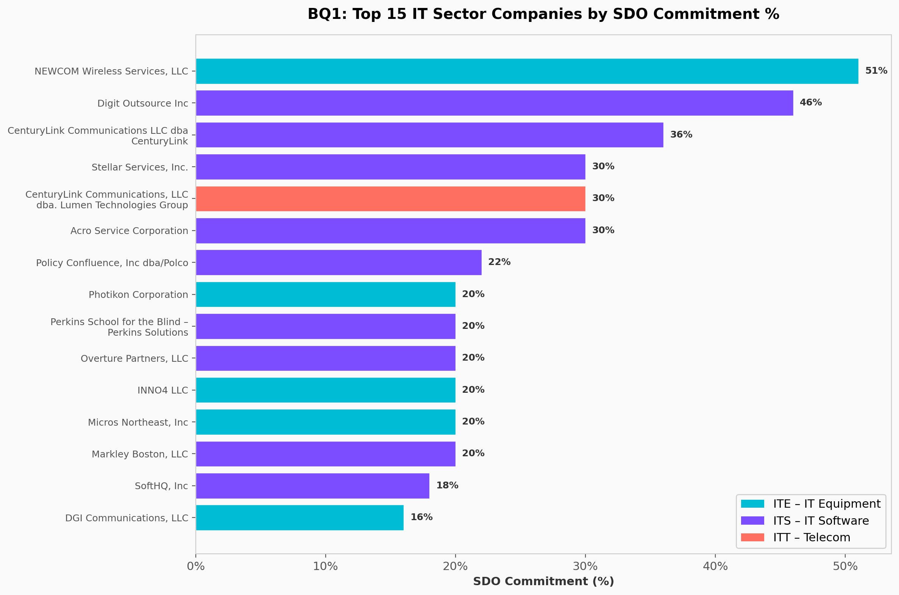

Analysis & Key Findings:
Among the three IT sub-categories, 262 vendor records have valid SDO commitments. NEWCOM Wireless Services leads with 51% SDO commitment (ITE category), followed by Digit Outsource Inc at 46% (ITS) and CenturyLink at 36% (ITS). The average SDO commitment across IT vendors is 6.2%, with a median of 5.0%, indicating most IT companies have relatively modest SDO commitments with a few standout performers.

BQ2: Which industry/category has the highest average SDO commitment percentage?
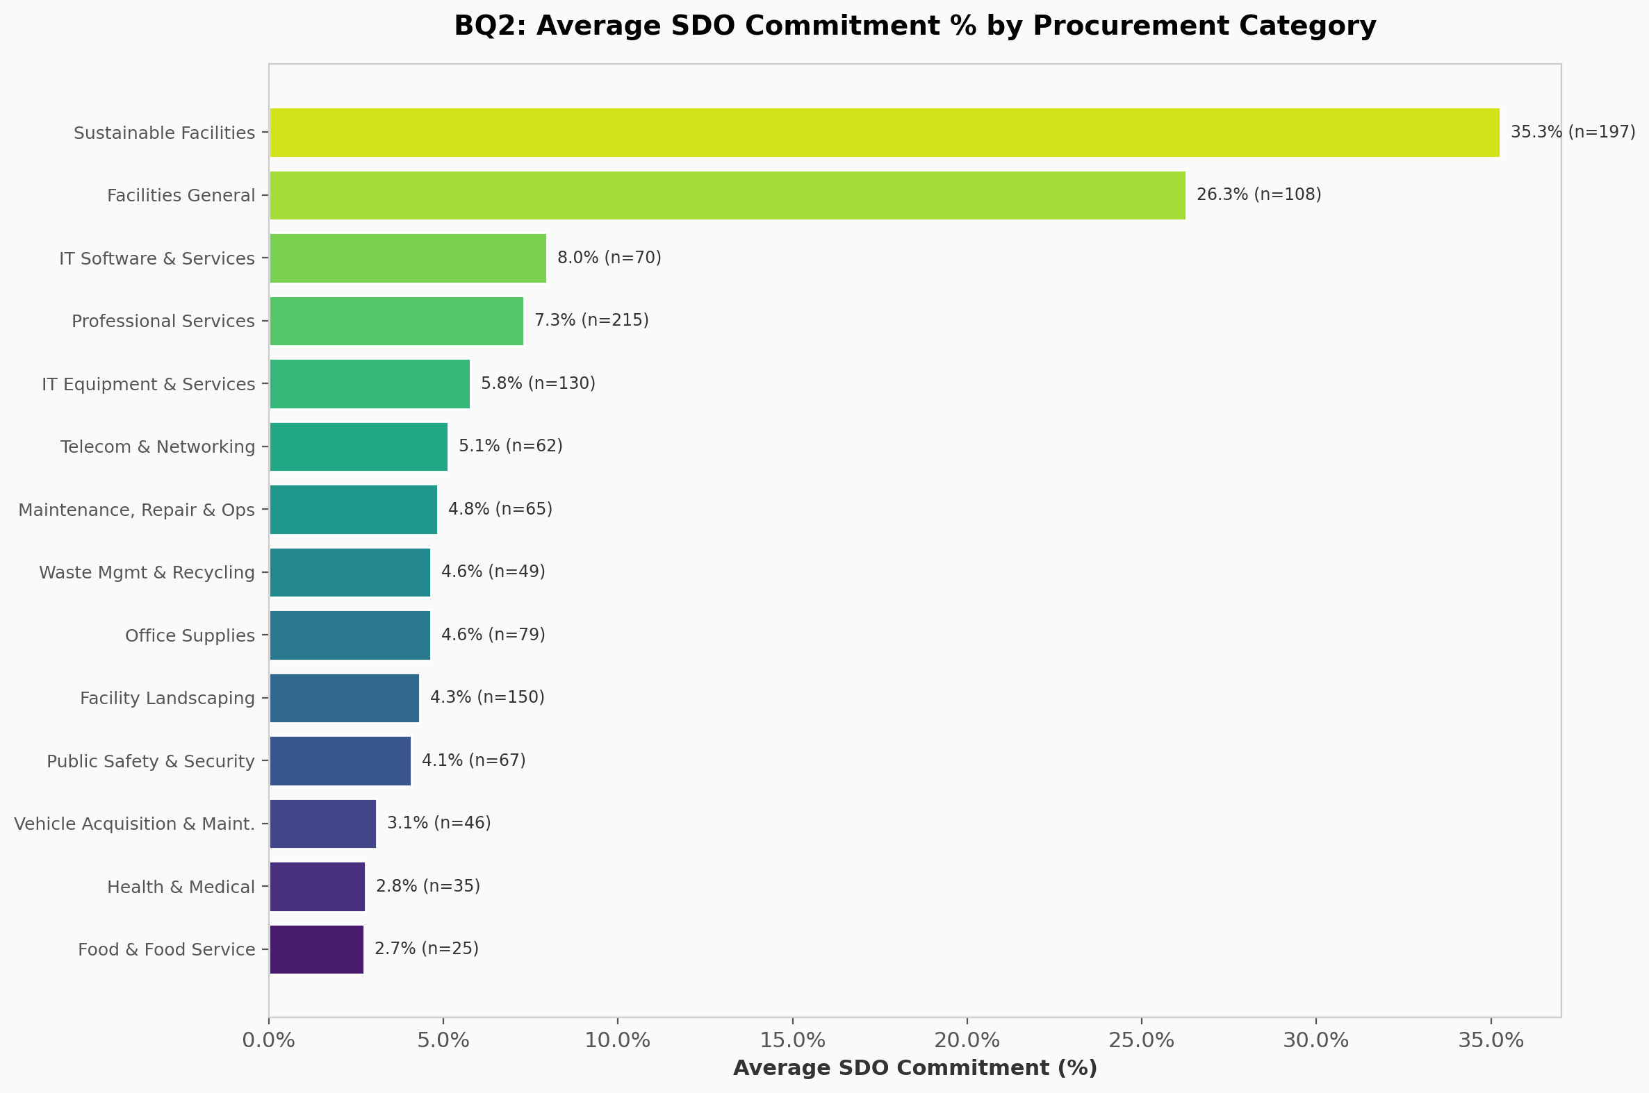

Analysis & Key Findings:
Across all 15 procurement categories, the average SDO commitment varies significantly. Categories like Professional Services and Facility Landscaping show higher average commitments, while Food & Food Service and Vehicle Acquisition show lower averages. This disparity highlights that supplier diversity policies are not uniformly adopted across all procurement sectors, suggesting targeted policy interventions may be needed.

BQ3: What is the distribution of vendors across procurement categories?
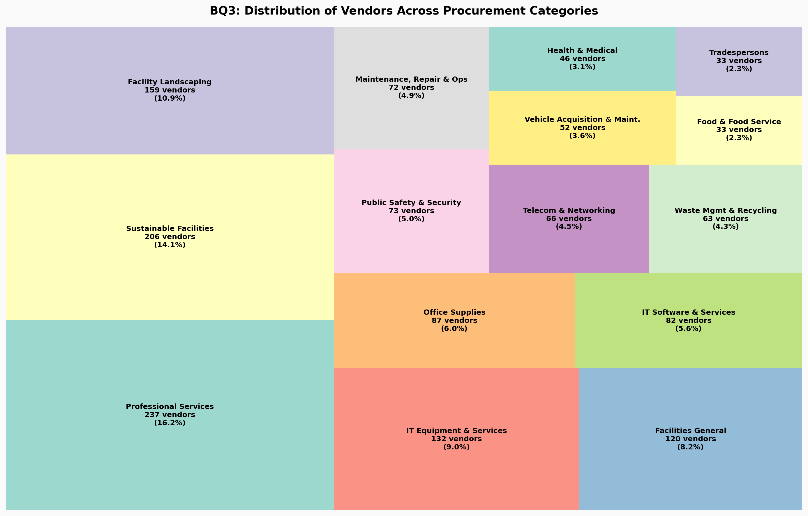

Analysis & Key Findings:
The treemap reveals significant variation in vendor density across categories. Professional Services (PRF) has the largest vendor pool, reflecting the broad range of consulting and advisory services Massachusetts procures. IT Equipment and Facilities General also have substantial vendor bases. Categories like Food & Food Service and Tradespersons have fewer vendors, suggesting more concentrated markets.

BQ4: How are vendors distributed across contract sub-category codes?
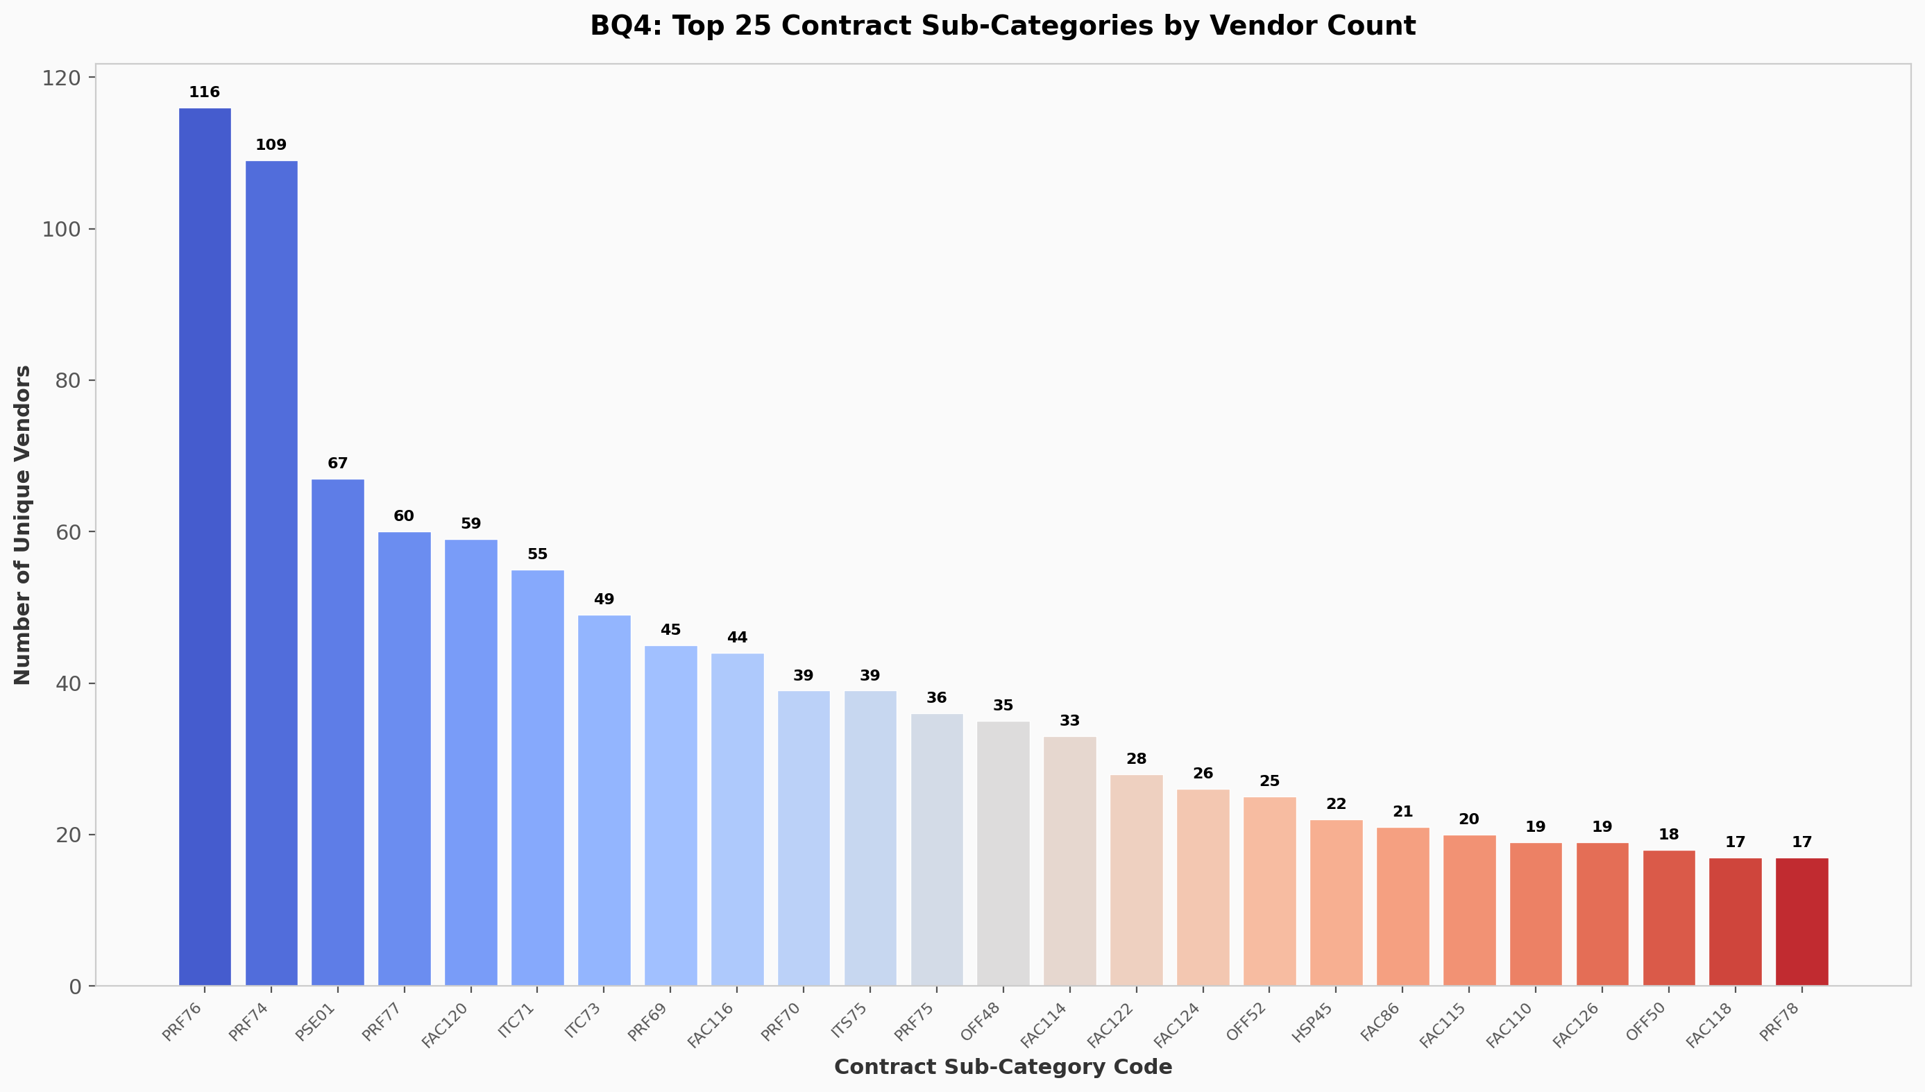

Analysis & Key Findings:
The top contract sub-categories by vendor count are PRF76 (116 vendors), PRF74 (109 vendors), and PSE01 (67 vendors). Professional Services dominates with multiple high-vendor-count sub-categories, indicating a fragmented and competitive market. This granular view helps procurement officers identify which specific contract areas have the most supplier options.

BQ5: How do National vs Local companies compare across industries?
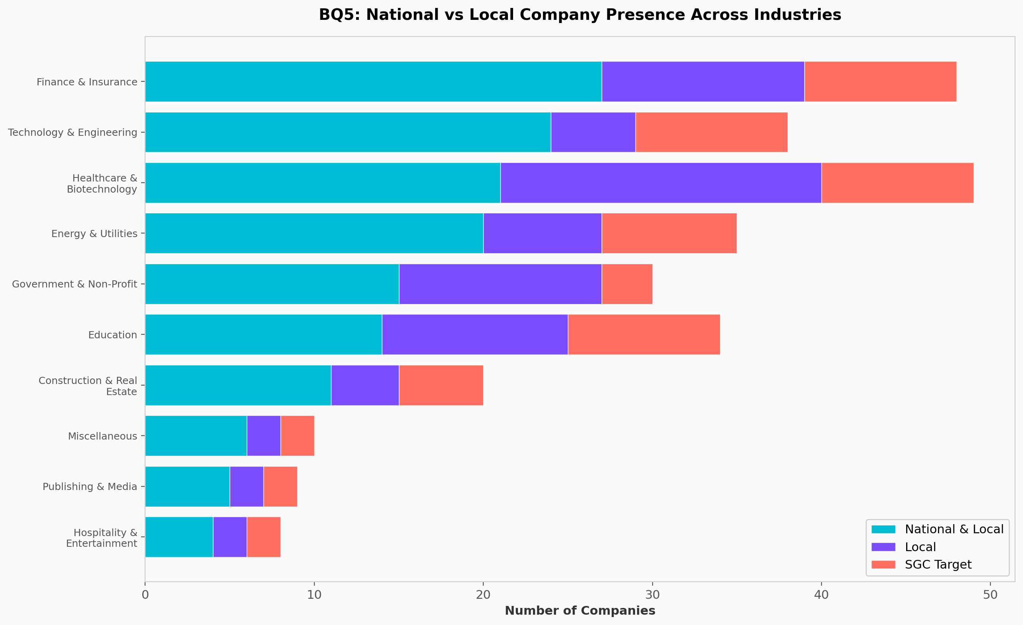

Analysis & Key Findings:
Finance & Insurance has the most National & Local companies (27), followed by Technology & Engineering (24) and Healthcare & Biotechnology (21). The SGC (Supplier/Government/Community) targets are relatively consistent across major industries at around 8-9 companies each. Hospitality & Entertainment has the fewest presence overall, likely reflecting Massachusetts' economic profile where finance, tech, and healthcare dominate.

BQ6: What is the SDO commitment distribution? Are there outliers?
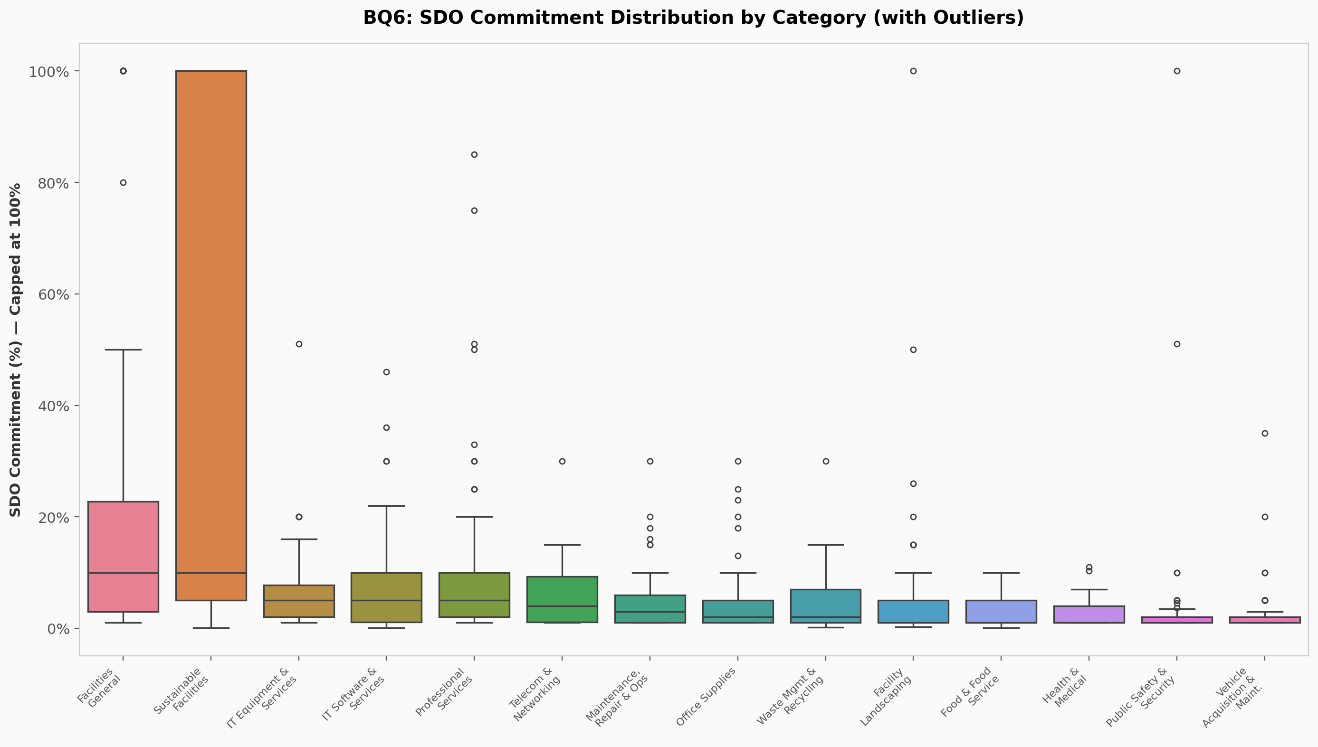

Analysis & Key Findings:
The box plot reveals significant outliers across multiple categories. Facilities General and Sustainable Facilities show the most extreme outliers with some vendors reporting SDO commitments above 100% (likely data quality issues). Most categories have median SDO commitments between 1-5%, with IQR-based outlier detection identifying 80+ outliers across 12 of 15 categories. This suggests a need for data validation in SDO reporting.

BQ7: What proportion of vendors have valid SDO commitments?
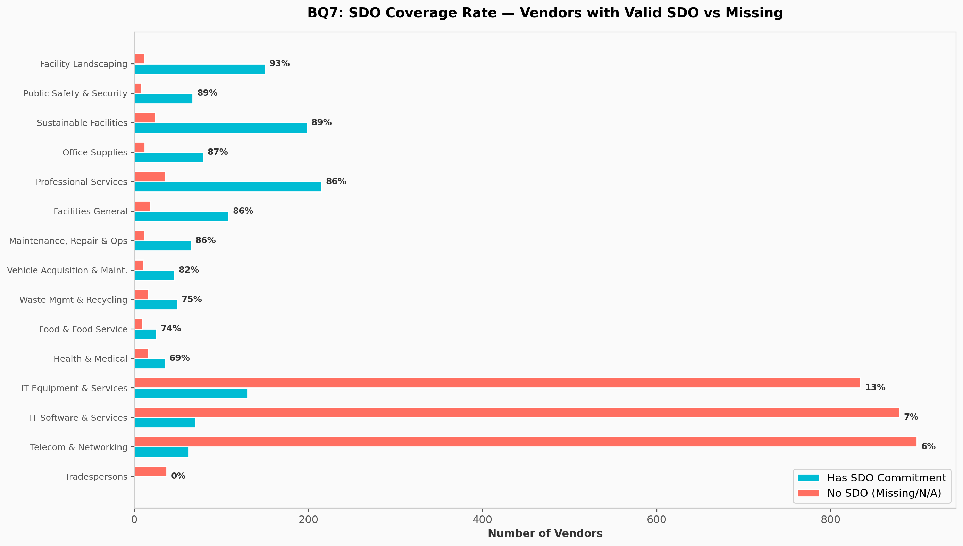

Analysis & Key Findings:
SDO coverage varies dramatically by category. Facility Landscaping leads with 93.2% of vendors reporting SDO commitments, while IT categories lag significantly: ITE at 13.5%, ITS at 7.4%, and ITT at 6.5%. Tradespersons has 0% coverage. This stark difference suggests that SDO reporting requirements may not be uniformly enforced across all procurement categories, particularly in the IT sector.

BQ8: Is there a correlation between vendor count and average SDO commitment?
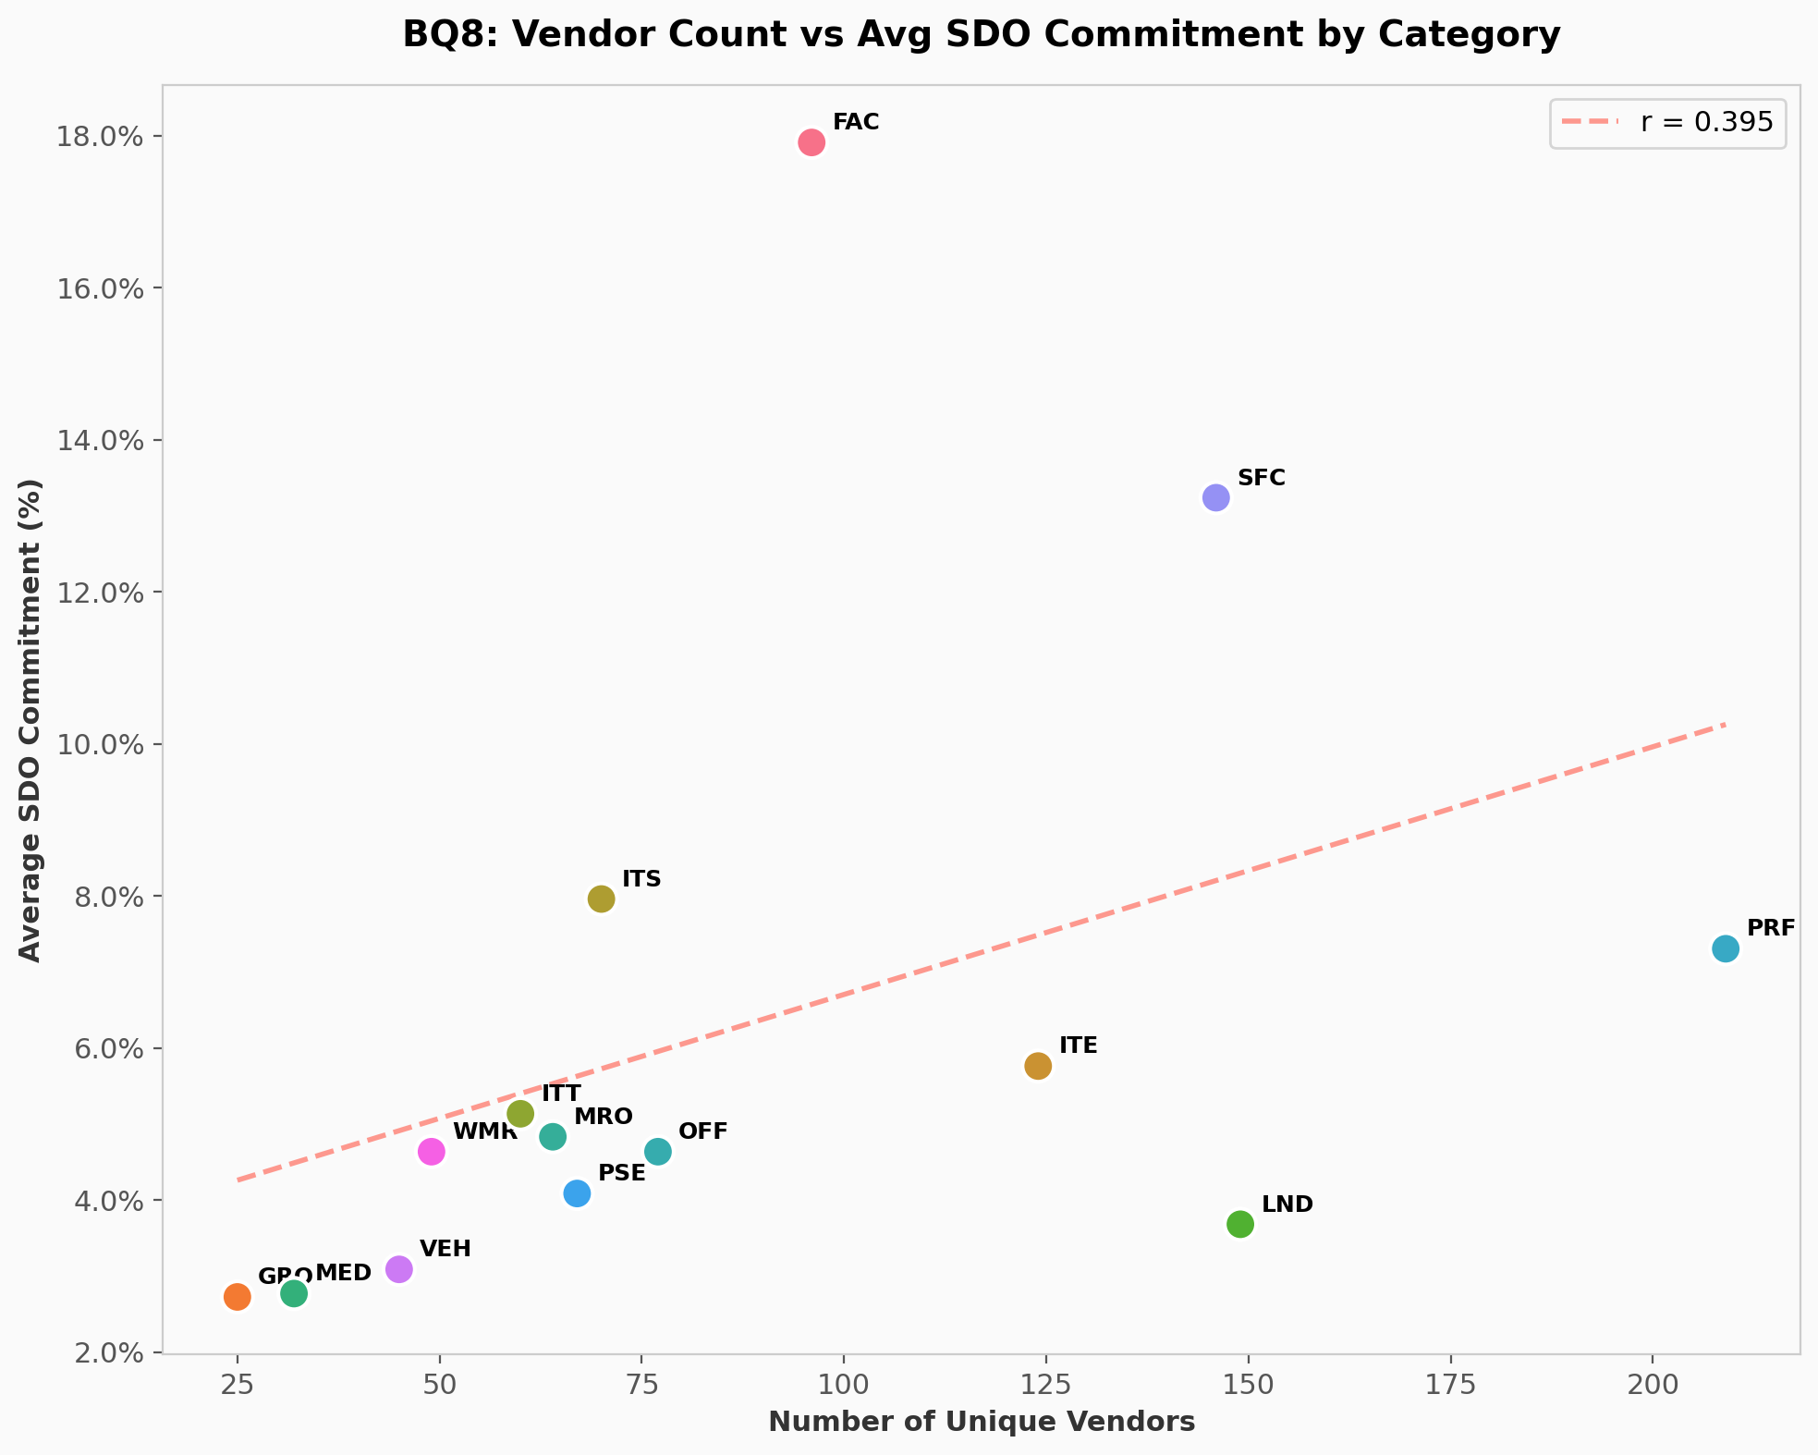

Analysis & Key Findings:
The Pearson correlation coefficient is r = 0.395 (p = 0.162), indicating a weak positive but statistically non-significant relationship between the number of vendors in a category and the average SDO commitment. This suggests that market competition alone does not drive supplier diversity — policy mandates and category-specific requirements are likely more influential factors.

BQ9: How diverse is the industry representation among categorized companies?
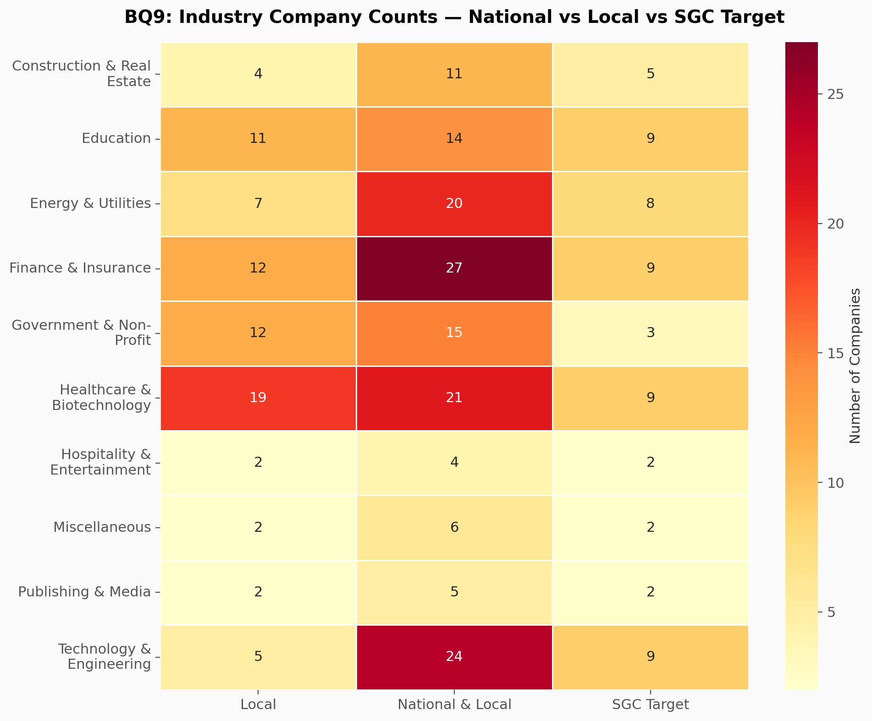

Analysis & Key Findings:
The heatmap shows that Finance & Insurance and Healthcare & Biotechnology have the most diverse company representation across all three types (National & Local, Local, SGC Target). Technology & Engineering has a strong National & Local presence (24 companies) but relatively fewer Local-only companies (5), suggesting the tech sector is dominated by national firms. The SGC target gaps are most visible in Government & Non-Profit (only 3 targets vs 15 national companies).

BQ10: Do a few companies dominate the IT sector? (Vendor Concentration)
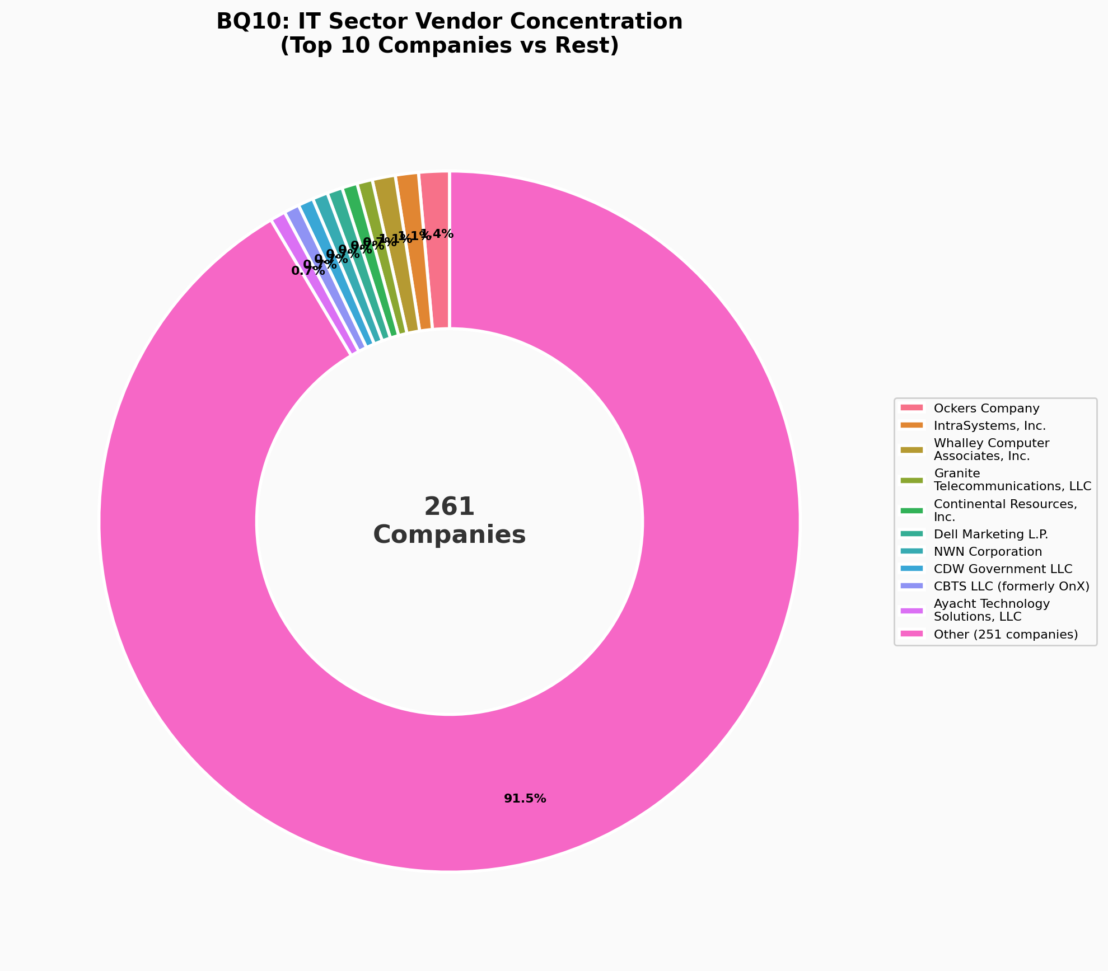

Analysis & Key Findings:
The IT sector has 261 unique companies across ITE, ITS, and ITT. The top 10 companies hold only about 8.5% of total contract associations, indicating a highly fragmented market with no single dominant vendor. This healthy competition suggests that Massachusetts has successfully avoided vendor lock-in in IT procurement, providing leverage for better pricing and service quality negotiations.

BQ11: Sector Analysis: Company Density by Industry
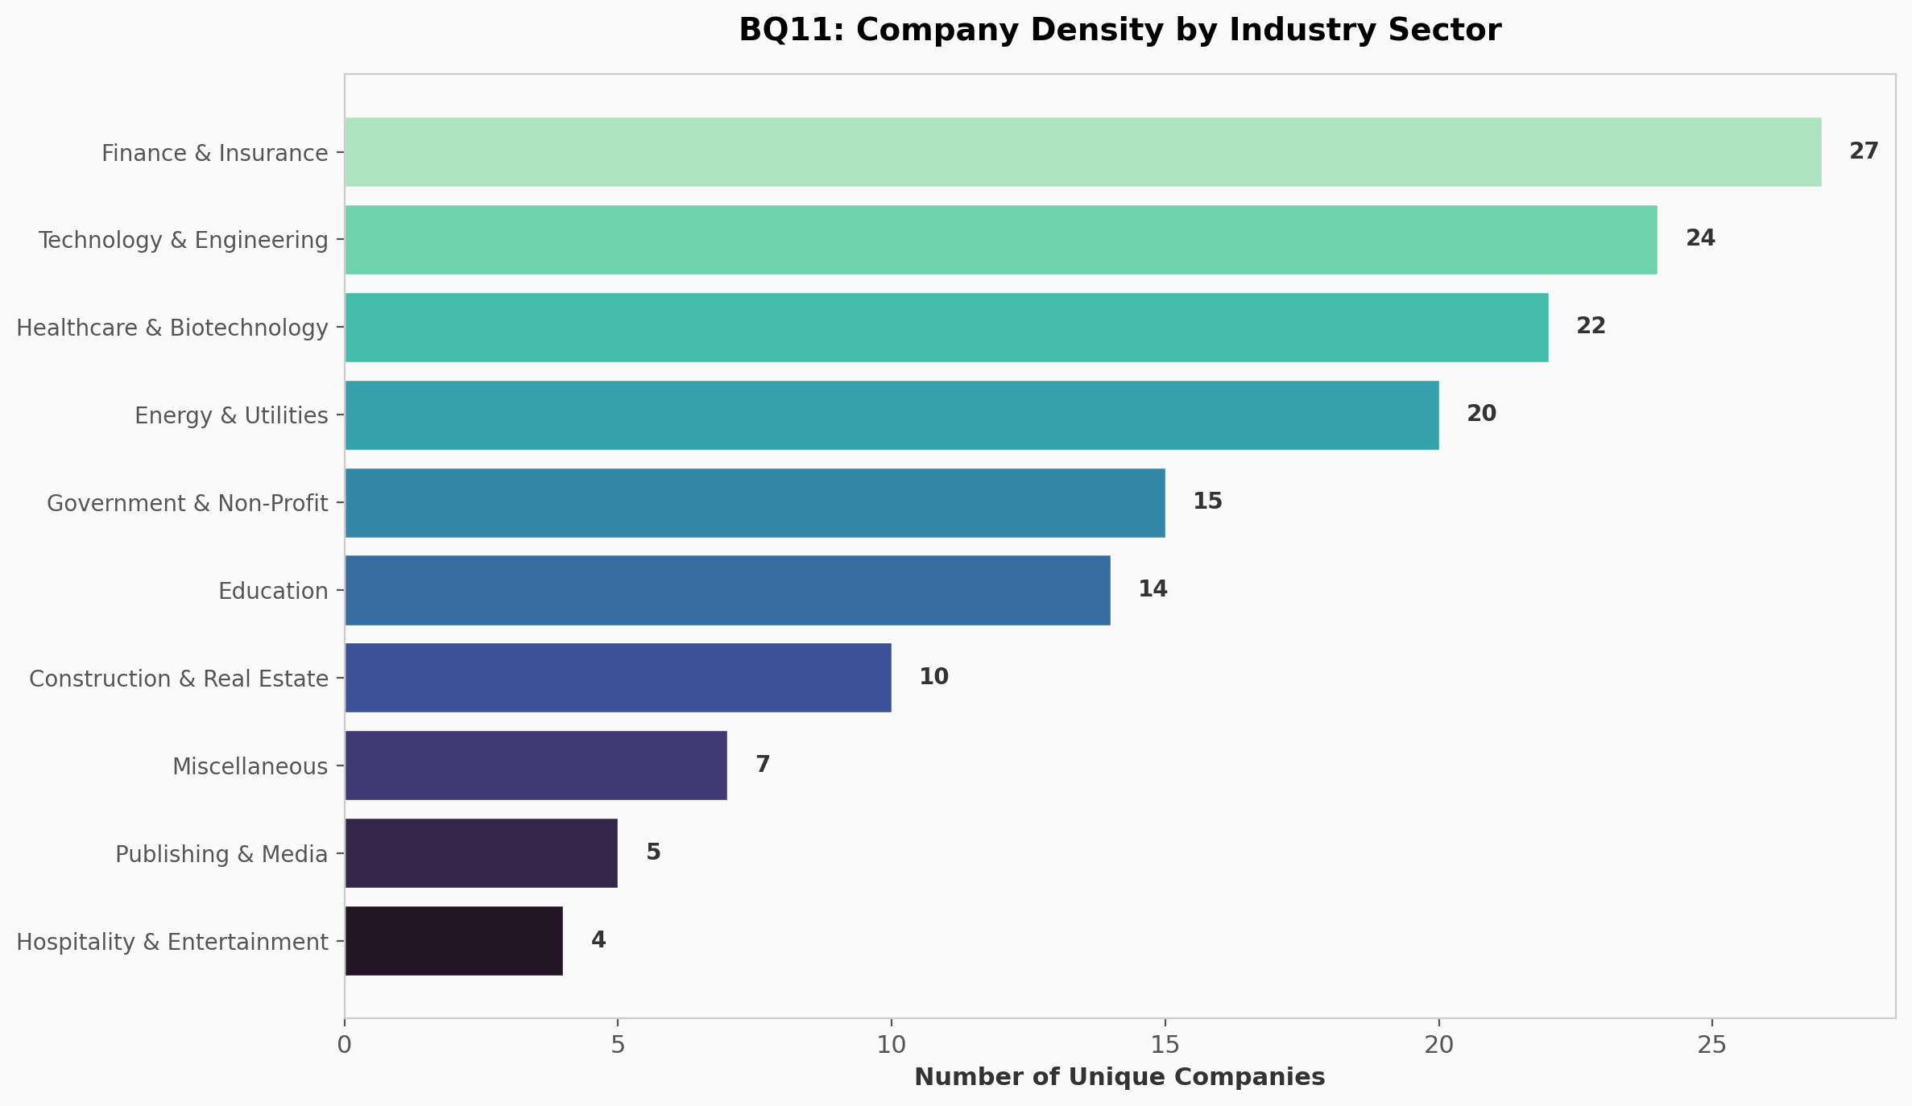

Analysis & Key Findings:
This sector analysis visualizes the company density across 10 industry classifications in the Massachusetts categorized companies dataset. Finance & Insurance leads with the highest density, followed by Healthcare & Biotechnology and Technology & Engineering. Hospitality & Entertainment and Publishing & Media have the lowest density, reflecting Massachusetts' economic specialization in financial services, life sciences, and technology sectors. This insight is valuable for policymakers targeting industry-specific supplier diversity programs.

Interactive Dashboard
The interactive dashboard provides additional features beyond the static EDA plots:
- KPI summary cards (Total Vendors, Average SDO, Categories)
- Interactive IT sub-category filter (ITE / ITS / ITT / All)
- Radar chart comparing IT sub-categories
- SDO histogram across all vendors
- Hover tooltips and zoom on all charts

Dashboard URL: https://sumesh-chakkaravarthi.github.io/mass-open-checkbook-dashboard/

