New Nature of Work in AI ITAI-4373

Sumesh Surendran

Prof: Patricia McManus

September 29, 2024

**Exploring AnyLogic Through Simulation: A Reflective Journal**

**Introduction**

In this reflection, I explore the Bank-Office simulation model using AnyLogic software. This tutorial was chosen due to its relevance to service industry operations, specifically banking, and its complex customer interaction dynamics which I aim to understand better.

**Learning Objectives**

My primary objectives were to:

1. Understand the fundamentals of process simulation within the banking sector.
2. Learn how to configure and use various AnyLogic modeling components such as sources, queues, delays, and sinks.
3. Gain insights into customer flow and service optimization in a bank setting.

**Step-by-Step Reflection**

**

* **Objective:** Set up a basic simulation model including elements like source, queue, delay (ATM), and sink.
* **Challenges:** Initially struggled with the proper configuration of the arrival rate and processing times to realistically simulate a bank's operation.
* **Insights:** Learned how to adjust model parameters to reflect realistic scenarios in banking environments.

**Queue Configuration**

* **Objective:** Configure the queue to manage customer flow effectively.
* **Challenges:** Determining the optimal queue capacity and understanding its impact on customer waiting times.
* **Insights:** Recognized the importance of queue management in minimizing customer wait times and ensuring efficient service delivery.

**Adding Delays for ATM Transactions**

* **Objective:** Implement delays representing ATM service times.
* **Challenges:** Balancing the delay times to avoid excessive customer wait times while allowing realistic transaction processing.
* **Insights:** Gained a better understanding of how transaction processing times affect overall service efficiency in a bank.

**Simulation and Analysis**

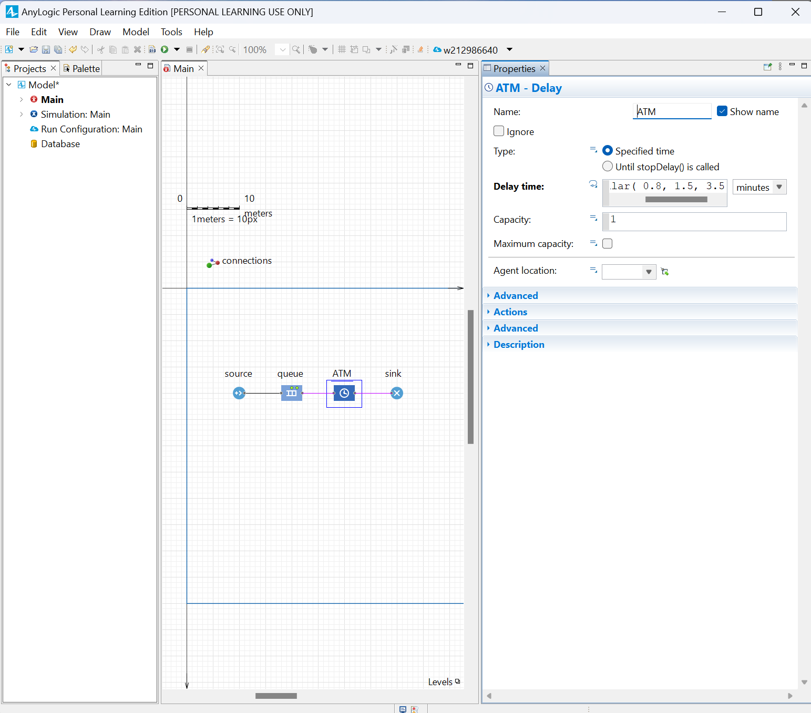

* **Objective:** Run the simulation to observe and analyze the flow of customers through the bank.
* **Challenges:** Interpreting the simulation results and adjusting the model parameters accordingly.
* **Insights:** Learned the critical role of iterative testing and parameter adjustment in developing an effective simulation model.

**Final Model**

The final model simulates the customer flow through a bank office, incorporating elements like customer arrival, queuing, ATM transactions, and leaving the bank. It provides a dynamic visualization of how different components interact and influence the banking operation's overall efficiency.

**Applications**

The skills and insights gained from this tutorial could be applied to:

* Optimize operations in real bank branches.
* Develop more complex simulations involving multiple services and customer paths.
* Assist in designing layouts and service processes that minimize customer wait times and maximize service efficiency.

**Conclusion**

Completing this tutorial has significantly enhanced my understanding of simulation modeling. It allowed me to practically apply theoretical knowledge in a simulated environment, preparing me for future projects that require modeling and analysis of complex systems.

Citations:

* https://anylogic.help/tutorials/bank-office/1-creating-simple-model.html
* https://chatgpt.com/c/66f9a37c-a22c-8004-8a2c-cf145dde6373