# Apply filters to SQL queries

## Project description

An organization recently discovered some potential security issues that involve login attempts and employee machines. The objective is to examine the organization’s data in their **employees** and **log_in_attempts** tables. Also to use SQL filters to retrieve records from different datasets and investigate the potential security issues.

## Retrieve after hours failed login attempts

SELECT * FROM log_in_attempts WHERE success=0 AND login_time>’18:00:00’;

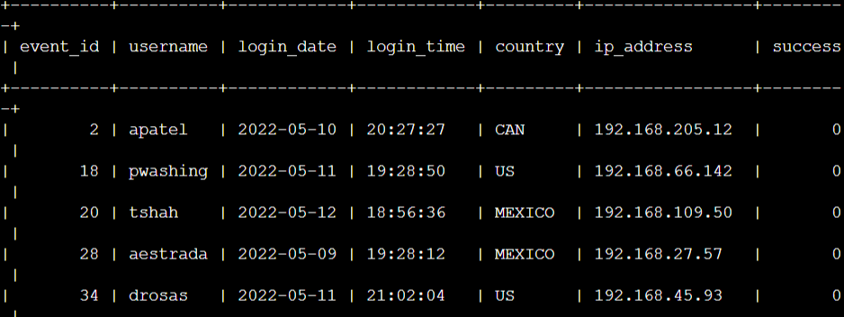

## Retrieve login attempts on specific dates

SELECT * FROM log_in_attempts WHERE login_date>=’2022-05-08’ AND login_date<= ‘2022-05-09’;

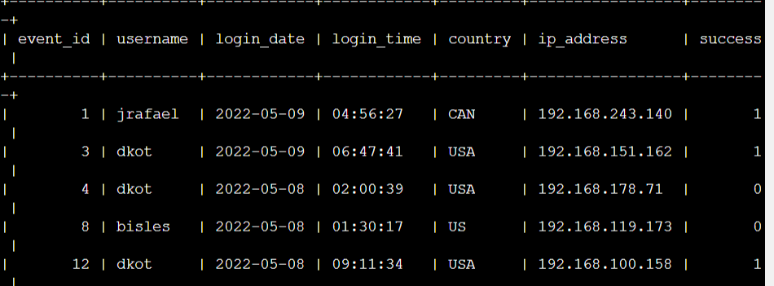

## Retrieve login attempts outside of Mexico

SELECT * FROM log_in_attempts WHERE country NOT LIKE ‘MEX%’;

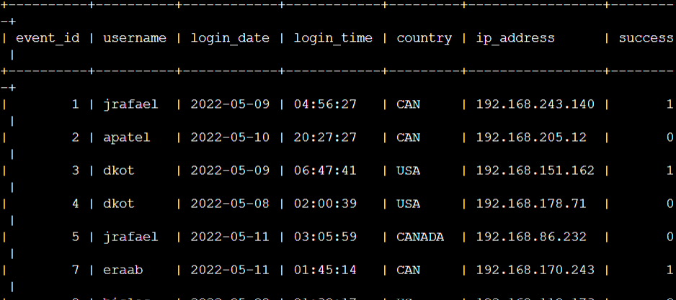

## Retrieve employees in Marketing

SELECT * FROM employees WHERE department=’Marketing’ AND office LIKE ‘East%’;;

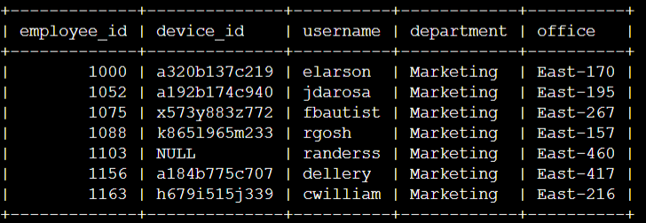

## Retrieve employees in Finance or Sales

SELECT * FROM employees WHERE department=’Finance’ or department=’Sales’;

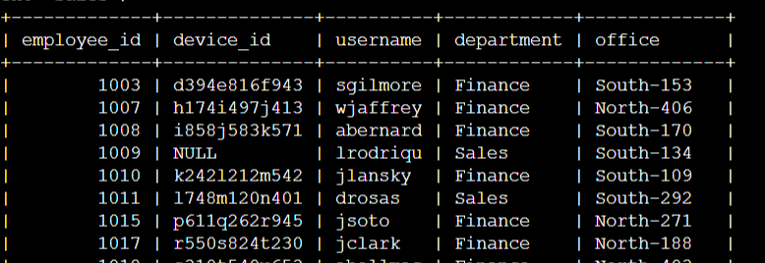

## Retrieve all employees not in IT

SELECT * FROM employees WHERE department NOT LIKE ’Information Technology’;

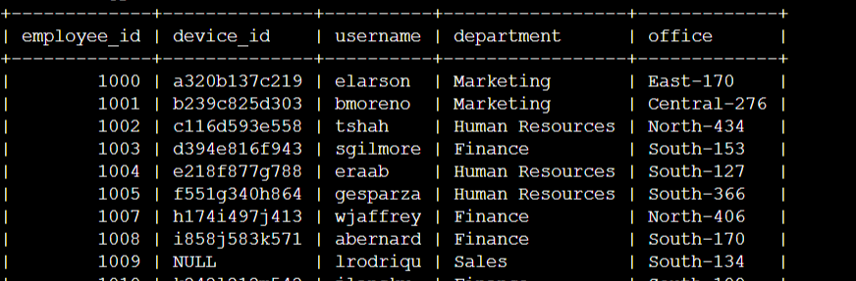

## Summary

I applied filters to SQL queries to get specific information on login attempts and employee machines. I used two different tables, log_in_attempts and employees. I used the AND, OR, and NOT operators to filter for the specific information needed for each task. I also used LIKE and the percentage sign (%) wildcard to filter for patterns.