SE322 - Software Architecture

Project - Phase 2

2021-22 Spring

//SUMAY//

//14/05/2022//

# The Health Monitoring System

## The system in a nutshell

What we did in this assignment was to create an HMS system. While creating this system, we implemented the system with processes, then we connected the ports with each other. We explained the processes using threads.

## Views

### Module View

*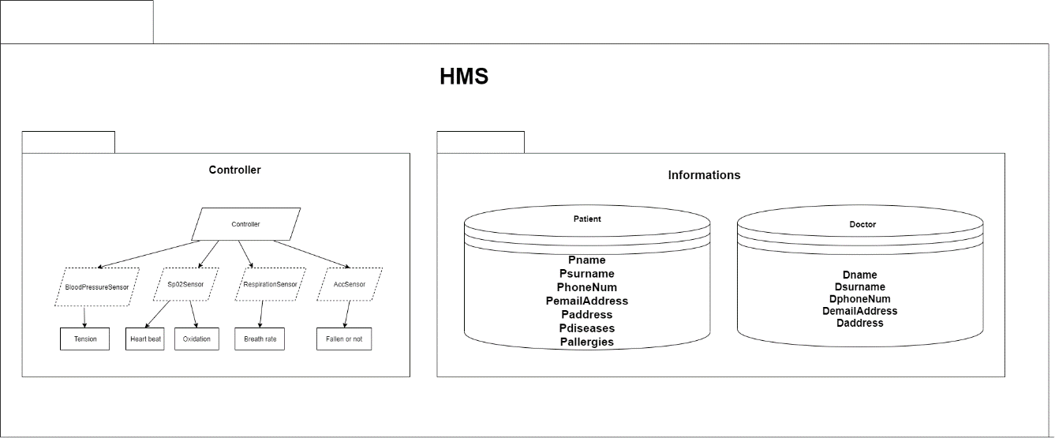.*

### C&C View

*Provide a set of sequence diagrams or activity diagrams to represent how the system works.*

### Allocation View

*Provide a deployment diagram for the whole system.*

## Architectural Diagrams by OSATE

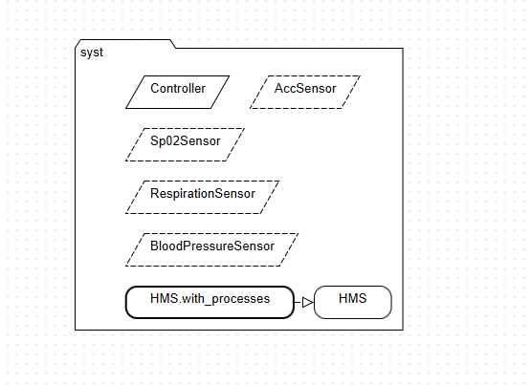

# Github Repo

[*https://github.com/SumeyyeAyse/SE322---SUMAY.git*](https://github.com/SumeyyeAyse/SE322---SUMAY.git)