**SERVICE FLOW DIAGRAM**

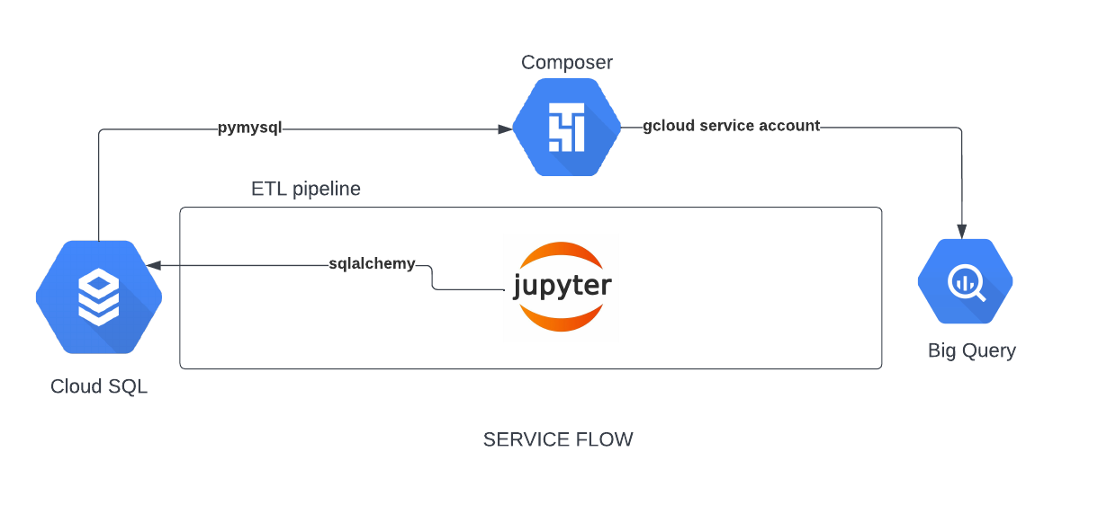

**DETAILED PROCESS FLOW**

1.Created a cloud SQL instance.

2. Created a SQL script to define the schema of tables in MySQL instance.

3.Created an ipynb file (in jupyter) to populate the data using faker library.

4. Created a script to create star schemas tables in BigQuery.

5. Created ETL python script to fetch the data from mysql instance to bigquery table.

6. Created a composer environment to execute ETL script.

7. Prepared analytics queries.