**FOODIES HUB**

**BY**

**SUMI BANIYA**

**T.U. Roll No. : 9711/18**

**T.U. Registration No. : 7-2-479-164-2018**

Hetauda School of Management and Social Sciences

*A Summer Project Report Submitted to*

**Faculty of Management, Tribhuvan University**

in partial fulfillment of the requirements for the degree of

**Bachelor of Information Management**

Hetauda

August/2022

# STUDENT DECLARATION

This is to certify that I have completed the Summer Project entitled “**Foodies Hub**” which is a web based food ordering platform, done under the guidance of **Mr. Sujan Devkota** in partial fulfillment of the requirement for the degree of **Bachelor of Information Management** at Faculty of Management Tribhuvan University. This is my original work and I have not submitted it earlier elsewhere.

Date: 6th August, 2022

Signature:

Name: Sumi Baniya

# CERTIFICATE FROM THE SUPERVISOR

This is to certify that the summer project entitled “**Foodies Hub**” is an academic work done by **Ms. Sumi Baniya** submitted in partial fulfillment of the requirements for the degree of Bachelor of Information Management at Faculty of Management, Tribhuvan University under my guidance and supervision. To the best of my knowledge, the information presented by him in the summer project report has not been submitted earlier.

Signature of the Supervisor

Name: Er. Sujan Devkota

Designation: Asst. Professor

Date:

# LETTER OF APPROVAL

This is to certify that we have read and recommended to the Faculty of Management for acceptance of a summer report entitled “**Foodies Hub**” submitted by **Ms. Sumi Baniya** in partial fulfillment of the requirement for BIM, sixth semester awarded by Tribhuvan University.



Mr. Sameer Gautam External Examiner

Head of IT Department

Hetauda School of Management

and Social Sciences

Hetauda, Nepal

# ACKNOWLEDGEMENT

This project has been an excellent opportunity for me to explore my knowledge and skill. The success and outcome of this project required a lot of guidance and assistance from many people, and I am highly privileged to get the support to complete my project. All that I have done is only due to such supervision and assistance, and I would not forget to thank them. I want to extend my sincere thanks to all of them.

Special thanks to the University for including such a task in the curriculum of BIM. Thanks to our college, Hetauda School of Management and Social Sciences for providing the environment and supporting all the stages of this project. I would like to thank our Head of IT Department, **Mr. Sameer Gautam**, and my project supervisor, **Er. Sujan Devkota**, for valuable guidelines, supervision, and suggestions to complete this project successfully.

My thanks and appreciation to all the people's direct and indirect help remained valuable and crucial at different project stages. This outcome is the result of their support and encouragement.

Name: Sumi Baniya

Exam Roll No: 9311/18

# EXECUTIVE SUMMARY

This report contains the procedure and steps developed for Foodies Hub. It is developed for food delivery, and to study the various aspects related to it. This report shows the complete information about my summer project on the "Foodies Hub" and how I was familiar with the practical aspects of computer application.

The primary objective of this project is to allow hotels and restaurants to increase scope of business by reducing the labor cost and recreate the environment to effectively study the overall workspace

# Table of Content

Title page of the Summer Project Report

Student Declaration i

Certificate from the Supervisor ii

Letter of Approval iii

Acknowledgement iv

Executive Summary v

Table of Content vi

List of Figures viii

Abbreviations ix

Chapter I: Introduction 1

1.1 Background 1

1.2 Objective 1

1.3 Literature Review 1

1.4 Methodology 2

1.4.1 Data and Information 2

1.4.2 Project Framework 2

1.4.3 Tools and Technologies Used 3

Chapter II: Tasks and activities performed 4

2.1 Analysis of tasks, activities, problems, issues 4

2.1.1 Analysis of tasks 4

2.1.2 ER-diagram 4

2.2 Analysis of Possible Solution 5

2.2.1 Requirement Analysis 5

2.2.2 Functional Requirement 5

2.2.3 Non-Functional Requirements 6

2.2.4 Class Diagram 6

2.2.5 Activity Diagram 7

2.2.6 Design Diagram Sequence Diagram 8

2.2.7 Testing 9

Chapter III: Discussions & Conclusions 10

3.1 Discussions 10

3.2 Conclusions 10

References 11

Appendix 12

# List of Figures

Figure 1: Project framework 2

Figure 2: Entity Relationship diagram 4

Figure 4: Use case diagram 5

Figure 5: Class diagram 6

Figure 6: Activity diagram 7

Figure 7: Sequence diagram 8

Figure 8: Index page 12

Figure 9: Customer Login Form 12

Figure 10: Customer registration form 13

Figure 11: Restaurants list 13

Figure 12: Checkout 14

Figure 13: View Order 14

Figure 14: Admin Login Form 15

Figure 15: Admin Registration form 15

Figure 16: Admin Dashboard 16

Figure 17: Admin orders Management 16

Figure 18: Database overview 17

# 

# ABBREVIATIONS

Admin: Administration

BIM: Bachelor of Information Management

ER: Entity-Relationship

SQL: Structured Query Language

TU: Tribhuvan University

UC: Use Case

# CHAPTER I: INTRODUCTION

## 1.1 Background

This project Foodie Hub is developed to enable restaurants and hotels to sell out their food. The system provides a platform for the users to order food and get it at their doorstep, similar to Zomato and Swiggy. It helps in understanding the environment of the product delivery system. This project enables us to present information and receive orders in a much more efficient and secure manner.

## 1.2 Objective

* To provide an online platform for its users to order fast food online.
* To and get it delivered to their doorstep at a minimum time and cost.
* To decrease labor costs for restaurant.

## 1.3 Literature Review

Web apps are the most convenient ways for ordering food. Due to rapid increase in mobile users, it has been seen that there is exponential growth in online food ordering. Consumers find it very easy to search on websites or apps to choose the food of restaurants they like. Reviews and ratings given by consumers on websites are beneficial for new customers in purchasing decisions. In business everyone is a stakeholder. But the most prominent stakeholder is the customer. Delivery time is the most important and deciding factor in customer satisfaction. If there is delay there is a high probability of consumers switching to other food ordering and delivery services. In the service sector, relationships are key to success, and employees are more focused on building strong relationships with customers. In food delivery services, restaurants take the ownership of food taste. That responsibility is taken by restaurant owners. The main concern of food delivery services is to provide food to the consumer’s doorstep, and that too, within a committed time framework.

Due to the large number of restaurants registered on food-tech websites, consumers are confused and there is a huge ambiguity in the minds of customers regarding online food ordering. If we consider demographic profiles, most of the working class and teenagers prefer to eat fast food. It is very important to have a user-friendly interface for web apps with elucidating metadata and crystal clear information. There are many factors that can affect the loyalty of customers toward food-tech delivering services. Some factors are delivery time, packaging, UI (User Interface) and UX (User experience) of webapps, etc.

Customer engagement creates value for firms. Some online ways of engagement are Facebook, Twitter, Instagram, Pinterest, etc. Food-tech companies put a lot of effort into engaging the customer. Some traditional ways are newspaper ads, ads on TV, and radio. There are many food delivery services available on the market. A customer is always in search of offers and discounts. Hence, providing the right offer at the right time can retain the customer from going somewhere else. As delivery time plays a vital role in creating loyalty with consumers, time is also important in keeping food fresh and pure during the time of delivery.

Online food ordering and delivery services are creating huge profits, but simultaneously, consumers are becoming unknowingly disloyal. There may be several factors like delay in delivery time; freshness and purity of food; user interface of websites; better offers and discounts from rivals; etc. Companies should be more focused on analyzing the attitudes and perceptions of consumers. Consumer engagement is also important to keep consumers updated. Many food-tech companies keep on informing customers regarding new offers by social media network sites like Facebook, Instagram, Pinterest, YouTube, etc. But the impact of these marketing and promotional strategies on consumers seems different, which is creating ambiguity in the minds of customers. The user interface of websites also plays a vital role, as these are the platforms from where orders are placed. Some seasoned customers feel that the reviews and ratings updated on websites are scripted just because some restaurants need to be more visible on websites.

## 1.4 Methodology

### 1.4.1 Data and Information

Primary methods of data collection were mostly used for the evaluation and required information. In terms of primary, the observation method is used to observe people's needs to get food delivered to their doorstep.

### 1.4.2 Project Framework

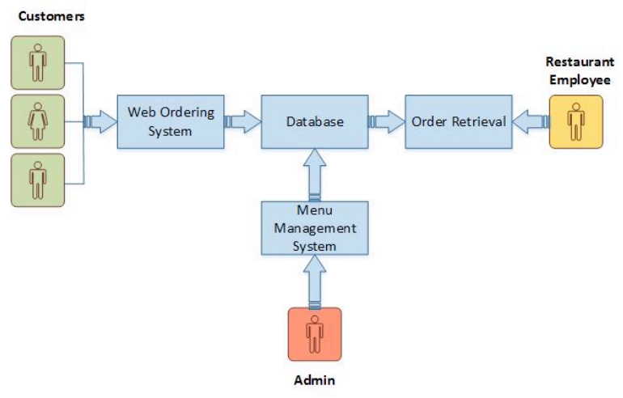

Figure 1: Project framework

The reasons behind considering this methodology are:

* Software changes on each iteration, evolves and grows.
* As software is delivered in parts, there is no need for a full specification from the project’s start and small changes to requirements are possible in the course of the development process.

### 1.4.3 Tools and Technologies Used

The tools used in this system's development include:

* Diagrams: Lucid Chart
* UI and Related Design: figma
* Front-End: HTML, CSS, JS
* Back-End: PHP, MySQL Database
* Code Editor: Visual Studio Code

# CHAPTER II: TASKS AND ACTIVITIES PERFORMED

## 2.1 Analysis of tasks, activities, problems, issues

### 2.1.1 Analysis of tasks

Task analysis is the process of learning about ordinary users by observing them in action to understand in detail how they perform their tasks and achieve their intended goals. Tasks analysis helps identify the tasks that your website and applications must support and can also help you refine or re-define your site’s navigation or search by determining the appropriate content scope.

### 2.1.2 ER-diagram

The following ER-diagram will try to solve the problems and issues of the system, which is drawn after the analysis tasks are done on the organization.

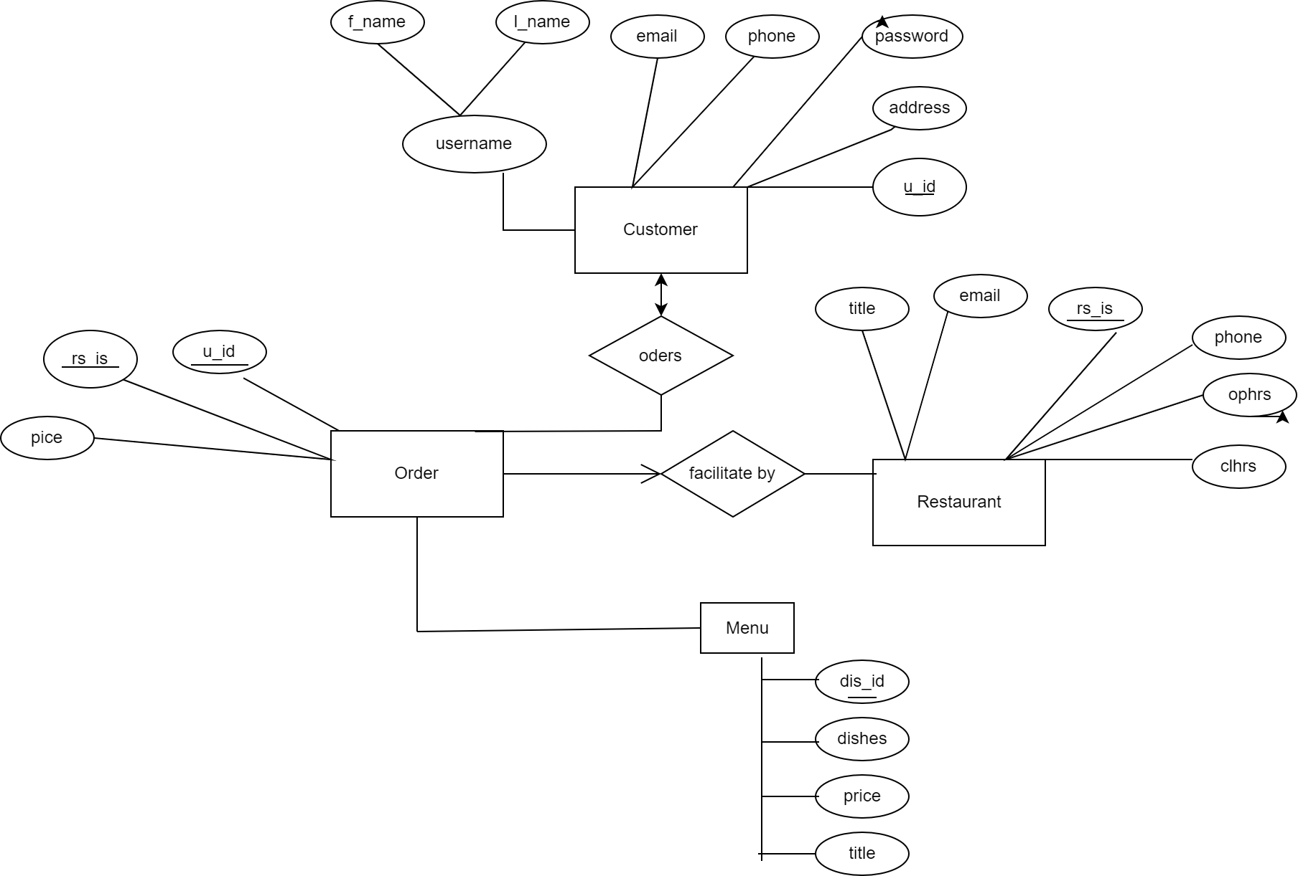

Figure 2: Entity Relationship diagram

## 2.2 Analysis of Possible Solution

### 2.2.1 Requirement Analysis

The main objectives of requirement analysis are to identify and evaluate the requirement of the proposed system. It helps to know user requirements, system requirements, functional requirements, and non-functional requirements for our system.

### 2.2.2 Functional Requirement

These are the statements of the service the system provides, how the system should interact with the particular inputs, and how the system should behave in a specific situation, which is as follows:

* Only the admin has the right to access and edit the database
* The system should help the user place orders, track orders, and make payments.
* The system should be able to provide the required information when needed.

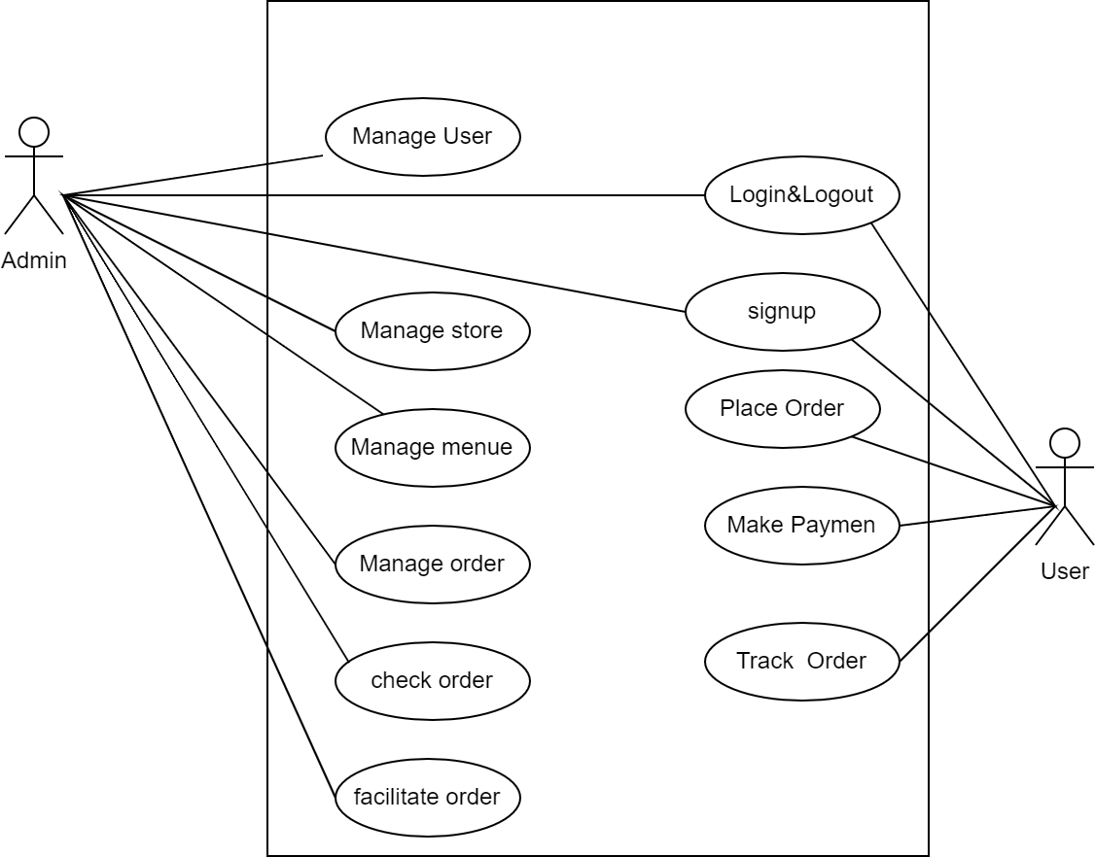

Figure 4: Use case diagram

### 2.2.3 Non-Functional Requirements

* + - * The system will be easier to use with a better GUI.
      * The system must be secure enough to operate.
      * The system should be affordable.
      * The system should be fast enough to process the data.

### 2.2.4 Class Diagram

The class diagram is a UML diagram that represents a static view of a system. It is a composition of different classes which are linked to each other through association.

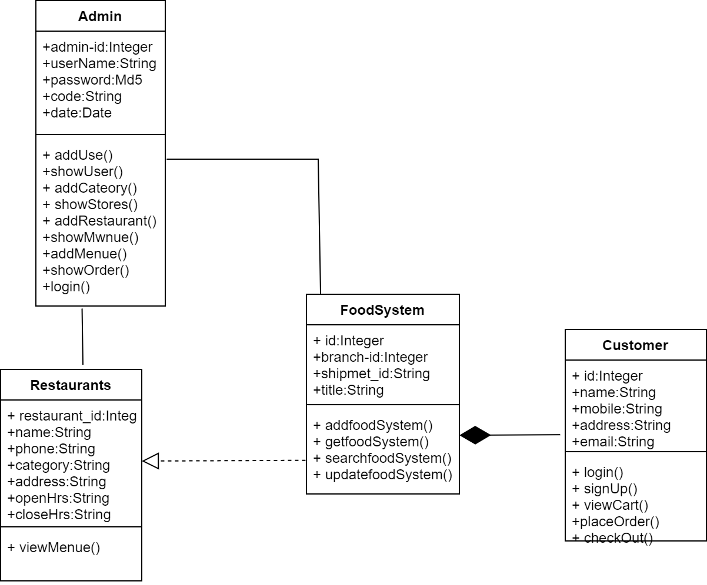

Figure 5: Class diagram

### 2.2.5 Activity Diagram

An activity diagram represents a series of actions or flow of control in a system, like a flowchart or a data flow diagram. They also describe the steps in a use case diagram. For example, the given diagram demonstrates one of the activities in this system:

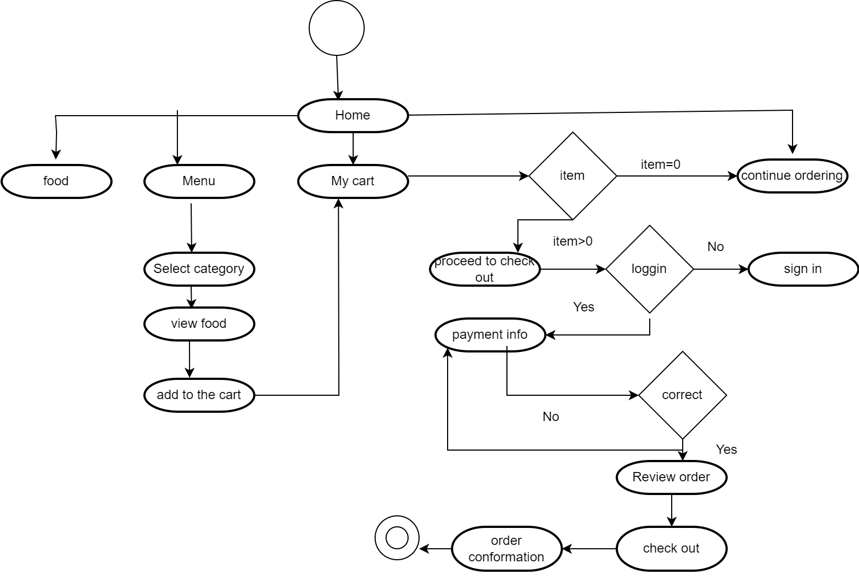

Figure 6: Activity diagram

### 2.2.6 Design Diagram Sequence Diagram

Sequence diagrams are dynamic modeling approaches used in object-oriented projects. The sequence diagram shows the communication between the system objects, or classes. The sequence diagram is shown below:

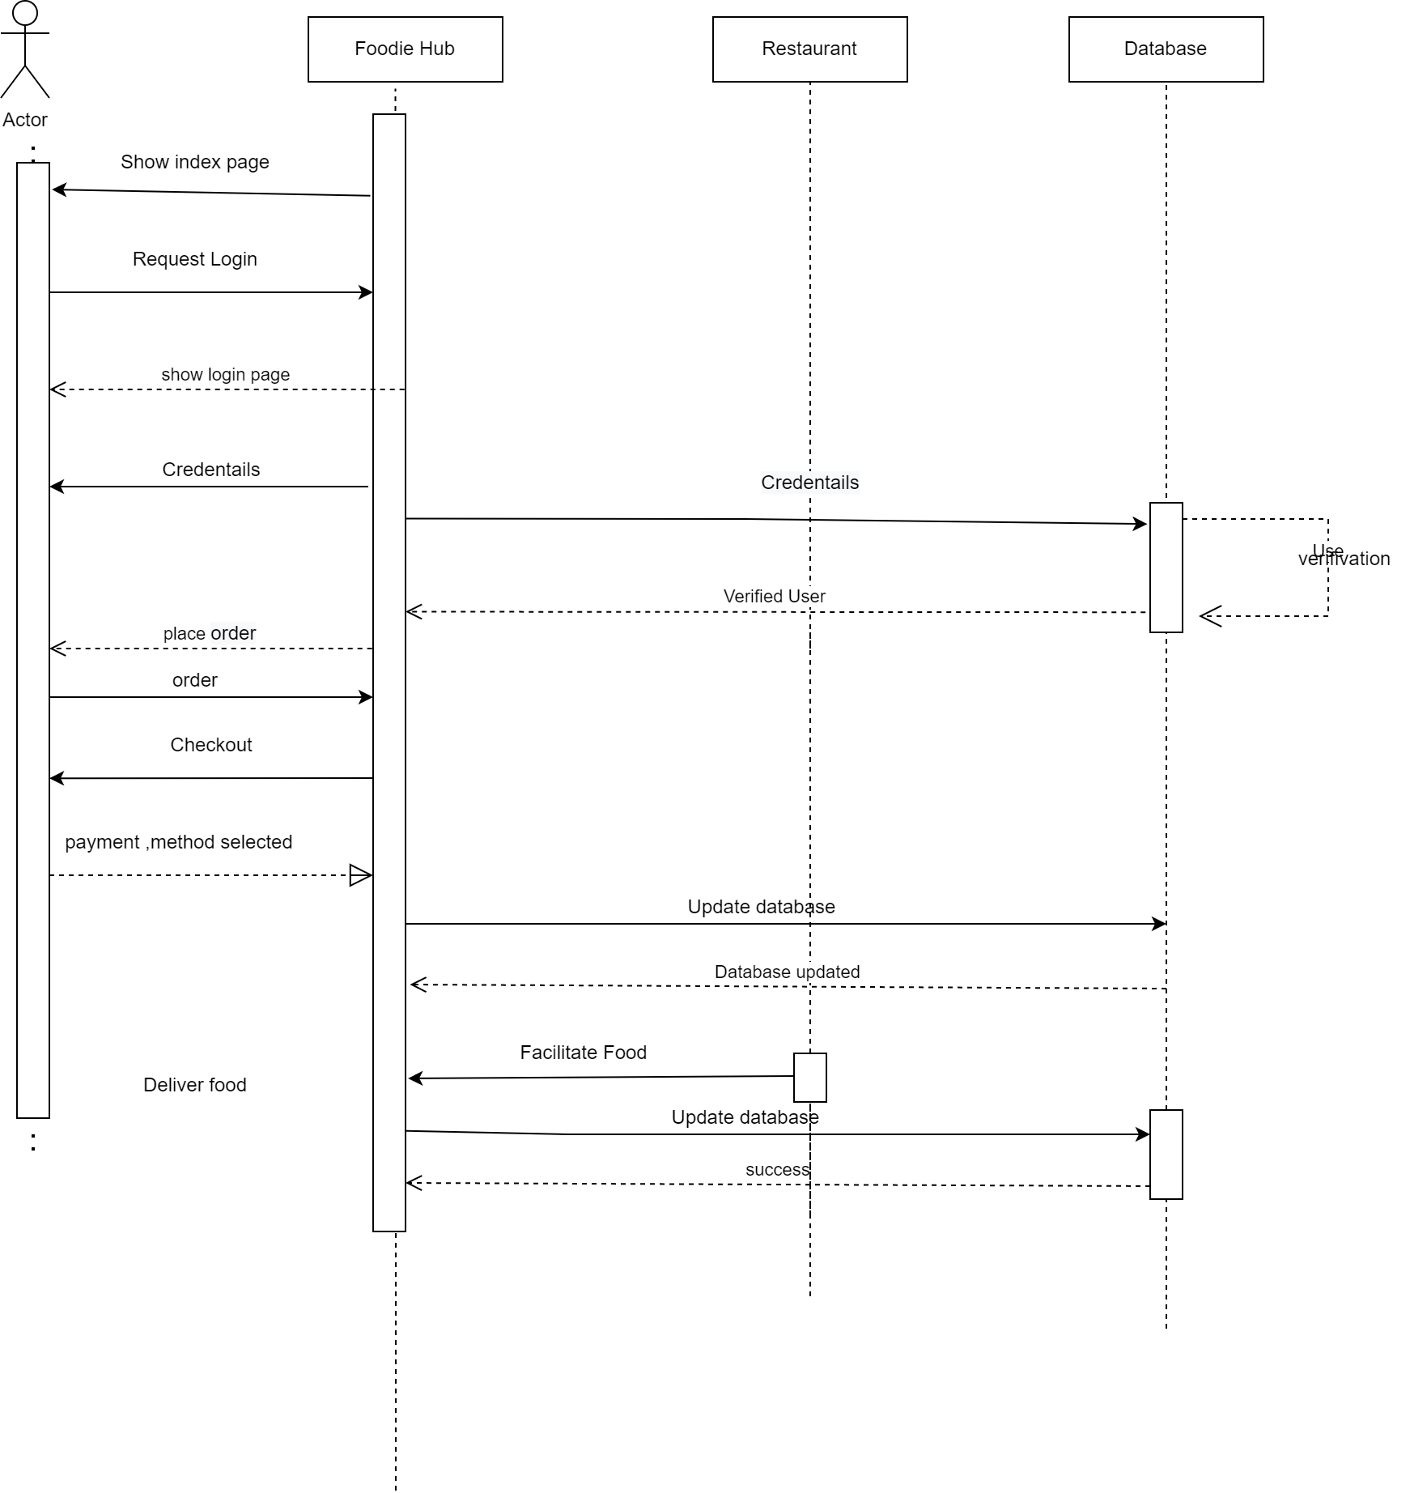

Figure 7: Sequence diagram

### 2.2.7 Testing

In testing, the different inputs were tested as input to GUI forms, which can be shown below with the help of the table and the figure.

Table 1: Test case

| **Project Name:** Foodies Hub | |
| --- | --- |
| **TEST CASE** | |
| Test Case ID: TC_01 | Test Designed by: Sumi Baniya |
| Test Priority: High | Test Designed Date: 30 july 2022 |
| Module Name: Place Orders | Test Executed by: Sumi Baniya |
| Test Title: Add orders to the database | Test Execution Date: 30 july 2022 |
| Description: Test orders and upload orders into the database. | |
| Pre-Conditions: Data is not in the database. | |
| Dependencies: | |

| SN | Steps | Test  Data | Expected  Result | Actual  Result | Status (Pass/Fai) | Notes |
| --- | --- | --- | --- | --- | --- | --- |
| 1 | User login | U: sumi2058  P: Sumi123 | Home Screen to be displayed | Home Screen is displayed | Pass |  |
| 2 | Admin login | U: sumi2058  P: Sumi123 | Admin Dashboard to be displayed | Admin Dashboard displayed | Pass |  |
| 3 | Order Food | Quantity: 2 | Calculate Total and display | Calculate Total and displayed | Pass |  |

| **Post Condition:** Data uploaded into the database, and is displayed on the Your orders page. |
| --- |

# CHAPTER III: DISCUSSIONS & CONCLUSIONS

## 3.1 Discussions

The system was successfully completed in time as per the objectives. After the evaluation of the system, the system is expected to facilitate an online food ordering system to its users.The iterative model used in this system is helpful to check in every phase after each coding. This summer project helped to acquire practical knowledge about the working procedure of a food ordering system.

## 3.2 Conclusions

It was a great learning experience. I have tried my best for the successive completion of this project and making it easy to understand, simple, and effective. In conclusion this project helped to enhance skill and learning.

# REFERENCES

* Martin, R. C. (2009). *Clean Code*. Prentice Hall.
* Jakobus, B., & Marah, J. (2018). *Mastering Bootstrap 4 - Second Edition: Master the latest version of Bootstrap 4 to build highly customized responsive web apps* (2nd Revised edition). Packt Publishing.
* *PHP: Hypertext Preprocessor*. (n.d.). PHP: Hypertext Preprocessor. <https://www.php.net/>
* *MySQL Tutorial*. (n.d.). Tutorialspoint.

<https://www.tutorialspoint.com/mysql/index.html>

* *JavaScript Tutorial*. (n.d.). W3Schools. <https://www.w3schools.com/js/>

# APPENDIX

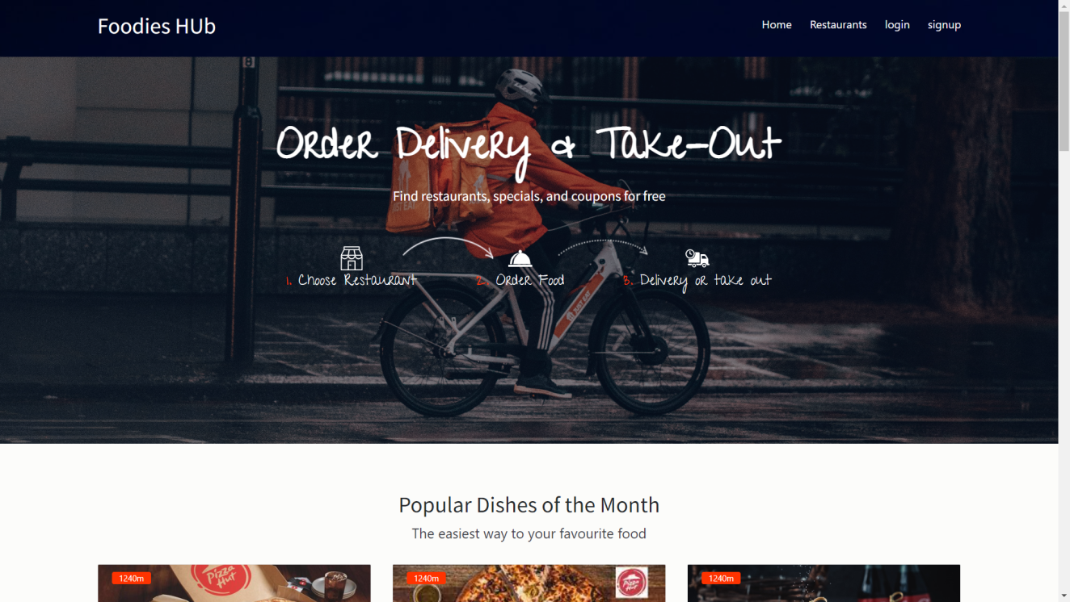

Figure 8: Index page

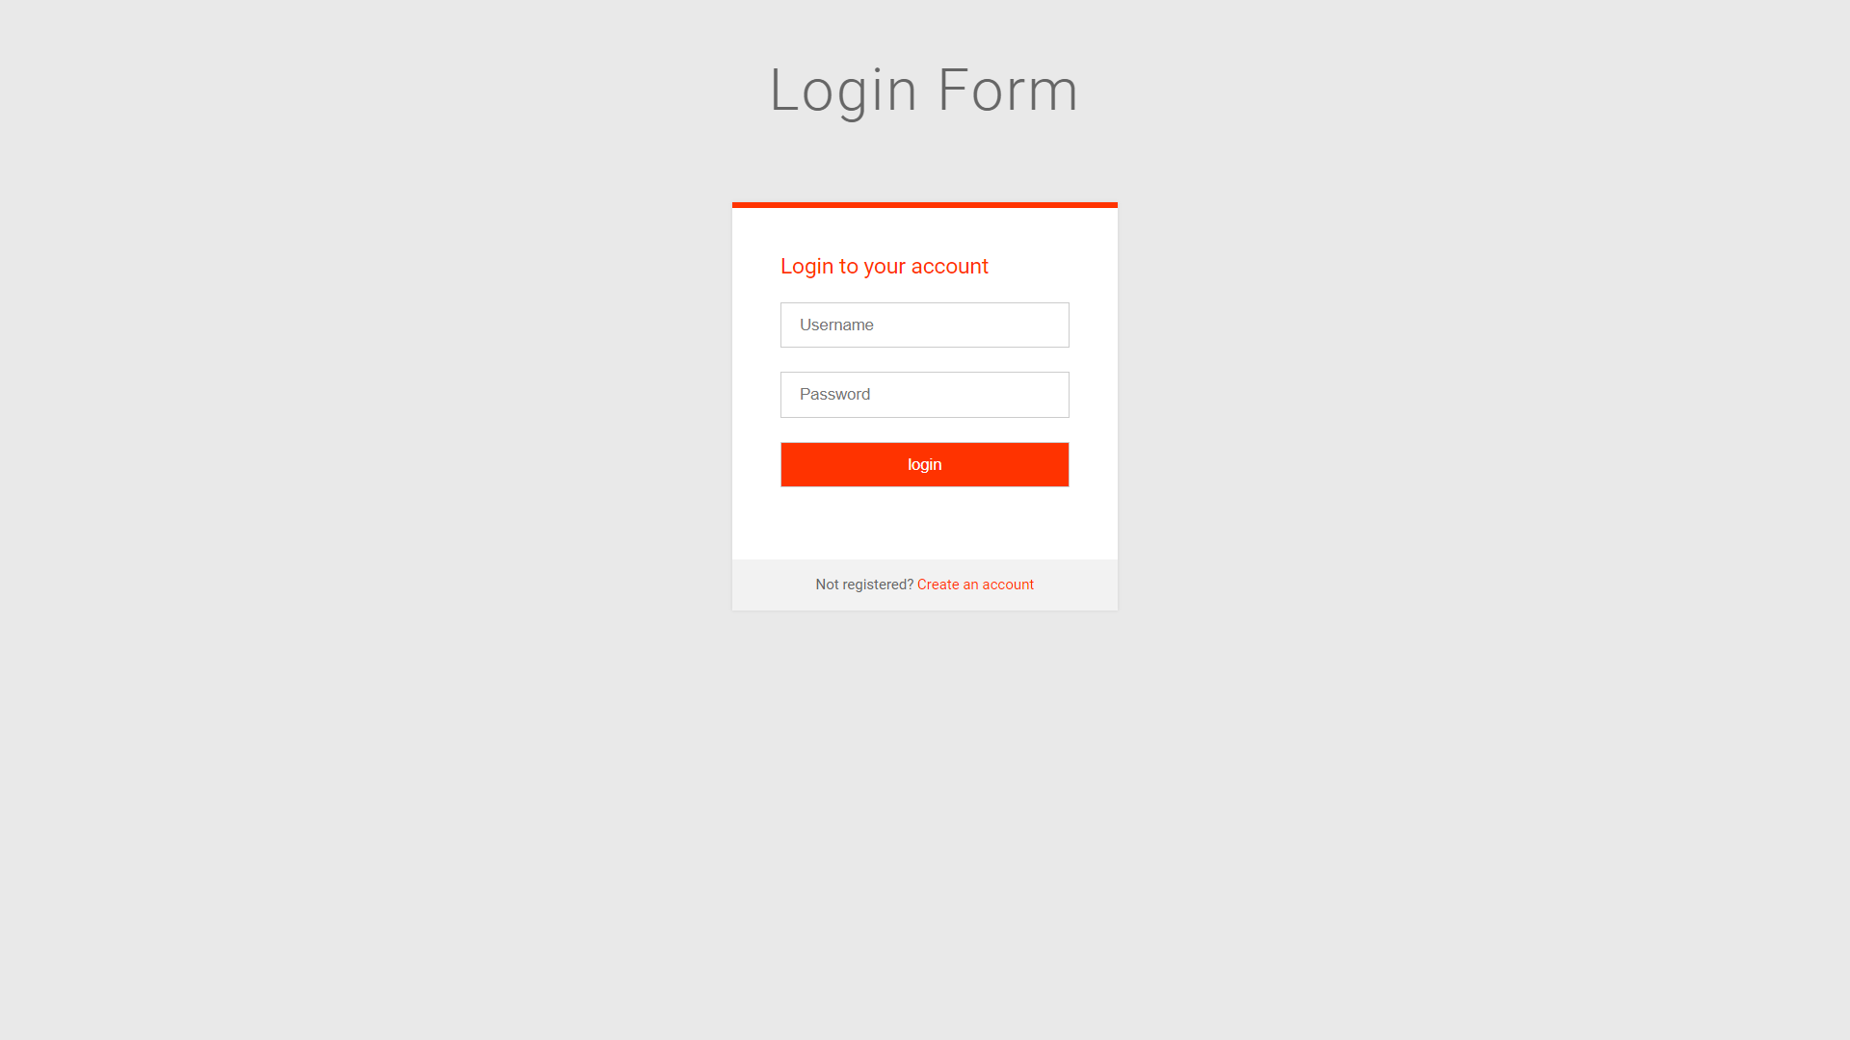

Figure 9: Customer Login Form

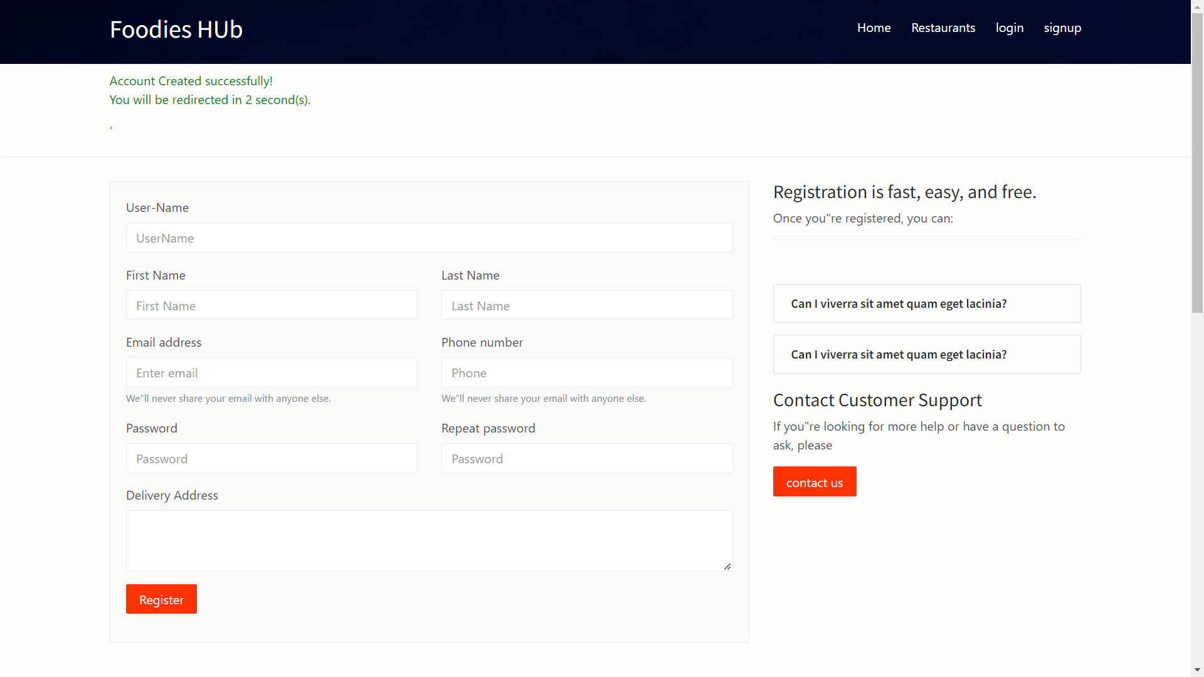

Figure 10: Customer registration form

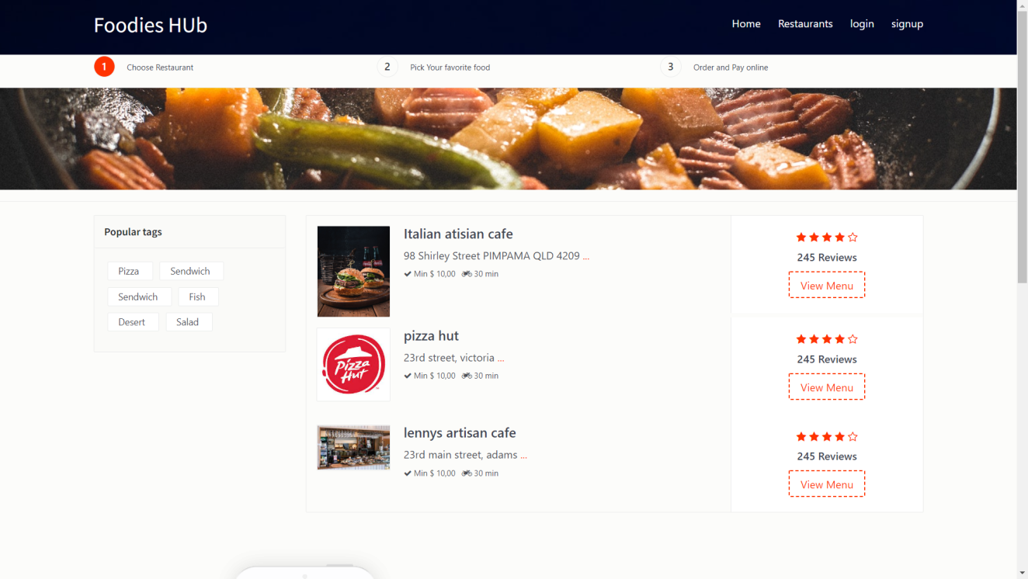

Figure 11: Restaurants list

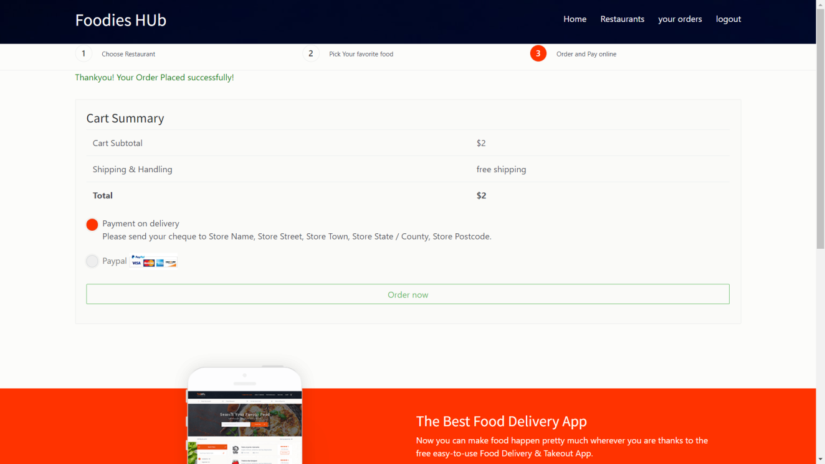

Figure 12: Checkout

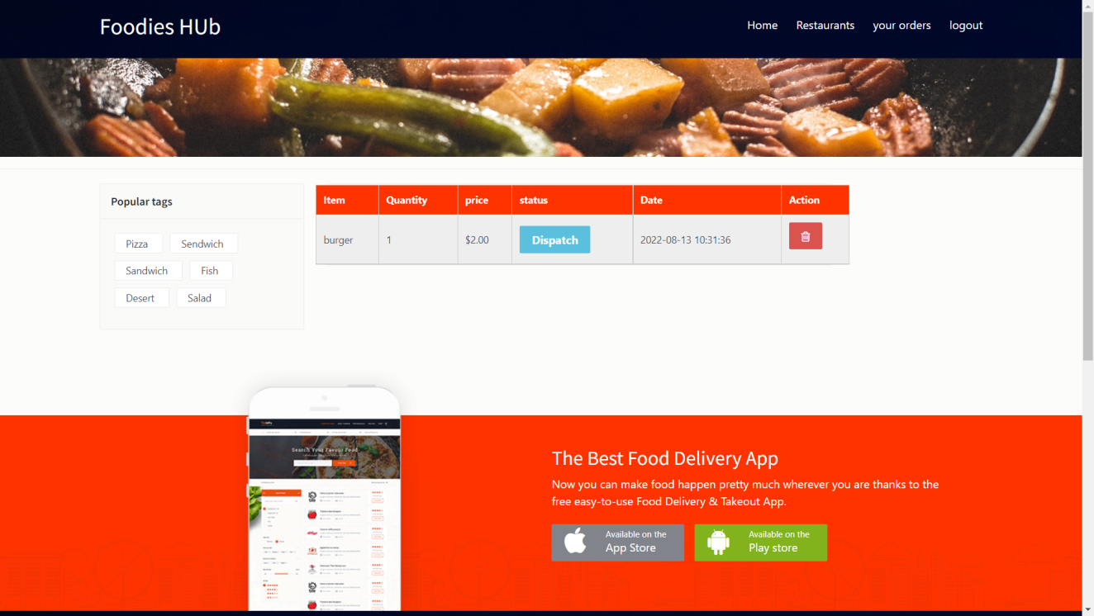

Figure 13: View Order

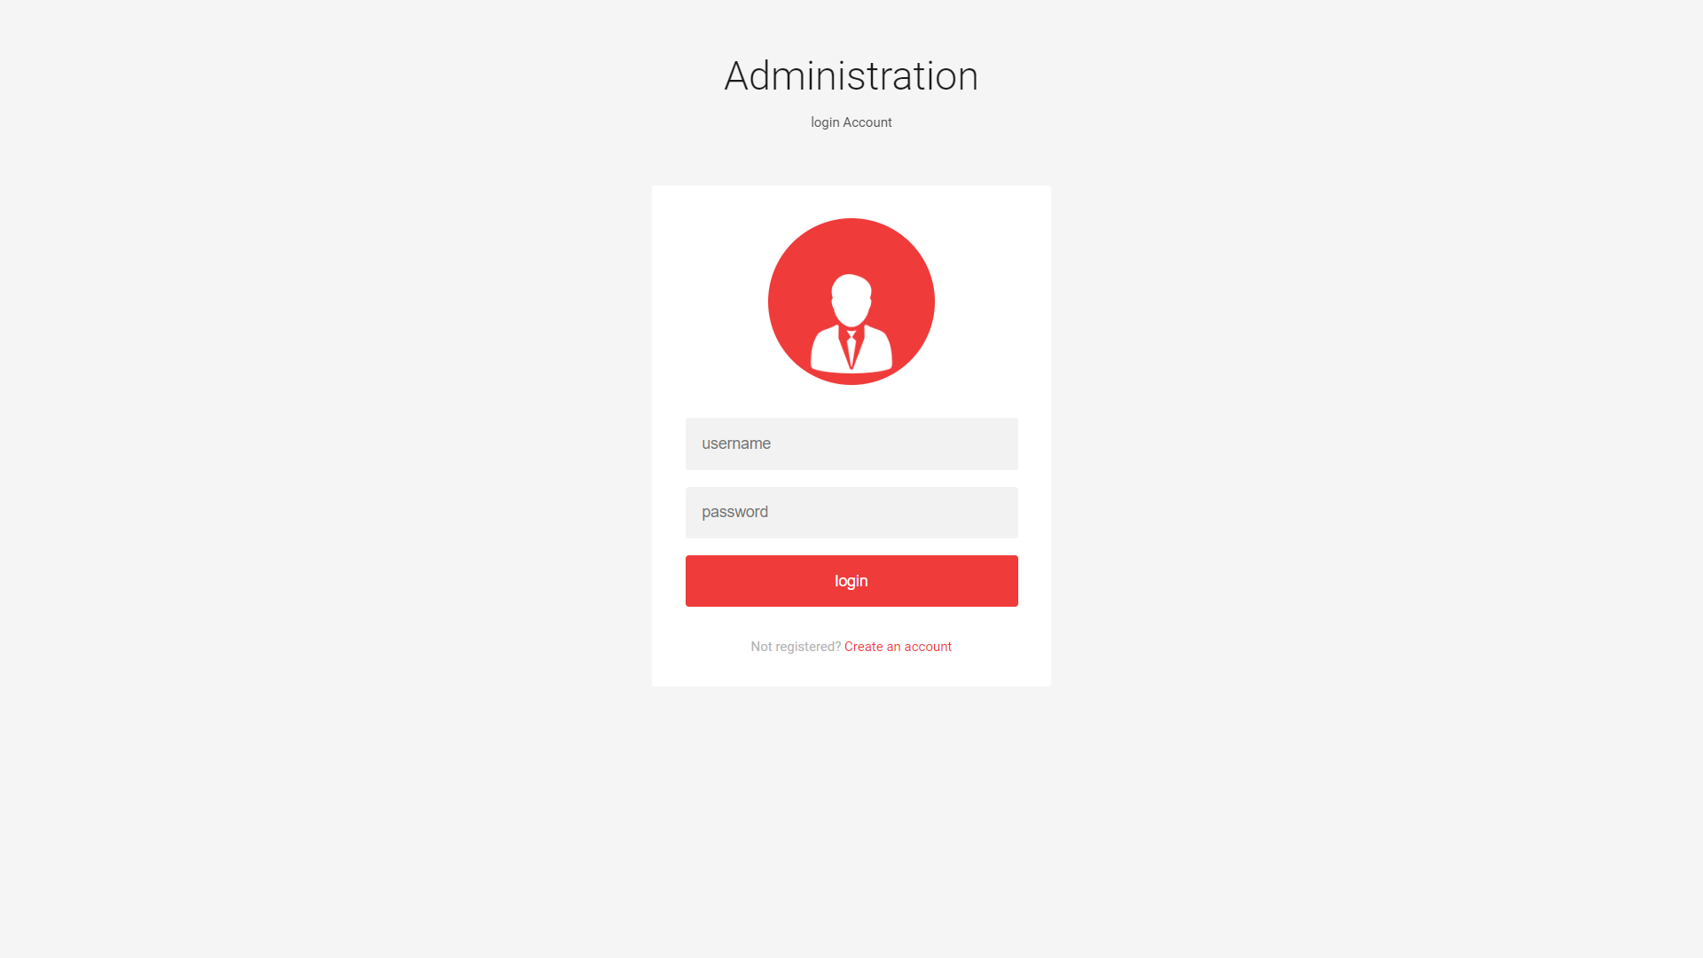

Figure 14: Admin Login Form

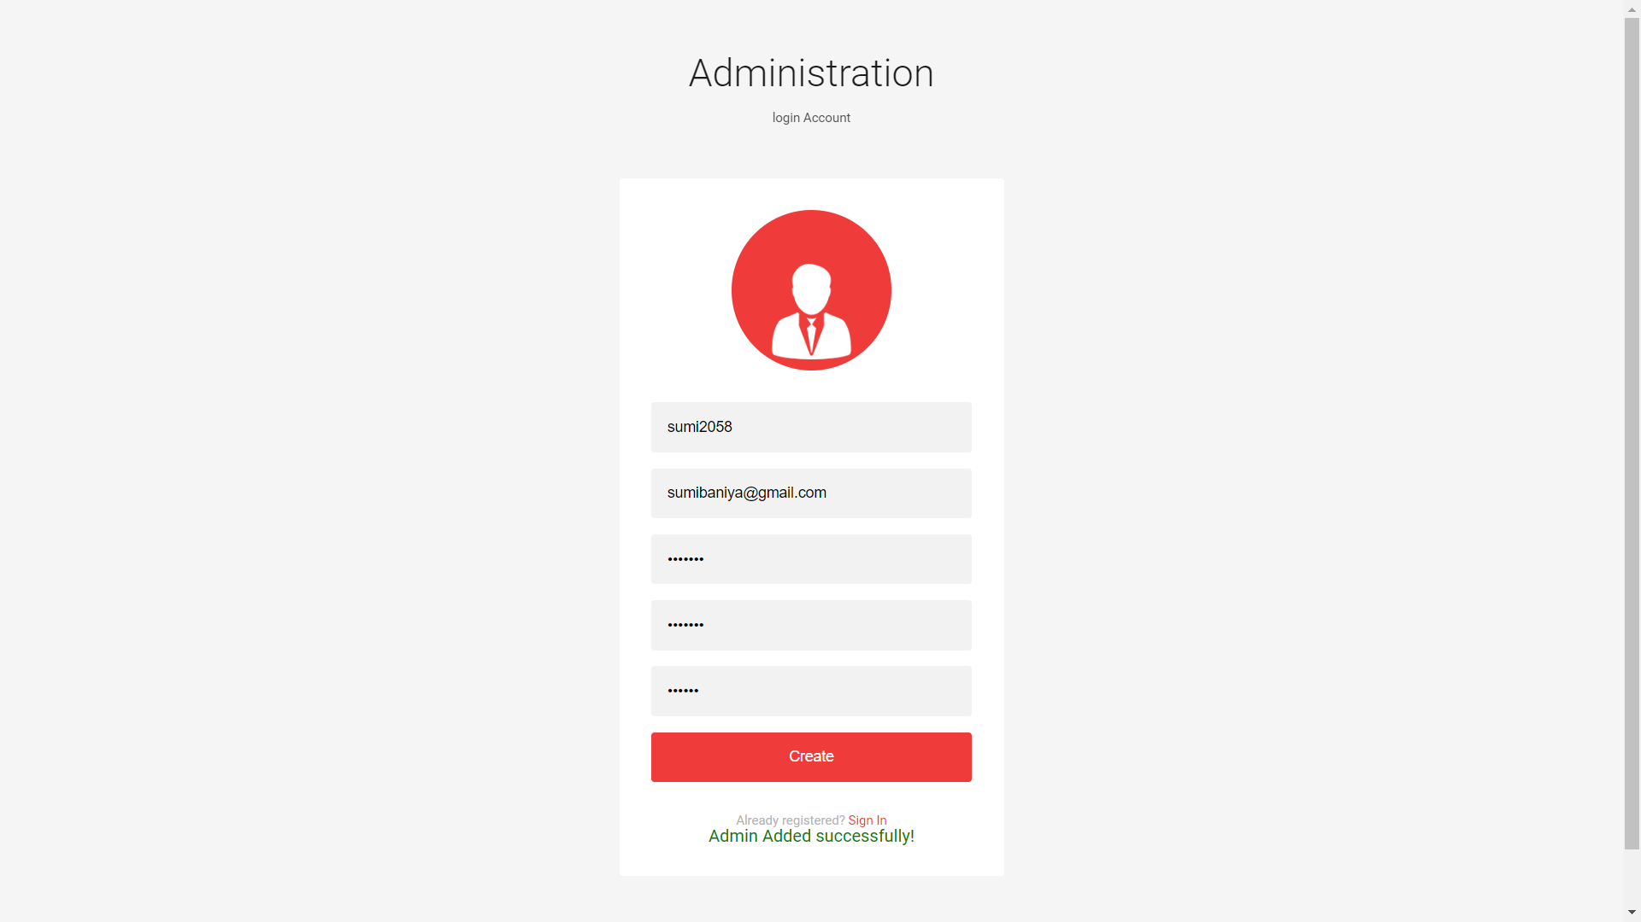

Figure 15: Admin Registration form

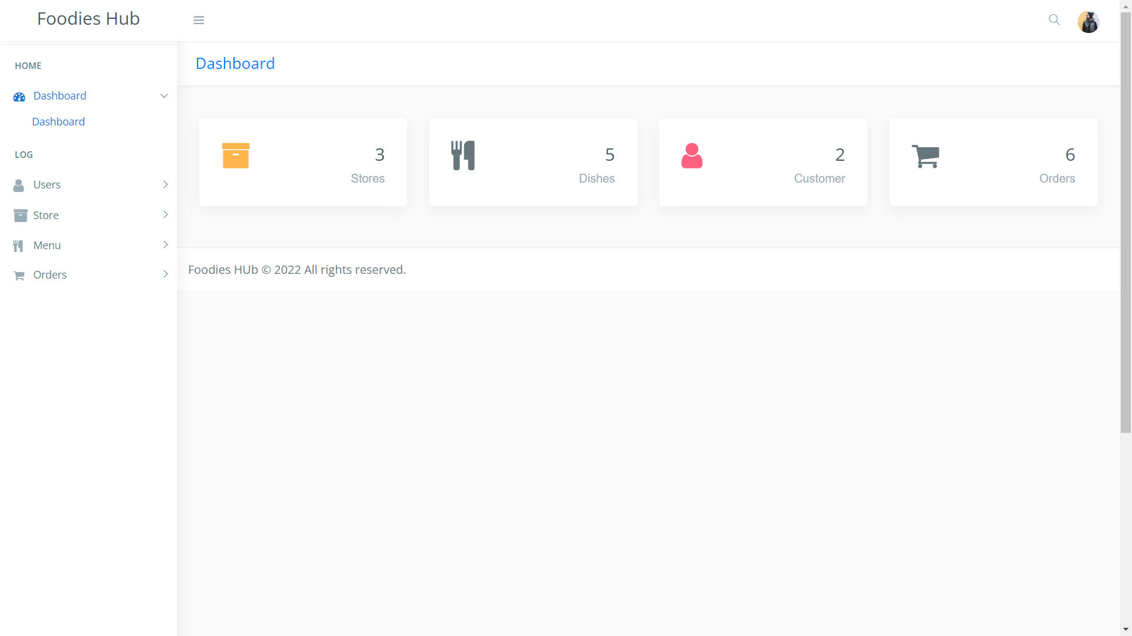

Figure 16: Admin Dashboard

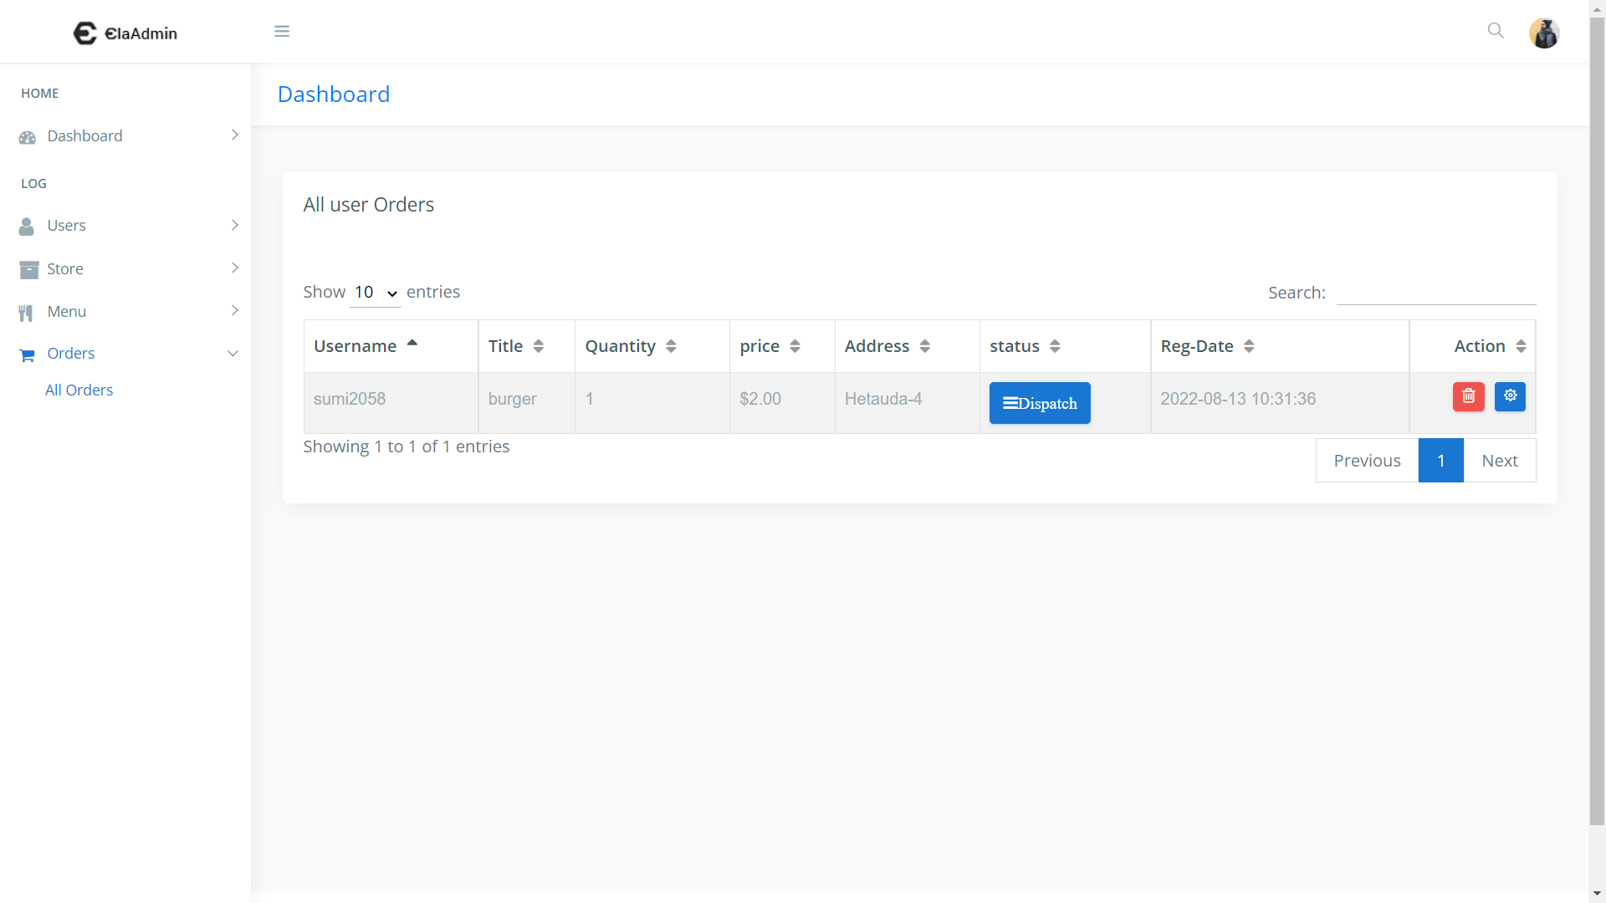

Figure 17: Admin orders Management

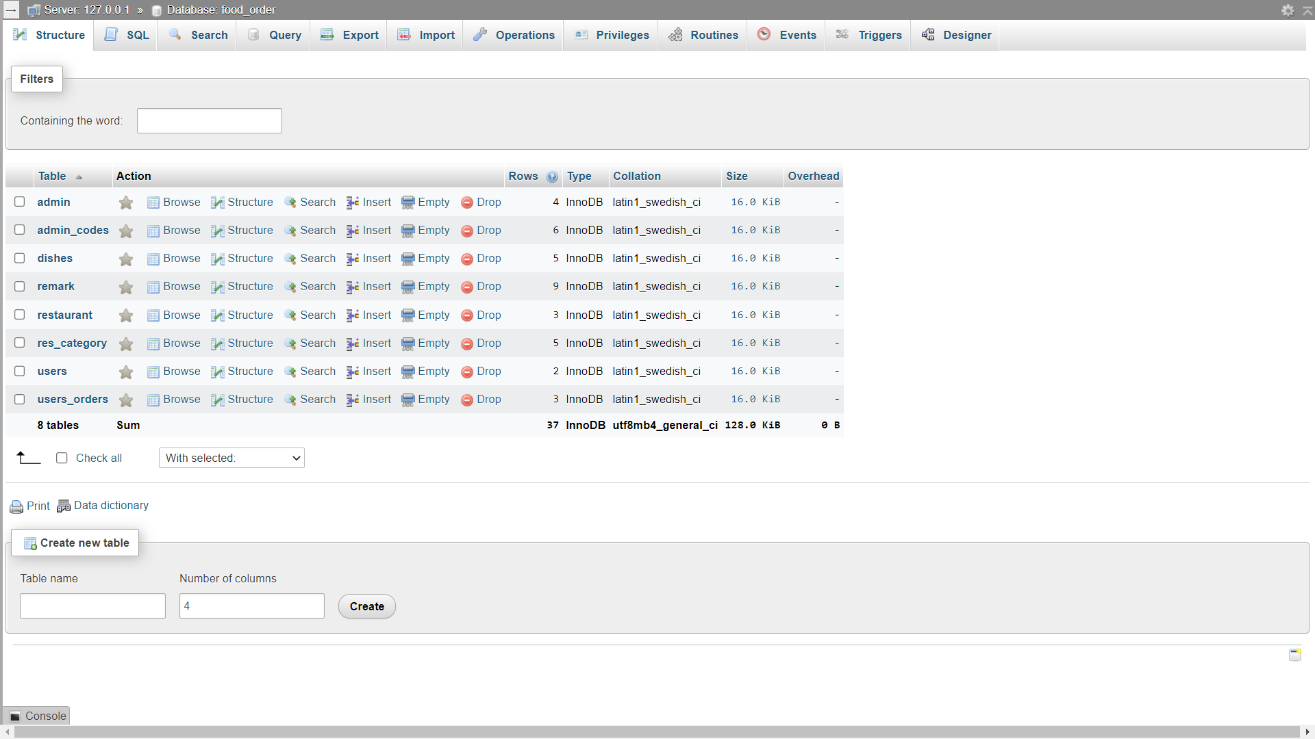

Figure 18: Database overview