Stage Specification and Biomarker Identification of Ovarian Cancer Using TCGA Data

By
Mosammat Sumiara Binte Rafiq
221-15-5365

Surit Sharmin
221-15-5931

FINAL YEAR DESIGN PROJECT REPORT
This Report Presented in Partial Fulfillment of the Requirements for the Degree of Bachelor of Science in Computer Science and Engineering

Supervised by

Dewan Mamun Raza

Assistant Professor
Department of Computer Science and Engineering Daffodil International University

Co-Supervised by

Md. Abdullah Al Kafi Lecturer
Department of Computer Science and Engineering Daffodil International University



DAFFODIL INTERNATIONAL UNIVERSITY
Dhaka, Bangladesh
December 10, 2025

APPROVAL

This Project titled “Stage Specification and Biomarker Identification of Ovarian Cancer Using TCGA Data” submitted by Mosammat Sumiara Binte Rafiq and Surit Sharmin to the Department of Computer Science and Engineering, Daffodil International University, has been accepted as satisfactory for the partial fulfillment of the requirements for the degree of B.Sc. in Computer Science and Engineering and approved as to its style and contents. The presentation has been held on 10-12-2025.

BOARD OF EXAMINERS

Name
Board Chairman
Designation, Department of CSE, FSIT Daffodil International University

Name
Internal Examiner 1
Designation, Department of CSE, FSIT Daffodil International University

Name
Internal Examiner 2
Designation, Department of CSE, FSIT Daffodil International University

Name
External Examiner
Designation, Department of CSE, FSIT Daffodil International University

DECLARATION

We hereby declare that this project has been done by us under the supervision of Dewan Mamun Raza, Assistant Professor, Department of Computer Science and Engineering, Daffodil International University. We also declare that neither this project nor any part of this project has been submitted elsewhere for the award of any degree or diploma.

Supervised by:

Dewan Mamun Raza
Assistant Professor
Department of Computer Science and Engineering Daffodil International University

Co-Supervised by:

Md Abdullah Al Kafi
Lecturer
Department of Computer Science and Engineering Daffodil International University

Submitted by:

Mosammat Sumiara Binte Rafiq
Student ID: 221-15-5365
Department of Computer Science and Engineering Daffodil International University

Surit Sharmin
Student ID: 221-15-5931
Department of Computer Science and Engineering Daffodil University

ACKNOWLEDGEMENTS

This work would not have been possible without the support and contributions of many individuals over the past two semesters. We are deeply grateful to everyone who has as- sisted us in one way or another.

First, we express our heartfelt thanks and gratefulness to the almighty for His divine blessing making it possible for us to complete the Final Year Design Project(FYDP) successfully.

We are grateful and wish our profound indebtedness to Dewan Mamun Raza, Assistant Professor, Department of Computer Science and Engineering, Daffodil International University, Dhaka, Bangladesh. Deep knowledge and keen interest of our supervisor in the field of Machine Learning to carry out this project. His endless patience, scholarly guidance, continual encouragement, constant and energetic supervision, constructive criticism, valuable advice, reading many inferior drafts, and correcting them at all stages have made it possible to complete this project.

We would like to express our heartfelt gratitude to the Head of the Department of Computer Science and Engineering, for his kind help in finishing our project and also to other faculty members and the staff of the Department of Computer Science and Engineering, Daffodil International University.

We would like to thank our entire course-mates at Daffodil International University, who took part in this discussion while completing the course work.

Finally, we must acknowledge with due respect the constant support and patience of our parents.

ABSTRACT

Ovarian cancer is one of the deadliest gynecological cancers since it is usually diagnosed too late and there are no reliable screening methods for early detection. In the current research, we took TCGA ovarian cancer genomic data and worked on the use of machine-learning–based molecular biomarker profiling if it would help in stage classification. From a starting point of more than 45,000 genomic features, we carried out dimensionality reduction and SHAP-based feature ranking to locate the most discriminative biomarkers. After the preprocessing of clinical variables and the rectification of class imbalance, we resorted to the evaluation of several machine learning models in classifying stages I–IV. Our machine learning model presented the best performance overall as it scored the highest in accuracy, precision, recall, and F1-score compared to the other algorithms. The selected model helped in recognizing the first 30 biomarkers as the main predictors of the stage, while SHAP stage-wise analysis using the top 100 biomarkers provided evidence for different molecular signatures linked to the progression of the disease. Our method proved its capability to deliver strong multi-class classification results even in the presence of an unbalanced dataset and with the input of high-dimensional genomic data. The combination of machine learning with interpretable SHAP analysis not only reveals the biochemically relevant molecular markers but also provides a better understanding when compared to the conventional statistical approaches. The results presented here underscore the potential of genomic biomarker profiling and interpretable machine-learning models to act as a support for early detection strategies and for further research into the mechanisms of ovarian cancer progression. This structure has the potential to be the basis for diagnostic research and clinical investigations in ovarian oncology driven by biomarkers in the future.

Table of Contents

Approval i

Declaration ii
Acknowledgements iii
Abstract iv
List of Figures vii
List of Tables viii
- Introduction 1-4
  - Introduction 1
  - Motivation 1
  - Objectives 2
  - Methodology 2
  - Project Outcome 3
  - Organization of the Report 3
- Background 5-10
  - Introduction 5
  - Literature Review 5
    - Similar Applications 7
  - Gap Analysis 8
  - Summary 9
- Research Methodology 10-22
  - Methodology/Requirement Analysis & Design Specification 10
    - Overview 10
    - Proposed Methodology/ System Design 10
    - Functional and Nonfunctional Requirements 13
    - UI Design……………………………………………………………14
  - Detailed Methodology and Design………………………………………….18
  - Project Plan……………………………………………………………………..21
  - Task Allocation…………………………………………………………….22
  - Summary………………………………………………………………………..22
- Implementation and Results 24-38
  - Environment Setup 24
  - Testing and Evaluation/Performance/ Comparative Analysis 25
  - Results and Discussion 34
  - Summary 38
- Engineering Standards and Design Challenges 39-44
  - Compliance with the Standards 39
    - Software Standards 39
    - Hardware Standards 40
    - Communication Standards 40
  - Impact on Society, Environment and Sustainability 40
    - Impact on Life 40
    - Impact on Society & Environment 40
    - Ethical Aspects 41
    - Sustainability Plan 41
  - Project Management and Financial Analysis 41
  - Complex Engineering Problem 42
    - Complex Problem Solving 42
    - Engineering Activities 43
  - Summary 44
- Conclusion 45-46
  - Summary .45
  - Limitation. .45
  - Future Work .46
References 47

List of Figures

3.1 Methodology Diagram of Prediction and Biomarker Identification ………...13
3.2 User Interface Dashboard………………………………………………………….……15
3.2 Input of CSV File to Input………………………………………………………………..16
3.3 Stage Prediction Result……………………………………………………………….....17
3.4 Gene Explanation using SHAP……………..…………………………………...…… .17
3.5 SHAPE value for responsible gene…………….……………………………………….18
4.1 Feature Correlation Heatmap…………………………………………………………..26
4.2 Comparison of Accuracy from Different Models…………………………………...… 27
4.3 Comparison of Precision……………………………………………………………..…..28
4.4 Comparison of F1 Score………………………………………………………………..…28
4.5 Comparison of Recall ……………………………………………………………….……29
4.6 Overall Comparison………………………………………………………………..……..30
4.7 Confusion Matrix in XGBoost Model…..…………………………………………….…31
4.8 Top 30 Biomarkers……………………………………………………………………….32
4.7 SHAP Interpretation for Stage I……………………………………………….……….33
4.8 SHAP Interpretation for Stage II…………………………………………….…………34
4.9 SHAP Interpretation for Stage III………………………………………………...……35
4.10 SHAP Interpretation for Stage IV……………………………………………...……..36

List of Tables

2.1 Summary of Literature Reviewed……………………………………………………………..5

2.2 Gap Analysis Between Existing Related Works……………………………………………8

3.1 Dataset Descriptive Table…………………………………………………………………….18

3.2. Project Plan…………………………………………………………………………………….21

3.3 Task Allocation…………………………………………………………………………………22

4.1 Model Performance Analysis…………………………………………………………………37

5.1 Estimated Cost Analysis………………………………………………………………………41

5.2 Mapping with Complex Engineering Problem……………………………………………..42

5.3. Mapping With Knowledge Profile…………………………………………………………...43

5.4 Mapping with Complex Engineering Activities……………………………………………44

Chapter 1

Introduction

This chapter is a presentation of the research topic, explanation of motivation, goals, and the methods of predicting ovarian cancer stages and identifying biomarkers through machine learning as the main feature. It also highlights the expected outcomes and introduces the organizational map of the whole report as a help for the reader.

Introduction

Ovarian carcinoma is a gynecological cancer that is extremely deadly and it is responsible for a large part of cancer-related deaths among women all over the world. It is estimated that there are about 239,000 new cases annually and 152,000 global deaths [22], which shows clearly that it has a major public health impact. The high death rate for ovarian cancer can be attributed to its intricacies in biological behavior and to the fact that most patients are diagnosed when the disease has progressed to a stage where therapeutic options are limited and prognosis is poor [1]. The issue of early detection is still a major difficulty as most of the cases are diagnosed after the cancer has spread and thus there is a limitation to the traditional treatment methods.
Presently, the methods for staging and diagnosis are mainly based on invasive techniques like biopsies and surgical examinations [5], which, although they provide much information, are very expensive, involve the risk of complications, and are not suitable for general screening. Besides, the diversity of ovarian tumors makes it difficult to classify the stages correctly and to intervene in time [5]. These drawbacks emphasize the necessity to come up with new methods that can deliver accurate, non-invasive, and scalable options for ovarian cancer staging.
Machine learning (ML) provides a revolutionary power in this context. The ML models when such complex clinical and genomic datasets are analyzed can detect even the minute patterns and predictive features which are usually not available through the conventional methods [21]. The use of computational intelligence in ovarian cancer research not only assists in precise stage prediction but also in the discovery of possible biomarkers which might lead to the development of personalized treatment strategies [19]. This study intends to apply ML methods to create a solid structure for ovarian cancer stage classification, which will deal with the two problems of early detection and the discovery of biomarkers with clinical applicability, and thus, it will be a factor in the increase of clinical success and a decrease in mortality rates.

Motivation

Ovarian carcinoma still poses a problem as regards early diagnosis, mainly because of the complexity of its ovarian cancer biological progression and the drawbacks of conventional diagnostic methods.
Consequently, the need for computational approaches that could quickly analyze genomic and support accurate stage prediction has become very urgent. Machine learning is the one that can extract the very meaningful patterns out of high-dimensional gene expression data with its capabilities and thus be the main tool to help in cancer staging improvement. Previously many research work has been occurred using genomic data i.e., genes, protein, DNA sequences to analyze responsible genes [11], methylation [5], prognosis reasoning [13]. This research work intends to offer an early cancer detection application and hence bring about a positive impact on clinical decisions by creating a predictive model and uncovering the main molecular features, i.e., biomarkers. Research wise this entire thing is a great opportunity to gain practical experience in machine learning applications in the challenging area of biomedical data strengthening the skills in data processing, model building, and the whole research method.

Objectives

The objective of this study is specifically designed to address an urgent problem of ovarian cancer diagnosis:
- To collect genomic data from the TCGA ovarian cancer for insightful information regarding stage detection.
- To train machine learning models to correctly predict cancer stages.
- To identify the biomarkers accurately which are involved in tumor progression and stage defining.
Having achieved these targets, the initiative is aimed towards innovatively improving aspects in oncological pathways.

Methodology

The present study adopts a controlled machine learning method to estimate the stages of ovarian cancer relying on the gene expression data from The Cancer Genome Atlas (TCGA). Data were subjected to a series of processing steps including data cleaning and construction of feature matrices fit for model training. A number of classifiers were employed, namely Logistic Regression, Random Forest, SVM, XGBoost, and LightGBM, which were tuned and ranked according to the measures of accuracy, precision, recall, and F1-score, in order to find the one model yielding the best results. XGBoost was declared the winner in terms of predictive power and the model was then selected as the main one. To improve the understanding of the predictive process, a SHAP analysis was carried out which revealed the most significant genes affecting the stage prediction and opened up avenues for potential biomarker identification. This approach brings together predictive modeling and explainability in a way that it is helpful for both classification and biological interpretation.

Project Outcome

This primary goal of the project is to develop a machine- learning-based framework aimed at predicting ovarian cancer stages and identifying diagnostic biomarkers. The following are the results of the project:
- Processing of proper features (e.g., data, genetic information, clinical data of patients) which can help to predict the stage of ovarian cancer using genomic data.
- Building machine learning models with high performance in order to predicting stages properly for the betterment of patients’ treatment.
- Finding a list of genes (biomarkers) that are strongly linked with different cancer stages which could be helpful in future medical research or diagnosis.
The article shows that an analysis of data could be simple using the clinical significance hence promoting the advancement of the diagnosis of ovarian cancer, its staging, and even the discovery of biomarkers.

Organization of the Report

The report has six main sections. Each part is continued from the previous one. While combined, they will provide a comprehensive picture of the research on stage specification and biomarker identification of Ovarian cancer. The structure is provided to the reader as a helping guide. It begins with an introduction and covers background analysis, methodology, implementation, result and analysis and finally conclusion of the work:
- Chapter 1: Introduction
This chapter is an introduction to the project, including the reason behind its development, goals, and approach. It also shows anticipated results and meaning of the work. It also provides the outline of the report to help the reader follow it.

- Chapter 2: Background
In this chapter, we are going to review literature and prior studies that are pertinent to the field of predicting the cancer stage and identification of biomarkers in ovarian cancer. It describes comparable uses, gaps in research, and how the research discussed in this paper will fill the gaps. The chapter ends with a conclusion drawn on the major findings of the background study.

- Chapter 3: Research Methodology
This chapter describes the methodology applied in the project, design of the system, functional and non-functional requirements and data flow diagrams. It also justifies the interface design of the user, project plan and the distribution of tasks between team members. The chapter offers a chronological manner in which the development and implementation process ought to take place.

- Chapter 4: Implementation and Results
This chapter will explain how the implementation will take place giving an environment setup, coding, and integration of the system. It also gives the testing, evaluation, and comparison of results. The main conclusions are presented, and it is noted that the developed models are effective and perform well.

- Chapter 5: Engineering Standards and Design Challenges
This chapter entails adherence to software, hardware and communication standards. It also argues the effect of the project on the society, environment and ethics. It further describes the project management design, financial analysis and the solutions to the complex engineering problems that were faced.

- Chapter 6: Conclusion
The last chapter of the work is the conclusion that sums up the entire work with its main achievements and results. It brings out the weaknesses of the project and offer suggestions that can be made in the future. The chapter highlights how the project helps in the research and practical use in predicting ovarian cancer.
Chapter 2

Background

Within this chapter, a thorough investigation of the past and present research related to ovarian cancer genomics, machine learning applications, and biomarkers discovery via TCGA datasets is offered. It brings out resembling research, pinpoints voids in the literature, and sets up the scientific and the demand for the proposed multiclass stage prediction system.

Introduction

Ovarian cancer is a life-threatening disease whose incidence is alarmingly increasing worldwide [1]. To understand its complex nature, researchers have investigated it from various clinical and molecular perspectives. One valuable resource in this domain is The Cancer Genome Atlas (TCGA), which provides large-scale genomic and clinical datasets [3]. With the increasing accessibility of these datasets, there is a growing demand for developing computational approaches that can effectively analyze and interpret both genomic and clinical information. These methods can play a crucial role in early detection, stage prediction, and personalized treatment planning for ovarian cancer patients. Several studies have explored the use of gene expression.

Literature Review

The area of ovarian cancer research through machine learning analysis has been advanced by TCGA genomic datasets. The current review brings together studies having similar research aims, particular cases of applying machine learning techniques or discovering biomarkers, as well as the works providing new methodologies, such as the combination of multi-omics, the use of interpretable features, and the prediction of cancer stages.

Table 2.1: Summary of Literature Reviewed.

Author (s) | Year | Title | Methodology | Key Findings
Chen, W. et al [11] | 2025 | Molecular subtype of ovarian clear cell carcinoma: 80 Chinese patients | ML clustering of 520-gene panel using TCGA endometrial subtypes; survival correlation. | ARID1A and PIK3CA most frequent; TCGA subtype did not predict prognosis; TP53 mutation associated with worse survival in advanced stages.
Medina, J.E. et al [12] | 2025 | Early detection of ovarian cancer using cell-free DNA fragmentomes and protein biomarkers | ML-based 10-gene PCD prognostic model integrating TCGA, GTEx, Genecards; survival and functional analysis. | 10-gene signature stratified patients; high-risk group had worse OS; low-risk had higher immune infiltration and drug sensitivity.
Liñares-Blanco, J. et al.  [18] | 2021 | Machine learning analysis of TCGA cancer data | Systematic review of >100 studies using TCGA for ML training; highlighted Random Forest, SVM, deep learning; multi-omic integration. | Prognosis, tumor subtypes, MSI, immune response, and pathway prediction dominated; multi-omic integrative ML models are a rising trend.
Hossain,M.A. et  al. [22] | 2019 | Machine learning and bioinformatics models to identify gene expression patterns of ovarian cancer associated with disease progression and mortality | Cox regression-based ML model on TCGA transcriptome and clinical data to identify gene-survival relationships. | TLR4, BSCL2, CDH1, ERBB2, BRCA2, SCGB2A1 independently correlated with survival; serve as prognostic biomarkers.
Cai, X. et al [17] | 2024 | A novel TCGA-validated programmed cell death-related signature of ovarian cancer | Constructed ML-based 10-gene PCD prognostic model using TCGA, GTEx, Genecards; validated with survival analysis and qRT-PCR. | High-risk group had worse OS; low-risk group had higher immune infiltration and drug sensitivity.
Wang, H. et al. [10] | 2025 | SNPs in ovarian cancer impacting lipid metabolism and prognosis: an integrated TCGA database analysis | ML based analysis SNPs and gene expression using TCGA; survival validated by qRT-PCR/Western blot | Five lipid-metabolism genes (APOB, BRCA1, COL6A3, LRP1, LRP1B) correlated with survival; potential prognostic markers.
Wadapurkar, R.M. et al [13] | 2023 | RNA-Seq  analysis of  clinical samples  from TCGA  reveal molecular. | DEGs identified from TCGA RNA-Seq; ML clustering and pathway enrichment to find biomarkers. | IRAK2, CXCL8, REG1A identified as biomarkers associated with recurrence, stage, and menopause.
Similä-Maarala et al [9] | 2022 | TCGA molecular classification in endometriosis-associated ovarian carcinomas | Applied TCGA molecular subtyping; ML-based clustering to classify EAOC tumors. | EAOC largely clustered with HGSOC; TP53 mutation predicted worse survival in advanced cases.
Zeng, H., et al. [5] | 2021 | Integration of histopathological images and multi-dimensional omics analyses predicts molecular features and prognosis in HGSOC | ML models trained on histopathological image features and multi-omics data; validated externally. | Multi-omics model predicted BRCA1/2 mutations, MSI, molecular subtypes; best 5-year OS prediction AUC=0.911.
Bao, M. et al [4] | 2020 | Novel gene signatures for prognosis prediction in ovarian cancer | LASSO Cox regression model (ML approach) on GEO and TCGA datasets for survival prediction. | Multi-gene signature stratified patients; SNRPD1 and EFNA5 as key prognostic markers; 16 potential drugs identified.
Li, C-J., et al.[21] | 2021 | Identification of novel biomarkers and candidate drug in ovarian cancer | ML integration of multi-omics (genomic, transcriptomic, proteomic) to identify biomarkers; survival analysis. | CREB1 overexpressed; high expression linked to poor survival; naloxone as potential drug.
Gui, T. et al. [15] | 2021 | Identification and analysis of genes associated with epithelial ovarian cancer | Integrated GEO datasets; ML-based PPI network and hub gene identification. | 306 DEGs identified; CDCA5 and ESPL1 were tumor-promoting hub genes.

Similar Applications
Several studies have not only conducted a detailed analysis of computational genomics and machine learning in ovarian cancer but also provided methodological insights that this project can use. Li et al. [21] performed one of the most thorough investigations in which they discovered new biomarkers in ovarian cancer from TCGA-OV RNA-Seq data. They pointed out important genes linked with tumor development by using differential expression analysis and network-based methods. The discovery of biomarkers was the main focus of their researches, however, they did not carry out multiclass stage classification which thereby left room for creating more focused clinical prediction models like the one proposed in this study.
Kourou et al. [23] surveyed the area of machine learning in cancer diagnosis and highlighted the predictive power of the algorithms like Support Vector Machines and Random Forests in clinical oncology. Their results lend support to the methodological approach of this study, particularly in terms of using multiple ML classifiers for evaluation and the incorporation of omic-scale genomic data along with the classifiers. Nevertheless, their review covered a wide range of topics and did not narrow down on the issue of ovarian cancer staging.
Likewise, an integrative bioinformatics approach was also employed by Chia-Jung Li et al. [21] that helped to identify candidate drugs and oncogenic pathways in ovarian cancer through data comparison.

Gap Analysis

The present research paper shows that the majority of the studies until now have been mainly concerned with the prognosis or the subtypes, rather than multiclass ovarian cancer stage prediction. Very few of the studies have given stage-specific biomarkers or have tackled the problem of data imbalance in a proper way. None of the studies that have used TCGA-OV data along with the machine learning and interpretable biomarker analysis have emphasized the demand for a specific model that focuses on the different stages.
Table 2.2: Gap Analysis Between Existing Related Works

Features | Li et al. 2021  [21] | Gui et al. 2021  [15] | Kuznetsov 2017  [6] | Hossain,M.A. et al 2019  [22] | Liñares-Blanco, J. et al. 2021  [18] | Proposed system
Uses TCGA-OV RNA-Seq | Yes | Yes | Yes | Yes | Yes | Yes
Uses selected biomarkers (gene filtering) | Yes | Yes | Yes | Yes | No | Yes
Machine learning classification | No | No | No | Yes | Yes | Yes
Uses multiple ML models for comparison | No | No | No | Yes | Yes | Yes
Multiclass stage prediction (I–IV) | No | No | No | No | No | Yes
SHAP global explainability | No | No | No | No | No | Yes
Class-wise SHAP explainability | No | No | No | No | No | Yes

Summary

This chapter has laid the groundwork for the research by reviewing the main pillars, starting with a short history of ovarian cancer and signaling the use of genomic data as the major factor for better diagnosis and treatment. A thorough review of the scientific literature on fifteen studies very similar to the one under consideration has shown how machine learning, mainly random forests, support vector machines, and deep learning techniques, has had a great impact through the use of TCGA datasets for the discovery of biomarkers, prediction of prognosis, classification of tumor subtypes, and pathway analysis. Though the computational methods were acknowledged as useful in trapping the patterns of high-dimensional gene expression, their applications were mostly limited to binary outcomes or survival predictions rather than to multiclass stage classifications. By doing so, the similar application section went on to investigate closely related research that collaborated with TCGA-OV RNA-Seq data and ML classifiers, pointing out main methodological advantages such as integrative omics analysis, feature selection, and model explainability. Be that as it may, none of these studies approached all the components of a complete staging framework so far. The gap analysis pointed out similar limitations with each preceding study, such as lack of comprehensive multiclass stage prediction, limited capability of dealing with imbalanced datasets, and not enough emphasis on interpretable biomarker explanation, among others. Moreover, no one combined machine learning modeling with a user-friendly prediction interface. The above-mentioned insights, in addition to providing a clear need for an interpretable, stage-specific, and clinically relevant ML model for ovarian cancer, have also laid the groundwork for the system discussed in the next chapter.
Chapter 3

Research Methodology

The methodology utilized in the study is thoroughly discussed in this chapter, which is focused on ovarian cancer stage prediction with gene expression data and machine learning techniques. It separates the system setup, data collections, analytical models, methods, performance metrics, and the time schedule of the project.

Methodology

Overview

The methodology has been developed in such a way that it tackles the issue of ovarian cancer stage classification with utmost efficacy by utilizing gene expression data from TCGA. The ultimate objective is to create, train, and assess machine learning models that can predict the cancer stages (I, II, III, IV) with high accuracy using genomic biomarkers. This study employs a data-driven approach that relies on feature selection and supervised machine learning models. The process is very simple and includes the following steps: collecting data, preparing it, training a model, assessing it, making sense of the results, and putting the model into practice. By choosing the features, only the most significant genes are permitted to participate in the model's performance, which subsequently enhances the accuracy and the interpretability of the results. Moreover, class imbalance is tackled with the use of techniques that prevent the model from being biased towards the more frequent stages. The interpretability of the model is further improved through the application of SHAP analysis which makes it possible to discover the leading biomarkers that influence the prediction of the stage. After all, a web-based GUI is being created which will serve as a showcase for the capability of making real-time predictions and will thus connect the research with the potential clinical application.

Proposed Methodology/ System Design

The suggested system works as a series of steps that gradually change the raw RNA-Seq gene expression data into predictions about cancer staging. The design of the system guarantees a workflow that is both modular and organized dealing with the whole process of data input, preprocessing, model training, evaluation, and interpretation.

In this system, the main phases are:
- Data Acquisition and Preparation: The first step in the process was the merging of numerous TCGA datasets which included mRNA sequencing data, clinical data, and copy number alteration (CNA) data. The dataset containing the most significant genomic and clinical features was then divided into three sets namely training, validation, and testing to provide an unbiased evaluation of the model.
  - Training Set (70%): The training set serves for extracting features and optimizing model parameters.
  - Validation Set (15%): The validation set is employed for selecting the model during training.
  - Test Set (15%): The test set is set aside to measure the last performance and check the impartial evaluation.
- Data Preprocessing: Before training the machine learning models, the raw TCGA datasets were subjected to a series of essential preprocessing steps that would ensure the input data to be clean, consistent, and of high quality. The sequence of actions included:

Data Integration: An integrated dataset consisting of clinical data (such as age, grade, and stage), mRNA expression profiles, and copy number alteration (CNA) data was generated, thereby allowing complete feature representation for each patient.

Missing Value Handling: Samples that contained a lot of missing data were removed to reduce bias and eliminate noise. The method of filling in small gaps was used in order to keep the dataset stable and not lose important samples at the same time.

Log Normalization (log2): Log Normalization (log2): The transformation of the raw gene expression values through log2 normalization was done with the purpose of reducing skewness and creating uniform variance. This in turn makes it possible for the models to learn from the high-dimensional genomic data in a more efficient manner.

Z-Score Standardization: The selected genes were subjected to Z-score scaling, which ultimately produced a mean of zero and a standard deviation of one for every gene in the study. Consequently, genes with large values would not be able to influence the learning process strongly or at all.
- Feature Reduction: The initial phase was to select the 500 genes bearing the most informational characters, then a more rigorous criterion was applied to further limit the selection down to the 100 genes, and hence the dimensionality was reduced. This procedure has the effect of removing noise and at the same time improving the model's performance and making it easier to understand.

Data Splitting: In order not to have biased evaluation, the preprocessed dataset was divided into three parts: training, validation, and test. The subsets are used separately for learning, tuning, and performance assessment of the final model, and each has its own specific role in these processes.

Class Balancing: SMOTE was applied to the training data to correct the problem of imbalanced stages. In this way, the fewer classes generate synthetic instances and the model can learn all the cancer stages more fairly.
- Model Selection & Training: Several models were trained to achieve the best model for accuracy:

feature importance capability as a built-in feature.

Logistic Regression (LR) was used as the most basic linear design.

Random Forest (RF) to detect non-linear patterns and to be able to explain the features.

Support Vector Machine (SVM, RBF kernel) for learning the decision boundary in a high-dimensional space.
- XGBoost, the main model due to its excellent performance on structured biomedical data and its feature importance capability as a built-in feature.

Model Evaluation: All the models under evaluation are subjected to the test set and their performance in terms of accuracy, precision, recall, and F1-score is measured and reported for each of the different stages of ovarian cancer.

Generating the confusion matrices helps to see the misclassifications and to get a clear picture of the errors happening at each stage. In addition, the AUC scores of One-vs-Rest and the ROC curves are computed to evaluate the capacity of each model to distinguish between the stages effectively.

The most successful model receives SHAP treatment as part of the interpretability guarantees. The overall model explanation by global SHAP shows which genes contributed the most to the predictions, whereas stage-wise SHAP points to the specific biomarkers that drive predictions for each of the four stages, I, II, III, and IV. Thus, the model is not just accurate but also biologically informative.

Deployment: This is a research project primarily, nevertheless, we are thinking about the practical use of the models, for example, in a web-based tool for predicting ovarian cancer stage classification. Through the deployment, global and stage-wise interpretation of the model's predictions for individual patients is made possible by SHAP explanations.
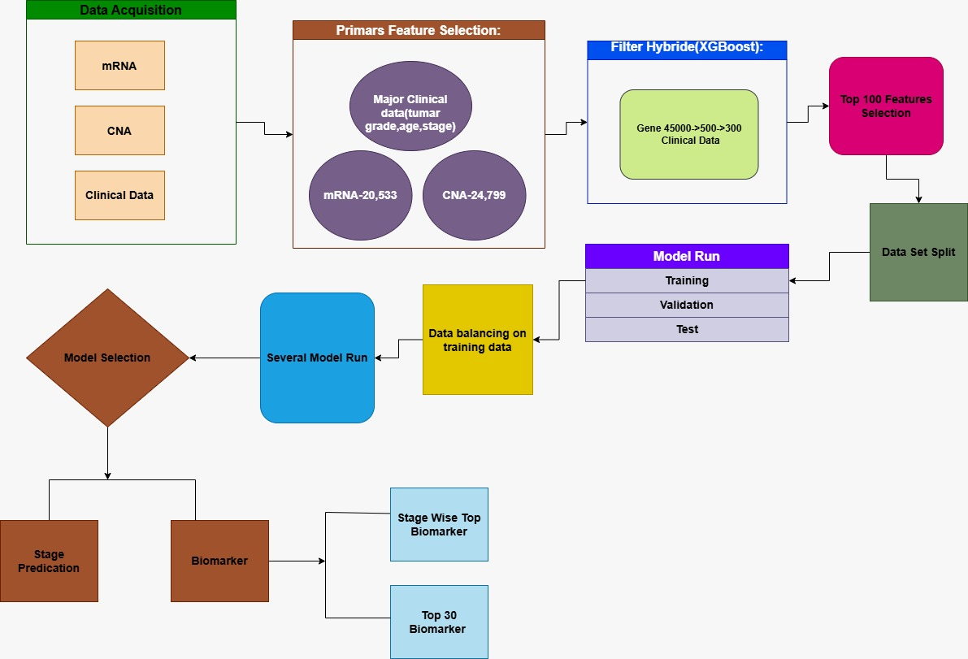
Fig 3.1 Methodology Diagram of Stage prediction & Biomarker Identification

Functional and Nonfunctional Requirements.
This system intends to accurately determine the ovarian cancer stage through the use of genomic data, machine learning, and interpretability tools, and its specifications serve as a guideline for the functional requirements. The latter refer to the required system actions, which include data management, cleaning, modeling, and SHAP-explained predictability. On the other hand, the non-functional specifications outline the performance of the system in terms of usability, reliability, efficiency, security, and maintainability.

3.1.3.1. Functional Requirements

F1: Dataset Input and Validation: The system must allow users to upload patient’s genomic dataset in CSV format or select predefined example sample. Besides, it must validate the uploaded dataset to make sure that all required genomic features.

F2: Data Processing: The system must preprocess input data automatically including – encoding categorical variables, Numeric Conversion and missing value handling and feature scaling.

F3: Machine Learning Model Interface: The system must load the pre-trained classification model and generate – predicted stage of ovarian cancer and probability distribution across all stage.

F4: SHAP-Based Model Explainability: The system must compute SHAP values for both global and pre sample explanations, including global feature importance ranking, stage wise biomarker interpretation and visualization of impactful genomic biomarkers.

3.1.3.2. Nonfunctional Requirements

NF1: Performance: The standard GPU hardware is expected to handle model training, while the prediction time is to be appropriate for practical use.

NF2: Accuracy: The model which has been chosen should not only attain but also possess high classification accuracy and stage prediction that is not easily affected by noise.

NF3: Scalability: The system needs to be future proof to the extent of accommodating larger datasets and more genomic features in the research that follows.

NF4: Usability & Reproducibility: The entire process, including the software used and the experiments carried out, must be properly recorded in such a way that the result can be replicated by others.

UI Design

The Ovarian Cancer Stage Detection and Biomarker Identification System's User Interface (UI) has been created to feature a clean, systematic, and researcher-friendly workflow. The interface is structured in a sequential manner to direct users from the uploading of the dataset to the predictions of stage and biomarkers, analysis, and reporting. The aim of the design is to make the process straightforward while simultaneously allowing complex machine learning operations to take place behind the scenes.

Key Elements and Design Consideration

Single-Page Layout: The layout is designed to be single page interface so as to have a seamless flow without the distractions of navigating through multiple pages [fig 3.1].

Header: A header that is easy to read and is placed in a prominent position indicates the objective of the system, "Ovarian Cancer Stage Predictor and Explainer", thus allowing the users to have immediate understanding [Fig 3.1].

Input Method: The pastel-colored interface permits the uploading of genomic patient data in the commonly used formats (CSV). After selecting a CSV file it will be uploaded and preprocessed. After that user can select the desired row of any patient to know the predicted cancer stage. [Fig 3.2]

Selection of Targeted Patient: With a dedicated section in the study page, a user can pick data to generate a stage prediction and presentation. [Fig 3.2]

Prediction Result: After analyzing the predicted ovarian cancer stage is retraced back in a clean and pliant manner, complete with a confidence value. [Fig 3.3]

Responsible Gene Visualization: Significant genes are visualized explaining classifier predictions to the selected patient, making these predictions interpretable for the final user. [Fig 3.4 & Fig 3.5]

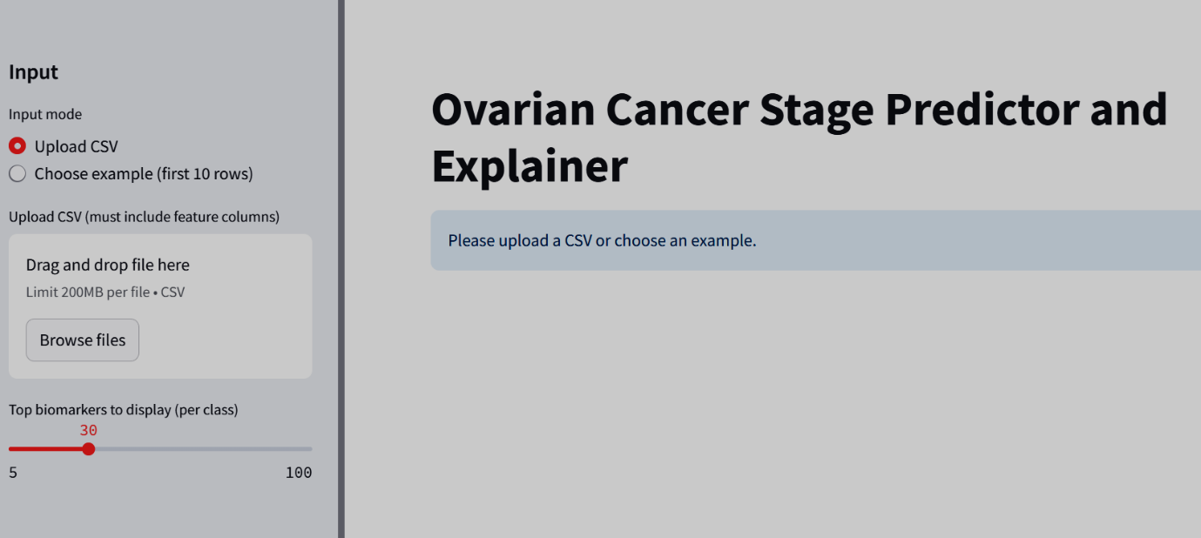Fig 3.1 User Interface Dashboard

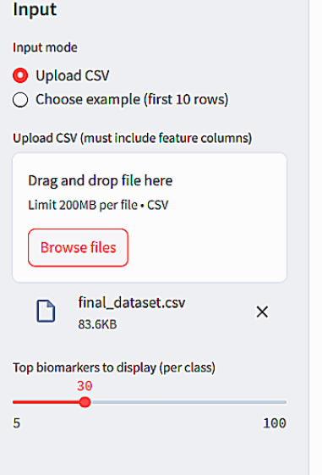
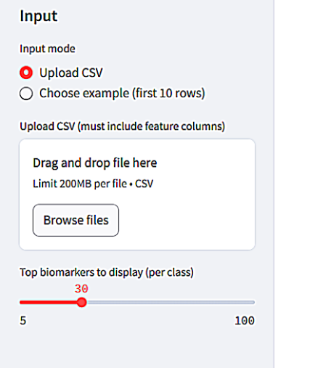

Fig 3.2: Input of a CSV file to predict

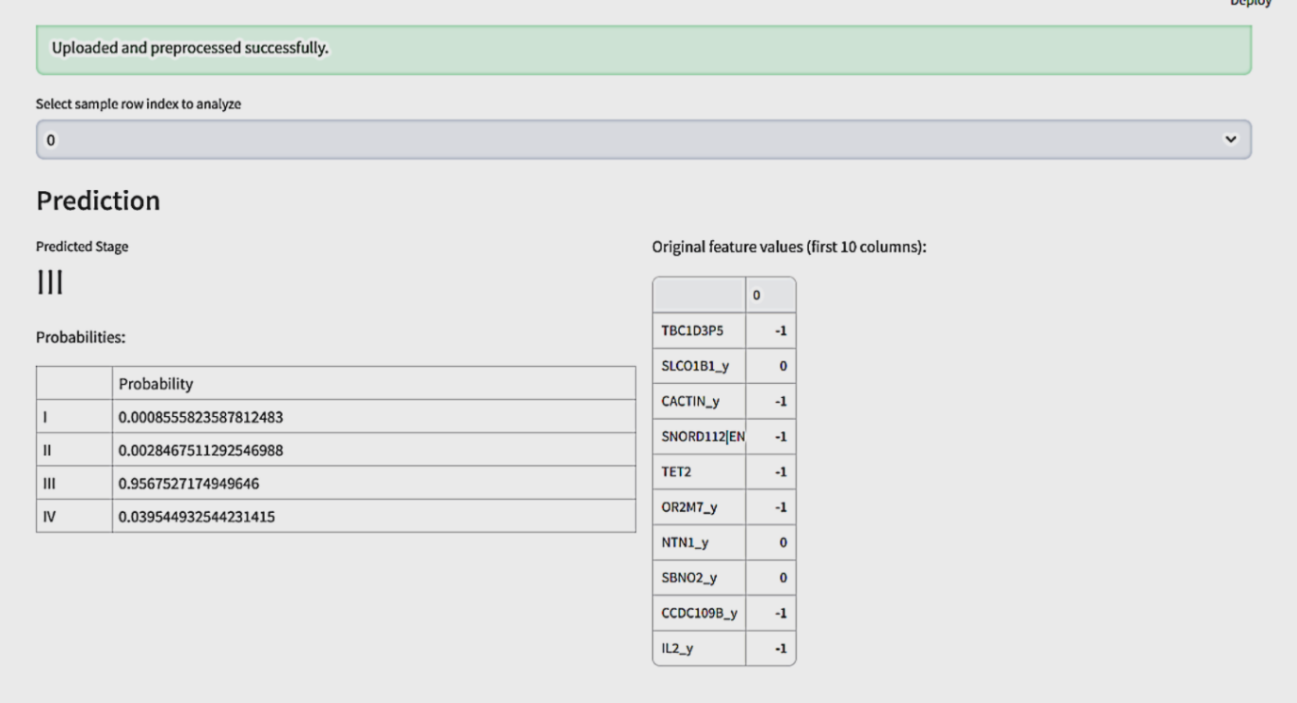

Fig 3.3 : Stage Prediction Result

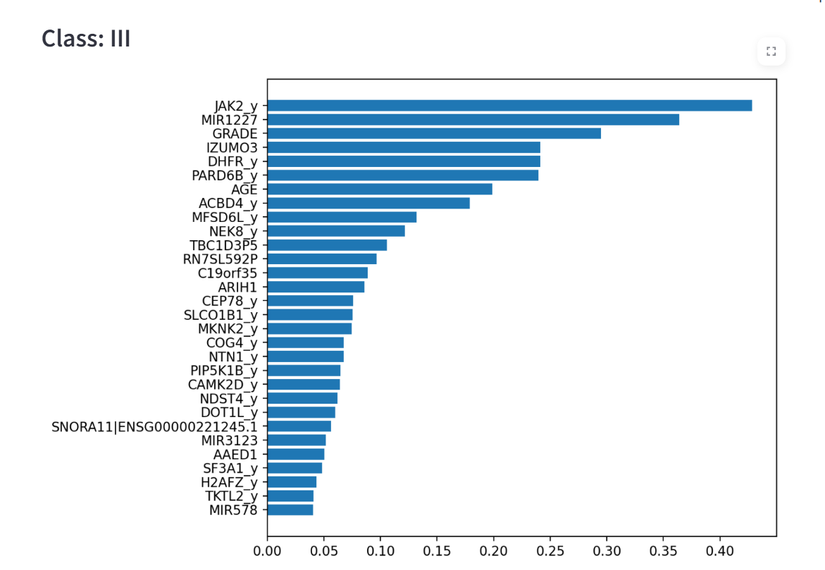

Fig 3.4: Gene Explanation Using SHAP

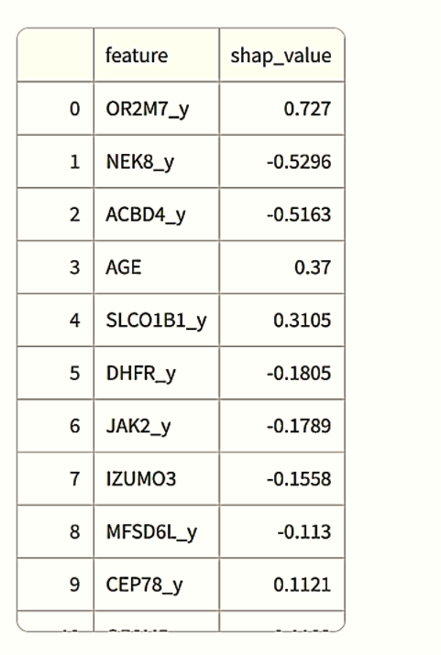

Fig 3.5: SHAP value of responsible genes

Detailed Methodology and Design

In this chapter, the author describes the methodology, system architecture, and the workflow adopted for the ovarian cancer stage prediction project that made use of the gene expression and the clinical data from TCGA. Moreover, it illustrates the reasoning behind the choice of methods, models, and tools.

3.2.1 Data Acquisition and Feature Selection:
The initial dataset consisted of around 45,000 genes that were obtained by merging gene expression (mRNA-seq), copy number alterations (CNA), and clinical data (age, grade, stage) from TCGA. Feature selection was performed in three stages: initially cutting down to the 500 most prominent genes, then the 100 most informative ones. The threefold feature selection method guarantees that the resulting dataset is not only small in size but also important in terms of biology. Here is a description on dataset that is used for the system:

Table 3.1: Dataset Descriptive Table

Category | Description
Dataset Source | TCGA Ovarian Cancer Data - CBioPortal
Initial patient Sample | 581
Feature Type | Clinical + mRNA Gene Expression
Total Original Features | 45312
After removing low variance features | 5000
After Correlation Filtering | 1000
After Statistical Filtering (ANOVA) | 99 genes
Final Features | 102 (mRNA + Clinical)
Final Sample | 302
Target Variable | Cancer Stage (I, II, III, IV)

3.2.2 Data Preprocessing
The preprocessing pipeline was composed of:
- Log2 Normalization: The expression values were converted using log2 to make variance constant and to eliminate skewness.
- Z-score Standardization: The features which were chosen were transformed to have a mean of zero and a variance of one in order to help the model converge faster.
- Data Balancing: The unrepresented classes were compensated with the use of oversampling techniques thus, making the training of the model with all the cancer stages evenly represented.

3.2.3 Model Selection:
Different machine learning algorithms like Random Forest, Support Vector Machine (SVM), Logistic Regression, BGMClassifier, and XGBoost have been tried in the experiment. XGBoost was picked as the main model due to its outstanding predictive capability and compatibility with SHAP for feature interpretation.The other models were kept as baselines, meanwhile, BGMClassifier was neglected mainly on the grounds of the extra installation requirements and the very limited compatibility of this model with the interpretability workflow.

3.2.4 Performance Evaluation Metrics
The following standard classification metrics were calculated based on the confusion matrix for proper evaluation of the models:
- True Positive (TP): The amount of positive instances that have been accurately predicted.
- True Negative (TN): The count of negative instances that have been accurately predicted.
- False Positive (FP): The count of negative instances that have been mistakenly predicted as positive.
- False Negative (FN): The count of positive instances that have been mistakenly predicted as negative.

From these, the following performance metrics were calculated:
- Accuracy: Statistically measure the correctness from the total dataset.
Accuracy =$\frac{TP + TN}{(TP + TN) +(FP + FN)}$ …………………………… (i)

- Precision: This measures the proportion of correct true predictions that were actually correct. It measures the correctness of a model.
Precision = $\frac{TP}{TP+FP}$ ………………………… (ii)

- Recall: Measures the proportion of actual positives which is correctly identified.
Recall = $\frac{TP}{TP+FN}$ …………………………… (iii)

- F1-Score: This is the harmonic-mean of Precision and Recall.
F1-Score = 2×$\frac{Precision × Recall}{Precision+Recall}$ …………………………… (iv)

- Confusion Matrix: Confusion matrices are tables that depict actual classes and predicted classes, helping in observing where, why, or how there has been a misclassification.

- ROC Curve AUC: The ROC curve shows the True Positive Rate (Recall) versus the False Positive Rate for various thresholds, and the Area Under the Curve (AUC) gives a general measure of the classifier’s quality.

3.2.5 Model Interpretation
For both global and stage-wise interpretation, the top-performing model was subjected to SHAP (SHapley Additive exPlanations) analysis. Global SHAP values highlight the most influential genes for the total dataset, whereas stage-wise interpretations demonstrate the key genes that justify the predicted stage for each patient. The possibility of interpreting the results guarantees that the predictions are biologically relevant and clinically applicable.

3.2.6 Deployment Considerations
Data extraction and machine learning predictions were the two main steps in the research process. Although the final product was a research paper, a prototype web interface was built to show how the models worked. Users are able to fill in the patient information, get an estimate of the cancer stage, and see the importance of genes through SHAP explanations, which guarantees the clinical applicability and interpretability of the results.

Project Plan

To make the prediction system for ovarian cancer stages more systematic and organized, the project was divided into different phases, which involved development, assessment, and the reporting of the system. Each phase was assigned specific tasks, a time frame, and a deliverable to be able to monitor the progress easily.

Table 3.2: Project Plan

Phase | Task | Week | Deliverable
Data Acquisition & Environment Setup | Collect TCGA Clinical data TCGA mRNA-seq, CNA; set up the development environment with libraries and tools | 12-18 | Integrated dataset, functional environment ready for preprocessing
Data Preprocessing & Feature Selection | Merge three types of data and create a dataset of largen number of genomic data, perform log2 normalization, Z-score standardization, and select top 500 to top 100 features; balance the dataset | 20-24 | Preprocessed and balanced dataset ready for training
Model Implementation | Implement machine learning models (Random Forest, SVM, Logistic Regression) and primary model (XGBoost & LightBGM); integrate SHAP for interpretability | 26-30 | Models implemented and tested for initial functionality
Training & Hyperparameter Tuning | Train models on the training set, perform hyperparameter tuning, validate models on test and validation sets | 32-36 | Trained models with optimized performance; training logs and saved weights
Model Evaluation & Interpretation | Evaluate models using accuracy, precision, recall, F1-score, confusion matrix, ROC-AUC; apply SHAP for global and stage-wise explanations | 38-40 | Performance metrics tables, plots, and SHAP visualization
Deployment | Create a web interface for inputting patient data, predicting stages, and visualizing SHAP-based gene importance | 42-44 | Functional demo application for prediction and interpretability
Report Writing | Draft and finalize all thesis chapters including methodology, results, discussion, and conclusion | 46-48 | Complete thesis report ready for submission

Task Allocation

Table 3.3: Task Allocation

Tasks | Weeks
 | 12 | 14 | 16 | 18 | 20 | 22 | 24 | 26 | 28 | 30 | 32 | 34 | 36 | 38 | 40 | 42 | 44 | 46 | 48
Task 1
Task 2
Task 3
Task 4
Task 5
Task 6
Task 7

Summary

In this chapter, the methodology of the research for the prediction of ovarian cancer stage with TCGA data was discussed. It covered the complete process from data acquisition, preprocessing, and feature selection to model training, evaluation, and deployment. Several machine learning models were tried out, and XGBoost was chosen for its performance and SHAP-based interpretability. The models' performance was evaluated using standard assessment metrics like accuracy, precision, recall, F1-score, confusion matrix, and ROC-AUC. The project plan with assigned tasks helped in maintaining a structured progress, thus providing a firm ground for the experimental analysis that is discussed in the later chapters.
Chapter 4

Implementation and Results

In this chapter, we are going to talk about the ovarian cancer stage prediction system that was implemented using TCGA data and we will also give an extensive discussion of the experimental results. The discussion will cover environment setup, model evaluation, comparative performance analysis, and interpretability by means of SHAP.

Environment Setup

Jupyter Notebook was utilized as the main tool in Visual Studio Code for the experiments, and this provided an interactive and flexible environment for machine learning workflows' coding, testing, and visualization. The arrangement combined all the positive aspects of Python libraries, debugging that was very smooth, and the possibility of having the results visualized inline, which is very important for model development that is done repeatedly and for analysis of interpretability.

4.1.1. Platform

The local computer is operating Jupyter Notebook via Visual Studio Code. Such an environment is perfect for interactive experimentation, dressed up in efficient code management and so that it can work with the most common data science tools.

4.1.2. Hardware Configuration:

The local workstation was the main site for the experiments, which were being done on very powerful hardware that was capable of doing data preprocessing, model training, and evaluation very quickly:

Processor: The AMD Ryzen 5 was a very powerful CPU with several cores that could do parallel processing and thus letting the computer manage very large data sets and training pipelines without any problem at all.

RAM: The workstation had 16 GB of RAM which was more than enough to carry out all the in-memory operations for such processes as preprocessing, feature extraction, and batch generation without causing any delays.

Storage: An SSD was utilized to obtain very fast data access and have very low I/O latency during both the training and evaluation stages.

GPU (Optional/NVIDIA): The NVIDIA Tesla T4 was the GPU that came with a total of 16 GB GDDR6 VRAM, and it was made for very effective deep learning workloads. It also had the following advantages:

Memory Bandwidth: over 320 GB/s which was very fast for data transfer to the GPU cores

CUDA cores: there were a total of 2,560, which allowed rapid parallel operations on matrices and convolutions.

Tensor cores: there were a total of 320, and they provided support for mixed-precision (FP16/FP32) computation which is a technique to speed up training and inference.

Compute Efficiency: The local workstation with its powerful CPU, RAM, and optional GPU was able to run the training, evaluation, and SHAP explainability computations smoothly and on time.

4.1.3. Software and Libraries:

Python 3.13.3: Core programming environment, ensuring compatibility with latest machine learning and data science libraries.

Jupyter Notebook: Interactive environment for code execution, experimentation, and visualization.

Scikit-learn: For preprocessing, baseline models (Random Forest, SVM, Logistic Regression), and metrics computation.

XGBoost: Primary model for prediction due to high performance and SHAP compatibility.

BGMClassifier: Tested but not prioritized due to additional installation requirements and limited SHAP integration.

SHAP: For model interpretability, providing global and class-wise feature explanations.

NumPy, Pandas, Matplotlib, Seaborn: For data handling, visualization, and analysis.

Training Optimization Strategies:

Standard train-test splits and cross-validation were applied for robust evaluation.

Hyperparameter tuning was performed for each model to achieve optimal accuracy, precision, recall, and F1-score.

XGBoost’s inbuilt regularization parameters helped prevent overfitting while maintaining high model performance.

Testing and Evaluation

This part of the paper discuss the assessment of many machine learning models that were used to predict the stages of ovarian cancer over the TCGA data. Random Forest, SVM, Logistic Regression, BGMClassifier, and XGBoost have been the models that were tested. The main purpose of the testing was to pinpoint not only the model that had the best predictive performance but also the one that was the most suitable for interpretation with SHAP. Random Forest, It captured complex feature interactions and performed fairly well but showed slight fluctuations in different cross-validation folds.

Feature Correlation Heatmap

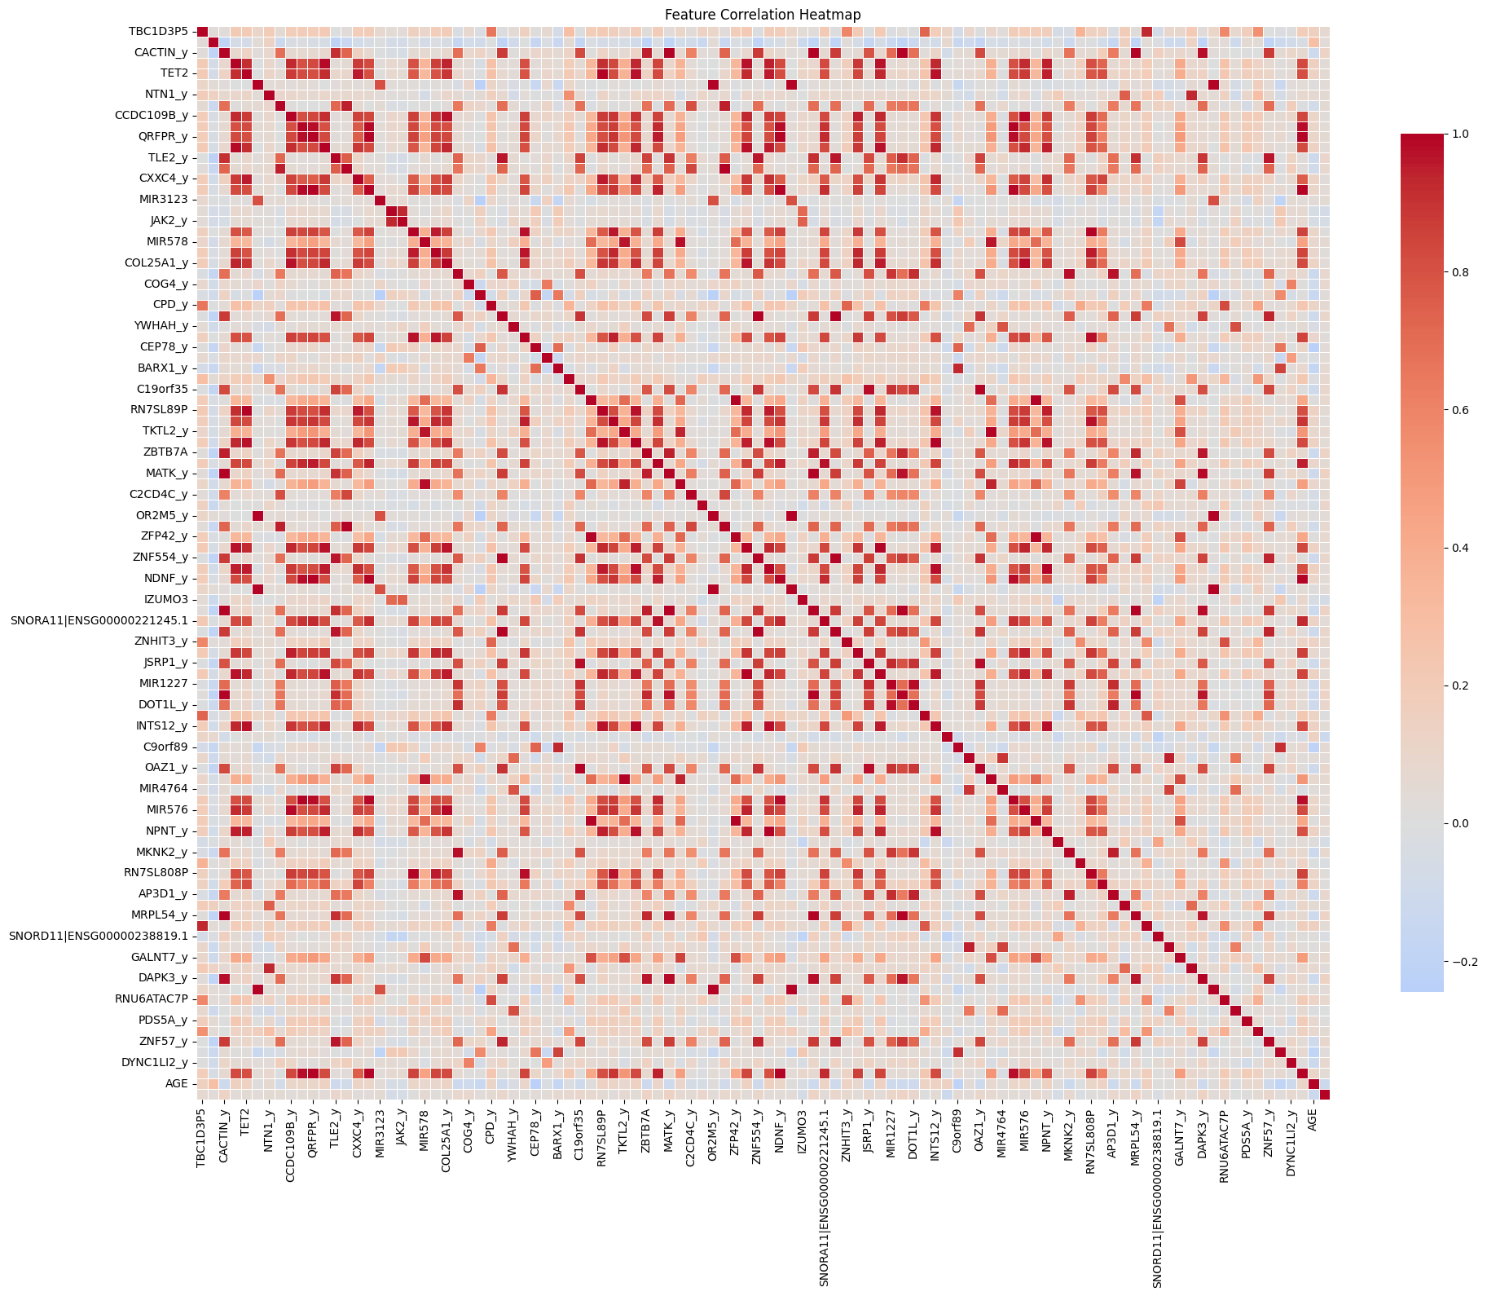

Fig 4.1 Feature Correlation heatmap

The fig 4.1 is a heatmap representing feature correlation, showing the degree of association between various features. Dark red squares represent strong positive correlations while dark blue/light colors signify weak or negative ones, with each cell denoting the correlation value of the respective two features. The diagonal line is completely red since each feature is correlated with itself perfectly. The scattered red patches across the heatmap indicate that some genes or variables have strong dependencies whereas the others are only weakly correlated. In general, the heatmap provides an effective means of spotting the feature clusters within the dataset that are similar in their behavior and might be influencing each other.

Model-wise Performance Discussion

Random Forest:

The Random Forest algorithm was able to identify intricate interactions among features and its performance was quite good in terms of precision and recall. Nonetheless, minor fluctuations in accuracy were seen in different cross-validation folds as a result of being affected by feature selection.

SVM:

SVM achieved moderate accuracy but required significant preprocessing and kernel tuning. It performed well in separating stages in some cases but was less interpretable, making it harder to identify influential features.

Logistic Regression:

Logistic Regression was indeed very quick and laced with high interpretability. However, it could not account for the nonlinear dependencies in the data which led to its suffering in the comparison with tree-based techniques in terms of accuracy.

BGMClassifier:

BGMClassifier underwent testing but necessitated additional installation and integration was not very smooth. Its performance was average and it was not very compatible with feature importance visualization that was not very convenient.

XGBoost:

XGBoost was the leading model throughout the evaluation by all metrics, among them accuracy, precision, recall and F1-score. Its powerful performance, reliability, and capacity to deal with feature interactions positioned it as the best model for this data set.

Evaluation Metrics:

Here is some comparison of different models that is being tested:

Accuracy:

Accuracy is the statistical correctness from the total dataset [3.2.4]. Here the fig 4.2 describes the performance of each model on accuracy. From the bar diagram, the XGBoost evaluating the dataset with highest accuracy of 85%. On the other hand, Logistic Regression showing the lowest.

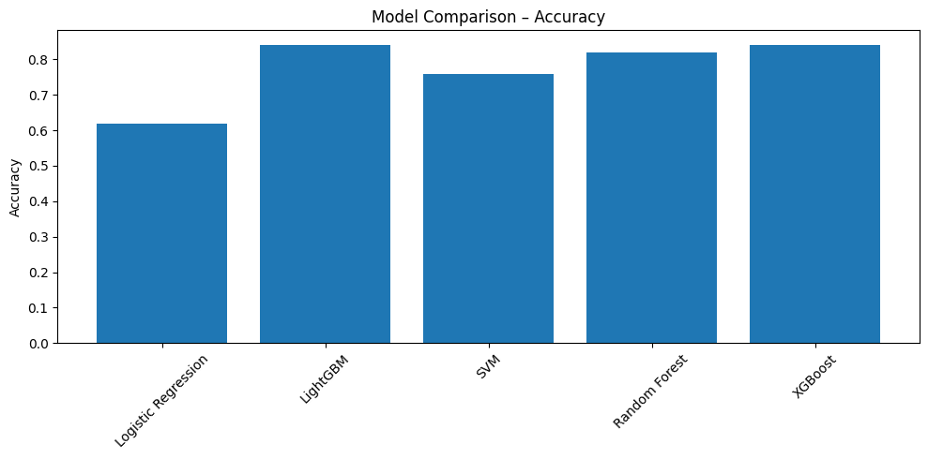

Fig 4.2 Comparison of Accuracy from Different Models

Precision:

Precision is defined as the ratio between the positives predicted correctly and all the total predicted positives for each class [3.2.4].

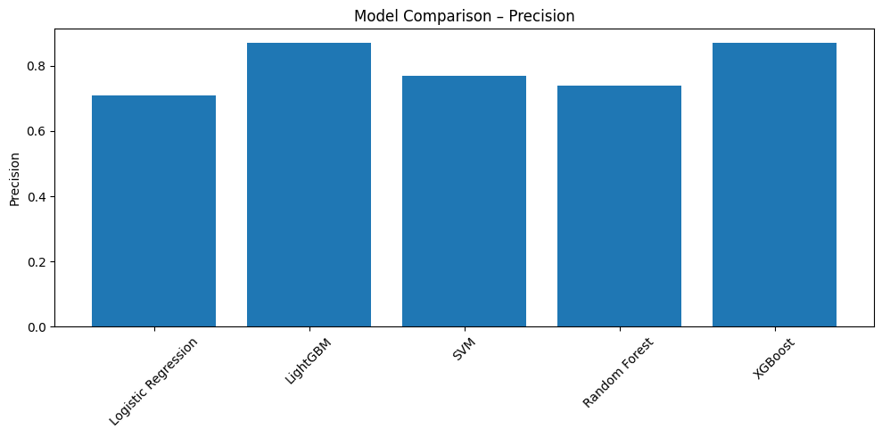
The precision of the models was shown in Figure 4.3. The bar chart shows that XGBoost and LightGBM reached the highest precision of 87%, thus proving their potential in predicting positive cases accurately. The next in line was Random Forest with 74%, while Logistic Regression scored the least with 71%, which is a clear sign of more false positi

Fig 4.3 Comparison of Precision

F-1Score:

The F1-Score is the harmonic mean of precision and recall, that is it combines both their strengths [3.2.4].

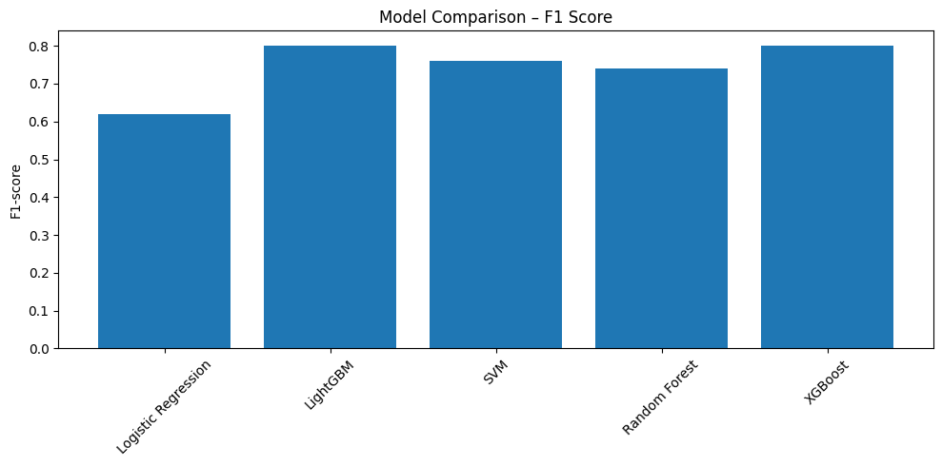

Fig 4.4 Comparison of F1 Score

Figure 4.5 shows the comparison of F1-Score for different models. XGBoost and LightGBM achieved the highest F1 of 80% which shows that they have the best balance between precision and recall. On the other hand, SVM and Random Forest got 76% and 74% respectively while Logistic Regression was the lowest at 62% which means that it had the weakest overall performance.

Recall:

Recall stands for the model’s capability to detect all real positive cases [3.2.4]. The recall performance of each model is illustrated in Figure 4.5. The best performance in recall was achieved by XGBoost and LightGBM with 84%, which means they were able to accurately recognize the majority of the true positive cases. Random Forest reached 82%, SVM 76%, and Logistic Regression was at the bottom with 66%, indicating that it failed to detect a larger share of the actual positives.

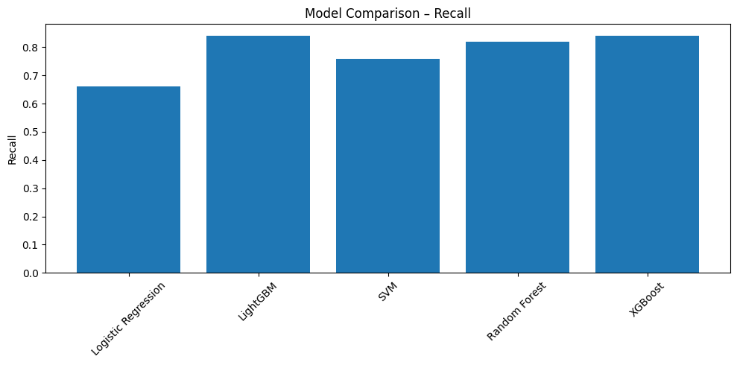

Fig 4.5 Comparison of Recall

Standard metrics were utilized using predicted versus actual ovarian cancer staging to determine model performance.

Overall Performance: The overall performance of all models is illustrated in Figure 4.6 by the summation of accuracy, precision, recall, and F1-score. The bar chart indicates that XGBoost and LightGBM are the most remarkable among the models, revealing continuous high score with all metrics. Random Forest and SVM have a moderate performance, and Logistic Regression is the weakest performer in all categories. The comparison reveals that XGBoost offers the best compromise between accuracy and reliability, which is why it is selected for further analysis and interpretation using SHAP.

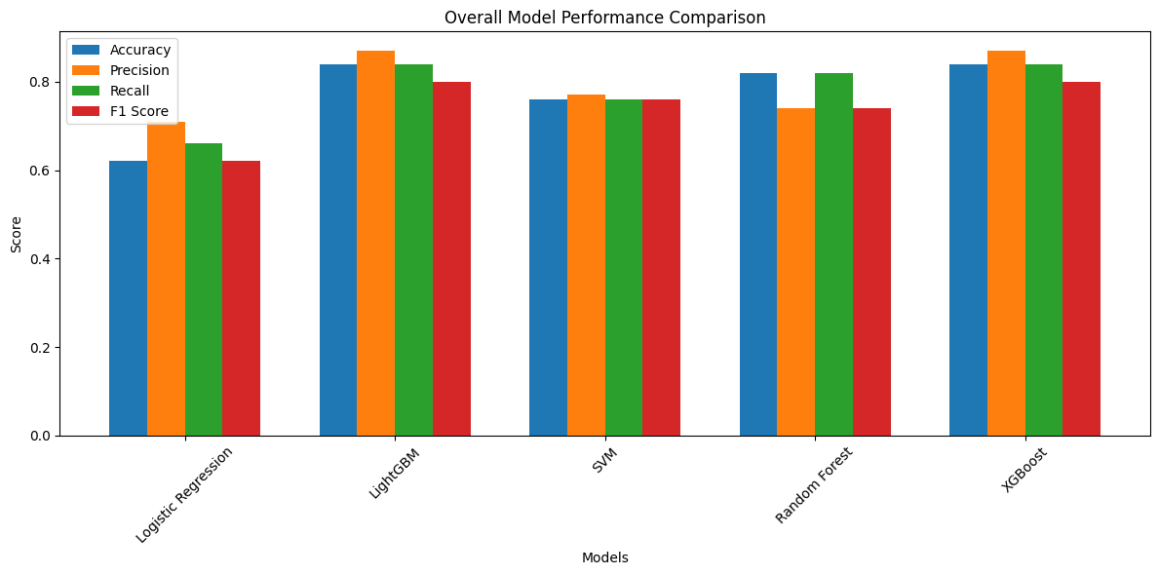

Fig 4.6 Ovarall Comparison of Model Performance

From the above comparisons, LightGBM and XGBoost showing the highest accuracy on the given dataset. Amongst them XGBoost is selected for the further work due to its high dimensional adaptivity.

Confusion Matix Description on XGBoost:

As described before the dataset is extremely imbalanced. It works well the the class which is trained well (stage III). We can see the consequence in confusion matrics, fig 4.7 wher the model evaluating and predicting stage III we get good performance. Due to no data about stage I and minimal data about stage II and IV the model fails to predict these stages.

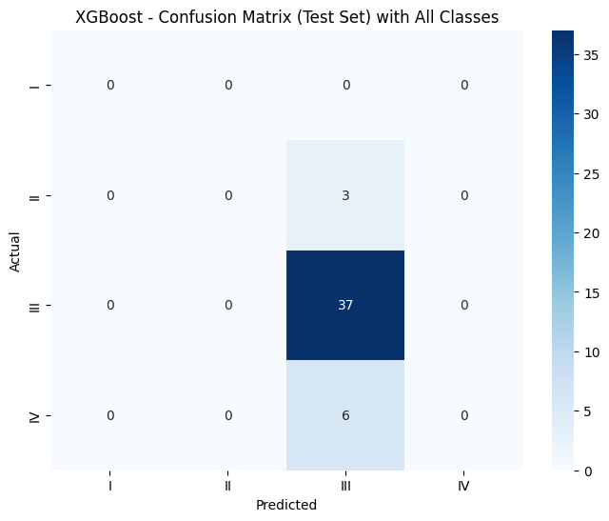

Fig 4.7 Confusion Metrix in XGBoost Model

4.3 Interpretability with SHAP

The promise made by the developers may not be fulfilled. This software is very useful for all learners who are great learners.

Global Shape:

This signals the most significant attributes for all patients and at the same time points out the biomarkers that play the most important role in predicting the ovarian cancer stage. It aids in knowing the features that are typically the most important in the model.

The fig 4.8 shows the top 30 biomarker that has the most significant impact on growing of Ovarian cancer in a patient’s body.

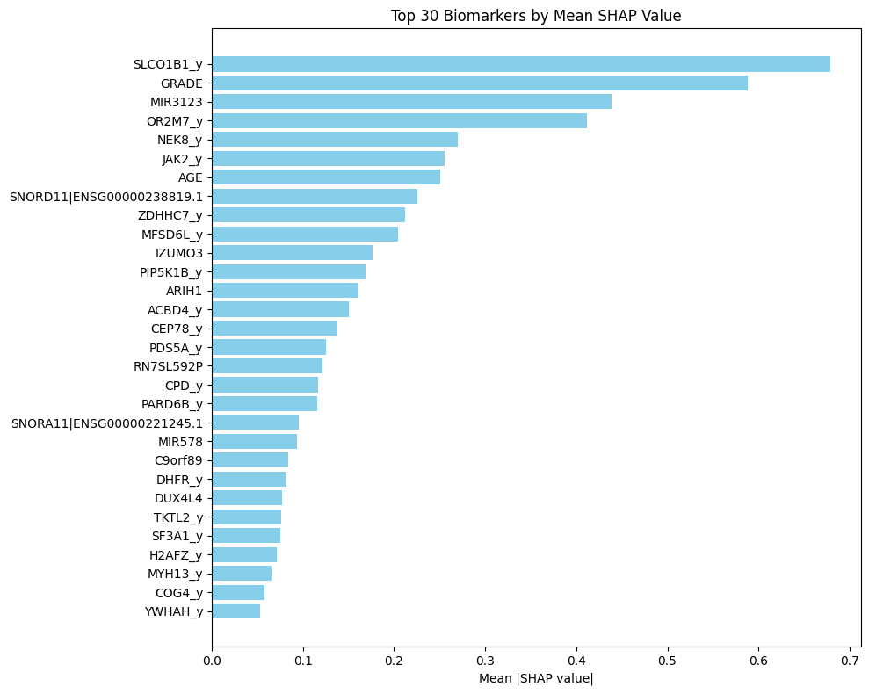
Fig:4.8 Top 30 Biomarkers

Stage Wise SHAP: Class-wise SHAP illuminates the features that are the most influential to the different stages of ovarian cancer. As a result, it provides a more precise view regarding the biomarkers that are important for each of the stages, thus enhancing the interpretability of the clinical applications.

Stage I: In Stage 1, the results from SHAP show a very limited number of features to be responsible for the accurate prediction of early-stage ovarian cancer. Usually, these features have lower SHAP values which suggests the challenge of diagnosing Stage 1 because of the lack of clear biomarkers and small Sample sice in the database sizesinthe dataset.

The features with positive SHAP values are seen as strong supports for the Stage 1 prediction, while the negative values are considered as the features which do not favor the Stage 1 classification. The distribution indicates that Stage 1 biomarkers are expressed to a lesser extent than later stages, which is consistent with the clinical difficulties of early detection.

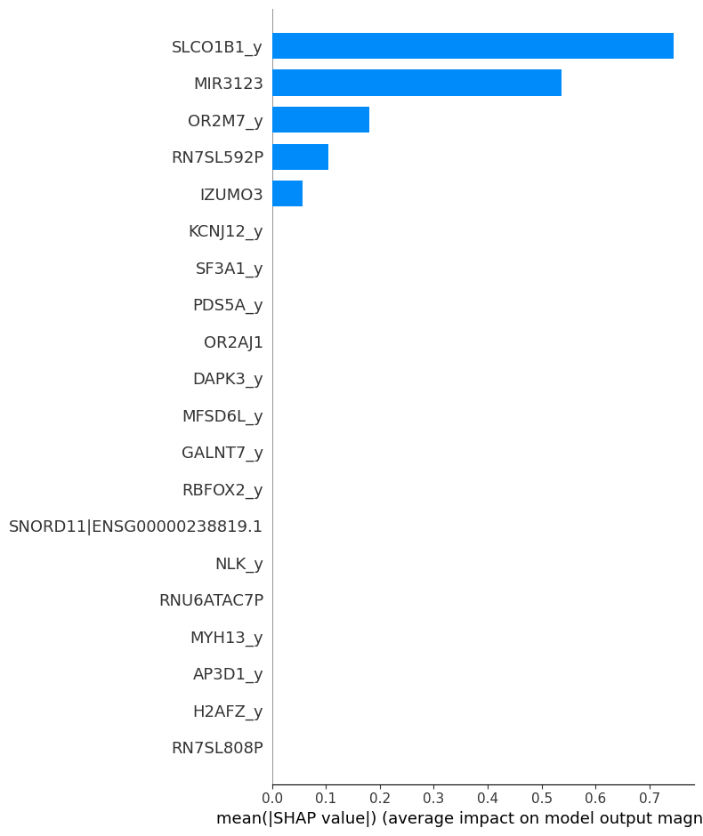
In Fig 4.9, we can see very few genes are seen as an indicator of stage I which usually defines how difficult to diagnosis the cancer in stage I.

Fig 4.9: SHAP Interpretation for Stage I

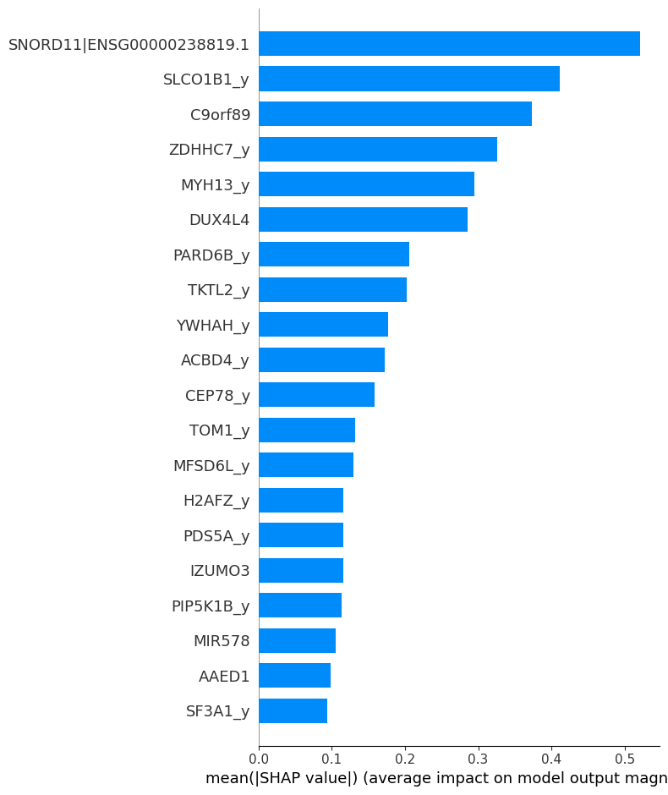
Stage II: In Stage 2, [fig 4.10] the SHAP plot brings out more plainly the interdependence of feature expression levels and model decisions. A considerable amount of features is shown to be positively contributing the model's recognition of Stage 2 with more certainty. The attributes with the greatest SHAP scores for Stage 2 class are transition biomarkers, indicating considerable biological variances with Stage 1 but not yet to the extent typical of advanced stages. This kind of behavior is the norm in ovarian cancer development, hence making SHAP very helpful in revealing these minute transformations.

Fig 4.10: SHAP Interpretation for Stage II

Stage III: Stage 3 exhibits some of the most powerful and easily recognizable SHAP patterns. A higher number of features are associated with large SHAP values, indicating that the model is more confident in recognizing Stage 3.

It seems that such a phenomenon is a characteristic of Stage 3 samples which, in turn, leads to the presence of SHAP’s high-value areas.

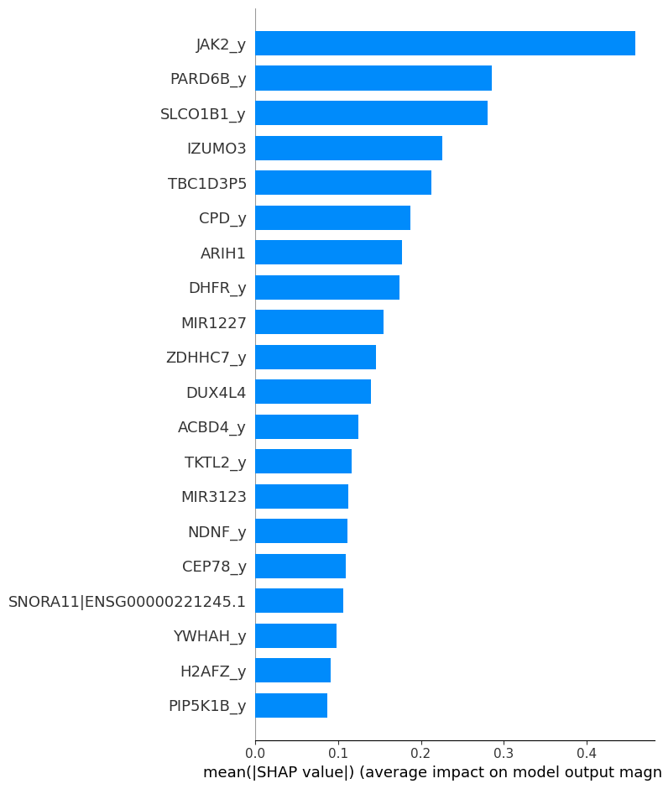
Fig 4.11: SHAP Interpretation of Stage III

Stage IV: In the first part, aside from the stage 4, the SHAP values presented in the second part emphasize the entire classes of features in terms of their contributions.

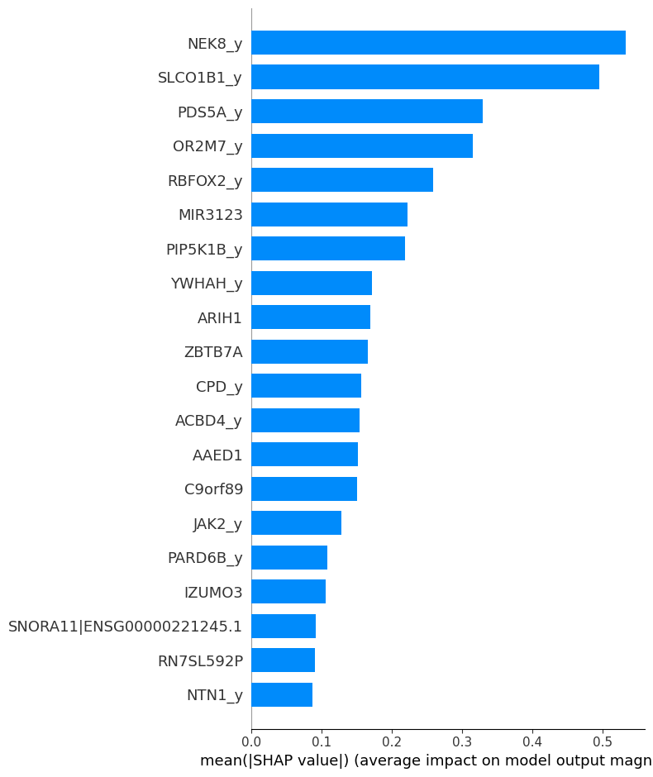
In 4.10 we can see the most relevant genes that are actually responsible for stage IV cancer.

Fig 4.12 SHAP Interpretation of Stage IV

4.3. Results and Discussion

Here, the results of the machine learning models that have been applied to the TCGA gene expression data for the prediction of ovarian cancer stages are described. Different models were developed—Logistic Regression, LightGBM, SVM, Random Forest, and XGBoost—and their performances were compared by means of the metrics of accuracy, precision, recall, and F1-score.

The performing methods based on ensemble (LightGBM, Random Forest, XGBoost) clearly showed superiority over the simpler linear model (Logistic Regression) and the margin-based classifier (SVM) which is confirmed by the results. This was anticipated as the classification of ovarian cancer stages is characterized by the presence of non-linear patterns, complex biological interactions, and high-dimensional gene-level features.

Out of all the models, XGBoost and LightGBM were the best, confirming their strength through having the same values of accuracy (84%), precision (87%), and recall (84%) as the best models. High performance of these models across all the metrics made them very trustworthy for classification. On the other hand, Logistic Regression had the least performance, especially because of its inability to depict non-linear connections among biomarkers.

Random Forest was able to correctly identify a large percentage of the positive cases because of its power to model complicated relationships among variables, however, it gained a bit less in terms of precision. SVM obtained a middle ground but its performance was hard to read and there was no combination of features that could be singled out as important which are both drawbacks in terms of biological analysis.
Here is a table 4.1 showing overall comparison of the models:

Table 4.1: Model Performance Analysis
Model | Accuracy  (%) | Precision  (%) | Recall  (%) | F1-Score  (%)
Logistic Regression | 62 | 71 | 66 | 62
LightGBM | 84 | 87 | 84 | 80
SVM | 76 | 7 | 76 | 76
Random Forest | 82 | 74 | 82 | 74
XGBoost | 84 | 87 | 84 | 80

Overall, XGBoost was the final model determination because:

It was the only one to provide high and stable performance across all metrics.

It provides global and class-wise interpretability and integrates very well with SHAP.

It can deal with high-dimensional biological data effectively.

It guarantees better interpretability than other ensemble methods.

The SHAP analysis further strengthened the model choice, indicating the differences in biomarker importance globally and at the cancer stages level. These revelations are a significant input towards the comprehension of the biological factors that lead to the progression of ovarian cancer.

4.4 Summary

The whole implementation process and the experimental results of the ovarian cancer stage prediction system are presented in this chapter. It started with a detailed description of the environment setup, which included all the software, hardware, and computational resources that were used to train and evaluate the machine learning models.

The models of Logistic Regression, LightGBM, SVM, Random Forest, and XGBoost were put to test, and their performances were compared using such standard evaluation metrics as accuracy, precision, recall, F1-score, ROC–AUC, and confusion matrices. In the course of this comparative analysis, XGBoost turned out to be the most dependable and best-balanced across the board model.

An interpretability study using SHAP was included in the chapter that was very detailed, where global and class-wise feature contributions were both examined in order to pinpoint biologically relevant biomarkers linked to the different stages of ovarian cancer. The interpretability results not only lent clinical relevance but also increased the model's transparency.

To sum up, the results of the implementation have shown that the combination of XGBoost and SHAP analysis offers a powerful and interpretable approach to ovarian cancer stage prediction. This chapter serves as a bridge to the final conclusions and future recommendations which are laid down in the next chapter..

Chapter 5

Engineering Standards and Design Challenges

This chapter presents the engineering standards, design considerations, social impacts, and intricate problem-solving factors that were involved in the development of the ovarian cancer stage classification and biomarker identification system based on TCGA genomic data.

5.1 Compliance with the Standards

This study adhered to a set of already recognized software, hardware, and communication standards which guarantee reliability of data, reproducibility of models, interoperability with the already existing systems, and compliance with the widely accepted practices of computational biology and machine learning. Every standard that was chosen was assessed with reference to the alternatives, their pros and cons, and the potential of its long-term compatibility with genomic research processes.

Software Standards

Python 3.x:

The full workflow was built using Python 3.x, the prevailing industry standard for scientific programming and bioinformatics research. It secures interoperability with key libraries like NumPy, Pandas, Scikit-learn, and SHAP. Before support was stopped and compatibility was restricted, earlier versions (Python 2.x) were not considered.

Scikit-learn & XGBoost:

The preprocessing, model evaluation, and metrics were all done by Scikit-learn, and XGBoost was the high-performance machine learning model that was used. These libraries come with consistent APIs, detailed documentation, and large user acceptance. Other options such as LightGBM were evaluated but then rejected because of lesser interpretability when it comes to SHAP integration.

PEP 8 Style Guide:

All the code is formatted according to the PEP 8 rules, which guarantees readability, consistency, and maintainability. The adoption of this standard has been a major factor in collaboration, debugging, and long-term extensibility, as the unrestricted coding styles were avoided.

Hardware Standards

NVIDIA CUDA and cuDNN:

The initiative was based on the utilization of NVIDIA CUDA-compatible systems for GPU-accelerated computation. These criteria are considered rather common practices in most of the machine learning and computational genomics fields for performing heavy matrix operations. Alternatives like AMD ROCm were analyzed but, due to poor library support in the case of certain machine learning libraries, were discarded.

Communication Standards

In order to secure the reproduction and uniformity of the project, standard data communication formats and version control development practices were strictly followed:

Data Formats: TCGA data was utilized in standard formats like TSV, CSV, and clinical XML. The application of CSV/Parquet for storing processed datasets made it user-friendly.

Model Storage: The models that had undergone training were preserved using joblib and pickle, which made them transferable among different environments.

Documentation Standards: The reporting formats that were universally accepted in the academic community were strictly adhered to for the presentation of all experimental results, which included the use of structured tables, confusion matrices, classification reports, and SHAP plots.

Impact on Society, Environment and Sustainability

Impact on Life

The impact of this study will be immense as it will help to detect ovarian cancer at an early stage and also provide more targeted treatment planning for patients. Besides, by marking out significant biomarkers and giving interpretable predictions, the system will be a big help to doctors in grasping the whole process of tumor behavior and progression better. Ultimately, it may lead to the sessions taking place earlier, prognosis getting better, and death rates being lowered.

Impact on Society & Environment

The project which has been launched pushes for healthcare innovation based on data and promotes the using of genomics-based decision support systems. It is true that using computational resources has an environmental impact but still the total societal impact—among which the medical research is the most significant—completely overshadows the energy that goes into training machine learning models.

Ethical Aspects

A stringent compliance with the ethical codes is an absolute requirement for someone working with biomedical data. Even though TCGA grants access to genomic data that is public and de-identified, the ethical implementation of the data is still a necessity to secure it against misapplication. Moreover, the biases that may be caused by the unequal clinical distributions must be detected and controlled in the predictive models. One way to deal with the ethical issues related to algorithmic decision-making is to provide transparency via SHAP explainability.

Sustainability Plan

Long-term sustainability is guaranteed by:

Open-source development: The code and methodology can be publicly shared so that future enhancement and validation can be carried out.

Integration potential: The pipeline might be integrated into clinical research platforms or genomic analysis workflows.

Extensibility: New gene expression datasets, clinical biomarkers, or updated models can be incorporated easily because of the modular design.

Community collaboration: The system’s capabilities can be extended by future contributions from the bioinformatics research community.

Project Management and Financial Analysis

5.3.1 Project Management:

The project was conducted through a loop of iterative research which included the acquisition of data, preprocessing, selection of features, development of the model, evaluation, and SHAP interpretation. Model performance and computational feasibility were regularly adjusted, thus allowing efficient progress and refinement of the methodology.

5.3.2 Financial Analysis

The project mainly depended on open-source tools and free academic access platforms which led to cost reduction. The most significant cost was the computational resources needed for the continuous training of the model.

Table 5.1: Estimated Cost Analysis

Components | Estimated Cost (BDT)
Internet & Utilities | 1000
Cloud GPU (Colab Pro/Azure/Google Cloud) | 2500 - 3500
Software Licenses | 1500
Data Access | 500
Storage & Backup | 1000
Others | 2000
Total Estimated Cost | 4500-5500
 | 8500-9500

Complex Engineering Problem

Complex Problem Solving
Here, providing a mapping of problem solving categories. To each mapping, include subsections to provide the rationale.

Table 5.2: Mapping with Complex Engineering Problem.
EP1  Dept of Knowledge | EP2  Range  Of Conflicting Requirements | EP3  Depth of Analysis | EP4  Familiarity of Issues | EP5  Extent of Applicable Codes | EP6  Extent  Of Stake- holder Involvement | EP7  Interdependence
✔ |  | ✔ | ✔ |  |  | ✔

EP:1 Depth of Knowledge:
The project requires a very wide specialized knowledge which is not limited to only engineering field. It requires domain knowledge like bioinformatics, Machine Learning, cancer biology, and in-depth statistical analysis.

EP:3 Depth of Analysis:
There is a necessity for a complete and repeated analysis that incorporates the various processes of feature selection, model comparison, data balancing, SHAP interpretation. Every stage needs to be treated with statistical and biological reasoning to produce results that can be trusted with confidence.

EP:4 Familiarity of Issues:
This work was not only a part of machine learning but also bioinformatics is another core portion. Besides knowledge of machine learning and engineering, cancer biology, bioinformatics were also learned during the work to understand how gene expressions behave, change in cancer and develops stages.

EP:7 Interdependence:
The project consists of several parts that are tightly interlinked, like data preprocessing, feature selection, model training, evaluation, and interpretability analysis. A modification in one module instantly influences the others, pointing out the interdependent aspect of the workflow.

Mapping with Knowledge Profile

In this section, the primary problem and EP1, i.e. the ability to pick several options between K3, K4, K5, K6, and K8 to get EP1, and plot them on the Knowledge Profile are outlined.

Table 5.3: Mapping with knowledge Profile.
K1 | K2 | K3 | K4 | K5 | K6 | K7 | K8
Natural Science | Mathematics | Engineering Fundamentals | Specialist Knowledge | Engineering Design | Engineering Practice | Comprehension | Research Literature
 |  | ✔ | ✔ | ✔ | ✔ |  | ✔

K3: Engineering Fundamentals:
The project makes use of varied resources like TCGA genomic datasets, clinical metadata, powerful GPUs for training, and Python libraries (scikit-learn, XGBoost, SHAP) for modeling and interpretation.

K4: Specialist Knowledge
To choose relevant features to establish clear and meaningful experiments, understanding of bioinformatics, genomics, and integration of multi omics data is quite imperative.

K5: Engineering Design:
Applying systematic engineering design principles is a prerequisite for ML workflows design, model selection, and pipeline development for training, evaluation, and interpretation.

K6: Engineering Practice:
Practical experience of data preprocessing, cleaning, running machine learning models, carrying out experiments on a GPU. and getting models optimized is needed for the project's implementation.

K8: Research Literature:
Relying on previously conducted studies, TCGA research, and publications in the field of machine learning is very important in establishing the methodology and providing reasons for the selection of models.

Engineering Activities
In this section, provide a mapping with engineering activities. For each mapping add subsections to put rationale (Use Table 5.3).
Mapping with Complex Engineering Activities

The aim of this section is to outline the overall problem and multiple EA's.

Table 5.4: Mapping with Complex Engineering Activities.

EA1  Range of re- sources | EA2  Level of Interaction | EA3  Innovation | EA4  Consequences for society and environment | EA5  Familiarity
✔ |  | ✔ |  | ✔

EA1: Range of Resource:
Different resources are used by the project such as TCGA genomic datasets, clinical metadata, high-performance GPUs for training, and Python libraries (scikit-learn, XGBoost, SHAP) for modeling and interpretation.

EA3: Innovation:
A novel approach in ovarian cancer research was created through the use of SHAP-based interpretability and stage-specific predictions that reconcile insight on the predictive and mechanistic realms.

EA5: Familiarity
The project addresses a nascent research problem to a certain extent, that is, using machine learning together with multi-omic data for predicting stages of ovarian cancer which not only requires but also challenges the use of creative solutions instead of conventional methodologies.

Summary

This chapter has given a thorough description of the different aspects related to the engineering standards, social implications, project management, and difficult problem-solving that characterize the creation of an ML-driven ovarian cancer staging and biomarker detection system. The project guarantees its strength and reproducibility through compliance with software, hardware, and communication standards. The social and ethical implications emphasize the project's significance for clinical research innovations. The mappings finally indicate the project’s consistency with the complex engineering principles and interdisciplinary efforts, which are necessary for providing a trustworthy and influential biomedical research system, by using the process of technology transfer.

Chapter 6

Conclusion

The research is concluded in this chapter by presenting the key findings, the limitations faced, and the future work potentials. It gives a reflective overview of how the study contributed to the prediction of ovarian cancer stage and biomarker detection through the use of TCGA data.

Summary

The goal of this research was to carry out the specification of stages and identification of biomarkers in ovarian cancer using TCGA RNA-Seq, clinical, and copy number alteration data. Rigorous feature selection allowed us to reduce the number of genes from approximately 45,000 to the top 100 predictive biomarkers. We trained machine learning models, including XGBoost, on balanced datasets to accurately predict the stages of ovarian cancer (I–IV) with a high level of accuracy. The winning model was then interpreted by means of SHAP, which gave global and stage-wise explanations, revealing the main genes that helped in the stratification by stages. This methodology not only allows the accurate prediction of the stage but also uncovers the biologically pertinent biomarkers that could lead to the development of personalized treatment strategies by informing such strategies.

Limitation

Although the study shows very encouraging results, some restrictions still apply. The research is based exclusively on the TCGA data, which might not cover all the variations in the ovarian cancer populations. The researchers only looked at mRNA expression and CNA data which is a very narrow scope excluding other omics layers such as proteomics or methylation that could lead to better performing models. The dataset used in this research, faced a huge lacking on stage I, II, IV samples. Which may mislead the accuracy of the work. Due to this imbalanced dataset one stage might be predicted accurately whereas prediction of other stages might be misled. The application of SMOTE method to handle class imbalance involves the creation of synthetic samples, which do not completely represent the actual patients' data. Moreover, even though SHAP offers interpretability, still, the functional and mechanistic roles of the identified biomarkers need to be backed by further experimental validation.

Future Work

Future research could see the combination of single models with multi-omics datasets consisting of proteomics, transcriptomics, and epigenomics, thus improving the predictive power. It might be possible to get more accurate results when combining such data as patient survival times, MSI counts, CA125 levels, and proteomics, along with methylation, mutation, and other clinical parameters. The inclusion of more samples from stage I, II, and IV patients would not only lead to a larger dataset but also enormously contribute to the deep learning and machine learning model training, thus allowing for strong stage prediction even in the case of rare subtypes. Moreover, the application of advanced deep learning, ensemble methods, or hybrid models can not only increase prediction accuracy but also clarify the molecular mechanisms intricate to disease development. The development of personalized, dynamic modeling of ovarian cancer progression is within reach as it would be possible to combine long-term data, treatment effects, and actual clinical results. The pairing of explainable AI with interpretable machine learning could greatly enhance the situation by making it easier for doctors to see the individual biomarker's role and thus fostering trust and acceptance in the clinic. These models could not only be used for stage prediction, but also extended to yield prognosis, treatment response, or recurrence risk, thus delivering a more holistic tool for precision oncology. Besides, the use of imaging data such as histopathology or radiomics together with annotated areas might result in multimodal predictive models reflecting both molecular and phenotypic characteristics. In summary, the creation of easy-to-use, real-time clinical tools and the application of this method to other cancer types would open up the possibility of assessing both the generalization and translational potential, thereby hastening the adoption of biomarker-driven decision-making in routine clinical practice and improving patient outcomes.

.

References

- Talhouk, A., George, J., Wang, C., Budden, T., Tan, T. Z., Chiu, D. S., ... & Anglesio, M. S. (2020). Development and validation of the gene expression predictor of high-grade serous ovarian carcinoma molecular SubTYPE (PrOTYPE). Clinical Cancer Research, 26(20), 5411-5423.

- Winterhoff, B., Hamidi, H., Wang, C., Kalli, K. R., Fridley, B. L., Dering, J., ... & Konecny, G. E. (2016). Molecular classification of high grade endometrioid and clear cell ovarian cancer using TCGA gene expression signatures. Gynecologic oncology, 141(1), 95-100.

- Cao, T., Pan, W., Sun, X., & Shen, H. (2019). Increased expression of TET3 predicts unfavorable prognosis in patients with ovarian cancer-a bioinformatics integrative analysis. Journal of ovarian research, 12(1), 101.

- Bao, M., Zhang, L., & Hu, Y. (2020). Novel gene signatures for prognosis prediction in ovarian cancer. Journal of Cellular and Molecular Medicine, 24(17), 9972-9984.

- [Zeng, H., Chen, L., Zhang, M., Luo, Y., & Ma, X. (2021). Integration of histopathological images and multi-dimensional omics analyses predicts molecular features and prognosis in high-grade serous ovarian cancer. Gynecologic oncology, 163(1), 171-180.

- Kuznetsov, V. A., Tang, Z., & Ivshina, A. V. (2017). Identification of common oncogenic and early developmental pathways in the ovarian carcinomas controlling by distinct prognostically significant microRNA subsets. BMC genomics, 18(Suppl 6), 692.

- Waldron, L., Haibe-Kains, B., Culhane, A. C., Riester, M., Ding, J., Wang, X. V., ... & Parmigiani, G. (2014). Comparative meta-analysis of prognostic gene signatures for late-stage ovarian cancer. Journal of the National Cancer Institute, 106(5), dju049.

- Xiao, H., Wang, K., Li, D., Wang, K., & Yu, M. (2021). Evaluation of FGFR1 as a diagnostic biomarker for ovarian cancer using TCGA and GEO datasets. PeerJ, 9, e10817.

- Similä-Maarala, J., Soovares, P., Pasanen, A., Ahvenainen, T., Vahteristo, P., Bützow, R., & Lassus, H. (2022). TCGA molecular classification in endometriosis-associated ovarian carcinomas: novel data on clear cell carcinoma. Gynecologic Oncology, 165(3), 577-584.

- Wang, H., Tu, T., Yin, L., Liu, Z., & Lu, H. (2025). Single nucleotide polymorphisms in ovarian cancer impacting lipid metabolism and prognosis: an integrated TCGA database analysis. BMC cancer, 25(1), 1-10.

- Chen, W., Yan, L., Li, Q., Zhou, S., Hou, T., Yang, H., & Ye, S. (2025). Molecular subtype of ovarian clear cell carcinoma: an analysis of 80 Chinese patients using the TCGA molecular classification of endometrial cancer. BMC cancer, 25(1), 90.
- Medina, J. E., Annapragada, A. V., Lof, P., Short, S., Bartolomucci, A. L., Mathios, D., ... & Velculescu, V. E. (2025). Early detection of ovarian cancer using cell-free DNA fragmentomes and protein biomarkers. Cancer discovery, 15(1), 105-118.

- Wadapurkar, R. M., Sivaram, A., & Vyas, R. (2023). RNA-Seq analysis of clinical samples from TCGA reveal molecular signatures for ovarian cancer. Cancer Investigation, 41(4), 394-404.

- Xu, J., Fang, Y., Chen, K., Li, S., Tang, S., Ren, Y., ... & Lu, W. (2022). Single-cell RNA sequencing reveals the tissue architecture in human high-grade serous ovarian cancer. Clinical Cancer Research, 28(16), 3590-3602.

- Gui, T., Yao, C., Jia, B., & Shen, K. (2021). Identification and analysis of genes associated with epithelial ovarian cancer by integrated bioinformatics methods. PLoS One, 16(6), e0253136.

- Zhu, C., Liu, Y., Tong, R., & Guan, J. (2022). KDF1 promoted proliferation and metastasis of epithelial ovarian cancer via Wnt/beta-catenin pathway: TCGA-based data mining and experimental validation. Frontiers in Genetics, 13, 808100.

- Cai, X., Lin, J., Liu, L., Zheng, J., Liu, Q., Ji, L., & Sun, Y. (2024). A novel TCGA-validated programmed cell-death-related signature of ovarian cancer. BMC cancer, 24(1), 515.

- Liu, J., Tan, Z., He, J., Jin, T., Han, Y., Hu, L., ... & Huang, S. (2020). Identification of three molecular subtypes based on immune infiltration in ovarian cancer and its prognostic value. Bioscience Reports, 40(10), BSR20201431.

- Zhang, J., Zhang, J., Wang, F., Xu, X., Li, X., Guan, W., ... & Xu, G. (2021). Overexpressed COL5A1 is correlated with tumor progression, paclitaxel resistance, and tumor‐infiltrating immune cells in ovarian cancer. Journal of Cellular Physiology, 236(10), 6907-6919.

- Hu, Y., Zheng, M., Wang, S., Gao, L., Gou, R., Liu, O., ... & Lin, B. (2021). Identification of a five-gene signature of the RGS gene family with prognostic value in ovarian cancer. Genomics, 113(4), 2134-2144.

- Li, C. J., Lin, L. T., Chu, P. Y., Chiang, A. J., Tsai, H. W., Chiu, Y. H., ... & Tsui, K. H. (2021). Identification of novel biomarkers and candidate drug in ovarian cancer. Journal of Personalized Medicine, 11(4), 316.

- Hossain, M. A., Islam, S. M. S., Quinn, J. M., Huq, F., & Moni, M. A. (2019). Machine learning and bioinformatics models to identify gene expression patterns of ovarian cancer associated with disease progression and mortality. Journal of biomedical informatics, 100, 103313.

- Kourou, K., Exarchos, K. P., Papaloukas, C., Sakaloglou, P., Exarchos, T., & Fotiadis, D. I. (2021). Applied machine learning in cancer research: A systematic review for patient diagnosis, classification and prognosis. Computational and structural biotechnology journal, 19, 5546-5555.

