Air Quality Index Prediction

Abstract
Maharashtra is a state of India which is highly populous with major industries, rural and urban regions. The high level of industrialization in this state makes it vulnerable to air quality. Consequently, the air quality in Maharashtra has been degrading over time. Poor air consists of various harmful pollutants. NO₂, SO₂, SPM, RSPM are one of them. Breathing poor air can lead to long-term damages including lung diseases, heart diseases, and skin diseases. Traditional methods require many features which needs extensive observation and data collection. Additionally, these approaches struggle to capture complex and non-linear relationships between pollutants and AQI. This paper constructs a machine learning model which can predict AQI without PM2.5. Two ensemble and two single methods were used in this research. The outcome suggests that ensemble-based machine learning models achieve higher predictive accuracy than individual regression models.
Introduction
Air is one of the most important natural resources of the Earth’s ecosystem. Clean air supports respirations, ecological balance, photosynthesis and climate stability, and it is essential for all living beings on Earth [1].However, this important resource is being polluted in many ways and posing a significant risk to both human and the environment. The World Health Organization (WHO) recognizes air pollution as the largest environmental health risk [2,3]. It has also been reported more than 7 million people die annually because of this issue [17]. Breathing contaminated air can cause respiratory diseases, emphysema, chronic obstructive pulmonary disease, skin infections and even cancers [3,18]. According to Bhagat et al. air pollution can also cause coughing, uncomfortable feeling around the chest, difficulty breathing. Climate change, global warming, acid rain is also caused by polluted air [5].
Contaminated air consists toxic elements. Such as SO₂, NO₂, SPM (Suspended Particulate Matter) and RSPM (Respirable Suspended Particulate Matter). SO₂ is a toxic gas which easily interacts with other chemicals and creates different types of harmful substances [6]. On the other hand, NO₂ is an orange-brown gas in high concentrations. The usual environmental level of NO₂ generally causes irritation of the eyes, nose and throat [10]. NO₂, SO₂, PM (particulate matter) are the most common and harmful outdoor pollutants. Particulate matter is a mixture of solid and liquid particles and released mainly from burning fossil fuels (oil, coal, gasoline) These tiny particles can easily pass through nose, lungs and even the lungs [16]. Air pollution caused by particulate matter alone can reduce global life expectancy by on average 20 months and is nearly close to the usage of cigarette and tobacco, which reduces life expectancy by 22 months. South Asia is one of the most affected regions by air pollution. People living in this region, losses approximately 30 months by breathing extremely polluted air [22]. Therefore, predicting air quality can help reduce its impact on the environment [6,9].
WHO reports that about 2.4 billion people still cook using open fires with wood, kerosene or other biomass which greatly reduces air quality [7]. In India, a large amount of people uses biofuels for their need. Therefore, indoor air pollution is widely spreading [8]. As a result, millions of people suffer from poor air quality. To deal with this issue, air quality index performs a key role to classify air quality grades (AQG). In-order to predict air quality, several challenges are faced. First of all, air condition is affected by traffic patterns, industrial activity, and weather conditions. These factors are not easy to measure accurately. Predicting the concentrations for a while based on historical data is the fundamental goal of predicting air quality [9]. For this, machine learning algorithms can provide more accurate predictions since it offers to work with the growing amount of historical data. It is much more reliable than traditional statistical models, because statistical models often fails to capture the nonlinear relationships present in data [14,24].
The air quality index (AQI) indicates daily and monthly variations in ambient pollutant concentration [4]. The larger the AQI number, the more hazardous it is to people’s health and life [9]. Different countries have different standards to measure AQI [20]. The CPCB has divided AQI into 6 categories within the 0-500 range. The categories are “Good’’, “Satisfactory”, “Moderate”, “Poor”, “Very Poor’’, “Severe’’ [18].
The application of ML techniques in this area has been gradually developing. As a result, many experiments have been done [17]. Machine Learning models are highly suited and effective for predicting air quality [1].This study approaches machine learning algorithm and finds the tendency of air quality to achieve its goal. We used both ensemble model and single model, such as- i) Linear Regression iii) Random Forest iii) SVR (Support Vector Regression) iv) Gradient Boosting Regression. The proposed machine learning algorithms have been evaluated using RMSE, R², MAPE, Accuracy.
Unlike existing studies, that rely on PM2.5 to predict air quality, this paper predicted air quality index without relying on PM2.5.

Literature Review
This framework focuses on predicting air quality using ML algorithms. In-order to understand existing work, selecting appropriate methods, justifying our research gaps the literature review is conducted. The existing approaches can be for air quality prediction can be distinct in the following categories. These are i) Traditional Statistical and Time Series Models (AR, SARIMA, Holt-Winters) ii) Single Machine Learning Models (GA-ANN, Linear Regression, LASSO, SVM, Random Forest, Neural Network) iii) Ensemble and Hybrid Machine Learning Approaches ( Stacking Ensemble, AdaBoost, LightGBM, XGBoost, CatBoost, Ensemble Boosting Models, Weighted Classifiers, Hybrid FGM+SVR)
Kang et al. [1] developed a machine-learning-based system to improve the accuracy of air quality prediction. They collected a large amount of data which includes pollutants and meteorological variables. Based on 6 models they used, Genetic Algorithm-ANN(GA-ANN) achieved the highest accuracy (82%). However, they faced multiple issues such as, highly variable environmental data, missing data, non-linear relationship and regional differences.
In paper [4], the goal was to forecast data points using Time Series Analysis. Models included AR Model (Autoregressive Model), Arima Model. AR model’s test MSE was 166.358, higher MSE. Hence, it is less accurate for long term prediction. On the other hand, ARIMA model better suited for time series. It captured trends and seasonality. If the missing features are significant, their time series models might fail.
Aram et al. [5] used linear regression to predict AQI and logistic regression for AQG. KNN, SVM, Decision tree, Random Forest (RF), Multilayer Perceptron, Gradient Boosting, Lasso Regression were used in their framework. For regression model, RF performed best with training R²=0.991, RMSE= 6.590, MAE= 1.048 while LASSO performed worst. During testing, GB achieved the best performance with R² = 0.979, RMSE=6.707, and MAE= 2.099. Whereas, Lasso again failed to show a better performance.
In [6], Liang et al. predicted AQI at different time steps in Taiwan. They used SVM, RF, AdaBoost (Adaptive Boosting), Artificial Neural Network (ANN), Linear Regression, Stacking Ensemble. They split data into 80:20 for training/ testing and trained models 20 times with random subsets to avoid bias. The best models for 1-hour AQI prediction were Stacking Ensemble, AdaBoost, Random Forest Stacking Ensemble and AdaBoost for 8 hours, and Ensemble for 24 hours.
Mampitita et al.[8] used XGBoost, CatBoost, LightGBM, LSTM, GRU to forecast PM10 concentrations. LightGBM performed best for both cities they worked for. On the other hand, LSTM was the lowest performing model for Battarmulla. To prevent overfitting, different regularization and optimization techniques were applied. For XGBoost, L1 regularization=0.9, L2 regularization=0.8,L2 regularization = 3 for CatBoost, L1 regularization=0.7 and L2 regularization= 0.7 for LightGBM.
Ravindiran et al. [9] predicted AQI for Vishakhapatnam, Andhra Pradesh, India, using ML models. LightGBM, Random Forest, CatBoost, AdaBoost, XGBoost were used to achieve their goal. The dataset was split into 80% for training and 20% for training. Hyperparameter tuning was performed using grid search, and overfitting was handled by L1, L2 regularization for boosting algorithms, ensemble averaging for RandomForest and grid-search optimization for CatBoost and LightGBM.
Kaur et al.[11] aimed to develop an AI-based air quality prediction and classification system. They performed feature selection to retain important pollutants and removed unnecessary features. On the training data they applied SMOTE. The models they used were Random Forest and TensorFlow-based Neural Network. The overall accuracy of Random Forest (UCI dataset) is 74%, Overall accuracy of Tensorflow Neural Network (UCI dataset) is not satisfactory (63%), and the Tensorflow Neural Network (Delhi dataset) is 78%.
Gladkova et al. [14] a secondary air quality prediction and classification framework for Jinan, China. Min-max normalization was applied to scale all variables to 0,1. They conducted normal distribution test, Pearson correlation analysis, Multicollinearity analysis (VIF, condition index) for statistical preprocessing and feature screening. They used ANOVA to test statistical significance between meteorological factors and pollutant concentration. To rank meteorological factors by importance a random Forest was used. Seven pollutant categories were classified by using Weighted regression classifier, Logistic Regression, random Forest, LightsGBM. Among all classifiers, LightGBM performed best with the achievement of 100% accuracy for no primary pollutant, 99.25% accuracy for O₃, 70-80% for PM10 and NO2.Weighted classifier was used to improve accuracy of PM2.5 from 57% to 72.73%. ARIMA, Random Forest, LSTM neural network, BP neural network were used to predict AQI. In this case, LSTM Neural Network performed best with AQI prediction R²= 91.37%.
Maltare el al. [16] AQI prediction for Ahmedabad city. Three different models such as- SARIMA, SVM and LSTM (Long Short-Term Memory) were implemented and compared to identify the most accurate approach for AQI forecasting. Three evalutaion metrics were used such as- R² Score, MSE, RMSE. SVM was tested with three different kernel functions (Linear Kernel, Polynomial Kernel, RBF kernel) to see which one handled the AQI dataset best. SVM with RBF kernel performed overall best with highest R²=0.9989 and lowest RMSE=4.94. SARIMA model struggled with fluctuations in AQI with RMSE of 29.71.
To predict short-term air pollutant concentrations (PM10, PM2.5 and NO2) Dun et al. [19] used a hybrid air-quality prediction model that combines two methods- i) FGM (0,m) ii) SVR. The outputs from both models then combined using weights determined by Absolute Percentage Error (APE). It gave them higher weight to the model with better accuracy. A Holt-Winters seasonal model was also applied for comparison because it handles time series with trend and seasonality. For PM10 FGM (0, m) and SVR each produced forecasting results but the combined hybrid model produced higher accuracy. The hybrid model achieved MAPE< 20%, and in many cases it is less than 10%.
Liu et al. [20] aimed to predict AQI for Beijing and NOX concentration for an Italian city. They used two methods, i) Support Vector Regression ii) random Forest Regression. To measure performance, RMSE, r, R² metrices were used. Beijing AQI prediction for SVR and RF were, r=0.9887, R²=0.9776, RMSE=7.666 and r=0.9823, R²=0.9633, RMSE=9.602 respectively. SVR performed better than RF. While predicting, NOX in Italian City, Rf performed better than SVR.
Gupta et al. [23] aimed to predict AQI for four major cities of India. In the original imbalanced dataset, he applied SMOTE to create a balanced dataset. SVR, Random Forest, CatBoost Regression were used to train model. To evaluate the performance, R², MSE, RMSE, MAE and Accuracy metrics were used. Performance was compared for both balanced and imbalance datasets. The accuracies were improved after applying SMOTE.
The main goal of Halsana et al. [25] was to accurately predict AQI levels. Multiple Linear Regression, Support Vector Regression, Decision Tree Regression and Random forest Regression models were used in their analysis. Outperforming all other models, Random Forest achieved highest accuracy with a low prediction error. Balancing training vs testing accuracy to avoid overfitting was one of the challenges he faced.
3. Methodology
The Proposed Method is developed to achieve air quality index forecast. To achieve accurate forecast, 4 regression-based machine learning algorithms were used. Both ensemble and single models were used. These are Linear Regression, SVR, Random Forest and Gradient Boosting. The methodology follows a sequential process. These are i) loading the dataset first ii) data pre-processing iii) exploratory data analysis iv) model training iv) model evaluation. Figure 1 visualizes the workflow of the proposed method.

Workflow
Dataset Import

Data Preprocessing

EDA (Exploratory Data Analysis)

Model Training

Model Evaluation

Figure 1

3.1 Dataset Import
The dataset was collected from Kaggle and stored in CSV (Comma Separated Value) format and loaded directly from Google Drive while analyzing.
3.2 Data Preprocessing
The dataset contains many missing values, irrelevant attributes, many duplicate values, and features with different scale.Without proper processing, these issues can create poor model performance.To prepare the dataset for modeling and machine learning algorithms, several steps were performed. For example-
3.2.1 Data filtering
The dataset contained air quality data from several states of India. For this study, only the records corresponding to Maharashtra were filtered and used for analysis. Rest of the data were dropped to focus only on Maharashtra’s qir quality trend.
3.2.2 Identification and handling of missing values
If a feature contained NULL values, the missing values were filled using mode to impute categorical and median was used to impute the numerical features. The attribute pm2_5 (PM2.5) contained no values for Maharashtra. As a result, it was unable to handle the column.
3.2.3 Dropping duplicate values and irrelevant attributes
98 duplicate values were filtered and dropped. The pm2.5 (pm2_5) column was completely missing. Hence, this column has been dropped.
3.2.4 Mapping categorical values
Label encoding was applied on categorical variables for calculating model performance appropriately.Label encoding enabled the models to process the categorical features numerically.The encoded mappings were stored to a list.
3.2.5 Feature Engineering
Lag features (lag1, lag2) were created to store historical trends of AQI. Lag1 captures the previous month’s AQI and lag2 captures the AQI from two months prior.
3.3 Exploratory Data Analysis (EDA)
After data preprocessing, EDA was performed to analysis trends, patterns and relationships among the variables. The EDA is presented below-
3.3.1 Correlation Analysis
Correaltion analysis was performed (Figure 3.1) to identify which pollutants were strongly connected with air quality.
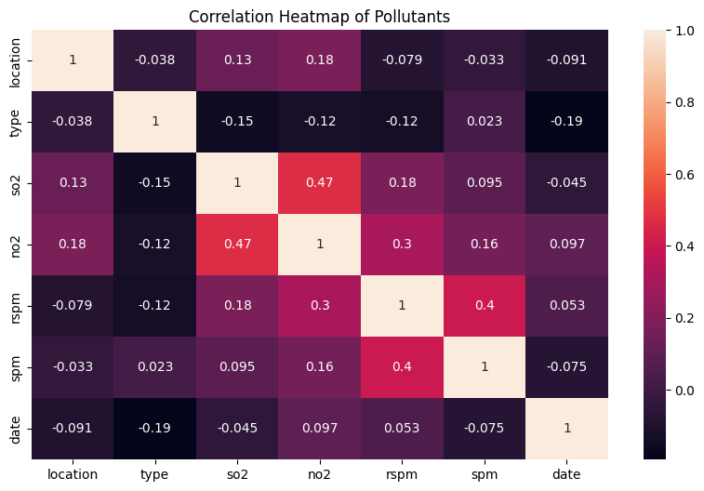
Figure 3.1
Figure 3.1 shows pairwise correlations. NO₂ and SO₂ have a correlation of 0.47 and rspm and spm show a correlation of 0.4, which are moderately positive. NO₂ and rspm have a correlation of 0.3, shows a slightly weak correlation.
3.3.2 Trend Analysis
To analyze the patterns of air quality and pollutants over the time a trend analysis (Figure 3.2) was performed. The monthly average AQI was calculated and visualized to observe variations. To calculate monthly average AQI, we needed daily AQI values. However, AQI was calculated first from the pollutants. The concentrations of spm, rspm, SO₂, NO₂ were taken so calculate AQI.
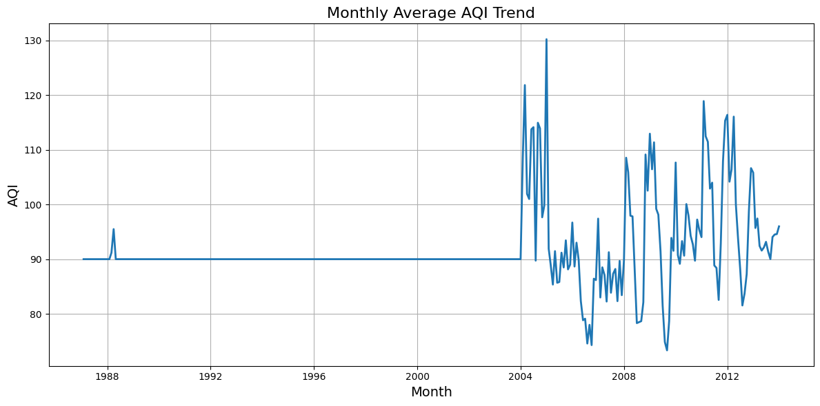
Figure 3.2
Figure 3.2 demonstrates that the monthly average AQI was almost stable in between 1989-2004. The AQI rapidly increased after 2004.
3.4 AQI calculation
The dataset contained pollutant parameters such as spm, rspm, NO₂, SO₂. However, the pm2.5 feature was completely missing for Maharashtra. As a result, pm2.5 was excluded from the AQI calculation for this region.
3.5 Machine Learning Algorithms
3.5.1 Linear Regression
Linear Regression model was chosen to predict AQI based on pollutant features. The dataset was split into 80:20 for training and testing, respectively. RMSE and R² metrices were used to evaluate the model’s generalisation performance. The Linear Regression performed well because the dataset was processed earlier, before training. In spite of having variability, the Linear Regression was able to learn accurate predictions of AQI well.
3.5.2 SVR (Support Vector Regression)
SVR was applied because of its ability to model non-linear relationships between pollutant features and AQI. Train-test split was 80% and 20% respectively. To ensure uniformity, the features were scaled. With parameters C=100,γ=0.1, eplison=0.1, an RBF kernel SVR was trained. This model achieved effective prediction performance.
3.5.3 Random Forest
Random Forest was used because of its ability to handle non-linear relationships and reduce overfitting through ensemble averaging. The Random forest built 200 decision trees and averaged their predictions. The maximum depth of each tree was set to 5 levels to prevent overfitting.
3.5.4 Gradient Boosting
A Gradient Boosting Regressor was applied to predict AQI. To prevent overfitting, this model used 200 estimators, a learning rate (alpha)= 0.1 and a maximum tree depth of 3.
3.6 Cross Validation
10-fold cross-validation was performed to ensure that the model’s performance metrics are not biased by a particular test and train split. Based on the 10-fold cross-validation results, Gradient Boosting performed the best with a lower median RMSE and a mean and median.
4. Result and Discussion
In this section, the performance of the models used for AQI forecasting is analysed. The evaluation metrices, 10-fold validation are considered to identify the most accurate result.
4.1 Dataset Description
The original dataset contained approximately 400,000 records. From this complete dataset, 60384 records related to Maharashtra were extracted. The dataset contained 13 features, and the target variable AQI was calculated from the pollutants' concentrations. The remaining variables were employed as input variables.
4.1.1 Model Performance
Linear Regression
Linear Regression achieved a test RMSE of 1.39 with a high R² value of 0.98. 10-fold cross-validation was done, which produced a median RMSE of 1.31 and a mean RMSE of 1.41.

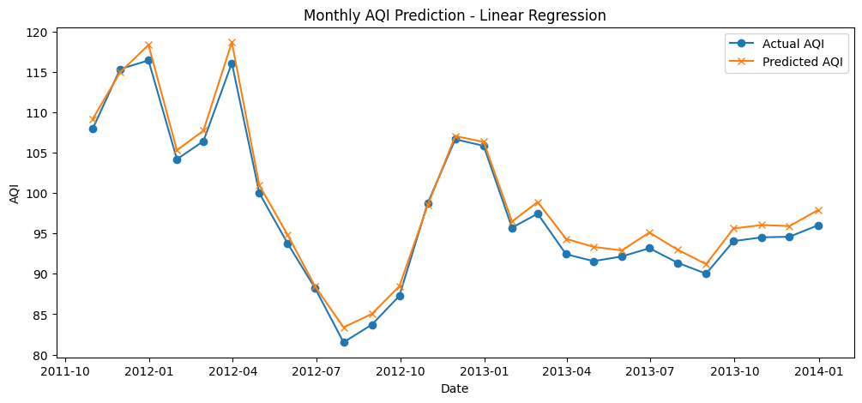

Figure 4.1

Figure 4.1 demonstrates that Linear Regression was able to capture the air quality patterns of air quality over time.However, some points where AQI changes sharply are noticeable where the predictions went wrong.
Table 4.1 shows the predictive performance of the model. A Mape-based accuracy has been shown, which indicates the average percentage deviation of predictive values from the actual AQI.
Table 4.1

Model: Linear Regression
Test RMSE | 1.39
Test R² | 0.98
Accuracy(R² *100) % | 97.75%
Average Mape-based Accuracy (%) (10-fold CV) | 98.88%
Average R² Score (10-fold CV) | 0.9789

SVR Model
The regularization parameter C=100 controlled the regularization and RBF kernel handled non-linearity. As a result, the result showed low prediction error. Theγ=0.1 ensured that the model could capture non-linear patterns without being overfitting or underfitting.

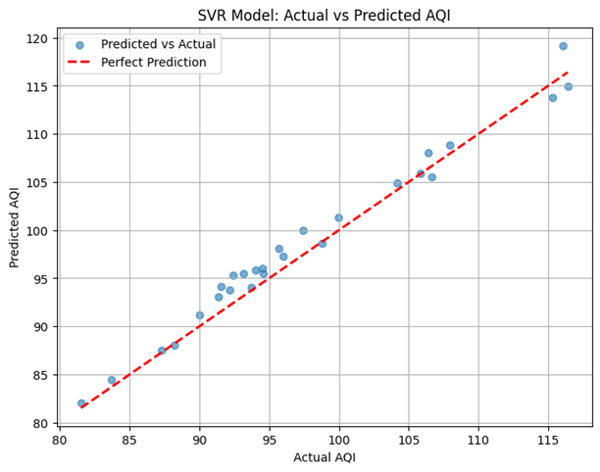
Figure 4.2
Figure 4.2 illustrates the performance of SVR model. The model underperformed as it couldnot capture the predictions well.
Table 4.2 shows the predictive performance of the SVR model.
Table 4.2
Model : SVM
Test RMSE | 1.61
Test R² | 0.97
Accuracy(R² *100) % | 96.97%
Average Mape-based Accuracy (%) (10-fold CV) | 98.45%
Average R² Score (10-fold CV) | 0.9445

Random Forest
n_estimator was set to 200, indicates that 200 decision trees were used in the ensemble.The performance. With less than 2% average deviation, the model’s predictions are too close to actual values.
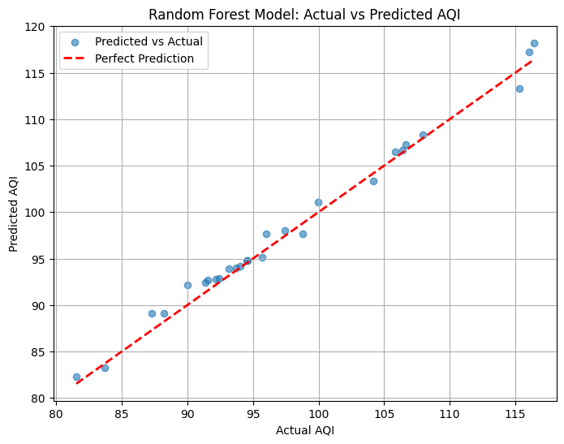
Figure 4.3
The Random Forest captured the non-linear relationships well. It showed prediction error and higher accuracy compared to SVR and Linear Regression.
Table 4.3 shows the predictive performance of the Random Forest model.
Table 4.3
Model : Random Forest
Test RMSE | 1.048
Test R² | 0.987
Accuracy(R² *100) % | 98.71%
Average Mape-based Accuracy (%) (10-fold CV) | 98.92%
Average R² Score (10-fold CV) | 0.9764

Gradient Boosting
The Gradient Boosting Regressor with 200 trees, learning rate,α=0.1 and a max depth =3 achieved RMSE= 1.29, R² = 0.98 on the test dataset. The Gradient Boosting achieved a low test RMSE and a high test accuracy.The MAPE-based accuracy re-ensured the robustness of the model.

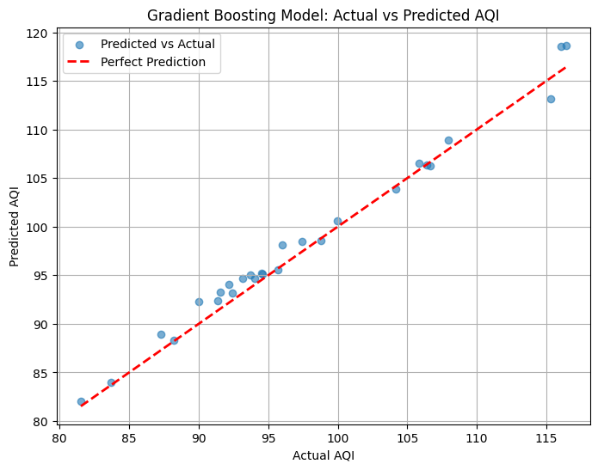
Figure 4.4
Figure 4.4 illustrates that Gradient Boosting captured non-linear relationships in the data effectively.
Table 4.4 shows the predictive performance of the Gradient Boosting Regressor Model.
Table 4.4
Model : Gradient Boosting Regressor
Test RMSE | 1.292
Test R² | 0.980
Accuracy(R² *100) % | 98.04%
Average Mape-based Accuracy (%) (10-fold CV) | 98.98%
Average R² Score (10-fold CV) | 0.9794

4.2 Model Comparison
Figure 8 illustrates the performance comparison of four machine learning models. The models were evaluated based on RMSE, R², and Average Accuracy (%). Using 10-fold cross-validation Average Accuracy(%) and Average R² score was also performed to evaluate the models.
Table 4.5 demonstrates the performance differences among the four models.

Model | Test RMSE | Test R² | Test Accuracy(%)  (R² * 100) | Average Mape- based Accuracy (%) (10-fold CV) | Average R² Score (10-fold CV)
Linear Regression | 1.385995 | 0.97756 | 97.75% | 98.88% | 0.9789
SVR | 1.607583 | 0.969671 | 96.97% | 98.45% | 0.9445
Random Forest | 1.048919 | 0.987088 | 98.71% | 98.92% | 0.9764
Gradient Boosting Regressor | 1.292372 | 0.980399 | 98.04% | 98.98% | 0.9794

Two ensemble methods were used- 1) Random Forest 2) Gradient Boosting. Gradient Boosting achieved the highest accuracy and R² while performing 10-fold cross-validation. On the other hand, Random Forest produces the smallest prediction errors.Therefore, ensemble methods demonstrated superior predictive performance for AQI prediction.

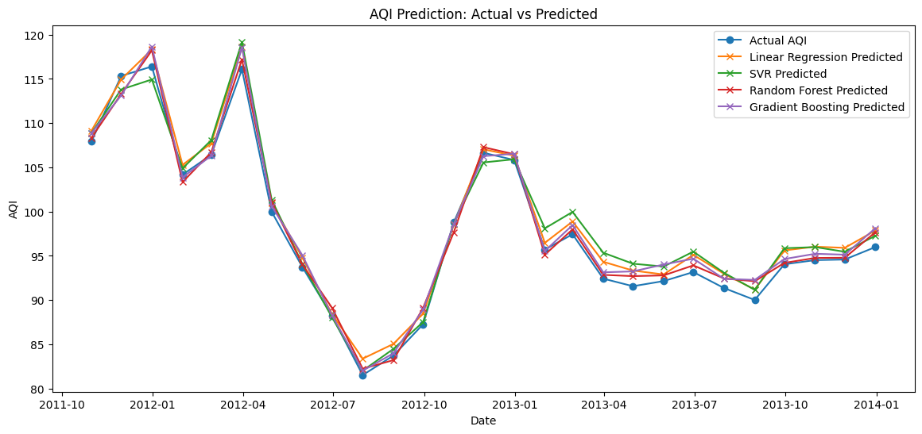
Figure 4.5

Both Gradient Boosting Regressor and Random Forest performed slightly better than LR and SVR.
Discussion
The original dataset did not contain a precomputed AQI column. AQI has been calculated from the raw pollutant concentrations. To obtain monthly average AQI, daily AQI values were subsequently aggregated an it served as the target feature for further analysis.
The result shows that both ensemble models outperform individual individual regression models. Random Forest achieved the lowest prediction error with a test RMSE of 1.048919 and a high R² = 0.987.On the other hand, Gradient Boosting achieved the highest overall predictive accuracy during cross-validation with an average MAPE-based accuracy of 98.98% and an average R² of 0.9794. Due to effective preprocessing and feature scaling Linear Regression and SVR performed reasonably well.
During this work, several challenges were encountered. The missing values of PM2.5 limited the proper calculation of AQI. Non-linear relationships between pollutants and AQI creates difficulties for traditional statistics.Many factors such as- meteorology,emissions make the air quality prediction complex. However, machine learning models, especially ensemble models proved more capable of overcoming these challenges by learning complex patterns from historological data.
Conclusion
This study demonstrates four ML models to predict AQI using historical pollutant (SO₂, NO₂, rspm, spm) data. More than 60,000 data were preprocessed and analyzed to ensure data quality before training them.Random Forest and Gradient Boosting Regression models can overcome challenges posed by missing features, non-linear relationships and complex environmental factors. Linear Regression model and SVR also achieved comparatively well accuracy due to effective preprocessing and feature scaling, still they achieved less accuracy than ensemble models. The absence of PM2.5 was a significant challenge as PM2.5 is usually a key component for AQI. Inspite of having this limitation, ensemble models show the potential for accurate air quality forecasting even with incomplete dataset.

References
1. Kang, G.K., Gao, J.Z., Chiao, S., Lu, S. and Xie, G., 2018. Air quality prediction: Big data and machine learning approaches. Int. J. Environ. Sci. Dev, 9(1), pp.8-16.
2. Agache I, Sampath V, Aguilera J, et al. Climate change and global health: A call to more research and more action. Allergy. 2022;77(5):1389-1407. doi:10.1111/all.15229
3. Singh, N.T., Singh, T.K., Anand, M., Saxena, Y. and Bhatt, A., 2023, December. Air Quality Analysis Using Machine Learning. In 2023 International Conference on Innovative Computing, Intelligent Communication and Smart Electrical Systems (ICSES) (pp. 1-5). IEEE.
4. Bhalgat, P., Pitale, S. and Bhoite, S., 2019. Air quality prediction using machine learning algorithms. International Journal of Computer Applications Technology and Research, 8(9), pp.367-370.
5. Aram, S.A., Nketiah, E.A., Saalidong, B.M., Wang, H., Afitiri, A.R., Akoto, A.B. and Lartey, P.O., 2024. Machine learning-based prediction of air quality index and air quality grade: a comparative analysis. International Journal of Environmental Science and Technology, 21(2), pp.1345-1360.
6. Liang, Y.C., Maimury, Y., Chen, A.H.L. and Juarez, J.R.C., 2020. Machine learning-based prediction of air quality. applied sciences, 10(24), p.9151.
7. Friberg, L. and Cederlöf, R., 1978. Late effects of air pollution with special reference to lung cancer. Environmental Health Perspectives, 22, p.45.
8. Mampitiya, L., Rathnayake, N., Leon, L.P., Mandala, V., Azamathulla, H.M., Shelton, S., Hoshino, Y. and Rathnayake, U., 2023. Machine learning techniques to predict the air quality using meteorological data in two urban areas in Sri Lanka. Environments, 10(8), p.141.
9. Ravindiran, G., Hayder, G., Kanagarathinam, K., Alagumalai, A. and Sonne, C., 2023. Air quality prediction by machine learning models: A predictive study on the indian coastal city of Visakhapatnam. Chemosphere, 338, p.139518.
10. Alberts, W.M., 1994. Indoor air pollution: No, No2, CO, and CO2. Journal of allergy and clinical immunology, 94(2), pp.289-295.
11. Kaur, E. and Sandha, S.S., Air Quality Prediction Using Machine Learning.
12. Zhou QingPing, Z.Q., Jiang HaiYan, J.H., Wang JianZhou, W.J. and Zhou JianLing, Z.J., 2014. A hybrid model for PM2. 5 forecasting based on ensemble empirical mode decomposition and a general regression neural network.
13. Liu, Q., Cui, B. and Liu, Z., 2024. Air quality class prediction using machine learning methods based on monitoring data and secondary modeling. Atmosphere, 15(5), p.553.
14. Gladkova, E. and Saychenko, L., 2022. Applying machine learning techniques in air quality prediction. Transportation Research Procedia, 63, pp.1999-2006.
15. Iskandaryan, D., Ramos, F. and Trilles, S., 2020. Air quality prediction in smart cities using machine learning technologies based on sensor data: a review. Applied Sciences, 10(7), p.2401.
16. Maltare, N.N. and Vahora, S., 2023. Air Quality Index prediction using machine learning for Ahmedabad city. Digital Chemical Engineering, 7, p.100093.
17. Harishkumar, K.S. and Yogesh, K.M., 2020. Forecasting air pollution particulate matter (PM2. 5) using machine learning regression models. Procedia Computer Science, 171, pp.2057-2066.
18. Méndez, M., Merayo, M.G. and Núñez, M., 2023. Machine learning algorithms to forecast air quality: a survey. Artificial Intelligence Review, 56(9), pp.10031-10066.
19. Dun, M., Xu, Z., Chen, Y. and Wu, L., 2020. Short‐Term Air Quality Prediction Based on Fractional Grey Linear Regression and Support Vector Machine. Mathematical problems in engineering, 2020(1), p.8914501.
20. Liu, H., Li, Q., Yu, D. and Gu, Y., 2019. Air quality index and air pollutant concentration prediction based on machine learning algorithms. Applied sciences, 9(19), p.4069.
21. Natarajan, S.K., Shanmurthy, P., Arockiam, D., Balusamy, B. and Selvarajan, S., 2024. Optimized machine learning model for air quality index prediction in major cities in India. Scientific reports, 14(1), p.6795.
22. Suri, R.S., Jain, A.K., Kapoor, N.R., Kumar, A., Arora, H.C., Kumar, K. and Jahangir, H., 2023. Air quality prediction-a study using neural network based approach. Journal of Soft Computing in Civil Engineering, 7(1), pp.93-113.
23. Gupta, N.S., Mohta, Y., Heda, K., Armaan, R., Valarmathi, B. and Arulkumaran, G., 2023. Prediction of air quality index using machine learning techniques: a comparative analysis. Journal of Environmental and Public Health, 2023(1), p.4916267.
24. Özüpak, Y., Alpsalaz, F. and Aslan, E., 2025. Air Quality Forecasting Using Machine Learning: Comparative Analysis and Ensemble Strategies for Enhanced Prediction. Water, Air, & Soil Pollution, 236(7), p.464.
25. Halsana, S., 2020. Air quality prediction model using supervised machine learning algorithms. International Journal of Scientific Research in Computer Science, Engineering and Information Technology, 8, pp.190-201.
26. Kothandaraman, D., Praveena, N., Varadarajkumar, K., Madhav Rao, B., Dhabliya, D., Satla, S. and Abera, W., 2022. Intelligent forecasting of air quality and pollution prediction using machine learning. Adsorption Science & Technology, 2022, p.5086622.

.

