Major Project Report on

FindMyStuff

Submitted in partial fulfillment of the requirements for the degree of
BACHELOR OF ENGINEERING
IN

Computer Science & Engineering

Artificial Intelligence & Machine Learning
by
Reva G. Tol – 23106083
Tejas Haresh Thorat – 23106120
Sumit Kailash Thakur - 23106036
Mayankkant Tiwari - 23106037

Under the guidance of

Prof. Viki Patil



Department of Computer Science & Engineering

(Artificial Intelligence & Machine Learning)
A. P. Shah Institute of Technology
G. B. Road, Kasarvadavali, Thane (W)-400615
University Of Mumbai
2024-2025


A. P. SHAH INSTITUTE OF TECHNOLOGY

CERTIFICATE

This is to certify that the project entitled “FindMyStuff” is a bonafide work of Reva G. Tol – 23106083, Tejas Haresh Thorat – 23106120, Sumit Kailash Thakur - 23106036, Mayankkant Tiwari - 23106037 submitted to the University of Mumbai in partial fulfillment of the requirement for the award of Bachelor of Engineering in Computer Science & Engineering (Artificial Intelligence & Machine Learning).

________________ | _______________
Prof. Viki Patil | Dr. Jaya Gupta
Mini Project Guide | Head of Department

A. P. SHAH INSTITUTE OF TECHNOLOGY

Project Report Approval

This Mini project report entitled “FindMyStuff” by Reva G. Tol – 23106083, Tejas Haresh Thorat – 23106120, Sumit Kailash Thakur - 23106036, Mayankkant Tiwari - 23106037 is approved for the degree of Bachelor of Engineering in Computer Science &Engineering, (AIML) 2022-23.

External Examiner:

Internal Examiner:

Place: APSIT, Thane
Date:

Declaration

We declare that this written submission represents my ideas in my own words and where others' ideas or words have been included, I have adequately cited and referenced the original sources. I also declare that I have adhered to all principles of academic honesty and integrity and have not misrepresented or fabricated or falsified any idea/data/fact/source in my submission. I understand that any violation of the above will be cause for disciplinary action by the Institute and can also evoke penal action from the sources which have thus not been properly cited or from whom proper permission has not been taken when needed.

Reva G. Tol | Sumit Thakur | Tejas Thorat | Mayank Tiwari
(23106083) | (23106036) | (23106120) | (23106037)

ABSTRACT

Index

Index |  |  | Page no.
Chapter-1
 | Introduction
Chapter-2
 | Literature Survey
 | 2.1 | History
 | 2.1 | Review
Chapter-3
 | Problem Statement
Chapter-4
 | Experimental Setup
 | 4.1 | Hardware setup
 | 4.2 | Software Setup
Chapter-5
 | Proposed system and Implementation
 | 5.1 | Block Diagram of proposed system
 | 5.2 | Description of Block diagram
 | 5.3 | Implementation
Chapter-6
 | Conclusion
References

CHAPTER 1 INTRODUCTION

Losing personal belongings is a common and frustrating experience for most of us. Current solutions for finding lost items are fragmented, inefficient, and fail to provide a centralized, user-friendly platform.We introduce "FindMyStuff," a website that allows users to upload any missing objects that they have found and search for lost stuff. It has a user-friendly interface and very efficient filtration. It works on the virtual volunteering of netizens.

Motivation: While travelling, all of us had few experiences of losing our personal belongings. Now most of the time we can't get them back, but a few times there's a chance that someone kind has found it and either reports it to the police or tries to contact us if there's any note in their belongings. But the thing is, not all of us mark our personal belongings. This led us to make a platform where we could connect both sides by using information of lost/found product, lost location, serial no./model no. (if available), physical condition of the lost object, etc.

Objectives: The primary objective of the lost and found website is to provide a centralized, user-friendly platform where individuals can report, search, and recover lost items efficiently.

Website’s Aim:

Facilitate Reporting: Allow users to easily report lost or found items by submitting descriptions, location of losting and contact details.

Connect People: Act as a bridge between those who have lost items and those who have found them, enabling secure and effective communication.

Increase Recovery Rates: By centralizing reports of lost and found items, the website aims to increase the chances of lost items being returned to their rightful owners.

Support Community Efforts: Foster a sense of community by encouraging users to help each other in locating lost items and reporting found items, thereby creating a collaborative network

CHAPTER 2 LITERATURE SURVEY

LITERATURE SURVEY

2.1-HISTORY

- Traditional Lost and Found Systems:

Early Methods: Historically, lost and found systems were simple, physical setups. People reported lost items by posting notices on bulletin boards, placing ads in local newspapers, or visiting designated lost and found offices in public places like schools, airports, train stations, and other public buildings. The process was manual, often involving handwritten logs or ledgers maintained by staff.
Limitations: These methods were inefficient, with limited reach and accessibility. The chances of reuniting lost items with their owners were low due to the lack of a centralized and systematic way to track and manage reports.

- The Advent of Digital Record-Keeping (1980s - 1990s):

Introduction of Computers: With the rise of personal computers in the 1980s and 1990s, organizations began using basic digital tools to manage lost and found inventories. This involved using spreadsheets or simple databases to track items and their corresponding reports.
Improved Efficiency: Digital records made it easier to organize and search for information compared to paper-based methods. However, these systems were still localized, with limited ability to share information beyond the organization or institution that maintained them.

- Early Online Lost and Found Services (Late 1990s - Early 2000s):

Rise of the Internet: The widespread adoption of the internet provided an opportunity to create centralized online platforms for lost and found items. Early versions of lost and found websites emerged, allowing users to post descriptions of lost items and search for found items online.

- Growth of Dedicated Lost and Found Websites (2000s - 2010s):

Specialized Platforms: The 2000s saw the emergence of specialized lost and found websites dedicated to helping users report and find lost items. Examples include websites for lost pets, lost baggage by airlines, and lost items on university campuses. These platforms started to incorporate more advanced features, such as categorization of items, geolocation, and image uploads.
Integration with Organizations: Many organizations, including airports, hotels, and public transit systems, began to integrate their lost and found services with these online platforms. This allowed for better coordination and increased the chances of reuniting items with their owners.

- Modern Lost and Found Websites (2010s - Present):

Feature-Rich Platforms: Modern lost and found websites offer comprehensive features to enhance the user experience and improve recovery rates. These include advanced search filters, image recognition, location-based services, user authentication, and notifications. The use of APIs allows for integration with other services and systems.
Mobile Accessibility: With the proliferation of smartphones, lost and found websites have become mobile-friendly, providing users with the ability to report and search for items on the go. Mobile apps have also been developed, offering push notifications and real-time updates.

- Future Trends and Developments:

AI and Machine Learning: The future of lost and found websites will likely involve the use of AI and machine learning to enhance search capabilities, predict recovery outcomes, and automate the matching of lost and found reports based on descriptions and images.
Blockchain Technology: To further ensure security and transparency, blockchain technology could be used to create immutable records of lost and found items, reducing fraud and increasing trust among users.
Augmented Reality (AR): AR could be utilized to provide users with a visual guide to the last known location of their lost items, enhancing the search experience.

2.2-LITERATURE REVIEW

- Case Studies: After observing existing lost and found websites such as AAI lost and found section, LostMyDoggie.com, Lost and Found Ads on social media platforms, and lost and found university of calgary.

What works: Easy reporting, category-based search, use of images.
Challenges: Lack of centralized reporting and difficulty in verifying claims.

- App-Based Solutions: After Observing mobile apps like Tile and Apple’s “Find My” that use technology for tracking and finding lost items.

What works: Integration with GPS, notifications, real-time tracking.
Challenges: privacy issues.

- Research Papers: Research papers help a lot with this type of project as they contain vast information on the working of the project and also talk about technologies used in the project. After reviewing a few research papers relevant to our website, we got:-

- Paper 1: “Understanding and Designing for Lost and Found Processes in the Sharing Economy.”

Authors: Julia Preece, Leon A. Watts
Summary: This paper explores how people deal with lost and found items in the context of the sharing economy. It discusses user behavior, motivations, and the design implications for systems that aim to facilitate item recovery.

- Paper 2: "Optimizing Database Queries for a Lost and Found System“

Authors: Database researchers focusing on query optimization.
Summary: Discusses the design of database queries specifically optimized for systems that manage lost and found reports, including search efficiency and data indexing.

- Paper 3: "Efficient Location-Based Services with Privacy Preservation"

Authors: Privacy and security researchers.
Summary: Investigates methods for providing location-based services while preserving user privacy, a critical aspect of a lost and found system that includes location data.

- Paper 4: "User Experience Design for Community-Based Digital Platforms“

Authors: UX researchers.
Summary: Provides guidelines for designing user-friendly and accessible digital platforms, focusing on community engagement and ease of use, relevant to lost and found websites.

CHAPTER 3

Problem Statement

Problem Statement: Existing lost and found systems often have inefficient search functionalities, which make it difficult for users to find their lost items. Users have to manually browse through numerous reports, which can be time-consuming and frustrating.

Problem Statement: Verifying the authenticity of lost and found claims can be challenging. There is a risk of false claims, which can lead to disputes over item ownership and loss of credibility for the platform.

Problem Statement: Many users are unaware of the existence of lost and found platforms, or they do not know how to use them effectively. This limits the platform's reach and reduces the chances of item recovery.

Problem Statement: Real-time tracking of lost items (such as pets or valuable objects) can be difficult without the use of specialized technologies, limiting the effectiveness of the platform for certain types of items.

CHAPTER 4

Experimental Setup

4.1 Hardware Setup

The database server stores all the information related to users, lost and found items, search queries, and more.

Cloud Storage: Services like AWS S3, Google Cloud Storage, or Azure Blob Storage can be used for scalable and reliable file storage, reducing the need for on-premise hardware.

Load Balancer: For high traffic, use a load balancer to distribute incoming traffic across multiple web servers.

CPU: 4-8 core processors to handle the application logic.

RAM: 8 GB to 16 GB for running application services and handling API requests.

Storage: SSDs (256 GB or more) for quick access to application data and logs.

4.2 Software Setup

Django (Python): A high-level, open-source web framework that encourages rapid development and clean, pragmatic design. Django comes with built-in features like an admin panel, ORM, authentication, and more.

HTML5 and CSS3: Fundamental technologies for structuring and styling web content.

JavaScript: The core scripting language for dynamic content. Frameworks and libraries can enhance the development process.

React.js: A JavaScript library for building user interfaces, particularly single-page applications where reactivity and component-based architecture are key.

Geolocation API: For location-based search and listing features, integrate geolocation services (e.g., Google Maps API) to map items and search based on location.

CHAPTER 5

Proposed System & Implementation

Proposed system & Implementation:-

5.1 Block diagram of proposed system

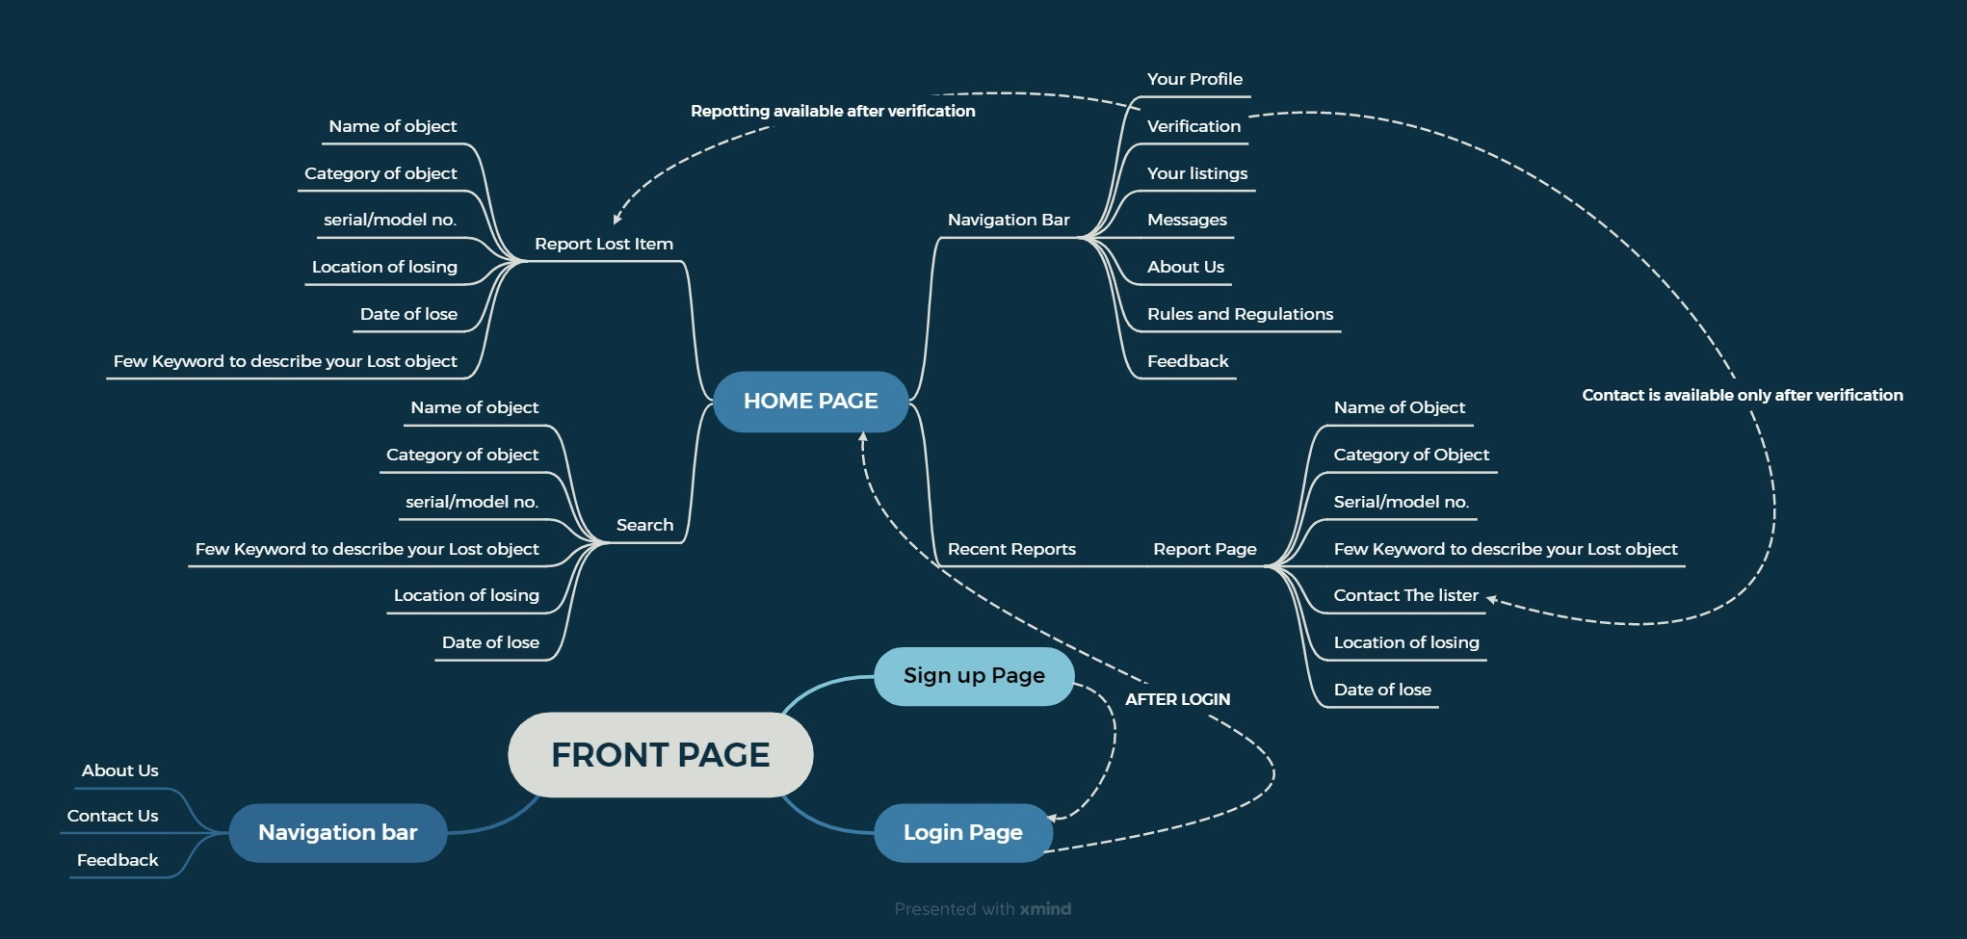

Above Diagram is Whole Flow of our Project from users perspective.

5.3 Implementation

Implementing a lost and found website involves several steps, from planning and development to testing and deployment. But inshort this website well act as middle man between people who lost their items and people who founded them.

5.4 Advantages/ Application/ result table can be included in this subsection.

- Mobile-Friendly: A responsive design ensures that users can access the platform from their smartphones, tablets, or computers, making it convenient and accessible on the go.
- Advanced Search Filters: Users can search for items using various filters such as category, location, date, and keywords, significantly improving the chances of finding lost items.
- Location-Based Search: Helps users find lost items by narrowing down the search to specific geographic areas.
- Instant Notifications: Users receive real-time notifications when a matching item is found or if someone has reported finding their lost item.
- User-Friendly Interface: A well-designed website with a clear and intuitive interface makes it easy for users to navigate, report, and search for items.

CHAPTER 6

Conclusion

Conclusion

A well-designed lost and found website has the potential to make a meaningful impact by reducing the emotional and financial distress associated with lost items. By focusing on user experience, security, community engagement, and continuous improvement, the platform can become a trusted and go-to solution for individuals seeking to recover their lost belongings. Ultimately, a successful lost and found website not only reunites people with their possessions but also fosters a sense of community and mutual support, contributing positively to society as a whole.

References
[1]“Investigating User Experience of Online Communities: The Influence of Community Type.”
[2]“Privacy Preservation in Location-Based Services.”
[3]“The location privacy protection research in location-based service.”
[4]“Survey on performance optimization for database systems.”

URL

- https://ieeexplore.ieee.org/document/5568118
- https://www.researchgate.net/publication/262370922_Investigating_User_Experience_of_Online_Communities_The_Influence_of_Community_Type
- https://www.researchgate.net/publication/323786350_Privacy_Preservation_in_Location-Based_Services
- https://www.researchgate.net/publication/367154902_Survey_on_performance_optimization_for_database_systems
- https://www.researchgate.net/publication/371694689_THE_SHARING_ECONOMY'S_SUCCESS_ADVANTAGES_DRAWBACKS_AND_APPLICATIONS

