-- find top 10 highest revenue generating products

SELECT PRODUCT_ID, SUM(SALE_PRICE) AS SALES

FROM DF_ORDERS

GROUP BY PRODUCT_ID

ORDER BY SALES DESC

LIMIT 10;

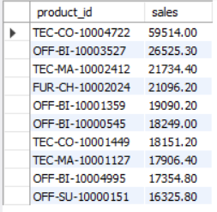

-- find top 5 highest selling products in each region

WITH CTE AS (

    SELECT REGION, PRODUCT_ID, SUM(SALE_PRICE) AS SALES

    FROM DF_ORDERS

    GROUP BY REGION, PRODUCT_ID

)

SELECT *

FROM (

    SELECT *,

           ROW_NUMBER() OVER (PARTITION BY REGION ORDER BY SALES DESC) AS RN

    FROM CTE

) A

WHERE RN <= 5;

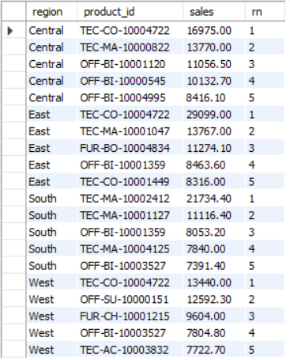

-----------------------------------------------------------------------------------------------------------------------------------------------------------

-- find month over month growth comparison for 2022 & 2023 sales ex: JAN 2022 vs JAN 2023

WITH CTE AS (

    SELECT YEAR(ORDER_DATE) AS ORDER_YEAR, MONTH(ORDER_DATE) AS ORDER_MONTH,

           SUM(SALE_PRICE) AS SALES

    FROM DF_ORDERS

    GROUP BY YEAR(ORDER_DATE), MONTH(ORDER_DATE)

    -- ORDER BY YEAR(ORDER_DATE), MONTH(ORDER_DATE)

)

SELECT ORDER_MONTH,

       SUM(CASE WHEN ORDER_YEAR = 2022 THEN SALES ELSE 0 END) AS SALES_2022,

       SUM(CASE WHEN ORDER_YEAR = 2023 THEN SALES ELSE 0 END) AS SALES_2023

FROM CTE

GROUP BY ORDER_MONTH

ORDER BY ORDER_MONTH;

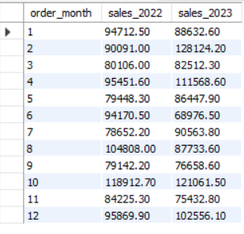

-----------------------------------------------------------------------------------------------------------------------------------------------------------

-- for each category which month had highest sales

WITH CTE AS (

    SELECT CATEGORY, FORMAT(ORDER_DATE,'YYYYMM') AS ORDER_YEAR_MONTH,

           SUM(SALE_PRICE) AS SALES

    FROM DF_ORDERS

    GROUP BY CATEGORY, FORMAT(ORDER_DATE,'YYYYMM')

    -- ORDER BY CATEGORY, FORMAT(ORDER_DATE,'YYYYMM')

)

SELECT * FROM (

    SELECT *,

           ROW_NUMBER() OVER (PARTITION BY CATEGORY ORDER BY SALES DESC) AS RN

    FROM CTE

) A

WHERE RN = 1;

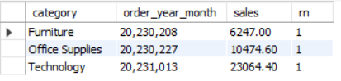

-----------------------------------------------------------------------------------------------------------------------------------------------------------

-- which sub category had highest growth by profit in 2023 compare to 2022

WITH CTE AS (

    SELECT SUB_CATEGORY, YEAR(ORDER_DATE) AS ORDER_YEAR,

           SUM(SALE_PRICE) AS SALES

    FROM DF_ORDERS

    GROUP BY SUB_CATEGORY, YEAR(ORDER_DATE)

    -- ORDER BY YEAR(ORDER_DATE), MONTH(ORDER_DATE)

),

CTE2 AS (

    SELECT SUB_CATEGORY,

           SUM(CASE WHEN ORDER_YEAR = 2022 THEN SALES ELSE 0 END) AS SALES_2022,

           SUM(CASE WHEN ORDER_YEAR = 2023 THEN SALES ELSE 0 END) AS SALES_2023

    FROM CTE

    GROUP BY SUB_CATEGORY

)

SELECT *,

       (SALES_2023 - SALES_2022) AS SALES_DIFFERENCE

FROM CTE2

ORDER BY SALES_DIFFERENCE DESC

LIMIT 1;

