SCHOOL OF COMPUTING
DIT UNIVERSITY, DEHRADUN
(State Private University through State Legislature Act No. 10 of 2013 of Uttarakhand and approved by UGC)
Mussoorie Diversion Road, Dehradun, Uttarakhand - 248009, India.
July, 2026

WEEK 4 ASSIGNMENT REPORT
Azure Cloud Fundamentals and Data Pipeline Implementation using ADF

CELEBAL TECHNOLOGY

NAME : SUMIT KUMAR SINGH
ID : CT_CSI_DE 1082
COLLAGE : DIT UNIVERSITY , DEHRADUN
EMAIL : 1000021037@dit.edu.in
1. Objective
The objective of this assignment is to gain hands-on understanding of core Microsoft Azure cloud concepts and to design and implement a complete, end-to-end data pipeline. The exercise covers provisioning of foundational Azure resources — a Resource Group and a Storage Account — followed by the creation of an Azure Data Factory (ADF) instance to orchestrate data movement. Through this task, key ADF components such as Linked Services, Datasets, the Get Metadata activity, and the Copy Data activity are explored and configured. The assignment also emphasizes secure access management using Azure Identity and Access Management (IAM) roles, ensuring that Data Factory has appropriate, least-privilege access to the Storage Account. The final deliverable is a validated, end-to-end pipeline that reads a CSV file from Blob Storage, checks its metadata, and copies it to a destination location, along with supporting documentation and screenshots.

2. Task 1: Explore Azure Portal and Create a Resource Group

What is a Resource Group?
A Resource Group in Azure is a logical container used to group related resources for an Azure solution — such as storage accounts, data factories, and virtual machines. It allows resources to be managed, monitored, and billed together as a single unit, and simplifies lifecycle management since deleting a resource group removes all resources within it.

Steps Performed
Step 1: Logged into the Azure Portal (portal.azure.com) using an active Azure for Students subscription.
Step 2: Navigated to the search bar and searched for "Resource groups".
Step 3: Clicked "+ Create" and provided the subscription, a unique resource group name (rg-week4-datapipeline), and selected an appropriate region.
Step 4: Clicked "Review + Create", validated the configuration, and clicked "Create" to deploy the resource group.

Deliverable: Screenshot of Resource Group
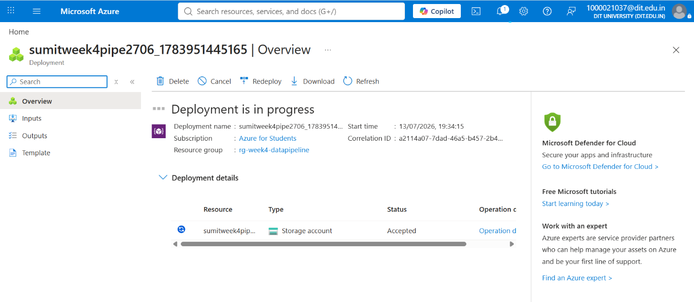
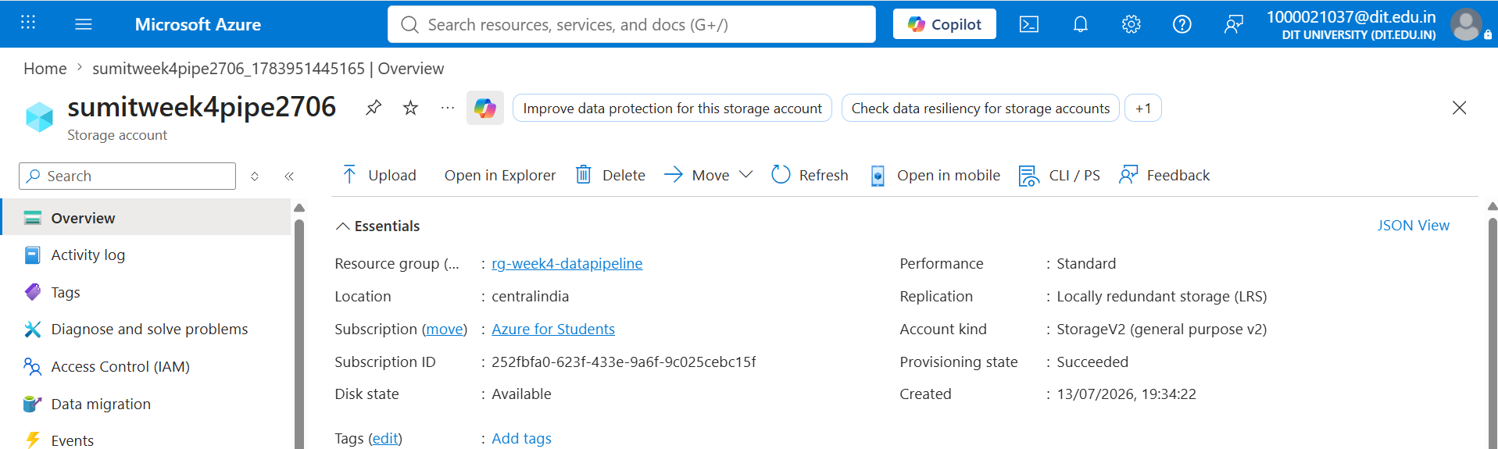

3. Task 2: Storage Setup

Overview
Azure Storage Accounts provide scalable, secure cloud storage for a variety of data objects, including Blob (unstructured object storage), File, Queue, and Table storage. For this task, a general-purpose v2 Storage Account was created, followed by a Blob Container to hold a sample CSV dataset that would later be used as the source for the ADF pipeline.

Steps Performed
Step 1: Searched for "Storage accounts" in the Azure Portal and clicked "+ Create".
Step 2: Selected the resource group created in Task 1, provided a globally unique storage account name, chose the Standard performance tier and Locally Redundant Storage (LRS) for redundancy.
Step 3: Resolved a region-restriction validation error (RequestDisallowedByAzure) encountered under the student subscription by switching the deployment region to one supported by the subscription.
Step 4: Deployed the storage account successfully and navigated to its Overview page.
Step 5: Created a Blob Container named "source-data" with Private access level.
Step 6: Uploaded a sample CSV file (employee dataset) into the container.
Deliverable: Screenshot of Storage Account
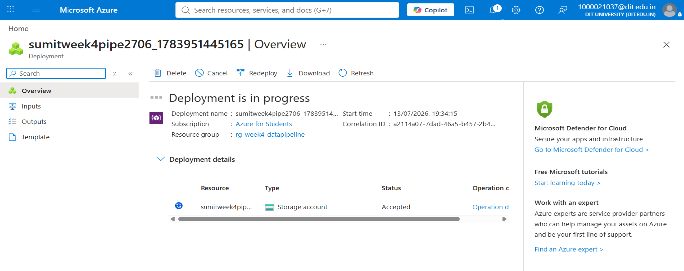

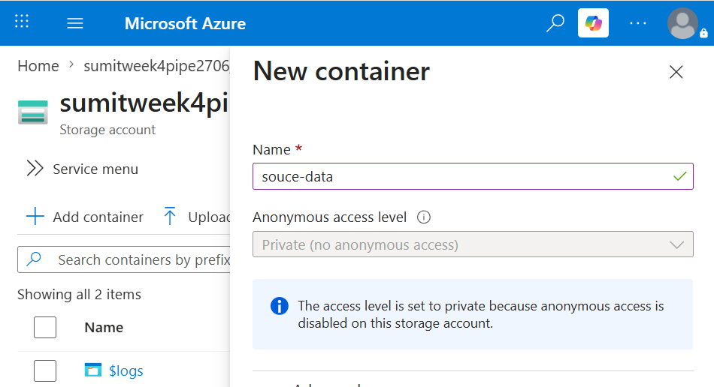

Deliverable: Screenshot of Container with Uploaded File
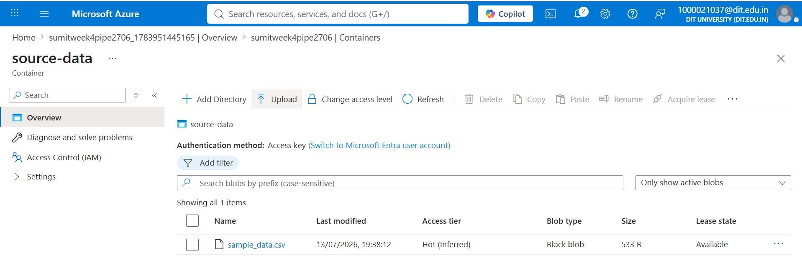

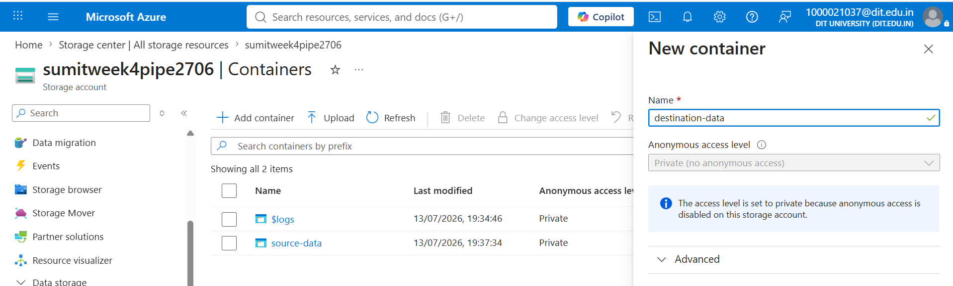

4. Task 3: ADF Basics

Overview
Azure Data Factory (ADF) is a cloud-based data integration service that allows creation of data-driven workflows for orchestrating and automating data movement and transformation. This task involved provisioning an ADF instance and exploring its three primary interfaces: Author (for building pipelines, datasets, and linked services), Monitor (for tracking pipeline execution), and Manage (for configuring linked services, IAM, and triggers).

Steps Performed
Step 1: Created a new Azure Data Factory (V2) resource within the same resource group and region as the storage account.
Step 2: Opened Azure Data Factory Studio and explored the Home, Author, Monitor, and Manage sections.
Step 3: Under Manage → Linked Services, created a new Linked Service of type "Azure Blob Storage", authenticated using Account Key, and validated the connection using "Test connection".
Step 4: Under Author → Datasets, created a source dataset (ds_source_csv) pointing to the uploaded CSV file, and a destination dataset (ds_destination_csv) pointing to an empty destination container.
Step 5: Added a "Get Metadata" activity to a new pipeline, configured it to read the source dataset, and specified the field list (Item name, Size, Last modified).
Step 6: Executed the Get Metadata activity in Debug mode and inspected the JSON output to confirm correct file metadata retrieval.

Deliverable: Screenshot of Linked Service

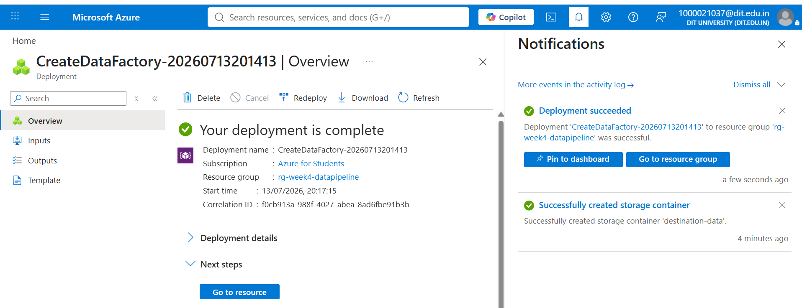

Deliverable: Screenshot of Dataset

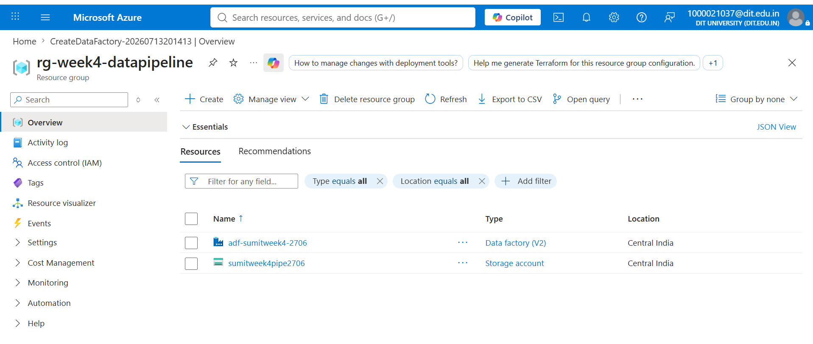

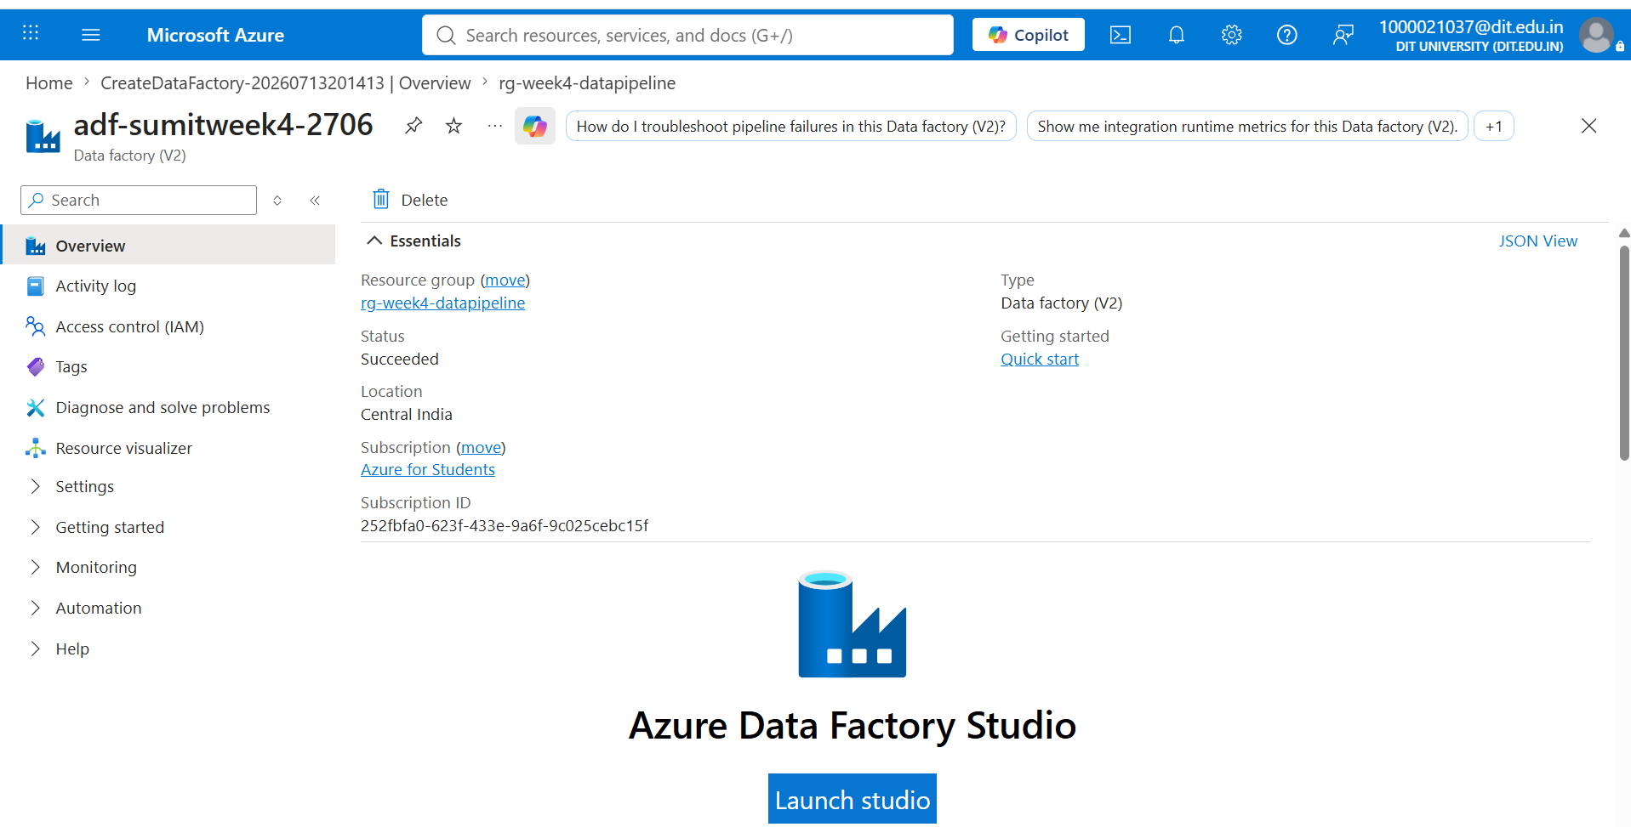

Deliverable: Screenshot of Get Metadata Activity

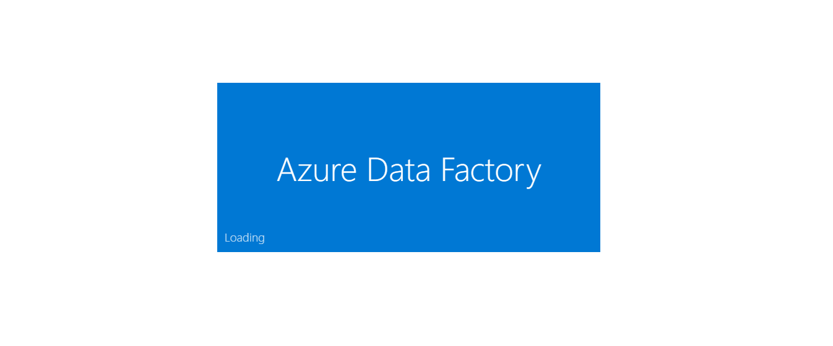

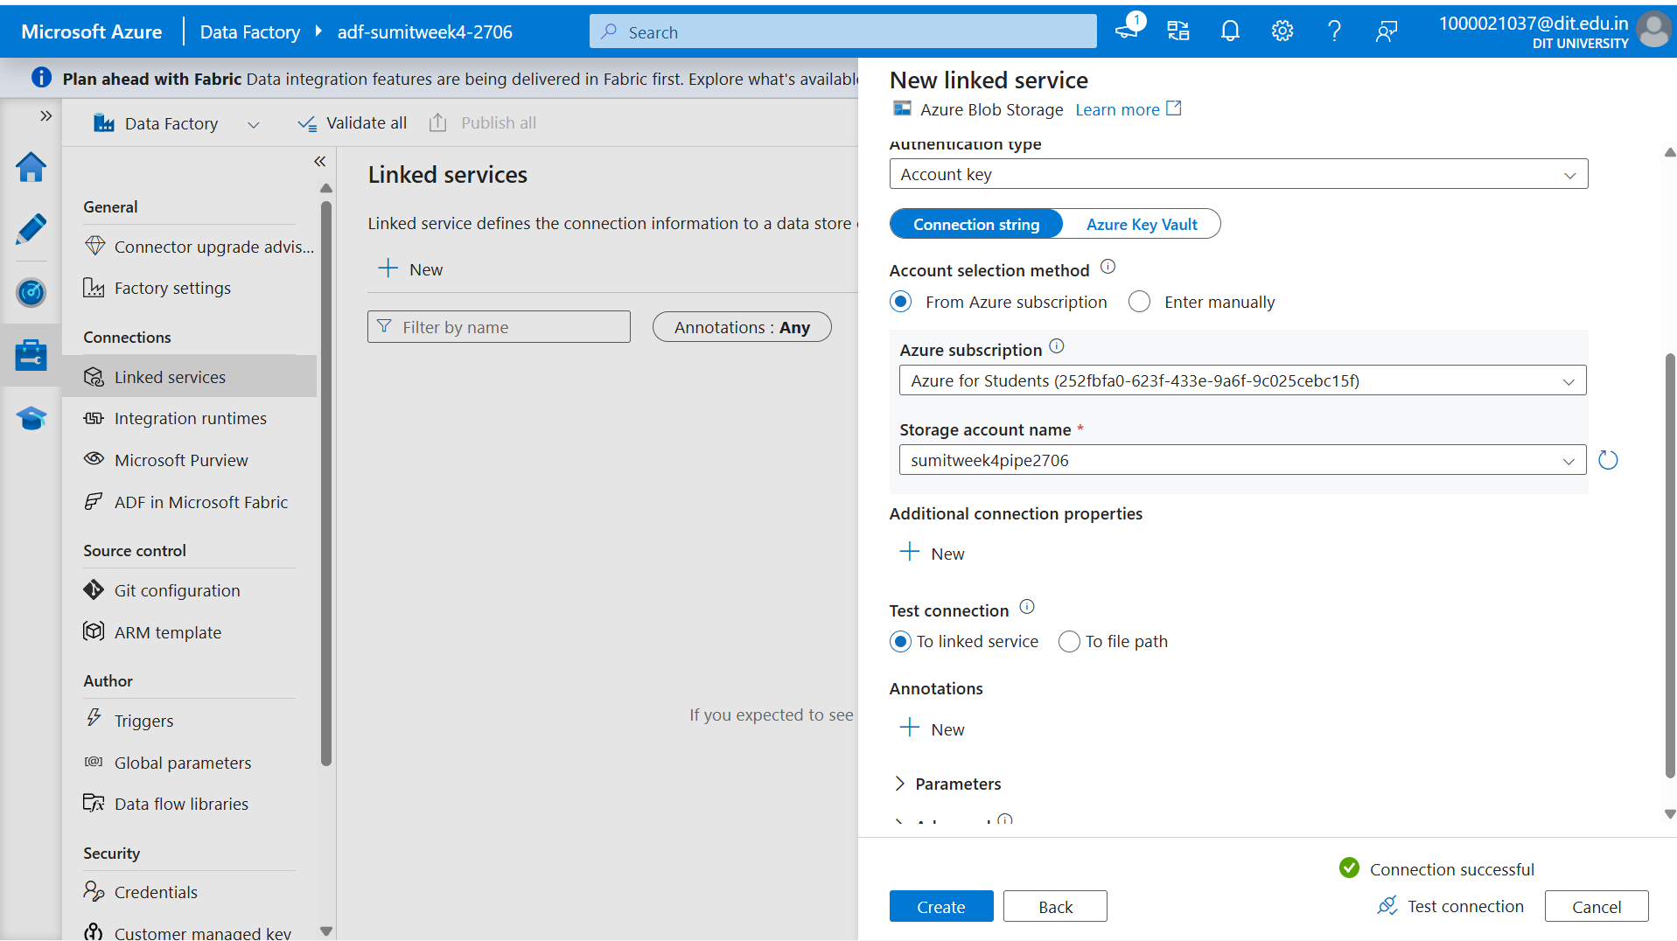

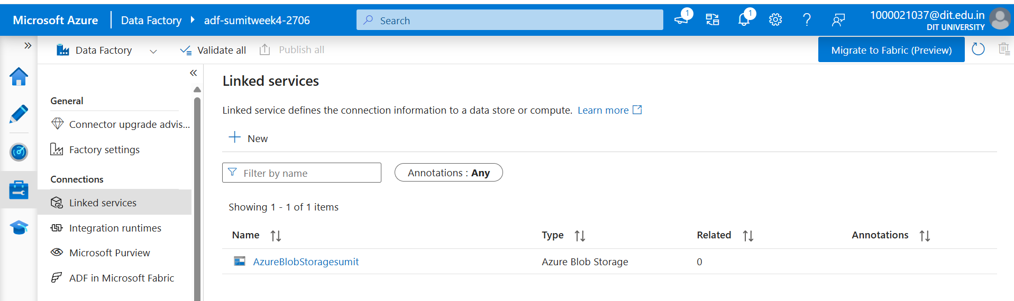
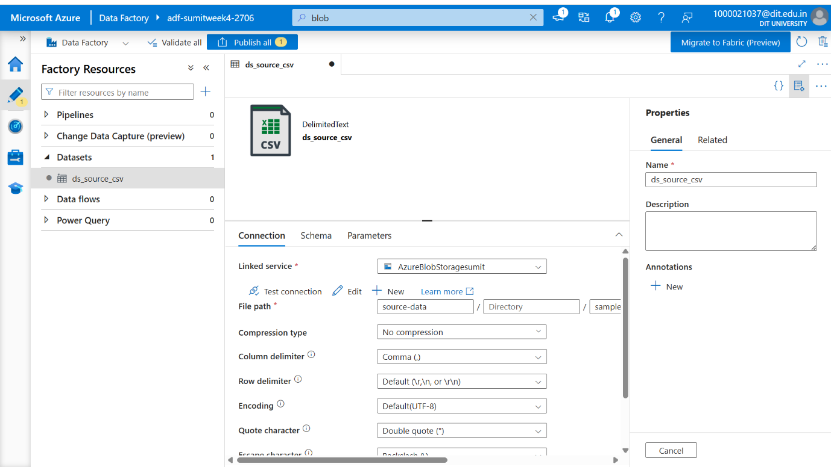

5. Task 4: Pipeline Development

Overview
With the Linked Service and datasets in place, a pipeline was built using the Copy Data activity to move the CSV file from the source container to the destination container. The Copy Data activity was chained after the Get Metadata activity so that file information is validated before the copy operation executes.

Steps Performed
Step 1: Created a new pipeline named pl_week4_pipeline in ADF Studio's Author section.
Step 2: Added a Copy Data activity to the canvas and connected it to the Get Metadata activity using a success dependency (green arrow).
Step 3: Configured the Copy Data activity's Source tab with ds_source_csv and the Sink tab with ds_destination_csv.
Step 4: Used the Mapping tab's "Import schemas" option to auto-map source and destination columns.
Step 5: (Optional) Considered a ForEach activity for scenarios involving multiple files, though a single file was used for this assignment.

Deliverable: Screenshot of Pipeline Design

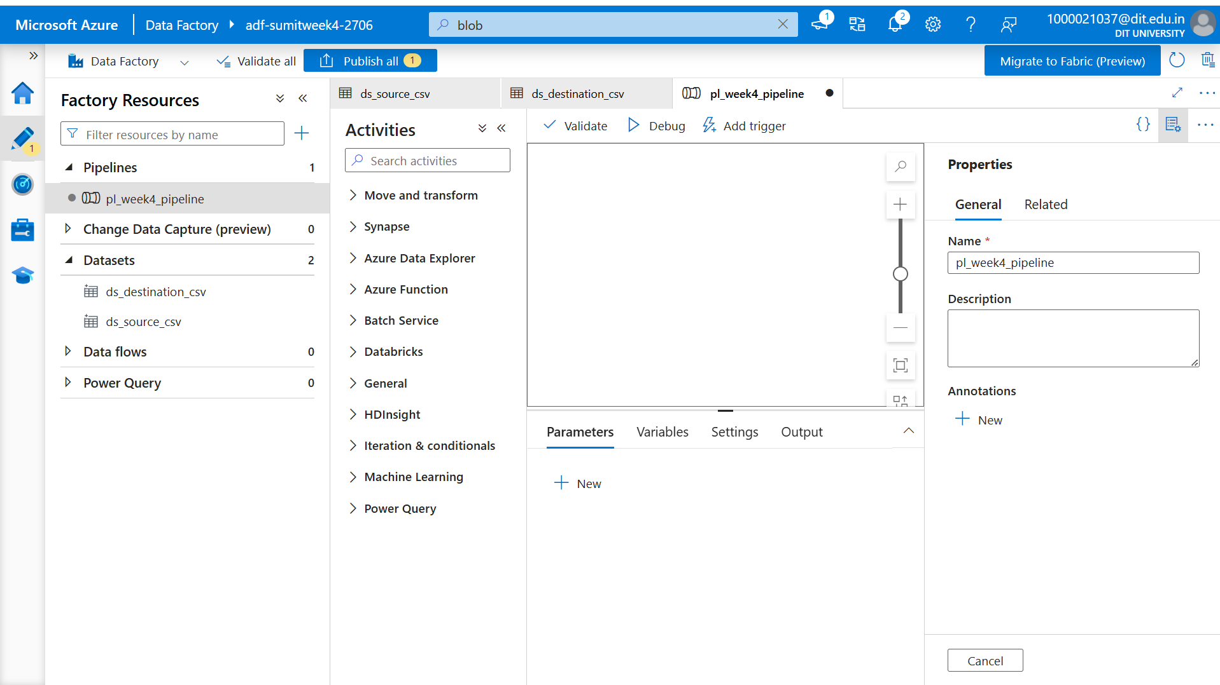

6. Task 5: Pipeline Execution

Overview
Once the pipeline was designed, it was executed and validated using ADF's Debug mode and Trigger Now option. Execution status and run duration were verified through the Monitor tab.

Steps Performed
Step 1: Clicked "Debug" to run the pipeline in test mode and observed the live output pane for activity status.
Step 2: Confirmed both the Get Metadata and Copy Data activities completed with a "Succeeded" status.
Step 3: Triggered the pipeline using "Add trigger → Trigger now" for an actual (non-debug) run.
Step 4: Navigated to the Monitor tab to review the pipeline run history, execution duration, and final status.

Deliverable: Screenshot of Pipeline Execution (Succeeded)

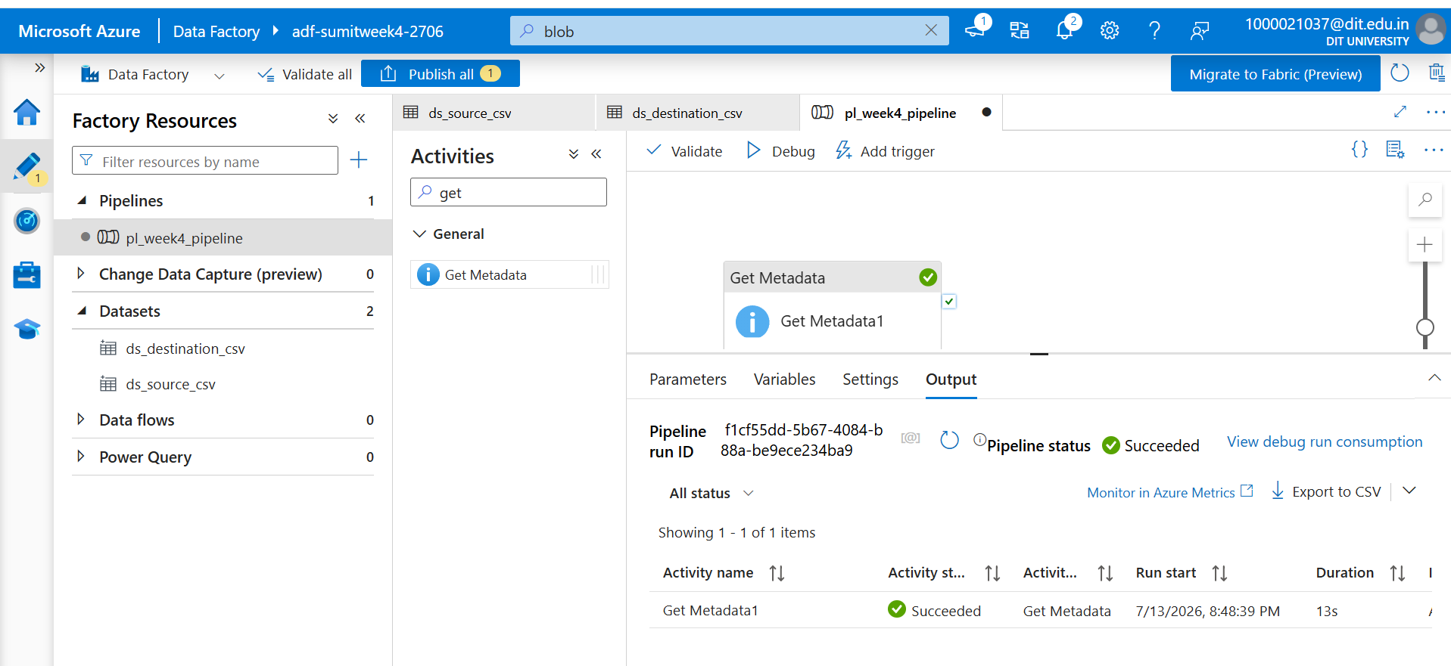

7. Task 6: IAM Roles

Overview
To follow the principle of least privilege and ensure secure, controlled access between Azure Data Factory and the Storage Account, Identity and Access Management (IAM) roles were assigned. Azure's role-based access control (RBAC) was used to grant the ADF managed identity the "Storage Blob Data Contributor" role on the storage account, and a Reader role was reviewed at the resource group level.

Steps Performed
Step 1: Navigated to the Storage Account's Access Control (IAM) blade.
Step 2: Clicked "+ Add" → "Add role assignment" and selected the "Storage Blob Data Contributor" role.
Step 3: Assigned access to a Managed Identity, selecting the Azure Data Factory instance created in Task 3.
Step 4: Reviewed and confirmed the role assignment, granting ADF the necessary permissions to read from and write to the storage account.
Step 5: Reviewed the Reader role at the Resource Group level for broader visibility across resources.

Deliverable: Screenshot of Role Assignment

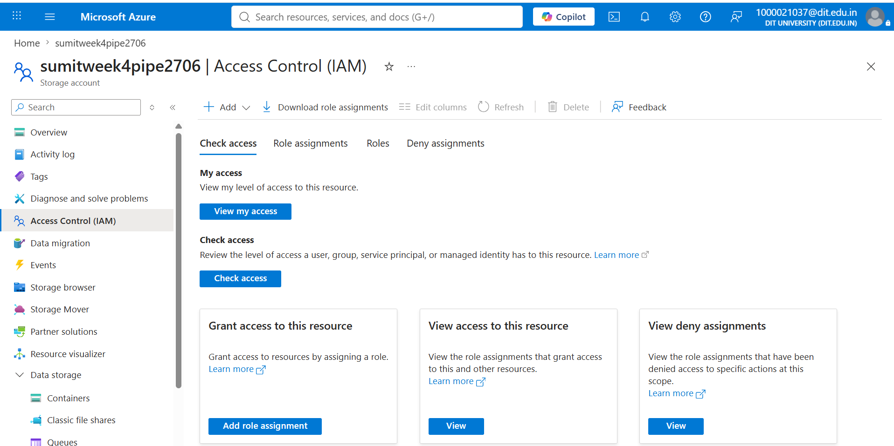

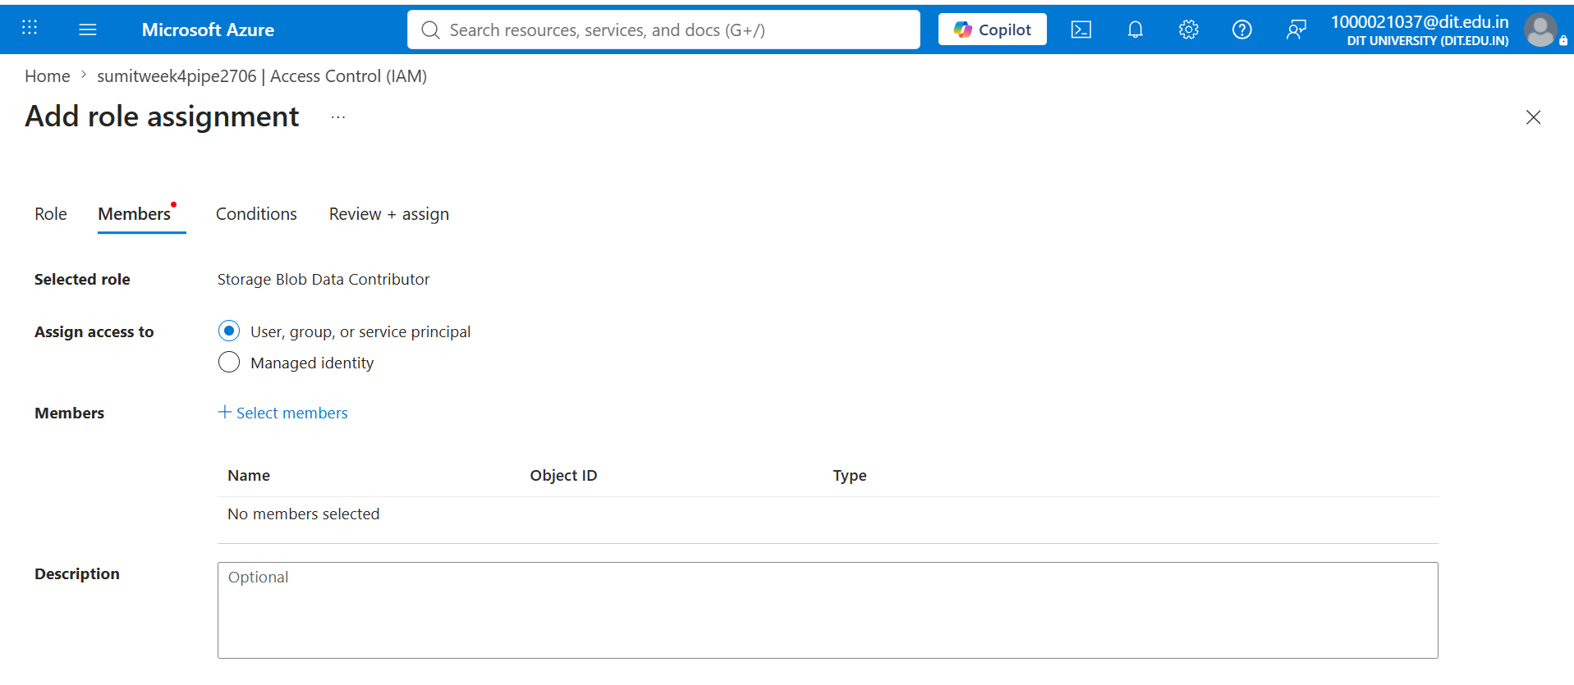

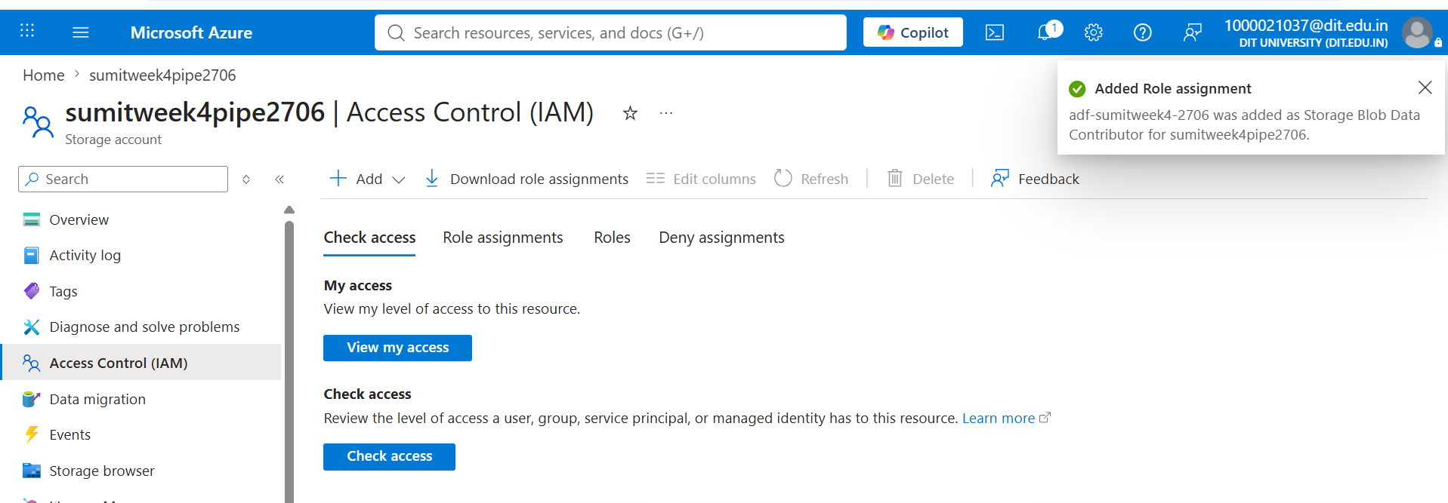

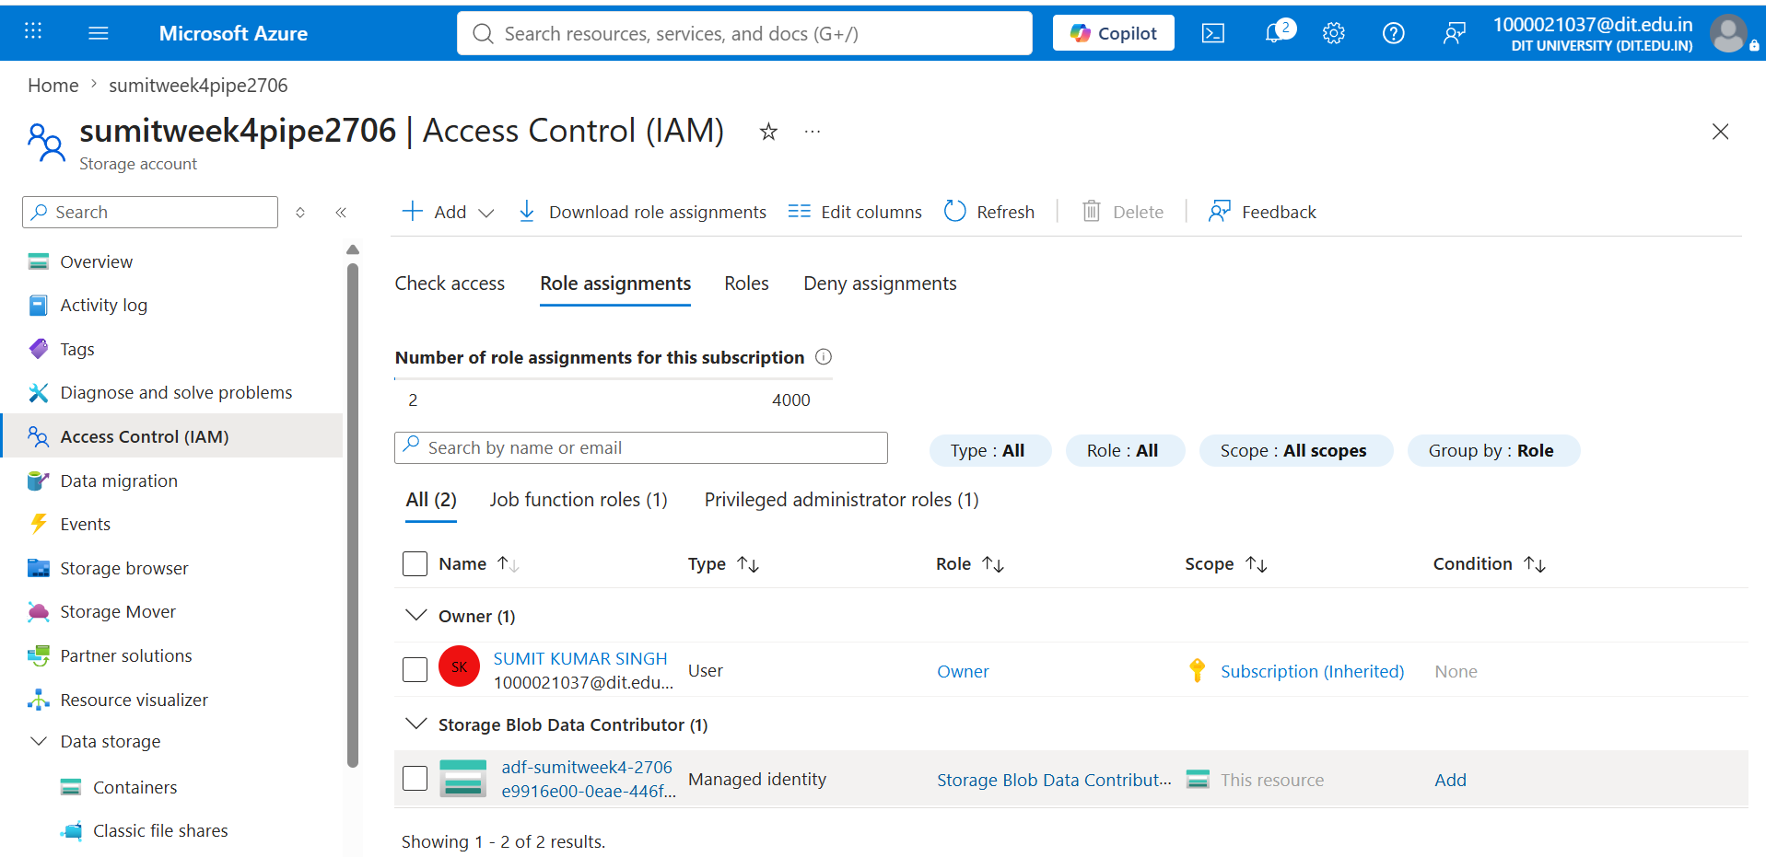

8. Mini Project (Final Task)

Problem Statement
Build a complete, end-to-end pipeline that reads a CSV file from Azure Blob Storage and processes it using Azure Data Factory, validating file metadata prior to copying the data to a new destination location.

Requirements
- Source: CSV file stored in an Azure Blob container (source-data).
- Components used: Linked Service (Azure Blob Storage) + Datasets (source and destination) + Pipeline.
- Process: Get Metadata activity for file validation, followed by Copy Data activity for data movement.
- Destination: A new container/location (destination-data) within the same storage account.

Implementation Summary
The pipeline pl_week4_pipeline was designed with two chained activities. The Get Metadata activity first retrieves the source file's name, size, and last-modified timestamp, confirming the file exists and is accessible before any data movement begins. On successful validation, the Copy Data activity executes, transferring the CSV file from the source-data container to the destination-data container. The entire workflow was tested in Debug mode and subsequently executed via Trigger Now, with both runs completing successfully as verified in the Monitor tab.

Expected Output — Verification
- Pipeline executed successfully (Get Metadata → Copy Data, both Succeeded).
- Data copied to the destination container (destination-data).
- Metadata validated prior to copy (file name, size, and last modified timestamp confirmed).

Deliverable: Screenshot of Destination Container (Final Proof)

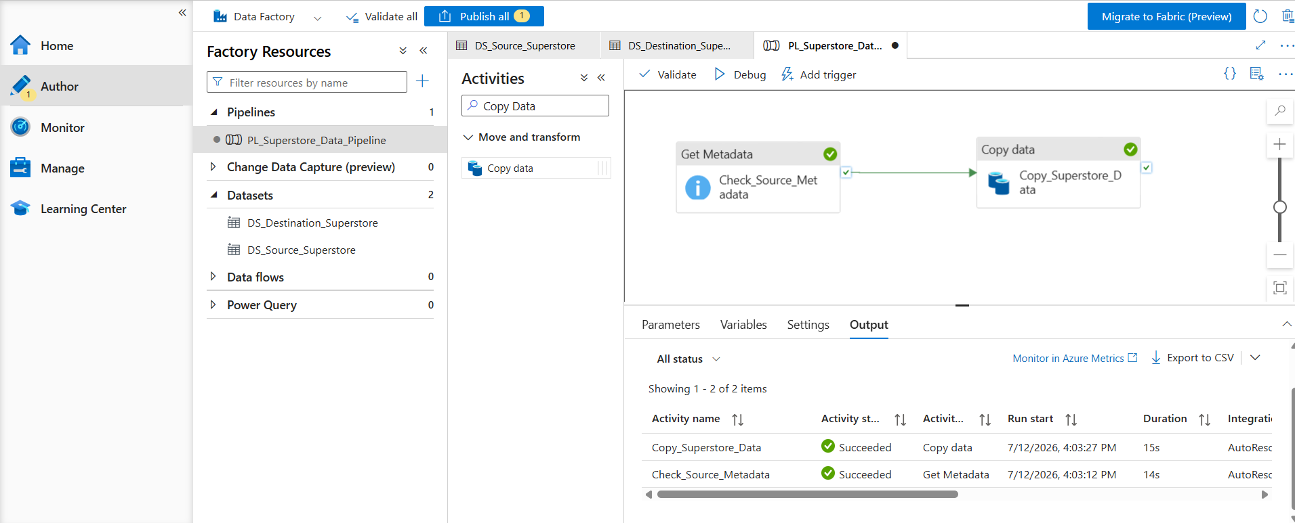

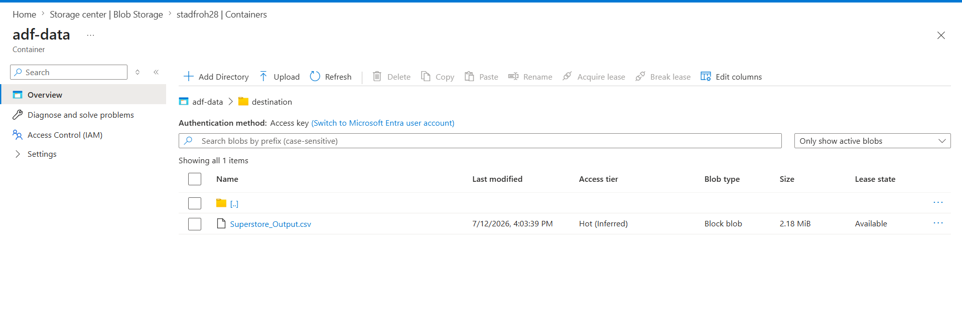
- Metadata validated: The Get Metadata activity successfully validated the source CSV file metadata before the Copy Data activity was executed.

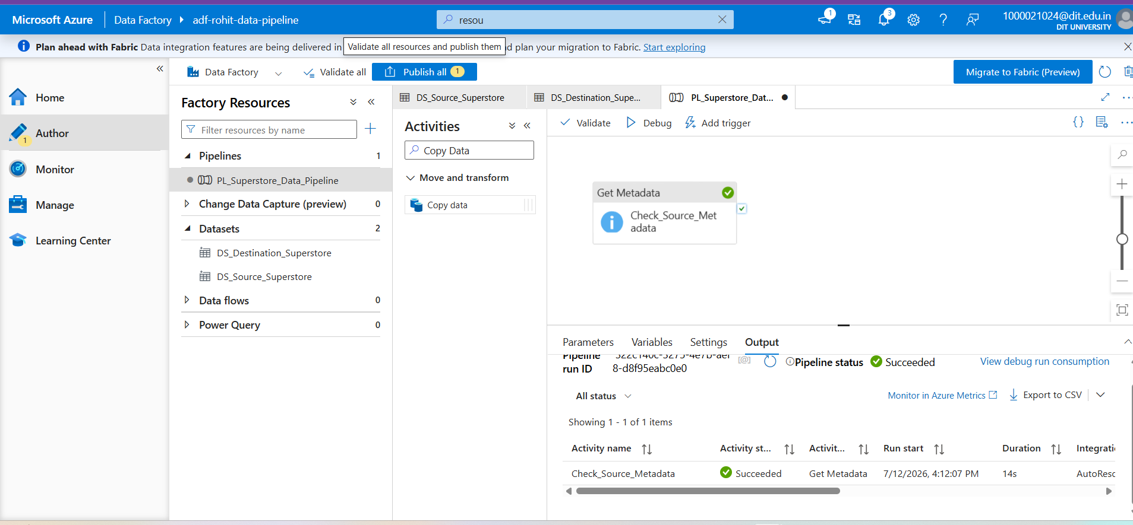

9. Conclusion
This assignment provided practical, hands-on experience with core Microsoft Azure services, including Resource Groups, Storage Accounts, Blob Containers, and Azure Data Factory. Through the process of provisioning resources, configuring Linked Services and Datasets, and building a validated Copy Data pipeline, a clear understanding was developed of how Azure orchestrates secure, automated data movement in the cloud. Troubleshooting the region-restriction deployment error also reinforced practical problem-solving skills relevant to real-world Azure administration. The successful execution of the end-to-end pipeline — from source validation through to destination copy — confirms that the core objectives of the assignment were achieved.

