DIT UNIVERSITY
Department of Data Engineering

Data Engineering – Week 5
Spark DataFrames: Data Cleaning, Transformation & Aggregation Assignment

INTRODUCTION :

Student Name: Sumit Kumar Singh Registration / Intern ID: CT_CSI_DE_1082
Department: Data Engineering College / University: DIT University
Faculty / Mentor: HR Tarun Sir Date of Submission: 20 July 2026
Course Name: Data Engineering003 – Celebal Summer Internship (CSI)
Subject: Data Engineering (Apache Spark / PySpark)

Question 1
What are the key limitations of traditional MapReduce that make Spark a preferred choice for modern big data processing?

Answer

As I learn the key limitations of traditional maps :

Disk I/O overhead: MapReduce writes intermediate results to disk after every Map and Reduce phase, causing heavy read/write latency. Spark keeps data in memory (RDDs/DataFrames) across operations.

Poor support for iterative algorithms: ML algorithms (like gradient descent) need multiple passes over data. MapReduce re-reads/re-writes to disk each iteration; Spark caches data in RAM.

No interactive/ad-hoc querying: MapReduce is batch-only. Spark supports interactive shells, SQL, and near real-time streaming.

Rigid programming model: MapReduce only offers Map and Reduce; Spark offers a rich set of transformations (map, filter, join, groupBy, window functions, etc.).

Higher latency for small jobs: JVM startup and scheduling overhead per job is high in MapReduce; Spark's DAG scheduler optimizes execution across the whole pipeline.
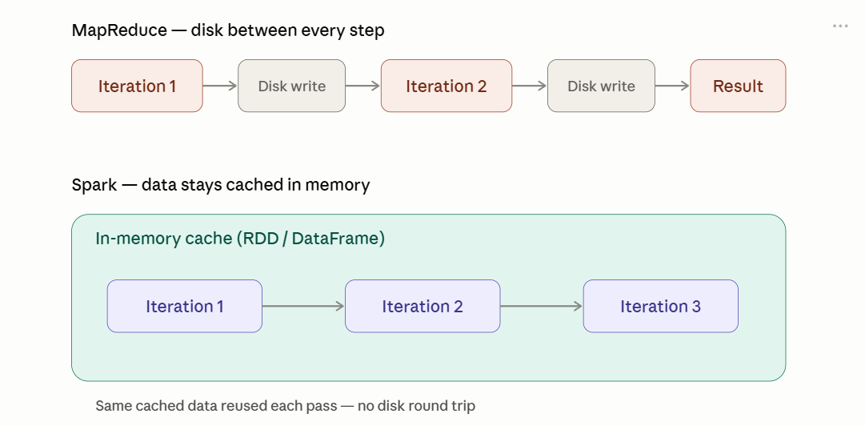

Question 2
Explain how Spark uses In-Memory Computing to speed up iterative machine learning algorithms compared to disk-based systems.

Answer
In disk-based systems (like classic MapReduce), each iteration of an algorithm (e.g., k-means, logistic regression) reads input from disk, processes it, writes output back to disk, and the next iteration reads it again. This repeated I/O dominates runtime.
Spark instead loads the dataset into memory once (via .cache() or .persist()) as an RDD/DataFrame. Each iteration reuses this in-memory copy, only recomputing the transformation logic, not re-reading from disk. This can make iterative ML 10-100x faster.
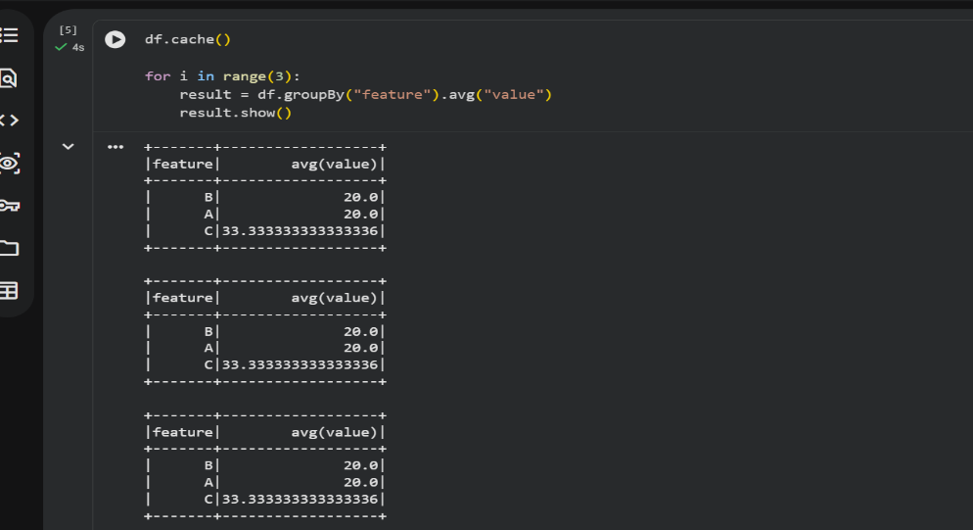

Question 3
Write a code snippet to remove all duplicate rows from a DataFrame based on a specific set of columns: user_id and transaction_date.

Answer
The dropDuplicates() method can take a list of column names to define what counts as a duplicate:
df_clean = df.dropDuplicates(["user_id", "transaction_date"])

df_clean.show()

This keeps only the first occurrence of each unique combination of user_id and transaction_date, and removes the rest.
- dropDuplicates() without arguments checks all columns; passing a list checks only those specific columns.
- Even if other columns (like amount) differ, rows are still considered duplicates if user_id and transaction_date match.
- Useful when the same event might get logged twice with slightly different metadata.

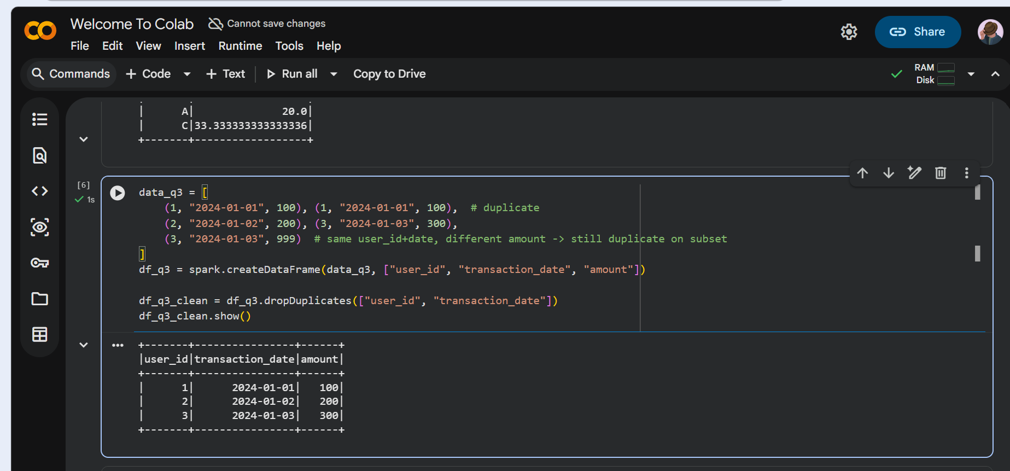
Question 4
Given a DataFrame df_sales, write a query to filter for rows where the region is 'West' and then group by product_category to find the average sale_amount.

Answer

.filter() happens first to reduce the dataset before grouping — filtering early is more efficient than filtering after aggregation.

.groupBy().agg() is the standard pattern for category-wise statistics.

Chaining filter → groupBy → agg keeps the code readable and mirrors SQL's WHERE → GROUP BY → aggregate order.
from pyspark.sql.functions import avg

result = (df_sales
.filter(df_sales.region == "West")
.groupBy("product_category")
.agg(avg("sale_amount").alias("avg_sale_amount")))

result.show()

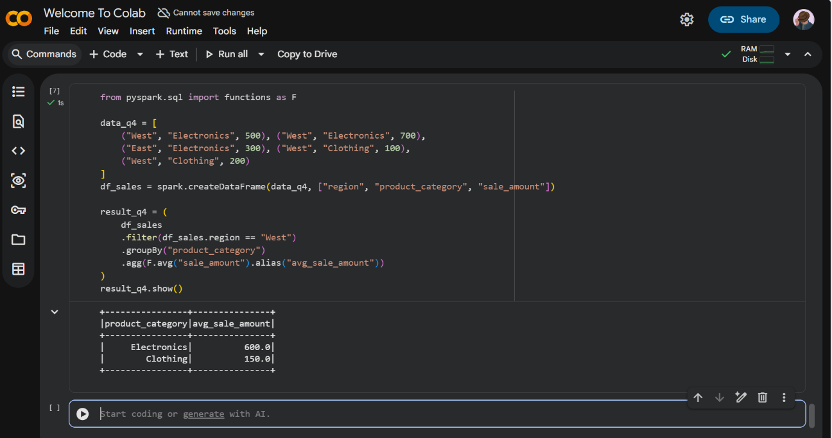

Question 5
What is the difference between .na.drop() and .na.fill()? Provide a code example of filling null values in a status column with the string 'Unknown'.

Answer
.na.drop() removes rows that contain null values (by default, any null in any column, though a subset of columns can be specified). It is useful when incomplete rows should be discarded entirely.
.na.fill() replaces null values with a specified default value while keeping the row in the dataset. It can accept a single value applied to all compatible columns, or a dictionary mapping specific column names to fill values.
df_filled = df.na.fill({"status": "Unknown"})

df_filled.show()

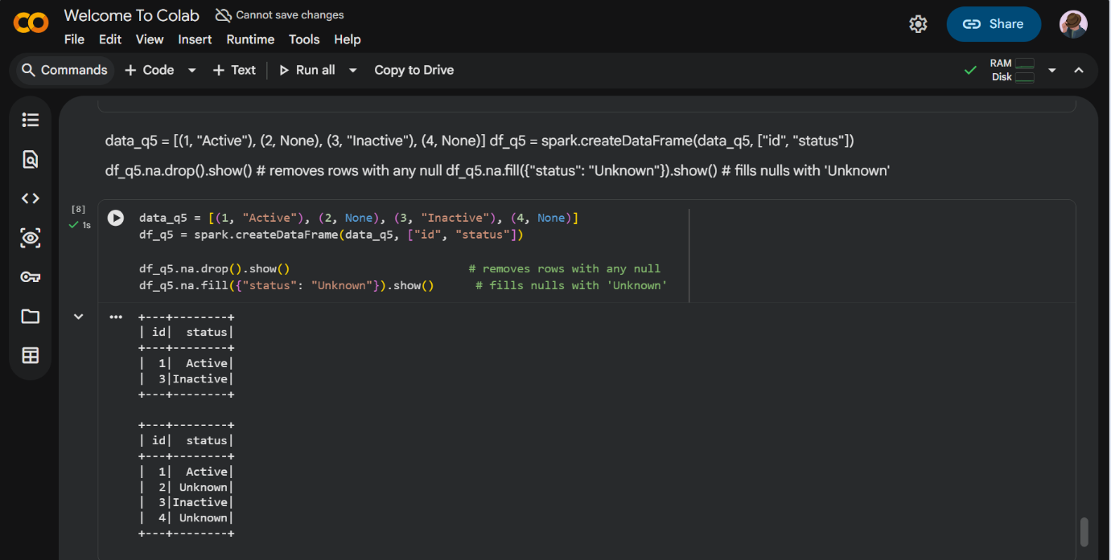

Question 6
Write a query to find the total count of records for each city in a DataFrame, but only for cities where the count is greater than 100.

Answer
from pyspark.sql.functions import col

result = (df.groupBy("city")
.count()
.filter(col("count") > 100))

result.show()

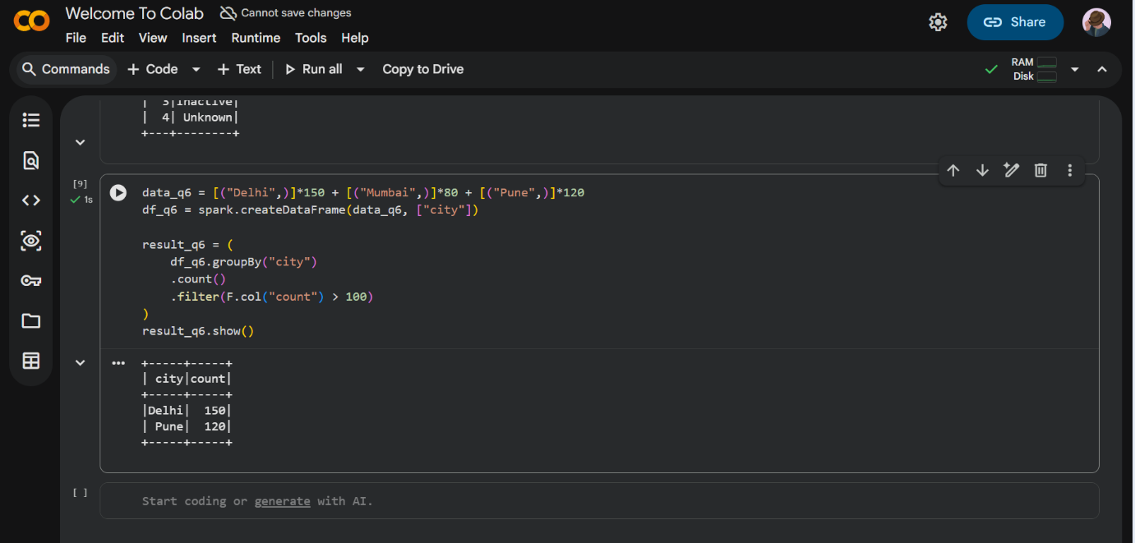

Question 7
How does the immutability of Spark DataFrames affect how you perform "data cleaning" steps like dropping columns or renaming them?

Answer
Spark DataFrames are immutable, meaning no transformation modifies the original DataFrame object in place. Operations such as .drop("column") or .withColumnRenamed("old", "new") do not change df directly — instead, each one returns a brand-new DataFrame representing the transformed data.
Because of this, cleaning steps must be chained together or explicitly reassigned to a variable (often the same variable name) to persist the change, for example: df = df.drop("temp_col").withColumnRenamed("old_name", "new_name").
This immutability also enables Spark's lazy evaluation model: each transformation simply adds a new node to a logical execution plan (DAG), which the Catalyst optimizer can analyze and optimize as a whole before any actual computation happens, rather than executing each step eagerly.
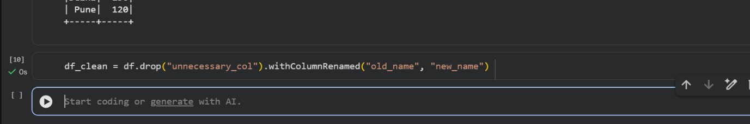

Question 8
Write a Spark command to filter a dataset for rows where the age is between 18 and 30 (inclusive) and the subscription is 'Premium'.

Answer
from pyspark.sql.functions import col

result = df.filter((col("age").between(18, 30)) & (col("subscription") == "Premium"))

result.show()

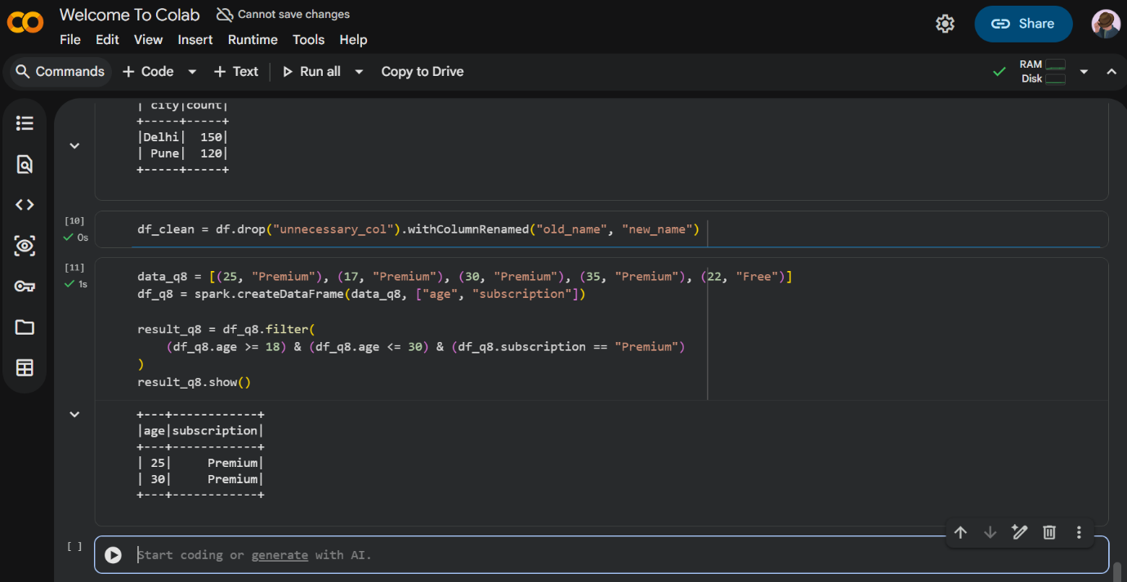

Question 9
When cleaning a dataset, why is it often better to handle null values before performing mathematical aggregations like sum() or avg()?

Answer
Null values represent missing or unknown data, and mathematical aggregation functions handle them inconsistently depending on context — for example, arithmetic on a null-containing derived column can itself produce null, and averages/sums computed over columns with unhandled nulls can be skewed or misleading (e.g., a wrong denominator when computing an average).
Functions like sum() and avg() silently ignore nulls in Spark, but if enough rows have nulls, the aggregate becomes misleading — e.g., avg() computed on 3 valid rows out of 10 gives a very different result than intended if the 7 nulls actually should have been zeros. Cleaning nulls first (via .na.fill() or .na.drop()) ensures the aggregation reflects a deliberate, correct decision rather than silently skewing the result.

Question 10
Write the code to revise a column named raw_timestamp by casting it to a TimestampType and renaming it to event_time.

Answer
from pyspark.sql.functions import col
from pyspark.sql.types import TimestampType

df = (df.withColumn("event_time", col("raw_timestamp").cast(TimestampType()))
.drop("raw_timestamp"))

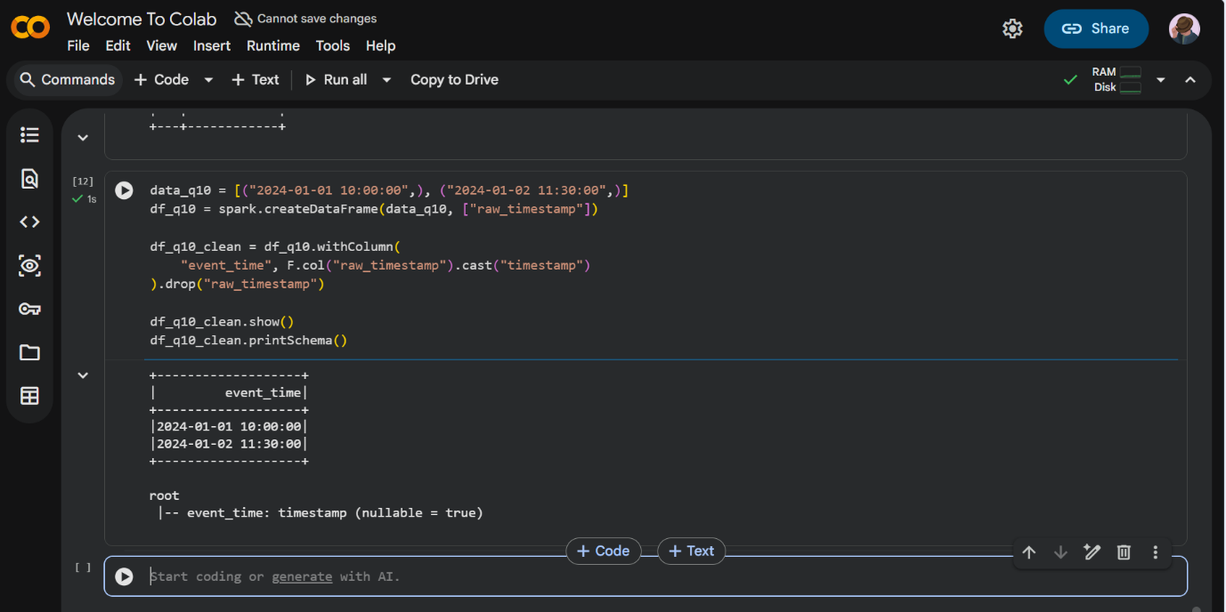

Question 11
Explain the "Shuffle" process that occurs during a grouping operation. Why is it considered a wide transformation?

Answer
When a grouping operation such as groupBy is executed, Spark needs to bring together all records that share the same key so an aggregation can be computed per key. Since the data is distributed across partitions on different executors, rows with the same key may live on different nodes.
The shuffle process redistributes data across the cluster: on the map side, each executor writes its data to disk, organized/partitioned by key; then, on the reduce side, each output partition reads (pulls) the relevant records for its assigned keys over the network from all the other partitions. This involves disk writes, network transfer, and serialization/deserialization, making shuffles the most expensive operations in Spark.
It is called a wide transformation because each output partition can depend on data from many (or all) input partitions — unlike a narrow transformation such as filter or map, where each output partition depends on only a single input partition. Wide transformations mark stage boundaries in Spark's execution DAG.

Question 12
Write a code snippet that identifies and removes rows where the email column contains null values OR the username is an empty string.

Answer
from pyspark.sql.functions import col

df_clean = df.filter(~(col("email").isNull() | (col("username") == "")))

df_clean.show()

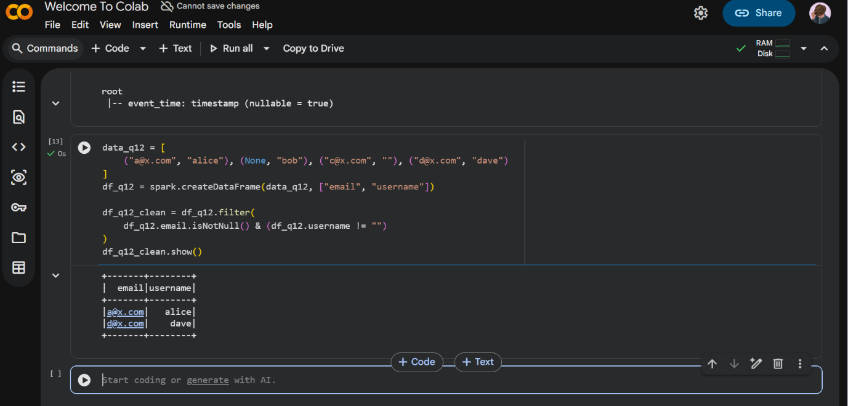

Question 13
How do you use the .agg() function to calculate multiple statistics at once, such as the min, max, and mean of the price column?

Answer
from pyspark.sql.functions import min, max, mean

result = df.agg(
min("price").alias("min_price"),
max("price").alias("max_price"),
mean("price").alias("mean_price")
)

result.show()

Passing multiple aggregate expressions to a single .agg() call computes all of them in one pass over the data, which is more efficient than calling separate actions for each statistic.
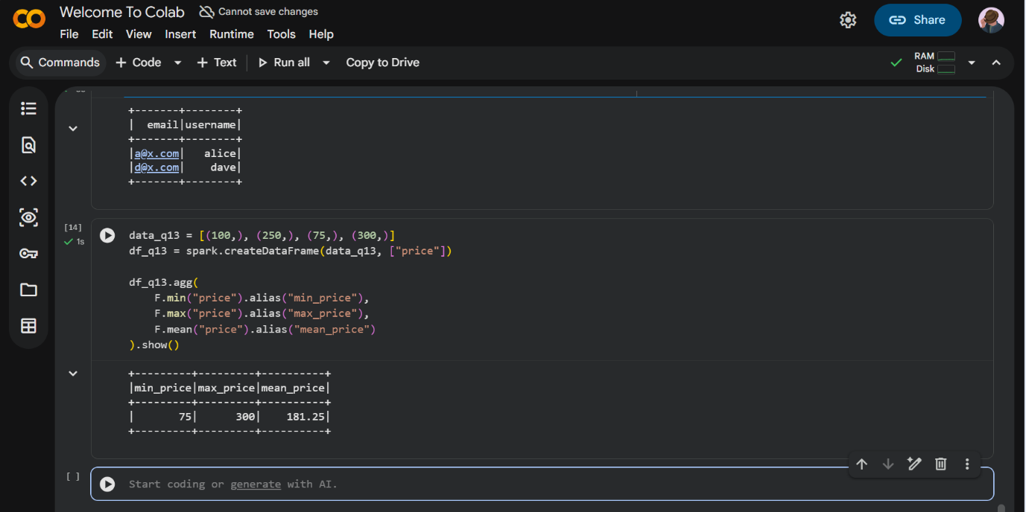

Question 14
In the context of cleaning a dataset, what is the risk of using inferSchema=true when your source data contains messy or inconsistent date formats?

Answer
With inferSchema=True, Spark samples a portion of the data to guess each column's data type automatically. If a date column contains inconsistent formats (for example, a mix of "DD/MM/YYYY" and "YYYY-MM-DD", or some rows with invalid/garbage values), Spark's inference logic may fall back to treating the entire column as StringType rather than a proper DateType or TimestampType.
Because inference is based only on a sample rather than the full dataset, problems that exist in the un-sampled rows may not be detected at load time, and can silently surface later as parsing errors, incorrect sort/filter behaviour, or unexpected nulls after casting.
For messy data, it is safer to explicitly define a StructType schema and parse/cast date columns deliberately using a known format string, rather than relying on automatic inference.

Question 15
Write a final processing pipeline that: 1. Filters out duplicates. 2. Fills null prices with 0. 3. Groups by store_id to calculate total revenue.

Answer
from pyspark.sql.functions import sum as _sum

final_df = (df
.dropDuplicates()
.na.fill({"price": 0})
.groupBy("store_id")
.agg(_sum("price").alias("total_revenue")))

final_df.show()

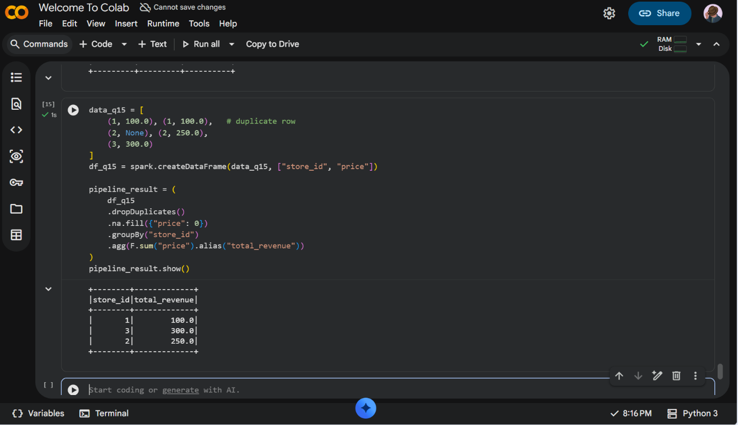

Conclusion
This assignment covers the fundamentals of Apache Spark and its advantages over traditional MapReduce, including in-memory computation and DAG-based execution. It demonstrates practical PySpark DataFrame operations for data cleaning (handling nulls and duplicates), filtering, schema modification, and aggregation using groupBy and agg(). Together, these exercises build a complete, working understanding of how to design and implement an end-to-end Spark data-cleaning and aggregation pipeline, from raw, messy data to a clean, analysis-ready dataset.

References
Apache Spark Official Documentation – https://spark.apache.org/docs/latest/
PySpark API Reference – https://spark.apache.org/docs/latest/api/python/
Celebal Technologies – Data Engineering003 Course Portal (CSI Learning Portal)

