

American International University-Bangladesh (AIUB)  
**Department of Computer Science  
Faculty of Science &Technology (FST)  
Spring 22 23**

[**Lawyer Connect: Find Your Legal Expert**](https://sumitchakraborty218.atlassian.net/browse/LCFYLE)

Software Requirement Engineering

Sec: **A**

Project submitted

By

*SUMIT CHAKRABORTY (20-43472-1)*

*MRIDUL KUMAR ROY (20-43517-1)*

*MD. JAHID HASAN (20-43466-1)*

*MD. AFIF ALL REZA (20-43409-1)*

**Checked By Industry Personnel**

Name: Md. Shamim Shahnawaz

Designation: Project Manager

Company: SEBPO

Sign:

Date: 01/05/2023

1. **PROBLEM DOMAIN**
   1. **Background to the Problem**

In Bangladesh, it is very difficult to find a qualified and reliable lawyer for specific needs. For example, land issues, accident cases, taxation, etc. Especially for those, who do not have personal connections in the legal industry. Many people rely on recommendations from family and friends or simply search for lawyers online or in directories. However, this process can be time-consuming, financially challenging and there is no guarantee of finding a lawyer who is suitable for the specific legal needs. Furthermore, in Bangladesh it is very hard for the people below the poverty line to access legal assistance. For this reason, they often fall victim of unwanted circumstances.

**Root Cause:**

The main problem is, the lack of a reliable and efficient system where people can find book appointments with lawyers in Bangladesh. It is also one of the serious issues which affects individual people and businesses across the country. The root cause of this problem is lack of centralized and extensive database of lawyers and their respective fields. For this reason, people find very difficult to connect with the lawyers. Furthermore, it is very hard to find the information on lawyer availability and scheduling appointments. As a result, people often rely on the recommendations and spend a lot of time, effort and money to meet their legal needs.

**Importance:**

It is very important to develop a system where people can easily find and book appointments with lawyers in Bangladesh. Firstly, it will help people access to justice by making it easier to find qualified lawyers. This is will also improve the overall justice system in Bangladesh and the development of the legal system. In addition, people's legal rights will be protected. Secondly, it will provide valuable legal services to the medium and small-sized enterprises, who may not have the resources to hire big law firms. Thirdly, the poor people can also benefit from this platform as it can be used very cost efficiently. Finally, this platform has the potential to drive innovation and digitization of the legal industry in Bangladesh, which will also boost the industry.

* 1. **Solution to the Problem**

To address the issue of discovering and booking appointments with lawyers in Bangladesh, we propose creating a web or application-based platform with the following features:

A comprehensive directory of verified lawyers with competence in a variety of legal disciplines, including credentials and client ratings. A search feature that will help users discover lawyers based on their legal needs, location, availability, and other related characteristics. A booking system that will allow users to schedule appointments with lawyers directly through the platform, with the option of online or in-person consultations.  
A user-friendly interface that allows clients to easily explore and use the site. This solution is especially well-suited to the problem because it provides a centralized and efficient mechanism for locating and booking meetings with lawyers in Bangladesh. By removing the need for phone conversations or in-person visits to law firms, the platform will save consumers time and effort. It will also give customers access to a larger pool of lawyers with various experiences, guaranteeing that they can find the best counsel for their legal needs.

The proposed solution is practical in terms of meeting the business goal since it matches with the company's vision of developing innovative software solutions that add value to users. The platform will generate cash for the corporation through booking commissions and advertising, making it a successful enterprise.

**Software Description:**

The program we're talking about is a web or application-based platform that will make it simple for people in Bangladesh to find and book appointments with lawyers. Users will have access to a database of verified lawyers with skills in a variety of legal disciplines, as well as ratings and reviews from previous clients. Users will be able to find lawyers based on their legal requirements, location, availability, and other pertinent characteristics. They will also be able to make appointments with lawyers directly through the platform, which will eliminate the need for phone calls or in-person visits to law offices.

The software's primary goals are to increase access to justice by making it easier for people to find qualified and trustworthy lawyers, to provide a valuable service to businesses, particularly small and medium-sized enterprises, and to drive innovation and digitization in Bangladesh's legal industry.

**Existing Studies:**

In Bangladesh, there are already various online directories and websites that provide information on lawyers and law companies. However, these resources are frequently insufficient or out of date, making it difficult for users to find trustworthy information. There are also some legal tech businesses in Bangladesh that provide online legal services, but they often specialize on certain legal fields, such as contract writing or dispute resolution, rather than offering a holistic solution for discovering and reserving appointments with lawyers.

Overall, the proposed solution is a novel and inventive approach to the problem of discovering and scheduling appointments with lawyers in Bangladesh, and it has the potential to have a substantial impact on the country's legal industry.

1. **SOLUTION DESCRIPTION**

2.1 **System Features:**

**System Features:**

1. **Lawyer Database:**

* **Functional Requirements:** 
  + Store lawyer profiles with their credentials and legal expertise.
  + Allow lawyers to update their profiles and availability.
  + Allow users to search for lawyers based on their legal needs, location, availability, and other relevant criteria.
  + Display lawyer ratings and reviews from past clients.
* **Quality Attributes:** 
  + Data accuracy and completeness.
  + Search speed and accuracy.
  + User-friendly and intuitive interface.
  + Privacy and security of lawyer and client data.

1. **Appointment Booking System:**

* **Functional Requirements:** 
  + Allow users to schedule appointments with lawyers directly through the platform.
  + Provide options for online or in-person consultations.
  + Send appointment confirmation and reminders to users and lawyers.
  + Allow users and lawyers to reschedule or cancel appointments.
* **Quality Attributes:** 
  + Reliability and availability of the booking system.
  + User-friendly and intuitive interface.
  + Efficient communication between users and lawyers.
  + Notification accuracy and timeliness.

1. **User Management:**

* **Functional Requirements:** 
  + Allow users to create and manage their profiles.
  + Provide user authentication and authorization.
  + Allow users to view their appointment history and ratings/reviews.
* **Quality Attributes:** 
  + Security of user data and privacy.
  + User-friendly and intuitive interface.
  + Efficient communication between users and lawyers.
  + Notification accuracy and timeliness.

1. **Lawyer Management:**

* **Functional Requirements:** 
  + Allow lawyers to create and manage their profiles.
  + Provide lawyer authentication and authorization.
  + Allow lawyers to view their appointment history and ratings/reviews.
* **Quality Attributes:** 
  + Security of lawyer data and privacy.
  + User-friendly and intuitive interface.
  + Efficient communication between users and lawyers.
  + Notification accuracy and timeliness.

1. **Payment System:**

* **Functional Requirements:** 
  + Allow users to make payments for their appointments.
  + Provide secure payment processing and management.
  + Generate invoices and receipts for users and lawyers.
* **Quality Attributes:** 
  + Security and accuracy of payment processing.
  + User-friendly and intuitive interface.
  + Efficient and reliable payment processing.
  + Notification accuracy and timeliness.

1. **Search Engine Optimization (SEO):**

* **Functional Requirements:** 
  + Optimize the website/app for search engines.
  + Research and use relevant keywords to improve search ranking.
  + Implement meta tags and descriptions for each lawyer profile.
* **Quality Attributes:** 
  + Improved visibility and discoverability of the platform.
  + Increased website/app traffic and user engagement.
  + Improved search engine ranking.
  + Efficient and effective use of SEO techniques.

1. **Notification System:**

* **Functional Requirements:** 
  + Send automated notifications to users and lawyers for appointment confirmations, reminders, cancellations, and rescheduling through portal.
* **Quality Attributes:** 
  + Notification accuracy and timeliness.
  + User-friendly and intuitive interface.
  + Efficient and reliable notification delivery.
  + Customizable notification settings.

1. **Feedback System:**

* **Functional Requirements:** 
  + Allow users to leave feedback and ratings for lawyers after their appointments.
  + Display lawyer ratings and reviews on their profile.
  + Allow lawyers to respond to feedback and ratings.
* **Quality Attributes:** 
  + User-friendly and intuitive interface.
  + Efficient and effective feedback collection and management.
  + Accurate display of lawyer ratings and reviews.
  + Constructive and respectful feedback environment.

1. **Reporting:**

* **Functional Requirements:** 
  + Collect and analyze platform usage data.
  + Generate reports on user and lawyer activity, appointment history, and revenue.
* **Quality Attributes:** 
  + Data accuracy and completeness.
  + Efficient and effective data collection and analysis.
  + User-friendly and intuitive reporting interface.
  + Timely and relevant data insights.

1. **Integration with External Services:**

* **Functional Requirements:** 
  + Integrate the platform with external services such as online payment gateways and third-party scheduling software.
  + Allow users to make payments through their preferred payment gateway.
* **Quality Attributes:** 
  + Seamless integration with external services.
  + Secure and reliable payment processing.
  + Efficient and effective integration design.
  + User-friendly and intuitive interface for external service integration.
  1. **UML Diagrams**

**Use-case diagram:**

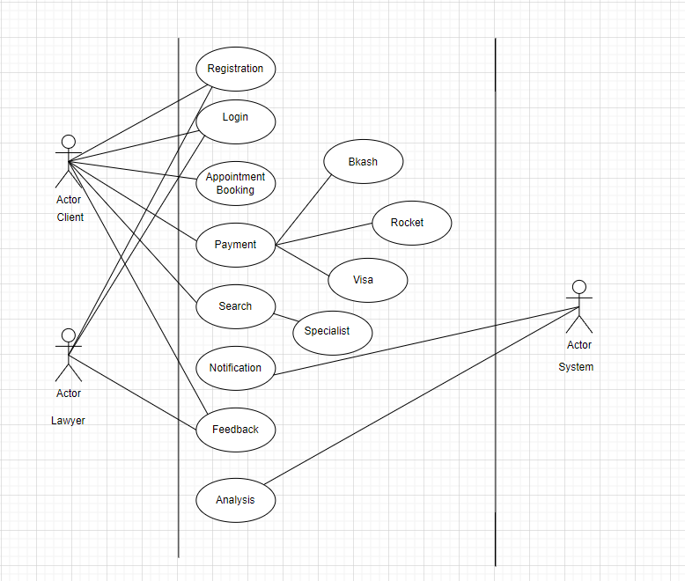

**Activity Diagram:**

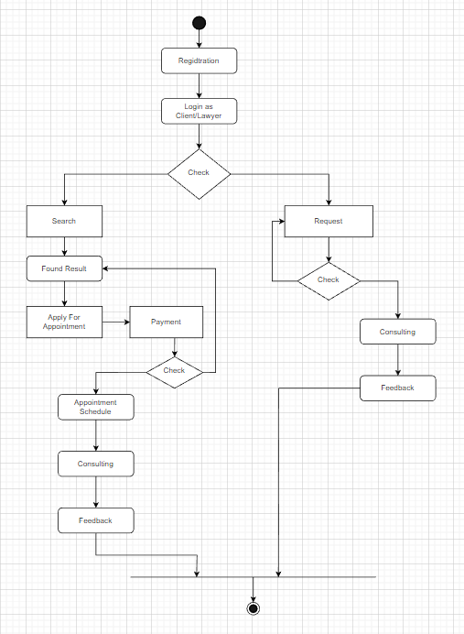

**E-R diagram:**

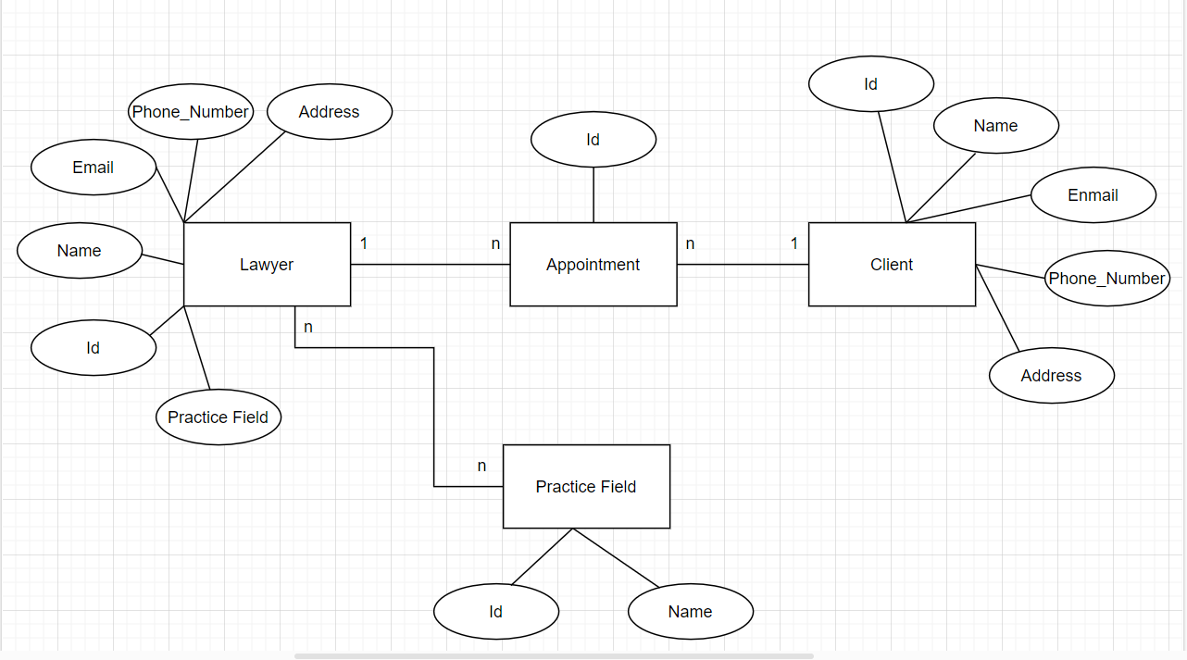

1. **Social Impact**

The proposed project concept of a web or mobile application for discovering and booking appointments with lawyers in Bangladesh has the potential to bring about a number of societal advantages.

For instance, the app can make legal services more accessible to people who might not have been able to find or afford a lawyer otherwise. This can assist to close the justice gap and ensure that everyone, regardless of poverty or location, has access to legal representation and guidance.

In addition, the platform has the ability to increase the efficiency of the legal system by making it easier for lawyers to interact with potential clients and organize their appointments. This can save lawyers time and resources spent on finding new clients and managing their calendars, resulting in cost savings and enhanced productivity.

Furthermore, by allowing users to submit feedback and ratings for the lawyers with whom they work, the platform can enhance transparency and accountability in the legal business. This can assist ensure that lawyers provide high-quality services and foster confidence between lawyers and clients.

In summary, the proposed project has the potential to improve access to legal services, increase legal sector efficiency, and promote transparency and responsibility in the legal profession.

1. **Development Plan with Project Schedule**

**Project Plan**

**Initiate Project**

**1.Develop Project Chart**

* Define Scope
* Define Requirements

**2.Finalize Charter and Gain**

* Consolidate and publish project charter
* Hold review meeting
* Revise project charter
* Gain approvals from government

**3.Plan Project**

* Develop work plan
* Develop project staffing plan
* Develop project schedule
* Develop project budget

**4.Develop Project Control Plan**

* Develop communication plan
* Develop quality management plan

**5.Design**

* Define Stages and activities
* Design content Formats
* Object design Review

**6.Build**

* Write Code
* Project Review with lawyers.

**7.Testing**

* Unit Testing
* Test of Usability

**8.Implementation**

* Move tool to production environment
* Announce Tool Arability

**9.Close Project**

**Project Schedule:**

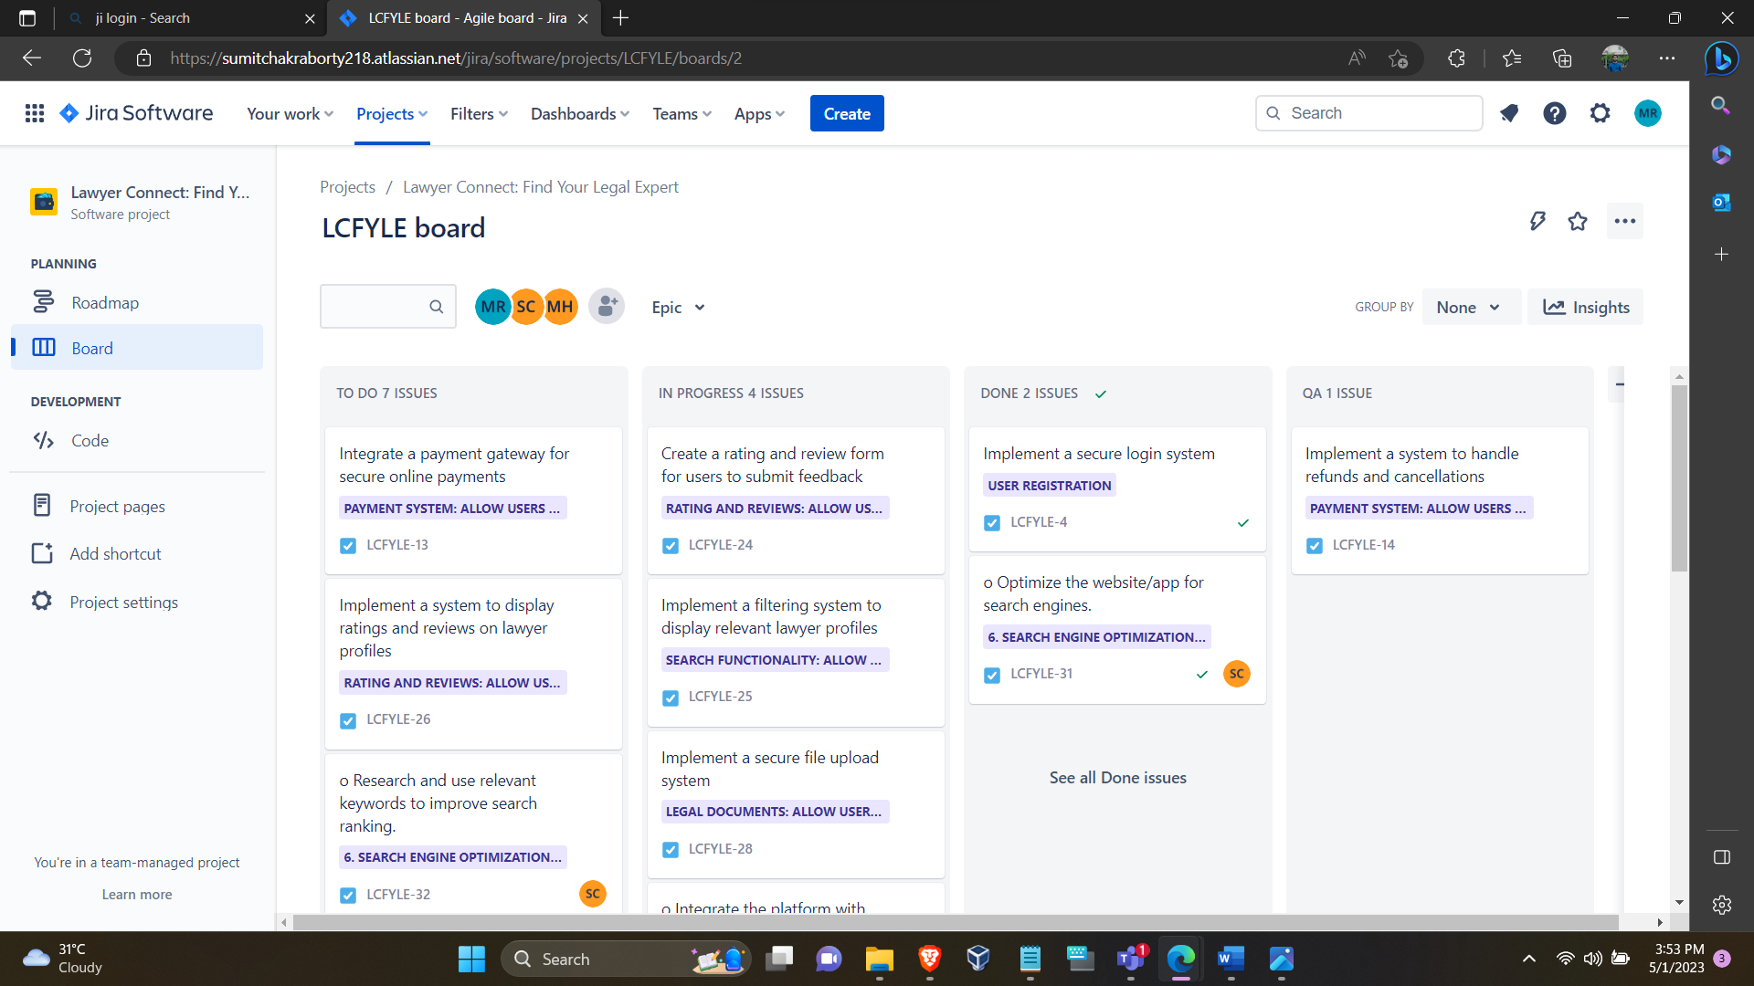

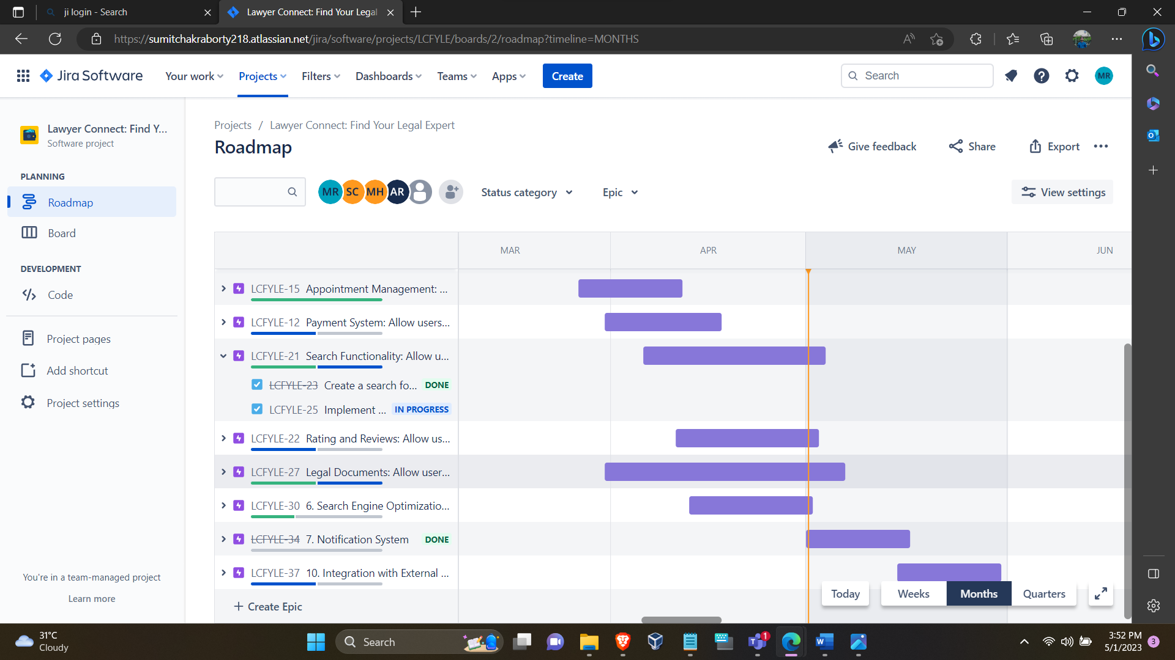

1. **Marketing Plan**

* The proposed web or mobile application for finding and arranging meetings with lawyers in Bangladesh has the potential to help both the legal sector and society as a whole. However, in order to successfully launch and promote the platform, a comprehensive marketing plan must be developed.

Short-Term Plan:

* + Build brand awareness: Use social media platforms such as Facebook, Instagram, and Twitter to promote the platform and increase brand awareness.
  + Offer introductory promotions: Provide initial discounts or free consultations to attract new users and encourage them to try out the platform.
  + Build strategic partnerships: Partner with law firms and legal associations to promote the platform to their clients and members.

Long-Term Plan:

* + Invest in Search Engine Optimization (SEO): Optimize the platform's website and content to rank higher in search engine results pages (SERPs) and increase organic traffic.
  + Implement paid advertising: Use targeted paid advertising through platforms like Google Ads and social media ads to reach a wider audience and drive traffic to the platform.
  + Expand platform features: Continuously develop and add new features to the platform to improve user experience and attract new users.

Continuous Plan:

* + Engage with users: Continuously engage with users through social media, email newsletters, and blog content to provide updates, legal news, and valuable information.
  + Build a referral program: Implement a referral program to incentivize existing users to refer new users to the platform.
  + Gather feedback and improve: Continuously gather feedback from users and make improvements to the platform to enhance user experience.

By implementing these short-term, long-term, and continuous marketing strategies, the platform can gain traction, attract new users, and establish itself as a reliable and effective solution for finding and booking appointments with lawyers in Bangladesh.

1. **Cost and Profit Analysis**

Development Cost:

Development team salaries: BDT 1,00,000 per month (for 6 months) = BDT 6,00,000

Server and hosting costs: BDT 50,000 per month (for 6 months) = BDT 3,00,000

Other development costs (e.g., software licenses, third-party APIs): BDT 1,50,000

Total development cost: BDT 10,50,000

Marketing Cost:

Social media advertising: BDT 10,000 per month

Search engine optimization (SEO) services: BDT 5,000 per month

Other marketing costs (e.g., events, partnerships): BDT 25,000 per month

Total marketing cost: BDT 40,000 per month

Revenue:

Assuming an average appointment fee of BDT 500 and 1000 appointments per month, the monthly revenue would be:

BDT 500 x 1000 = BDT 5,00,000

Profit:

Total profit = Total revenue - Total cost

Total cost = Development cost + Marketing cost

Total cost = BDT 10,50,000 + (BDT 40,000 x 6) = BDT 12,90,000

Total revenue = BDT 5,00,000 x 6 = BDT 30,00,000

Total profit = BDT 30,00,000 - BDT 12,90,000 = BDT 17,10,000

Investment Return:

Assuming investors are interested in a 10% return on their investment, the amount of investment required would be:

Investment = Total cost / (1 - Investment return rate)

Investment = BDT 12,90,000 / (1 - 0.1) = BDT 14,33,333.33

Based on the profit analysis, the project is expected to generate a profit of BDT 17,10,000, which should be attractive to potential investors. The marketing plan involves social media advertising, SEO services, and other marketing costs such as events and partnerships. The development cost includes team salaries, server and hosting costs, and other development costs. The revenue is expected to come from appointment fees, assuming an average fee of BDT 500 and 1000 appointments per month.

1. **Online meeting with Project Manager:**

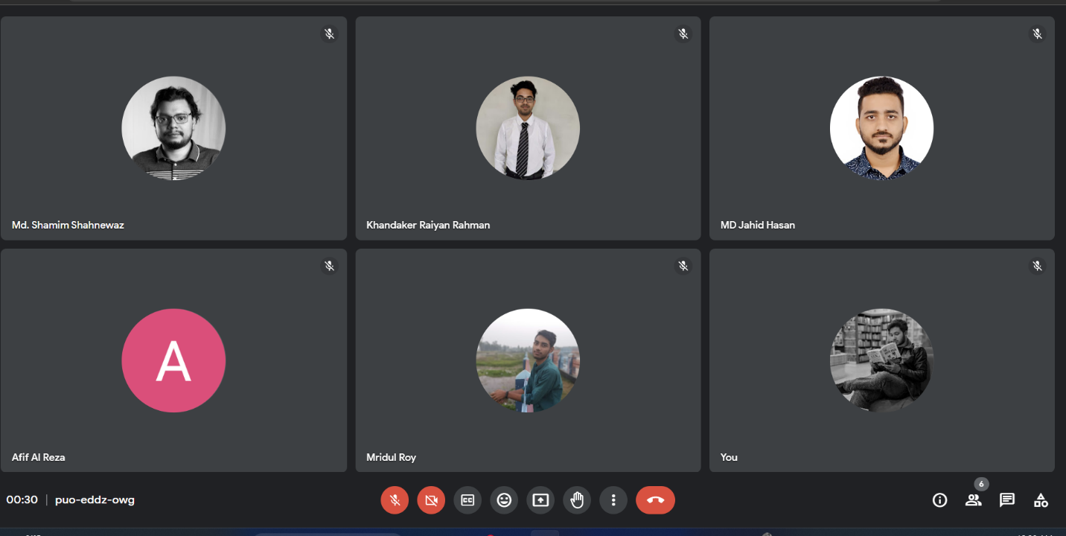

1. **Reference**
2. <https://sumitchakraborty218.atlassian.net/jira/software/projects/LCFYLE/boards/2>
3. <https://app.diagrams.net/>