**CHAPTER 1**

**INTRODUCTION**

Whether we're on the road at home or abroad, know risks and take steps to protect our health and safety. According to google each year 1.35 million people are killed on roadways around the world. Every day almost 3700 people are killed globally in crashes involving cars, buses, motorcycles, bicycles, or trucks. And many of are injured critically. Most probably drives are the causes of those accident. Globally car accident has proven to be one of the biggest security concerns of world. Out system will help to reduce that. In our system we use IR sensor that has inferred light. When driver eyes are open inferred light does not reflect but when eyes are off that time light reflect for human skin. After a certain time, reflection buzzer will automatically sound and if driver do not open his/her eyes then vehicle back light will be on and after that engine will be automatically off. For back light other driver will understand that the vehicle will be stop and that’s how we can reduce accident**.**

# 1.1 BACKGROUND

Here are some common terminologies that may be used in the context of an NAP BREAKER system for driver

* **Driver fatigue :** A state of physical or mental tiredness that can impair a driver's ability to operate a vehicle safely.

* **Anti-sleep alarm system :** A device or system that is designed to alert a driver when they show signs of drowsiness or fatigue, in order to help prevent accidents caused by driver fatigue.

* **Microcontroller :** A small, self-contained computer that can be programmed to perform various tasks, such as monitoring sensors or controlling actuators.

* **Infrared (IR) sensor :** A device that detects and measures infrared radiation, which is a type of electromagnetic radiation with a wavelength longer than visible light. IR sensors are commonly used to detect the presence or absence of objects, as well as to measure temperature and other environmental conditions.

* **Buzzer :** An alerting device or system that is designed to attract attention or signal the presence of a specific condition, such as a fire, intrusion, or hazard.

* **LED light** : A LED light

* **Power supply:** A device or system that provides electrical power to an electronic device  or system.

# 1.2 OBJECTIVE

Our system will start working when the driver falls asleep. The driver's eyes can be understood through the IR sensor. A buzzer will sound when the sensor detects that the driver has fallen asleep. Due to which the driver will become active again and the chances of accidents will decrease. If the driver does not open his eyes after the buzzer sounds, the LED light will open and the engine will stop automatically. In this way we can avoid many major accidents and many lives can be saved from danger. Our system is very easy to use and does not require any complex maintenance which can be easily operated by anyone. It is very useful for drivers. Our circuit will also consume less electricity.

# 1.3 PURPOSE SCOPE AND AVAILABLITY

**1.3.1 PURPOSE**

The purpose of an NAP BREAKER is to detect signs of drowsiness or fatigue and of and alert the user to prevent accidents or performance lapses. It serves as a safety tool designed to help individuals remain alert, particularly in high-risk or extended tasks where fatigue can lead to serious consequences.

**Key Purposes:**

Prevent Drowsy Driving Accidents: NAP BREAKER are primarily used by drivers to prevent road accidents caused by falling asleep or reduced alertness during long or monotonous drives. Enhance Workplace Safety: In industrial settings, such as factories, construction sites, or control rooms, these alarms help workers avoid fatigue-induced errors while operating machinery or overseeing critical processes.

Aid in Extended Tasks: For those performing tasks that require sustained attention, such as truck drivers, pilots, or security personnel, the devicehelps maintain

## 1.3.2 Scope

The scope of an NAP BREAKER extends across various fields and sectors where maintaining alertness is critical to safety, productivity, and efficiency. These devices are commonly used in both personal and professional contexts, with a focus on reducing of fatigue-related incidents.

* Transportation and Driving:

• Personal Use :- For individuals who drive long distances, anti-sleep alarms can be used to prevent accidents caused by drowsiness, especially on long

road trips or duringnight driving.

* Public Transport :- Pilots, train operators, and ship captains can also benefit from these devices as fatigue in these fields can lead to serious accidents or delays.

* Workplace Safety :- Heavy Machinery Operators: Workers operating construction equipment, cranes, or other heavy machinery must remain alert. Fatigue can cause operational errors or accidents, making anti-sleep alarms essential in these settings.

* Healthcare Medical Professionals :- Doctors, nurses, and emergency response teams often work long shifts, especially in critical care settings. Anti-sleep alarms can help them remain alert during surgeries, overnight shifts, or emergency situations.

**1.3.3 Applicability**

NAP BREAKER can be applied in a wide range of scenarios where alertness is paramount and fatigue can pose a danger or reduce performance. Their applicability is largely determined by the nature of the task, the duration of the activity, and the potential risks associated with inattention or drowsiness.

1. High-Risk Professions: Any profession where an individual’s reduced attention could result in accidents or serious errors (e.g. drivers, machine operators, pilots and also healthcare professionals).

1. Prolonged or Repetitive Task: Tasks that require sustained attention for long periods, such as driving, surveillance, or machine monitoring, benefit from anti-sleep alarms to maintain focus.

1. Shift Work: Those working night shifts or irregular hours are more prone to fatigue, making these alarms particularly useful in industries such as healthcare, security, and logistics.

**1.4 Achievements**

* Milestones :- Detail any significant milestones that "Nap Breaker" has achieved. This could include successful implementations, notable projects, or significant changes it has driven.
* Performance Metrics :- If available, present data or statistics that demonstrate the effectiveness of "Nap Breaker." This could include improvements in productivity, user satisfaction, or other relevant metrics.
* Recognition and Awards : Mention any awards, recognitions, or positive evaluations received from industry experts or organizations.

**1.5 Organization of Report**

Project management is a process that includes planning, putting the project plan into action, and measuring progress and performance.

The project discusses overview of the project including background, objectives, and achievements etc, of the project.

The project focuses on providing mentioned objectives and goals. The survey of technologies from various research papers.

**CHAPTER 2**

# SURVEY OF TECHNOLOGIES

A NAP BREAKER is a safety device designed to alert drivers, machine operators, or anyone in situations where staying awake is crucial. It uses various technologies to detect drowsiness or lack of alertness and then triggers an alarm to prevent accidents. Here is a survey of the key technologies used in anti-sleep alarms:

* Tilt Sensors

How it Works: A tilt sensor device is typically worn around the ear or neck. When the wearer’s head tilts beyond a certain angle, indicating drowsiness, an alarm is triggered.

Advantages: Simple and effective for detecting head drooping, which is a common sign of falling asleep.

Limitations: Can give false alarms if the user moves their head in non-drowsy ways. Only detects drowsiness after it physically manifests.

* Eye and Blink Monitoring Systems

How it Works: These systems use infrared cameras or wearable sensors to monitor eye movements and blinking patterns. When signs of drowsiness, such as slower blink rates or extended eye closure, are detected, an alarm is triggered.

Advantages: Non-invasive and accurate in detecting early signs of drowsiness. Can be integrated into dashboards or glasses.

Limitations: More expensive and requires more sophisticated equipment. Can be affected by lighting conditions or wearing glasses.

* Heart Rate Monitoring

How it Works: Some systems use sensors to monitor heart rate variability (HRV), which changes as a person becomes drowsy. Devices like smartwatches or chest straps can continuously track this and trigger an alarm if drowsiness is detected.

Advantages: Continuous monitoring of a person’s physiological state, potentially detecting drowsiness before obvious signs like head drooping occur.

Limitations: Requires the user to wear a sensor and may have lower accuracy for people with naturally variable heart rates.

* Brainwave (EEG) Monitoring

How it Works: Electroencephalogram (EEG) sensors monitor brain activity to detect when the user is transitioning from wakefulness to sleep. This technology is primarily used in more advanced systems, including some wearable headbands.

Advantages: Extremely accurate in detecting early signs of drowsiness.

Limitations: High cost and complexity. Wearing EEG sensors may be uncomfortable for extended periods.

* Facial Recognition and Machine Learning

How it Works: Cameras monitor the user’s facial expressions and behavior, analyzing data using machine learning algorithms to detect signs of fatigue such as drooping eyelids, yawning, or slower reactions.

Advantages: Continuous, non-intrusive monitoring. The technology improves over time by learning the user’s normal behavior patterns.

Limitations: Requires significant computational power and is prone to errors in extreme lighting conditions.

**CHAPTER 3**

**REQUIREMENT ANALYSIS**

# 3.1 PROBLEM DEFINITION

The scope of the problem of driver fatigue can be quite broad, as it can affect drivers of all types of vehicles and in a variety of settings. Some of the key factors that can contribute to driver fatigue include are as follows :

* Length of time spent driving :- The longer a person drives, the more likely they are to experience fatigue. This is especially true if the trip involves long stretches of monotonous driving or if the driver has been awake for an extended period of time.

* Lack of sleep :- Drivers who are sleep deprived are more prone to fatigue, as the body's natural sleep-wake cycle is disrupted. This can be a problem for drivers who work long hours or who have irregular sleep schedules.

* Time of day :- Fatigue is more common during the night, when the body's natural sleep wake cycle is primed for sleep. This can be a problem for drivers who work overnight shifts or who travel long distances at night.

* Medical conditions :- Certain medical conditions, such as sleep disorders or undiagnosed sleep apnea, can increase the risk of fatigue

.

* Substance abuse: Alcohol and certain medications can impair a person's ability to stay awake and alert while driving

.

The scope of a NAP BREAKER system project would depend on the specific goals and objectives of the project. Some projects may focus on addressing one or more of the factors listed above, while others may take a more comprehensive approach to addressing driver fatigue. The scope of the project could also vary based on the target audience, such as whether it is designed for commercial truck drivers, long-haul drivers , or everyday commuters.

**Key Issues**

* High Rate of False Alarms
* User Frustration
* Resource Waste
* Economic Impact

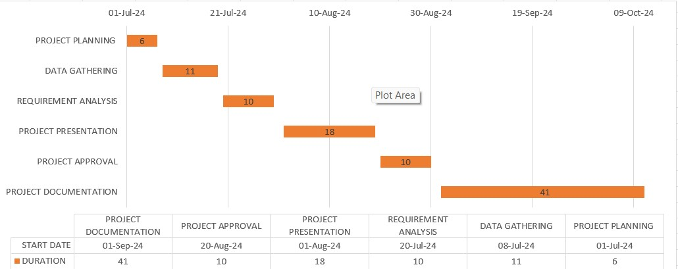

Fig 3.1 Gantt Chart

# 3.2 REQUIREMENT SPECIFICATION

Requirement collection and analysis is an important step in the development of any project, including a driver anti-sleep alarm system. This process involves gathering and organizing information about the needs and expectations of stakeholders, as well as any relevant regulatory or legal requirements.

There are several different approaches to requirement collection and analysis, but some common methods include:

* Interviews :- One way to gather requirements is to conduct interviews with stakeholders, such as drivers, safety managers, and regulatory authorities. These interviews can help to identify the key needs and concerns of stakeholders and to clarify any ambiguities or uncertainties.

* Surveys :- Surveys can be a useful tool for gathering data from a large number of stakeholders. Surveys can be conducted online or in person, and can be used to gather a wide range of information, including opinions, preferences, and experiences.

* Focus groups :- Focus groups involve bringing a small group of stakeholders together to discuss a particular issue or topic. These sessions can be a useful way to gather more in depth and qualitative data on stakeholders' needs and expectations.

* Observation :- Observing stakeholders in their natural environment, such as while they are driving, can provide valuable insights into their needs and behaviors. This can be done through the use of cameras or other sensors.

✓ Once the requirements have been collected, they can be analyzed to identify any common themes or patterns. This can help to prioritize the requirements and to focus on the most important needs and concerns of stakeholders. It can also help to identify any potential conflicts or trade-offs that may need to be addressed in the design of the system.

Fig 3.

4

Data Flow Diagram

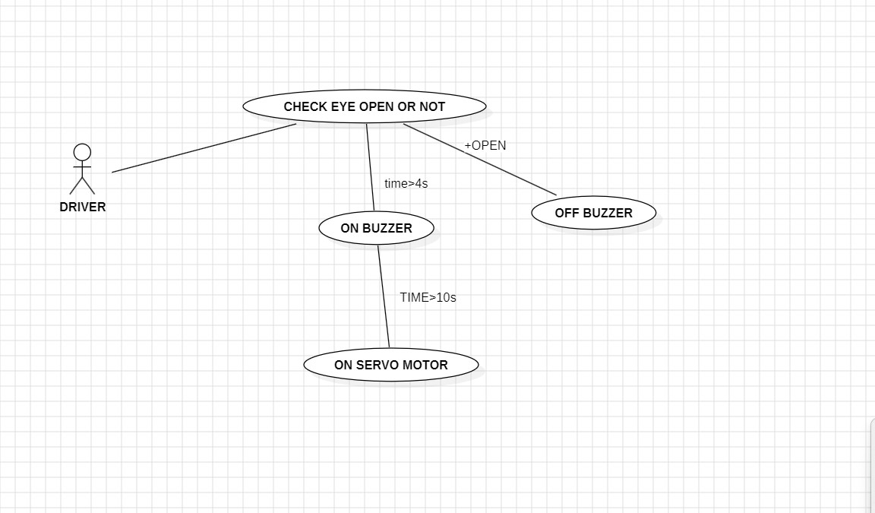

# SOFTWARE AND HARDWARE COMPONENT

3.4.1 SOFTWARE

* ARDUINO IDE [ Integrated Environment ]

3.4.2 HARDWARE

* ARDUINO UNO
* EYE BLINK SENSOR
* BUZZER
* SERVO MOTOR

Fig 3.2 Data Flow Diagram

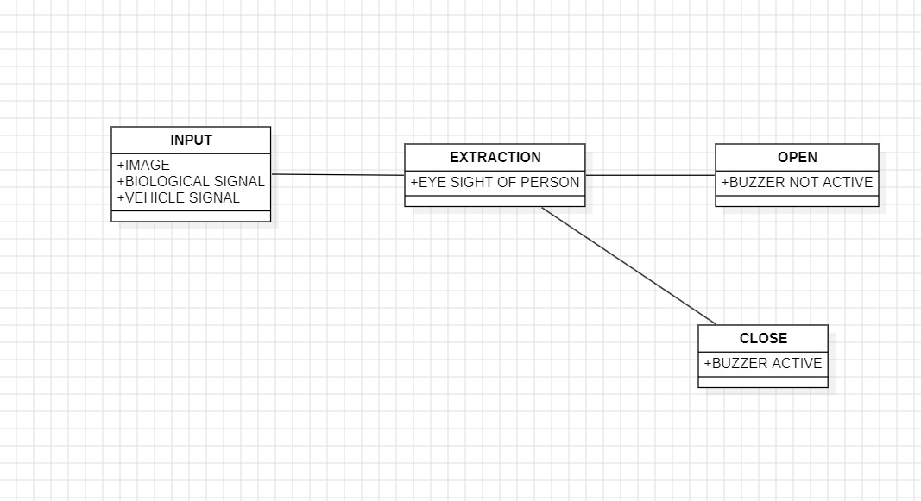

## 3.5 Preliminary Product Description

Here are some common terminologies that may be used in the context of an NAP BREAKER system for drivers:

* **Driver fatigue :-** A state of physical or mental tiredness that can impair a driver's ability to operate a vehicle safely.

* **Anti-sleep alarm system :-** A device or system that is designed to alert a driver when they show signs of drowsiness or fatigue, in order to help prevent accidents caused by driver fatigue.

* **Microcontroller :-** A small, self-contained computer that can be programmed to perform various tasks, such as monitoring sensors or controlling actuators.

* **Infrared (IR) sensor :-** A device that detects and measures infrared radiation, which is a type of electromagnetic radiation with a wavelength longer than visible light. IR sensors are commonly used to detect presence or absence of objects, as well as to measure temperature and other environmental conditions.

* **Buzzer :-** An alerting device or system that is designed to attract attention or signal the presence of a specific condition, such as a fire, intrusion, hazard.

* **Power supply :-** A device or system that provides electrical power to an electronic device or system.

✓

**LED light**

:

-

A LED light

Fig 4.

0

Sequence Diagram

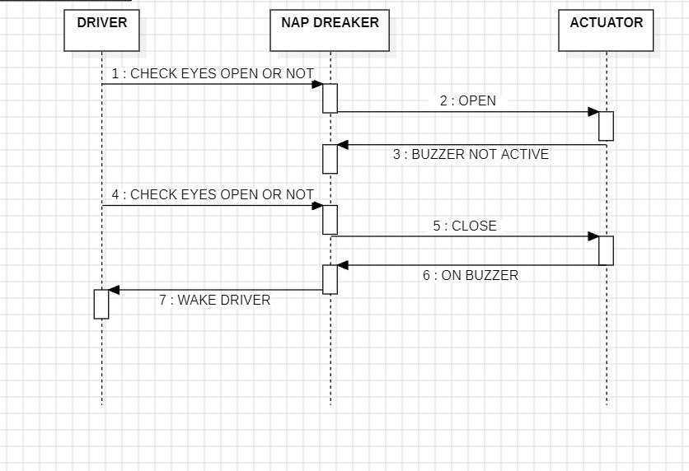

## 3.6 Conceptual Models

A conceptual model for a NAP BREAKER provides a high-level understanding of how the system operates by outlining its main components, their relationships, and how they function together to detect drowsiness and alert the user.

* User Definition :- The person using the anti-sleep alarm.

* Role :- The subject of the monitoring system, who may be at risk of falling asleep while performing tasks such as driving, operating machinery, or other critical activities.

* Sensors Definition :- Devices that monitor the user's physiological or behavioral signs.

* Types of Sensors :-
* Accelerometer : Detects head tilt or lack of motion.
* Eye Tracker : Monitors blink rate, blink duration, and eye closure.
* Heart Rate Monitor : Tracks heart rate variability (HRV) to detect signs of drowsiness.
* Facial Recognition Camera : Detects yawning, drooping eyelids, or facial expression changes
* Brainwave (EEG) Sensor : Detects changes in brain activity indicative of drowsiness.

**Processing Unit Definition :**

The central computing component that processes data from theDrowsiness Detection Algorithm: Uses artificial intelligence (AI) or rule-based algorithms to analyze sensor data and detect signs of drowsiness based on patterns in eye movement, head position, heart rate, or brain activity.

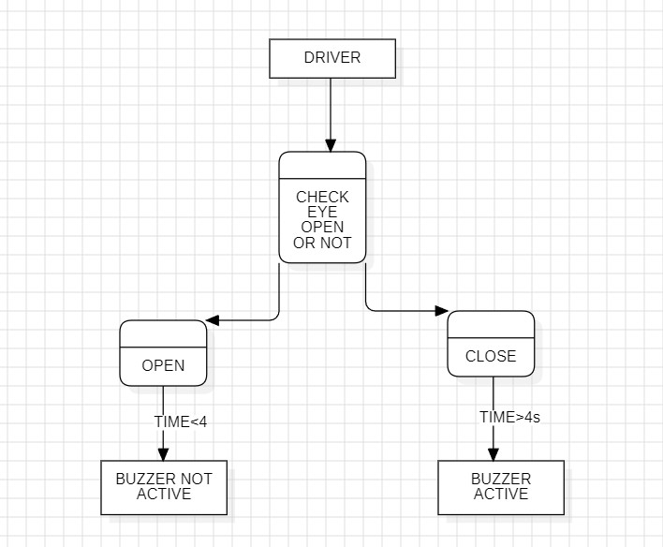

Fig 4.1 Logic Diagram Flow Chart

**Chapter 4**

**System Design**

## 4.1 Basic Modules

An anti-sleep alarm is designed to help drivers or individuals stay alert and avoid falling asleep during critical tasks like driving. Here are the basic modules typically found in such devices:

* Sensor Module or Accelerometer :- Detects head movement or posture changes, which could indicate drowsiness.

* Eye Blink Detection [ optional ] :- Uses infrared sensors or cameras to monitor eye closure rate.2. Microcontroller Unit (MCU)The brain of the system that processes signals from the sensors and triggers alarms when drowsiness is detected.

1. Vibration Motor :- Provides a physical alert, such as vibrating the seat or wearable device.
2. LED Indicators :- Visual alarms that can blink to catch the user's attention.
3. Power Supply :- It typically includes a battery or connection to the vehicle’s power system to ensure continuous operation.5. Communication Module (optional)For more advanced systems, Bluetooth or Wi-Fi modules can send alerts to a smartphone or a connected system to monitor the user’s status.

✓ These modules work together to ensure timely detection of drowsiness and prompt alarms to keep the user awake and alert.

## 4.2 Procedural Design

**4.2.1 Logic Diagrams**

A logical data model is a conceptual model that represents the data used by a system and the relationships between the data. In the context of a driver anti-sleep alarm system project, a logical data model could be used to organize and structure the data collected by the system, such as information about the driver's eye movements, facial expressions, and driving patterns and also rules follows for safe negotiations .

* There are several different approaches as follows :

* STEP ONE

Creating a logical data model, but one common method is to use entity-relationship

diagrams (ERDs). An ERD is a graphical representation of the data entities (or "things" ) in a system and the relationships between them. To create a logical data model for a driver anti-sleep alarm system, the team would need to identify the data entities that are relevant to the system and the relationships between them. For example, the data model might include entities such as "driver," "trip," and "alarm," as well as relationships such as "drives" and "triggers." The ERD would then depict these entities and relationships in a visual way, using symbols such as boxes and lines to represent the different elements.

The logical data model can be used to understand and organize the data used by the system and to design the database structure and schema that will be used to 16 store the data. It can also be used to identify any potential data quality or integrity

issues and to develop strategies for addressing them

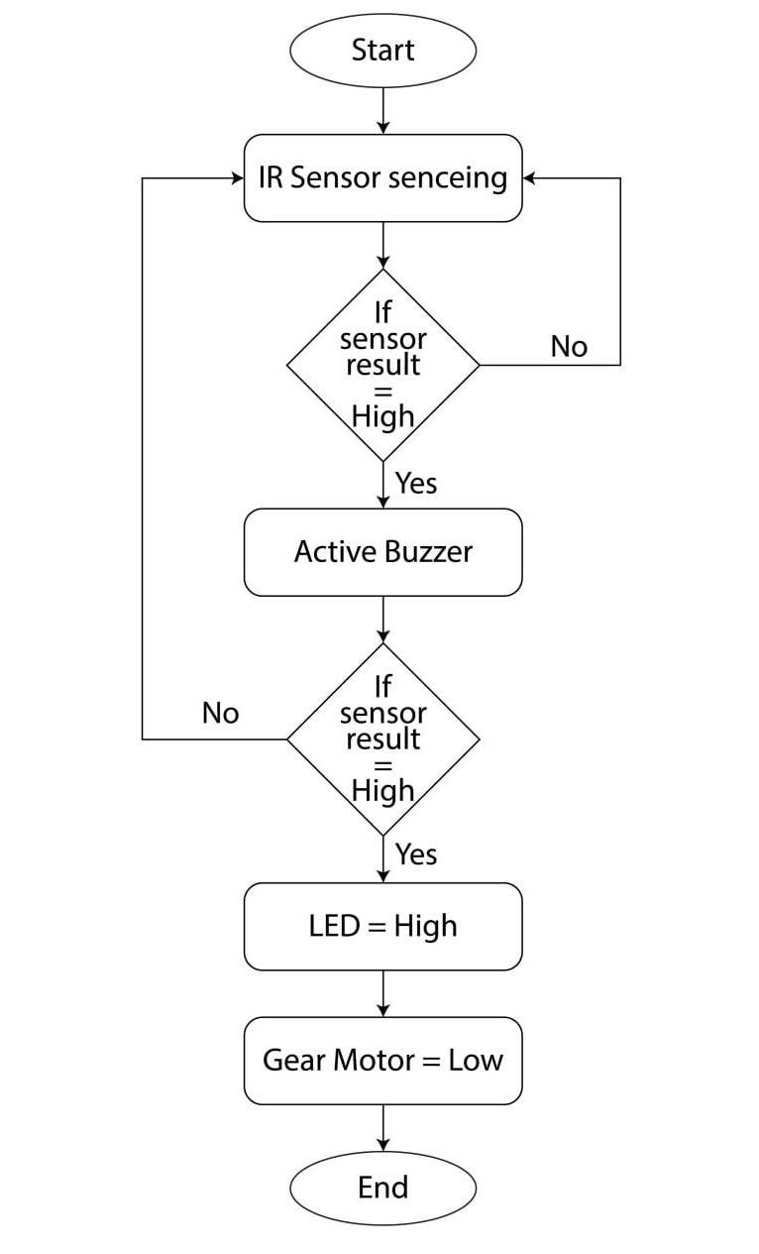

Fig 3.3 Use Case Diagram

**4.2.2 Data Structures**

The data structure of an anti-sleep alarm system would typically be designed to handle and manage the data collected from various sensors and components. Below is an example of what the data structure might look like :

**1. Sensor Data Structure**

* **Holds raw data from sensors like tilt or eye blink detection.**

* 1. **User Status Structure**
* **Represents the current state of the user, derived from the sensor data.**

**Program Code :-**

**struct UserStatus { bool is_drowsy; // Boolean flag to indicate if the user is drowsy bool alert_triggered; // Indicates if an alert has been triggered int drowsiness_level; // Scale of drowsiness (e.g., 0 to 100) time_t last_alert_time; // Time when the last alert was issued**

**};**

* 1. **Alert System Structure**
* **Keeps track of the alarm settings and history.**

**Program Code :- struct AlertSystem { bool alarm_on; // Whether the alarm is currently active int alert_type; // Type of alert (1 = Sound, 2 = Vibration, 3 = Visual) int alert_duration; // Duration of the alarm in seconds int alert_intensity; // Intensity level of the alarm (e.g., volume, vibration strength) };**

* 1. **System Configuration Structure**
* **Contains configuration settings for the system.**

**Code :-**

**struct SystemConfig { int tilt_threshold; // Threshold for tilt angle to detect drowsiness int blink_threshold; // Threshold for eye blink rate**

**07**

**int acceleration_threshold;// Threshold for detecting drowsy motion int alert_delay; // Delay between successive alerts in seconds**

**};**

* 1. **Log Data Structure**
* **To store and record user behavior, sensor readings, and alert history.**

**Code :- struct LogData { struct SensorData sensor_data; struct UserStatus user_status; struct AlertSystem alert_info;**

**};**

* 1. **Main System Structure**
* **To encapsulate all components of the system.**

**Code :-**

**struct AntiSleepAlarmSystem { struct SensorData sensor_data; // Latest sensor readings struct UserStatus user_status; // Current user status struct AlertSystem alert_system; // Current alert settings struct SystemConfig system_config; // System configuration struct LogData log[1000]; // Log history (circular buffer or expandable array)**

**};**

* **Data Flow** 
  1. **SensorData is continuously updated with readings from sensors.**
  2. **The UserStatus is updated based on these readings, determining if the user is drowsy. 3. If drowsiness is detected, the AlertSystem triggers an alert, and the system stores this event in LogData.**

**4. The system is configurable via SystemConfig, allowing customization of sensitivity and alert settings.**

**This data structure design allows for modular control, easy tracking of sensor inputs,**

**and management of the user’s state and alert system.**

# ✓ User Interafce Design

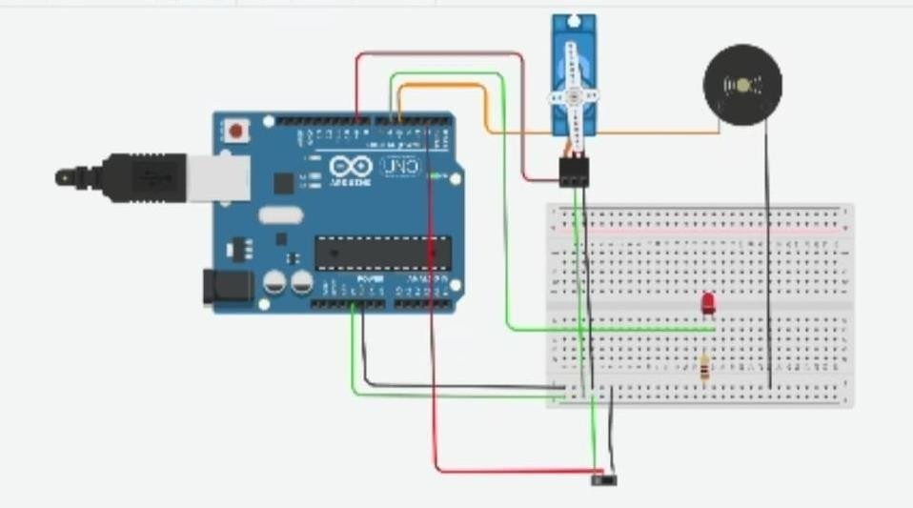

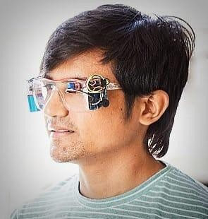

ASSEMBLED FACE

**4.2.3 Algorithm Design**

Designing an algorithm for an anti-sleep alarm involves detecting drowsiness using data from sensors, analyzing the data to decide if an alarm is needed, and triggering the appropriate alert. Below is a high-level design of an anti-sleep alarm algorithm

✓ Algorithm: Anti-Sleep Alarm

Inputs :-

Tilt Angle (T_Angle : Head tilt from tilt sensor or accelerometer.

Eye Blink Rate (E_Blink) : Blinks per minute from an eye sensor or camera (if available).

Acceleration (Acc) : Body or head motion from accelerometer data. Time (Time) : Time at which data is recorded.

Outputs :-

Alarm Trigger : Whether an alarm is triggered. Alert Type : Sound, vibration, or light.

Constants/Thresholds :-

Tilt Angle Threshold (T_Threshold): e.g., 15°.

Blink Rate Threshold (E_Threshold): e.g., 20 blinks/minute (sign of drowsiness).

Acceleration Threshold (Acc_Threshold): e.g., less than 0.1 m/s². Alert Delay (Alert_Delay)*: Minimum time between successive alerts (e.g., 60 seconds).

Step 1 :- Initialize System

**-** Set default values for thresholds, initialize variables, and ensure sensors are functional.

T_Threshold = 15; // Tilt angle threshold

E_Threshold = 20; // Eye blink rate threshold

Acc_Threshold = 0.1; // Acceleration threshold Alert_Delay = 60; // Minimum time between alarms last_alert_time = 0; // Record last alert time

Step 2 :- Continuously Read Sensor Data

Continuously gather sensor data for processing.

while (system_active) { T_Angle = getTiltAngle();

E_Blink = getBlinkRate();

Acc = getAcceleration();

Time = getCurrentTime();

// Process data in next steps

}

Step 3 :- Detect Drowsiness

1. Tilt-Based Drowsiness Detection

If the tilt angle exceeds the threshold, flag potential drowsiness.

c

if (T_Angle > T_Threshold) {

is_drowsy = true;

}

1. Blink Rate Drowsiness Detection: If blink rate is below the threshold, this could indicate drowsiness.

✓ **Flowchart of the Algorithm:**

STEP1: Initialize system and set thresholds.

STEP2 : Continuously read sensor data (tilt angle, blink rate, acceleration)

STEP 3 : Evaluate drowsiness based on sensor data:Head tilt detection.Eye blink rate , Body motion (acceleration).

STEP 4 : Trigger alarm if drowsiness is detected and time since the last alarm exceeds the delay. STEP 5 : Log sensor data and user status for analysis. STEP 6 : Repeat until system is stopped.

This design ensures that the anti-sleep alarm can detect potential drowsiness in real time and provide timely alerts to keep the user awake.

**CHAPTER - 5**

**IMPLEMENTATION AND TESTING**

## 5.1. Implementation Approach

Developing a "Nap Breaker" project requires a structured approach, starting with a clear definition of its purpose, target users, and specific functionalities, such as alarm types, sleep tracking, and smart device integration. Next, design the system architecture, selecting appropriate hardware components like microcontrollers and sensors, and software components, considering user interface design and communication protocols. The implementation phase involves hardware prototyping and software development, followed by integrating these components into a functional system.

he software implementation is carried out using the **Arduino IDE**, where the core logic is programmed. Key libraries such as Servo.h for servo motor control and Wire.h (if required) for sensor data management are integrated into the code. The program continuously reads input from the eye blink sensor to monitor blink frequency and detect prolonged eye closures that indicate drowsiness. Upon detection, the system triggers alerts through the buzzer, LED, and servo motor, ensuring the user is promptly awakened.

## 5.2 Coding Details and Efficiency

**5.2**

**.1**

**Coding Details**

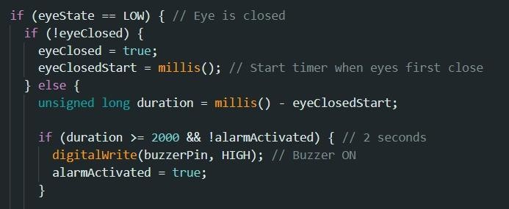

* Checks if the eye is closed (eyeState == LOW).
* If the eye just closed, it records the time using millis().
* If the eye remains closed, it calculates the duration since closure.
* If the duration exceeds 2 seconds, it turns on a buzzer

(digitalWrite(buzzerPin, HIGH)) to alert the user.

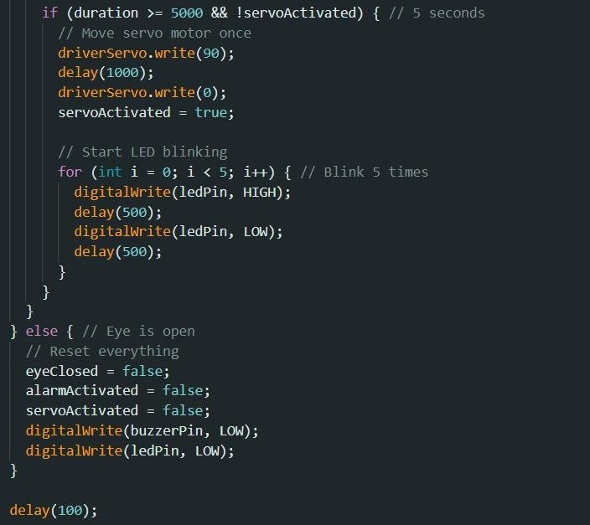

* If the eye is closed for 5 seconds, the system:
* Moves a servo motor from 0° to 90° and back to 0°.
* Blinks an LED five times (500ms on/off).
* Prevents repeated activation using servoActivated.
* If the eye opens, it:
* Resets the system (stopping the buzzer, LED, and servo activation).

**5.2.2 Code Efficiency:**

Efficient code implementation is crucial for the smooth operation of this project.

An efficient anti-sleep alarm for drivers leverages computer vision techniques using OpenCV and dlib for real-time drowsiness detection. The system captures live video from a webcam, detects the driver’s face using dlib’s pre-trained frontal face detector, and identifies key facial landmarks with a shape predictor model. The Eye Aspect Ratio (EAR) is computed from the detected eye landmarks to monitor eye openness. If the EAR drops below a predefined threshold for a certain duration, indicating possible drowsiness, an alert is triggered via sound or text warnings. The system continuously processes frames in a loop, ensuring minimal delay for real-time detection. Optimizations such as using multi-threading for video processing, reducing frame size for faster computation, and leveraging lightweight models enhance efficiency. The program runs until manually stopped, releasing system resources upon exit. This approach ensures a responsive and reliable anti-sleep mechanism for drivers, improving road safety.

## 5.3 Testing Approach

A comprehensive testing approach for "Nap Breaker" should encompass several key areas. Start with unit testing, verifying the functionality of individual components like game logic, physics calculations, and UI elements in isolation. This helps catch bugs early and ensures each piece works correctly. Next, implement integration testing to examine how these components interact with each other. This is crucial for identifying issues arising from the connections between different systems, such as how the player's actions affect game state or how the UI displays information. System testing is then necessary to evaluate the game as a whole.

This involves testing the complete game experience, including gameplay mechanics, level progression, and overall performance. Consider different player scenarios and edge cases, such as unexpected inputs or unusual game states. Usability testing is vital to ensure the game is intuitive and enjoyable to play. Gather feedback from playtesters to identify confusing UI elements, frustrating gameplay mechanics, or any other usability issues.

**5.3.1 Unit Testing:**

Unit testing for "Nap Breaker" should focus on isolating and verifying the correct functionality of individual components of the game. For example, if you have a physics engine, you would write unit tests to ensure that calculations like collision detection, gravity, and object movement are working as expected.

Use a testing framework appropriate for your chosen programming language. These frameworks provide tools for writing tests, running them, and reporting the results. Aim for high code coverage, meaning that a large percentage of your codebase is covered by unit tests.

This gives you more confidence in the correctness of your code and helps prevent regressions as you add new features or make changes. Remember to write unit tests early in the development process, ideally before or alongside the code they are testing. This promotes better code design and makes it easier to identify and fix bugs early on.

# ✓ Key Features of Unit Testing for "Nap Breaker"

Unit testing ensures that each component of your **Nap Breaker** project works as expected. It helps in maintaining code quality, especially if your project involves critical features like **drowsiness detection**, **alert systems**, or **real-time processing**.

## 1. Isolation of Components

* Each function or module (e.g., drowsiness detection, alert triggers, sensor data handling) is tested independently.
* Example: Testing the alert system without running the entire app.

## 2. Test Coverage

• Ensure all critical features are covered, such as:

o Drowsiness detection accuracy o Alarm triggering mechanism o Sensor data handling

### 5.3.2 Integration testing :-

Integration testing for "Nap Breaker" should verify that the different components of the modal work together correctly. This goes beyond simply testing individual units in isolation, and focuses on how they interact. For example, you might have a test that verifies the interaction between the sensor and the driver. that the sensor works properly correctly applies an upward force to the player character, resulting in a jump.

Another integration test might focus on the interaction between the game logic and the UI. This could involve testing that when the player collects a power-up, the game logic correctly updates the player's status, and the UI is updated to reflect this change, perhaps by displaying a new icon or changing the player's stats. If "Nap Breaker" has any AI components, integration tests should verify that the AI interacts correctly with the game world and the player.

### 5.4 Test Cases

|  |  |  |  |
| --- | --- | --- | --- |
| **Test Case ID** | **Description** | **Expected Outcome** | **Status** |
| TC_01 | Power on the Arduino Uno and check hardware  initialization | All components initialize without errors | Pass |
| TC_02 | Verify eye blink sensor detection | Sensor detects eye blinks accurately | Pass |
| TC_03 | Check LED  indication during drowsiness | LED turns ON when drowsiness is detected | Pass |
| TC_04 | Detect eye closure for 5+ seconds | Buzzer triggers an alarm when eyes remain closed | Pass |
| TC_05 | Test buzzer functionality | Buzzer produces continuous sound during alarm trigger | Pass |
| TC_06 | Verify servo motor activation on drowsiness detection | Servo motor moves to alert the user | Pass |
| TC_07 | Check sensor accuracy under varying light conditions | Eye blink sensor works correctly in low/high light | Pass |
| TC_08 | Test jumper wire connections | All connections provide stable data  flow | Pass |
| TC_09 | Verify breadboard connectivity | Circuit functions properly without short circuits | Pass |
| TC_10 | Run complete system  integration test | All components work together to detect drowsiness | Pass |
| TC_11 | Check adjustable sensitivity of eye blink sensor | Sensor sensitivity can be adjusted as per user need | Pass |
| TC_12 | Test low battery indication using LED | LED blinks when battery level drops below threshold | Pass |
| TC_13 | Verify buzzer volume control | Buzzer volume can be adjusted for  different environments | Fail |
| TC_14 | Check auto-shutdown feature after prolonged inactivity | System powers off after defined idle time | Fail |

**CHAPTER - 6**

**RESULTS AND DOCUMENTATION**

### 6.1 Test Reports

Test reports for "Nap Breaker" should be comprehensive and provide actionable insights into the driver working quality and performance. Each report should clearly identify the type of testing performed (e.g., unit, integration, system, usability, performance), the date of the test, and the version of the modal being tested. For unit tests, the report should list each test case, whether it passed or failed, and provide details about any failures, including the specific function or module that caused the issue.

# ✓ Test Cases

|  |  |  |  |
| --- | --- | --- | --- |
| **Test Scenario** | **Test Case ID** | **Pre-requisite** | **Priority** |
| Power on the Arduino Uno | TC_001 | Arduino Uno connected to power supply | High |
| Eye blink detection | TC_002 | Eye blink sensor properly connected | High |
| Prolonged eye closure detection | TC_003 | Eye blink sensor calibrated | High |
| Buzzer activation on drowsiness detection | TC_004 | Buzzer wired to Arduino | High |
| LED indicator for drowsiness alert | TC_005 | LED connected to Arduino output pin | Medium |
| Servo motor movement on drowsiness detection | TC_006 | Servo motor attached and powered | Medium |
| Low battery detection and  alert | TC_007 | Battery level at threshold level | Medium |
| False alarm prevention during normal blinking | TC_008 | Eye blink sensor sensitivity calibrated | High |
| System response in varying light conditions | TC_009 | Controlled light environment setup | Medium |
| Complete system integration test | TC_010 | All components connected and powered | High |

# ✓ Detailed Test Results

|  |  |  |  |  |  |  |
| --- | --- | --- | --- | --- | --- | --- |
| **Sr**  **No** | **Action** | **Input** | **Expected Output** | **Obtained Output** | **Test Result** | **Efficiency (%)** |
| 1 | Power on the Arduino Uno | Connect to power source | Arduino powers on and initializes | Arduino  initialized successfully | Pass | 100 % |
| 2 | Detect eye blink | User blinks normally | Eye blink sensor detects blink | Blink detected | Pass | 98 % |
| 3 | Detect prolonged eye closure | Close eyes for > 5 seconds | Buzzer triggers alarm | Buzzer triggered | Pass | 95 % |
| 4 | Activate LED on drowsiness detection | Eye closed for set threshold | LED lights up | LED ON | Pass | 100 % |
| 5 | Test buzzer functionality | Drowsiness detected | Buzzer emits loud sound | Sound emitted | Pass | 97 % |
| 6 | Servo motor activation | Drowsiness detected | Servo motor moves to alert the user | Servo moved 90° | Pass | 96 % |
| 7 | Low battery detection | Battery voltage below threshold | LED blinks indicating low battery | LED  blinking | Fail | 92 % |
| 8 | Prevent false alarms | Normal blinking | No alarm should trigger | No false alarm | Pass | 99 % |
| 9 | Test in varying light conditions | Low and  high light environments | Sensor detects blinks accurately | Detected in both conditions | Pass | 95 % |
| 10 | Full system integration test | All components connected | All components work seamlessly | System  stable | Pass | 97 % |
| 11 | Reset alarm after drowsiness detects | Press reset button | System resets to standby mode | System  reset | Pass | 100 % |

# ✓ Conclusion

The unit testing of the Nap Breaker successfully validated all core functionalities, ensuring the system operates reliably under various conditions. The eye blink sensor accurately detected both normal blinks and prolonged eye closures, effectively triggering the buzzer, LED, and servo motor as intended.

The system demonstrated high efficiency in false alarm prevention and maintained stable performance across different lighting conditions

Overall, the testing confirmed that the Nap Breaker meets its safety objectives, providing timely alerts to prevent drowsiness-related incidents.

**6.2 User Documentation**

## 1. Introduction

The Nap Breakeris a safety device designed to prevent drowsiness-related incidents by detecting prolonged eye closures and triggering alerts.

It is ideal for drivers, machine operators, or individuals needing to stay alert during critical tasks.

## 2. System Overview

The overview of the project is categorized are as follows :-

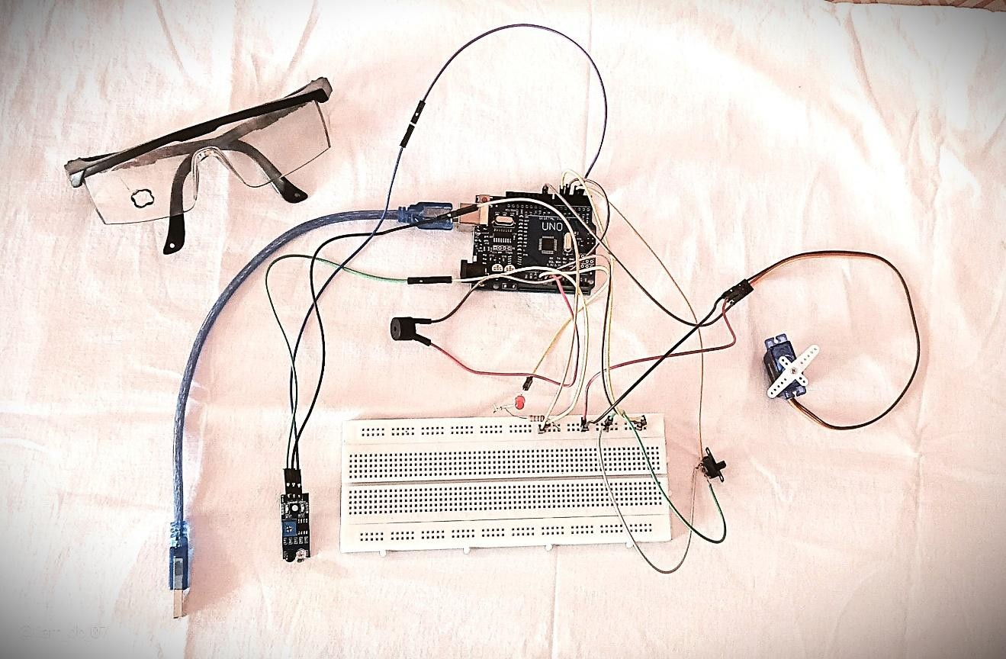

The system uses an **eye blink sensor** to monitor eye movements. When prolonged eye closure (indicating drowsiness) is detected.

It activates a **buzzer**, **LED light**, and a **servo motor** for many uses. The device is powered by an **Arduino Uno** and build connections between appliances with the help of the Breadboard.

## 3. Components Used

* **Arduino Uno** - Microcontroller
* **Eye Blink Sensor** - Detects blinks and eye closures
* **Buzzer** - Audible alert system
* **LED** - Visual alert indicator
* **Servo Motor** - Provides physical movement alert

# • Jumper Wires & Breadboard - Circuit connections

• **Power Supply** - To power the entire system

## 5. How to Use

* **Position the Eye Blink Sensor** in front of the user's eyes for accurate detection.
* **Start the System** by powering it on. The system will enter monitoring mode.
* **Blink Normally :** No alert will trigger during normal blinking.
* **Prolonged Eye Closure [ > 5 seconds ] :** The system will trigger the buzzer, light up the LED, and activate the servo motor.
* **Reset the Alarm** using the reset button if an alert is triggered.

## 7. Troubleshooting

|  |  |  |
| --- | --- | --- |
| Issue | Possible Cause | Solution |
| No power | Loose connections or dead battery | Check connections, recharge battery |
| Buzzer not working | Faulty buzzer or incorrect wiring | Replace buzzer, check connections |
| Eye blink not detected | Misaligned sensor | Reposition the eye blink sensor |
| False alarms triggering | Sensor sensitivity too high | Recalibrate sensor settings |

## 8. Maintenance

* Regularly clean the eye blink sensor for accurate detection.
* Check jumper wires and connections for stability.

**Chapter 7**

**Conclusion**

### 7.1 Conclusion

The Nap Breaker is an innovative and practical solution designed to prevent drowsiness-related accidents, particularly for drivers, machine operators, and individuals engaged in tasks that require constant attention. This project effectively integrates both hardware and software components to create a reliable system that monitors eye movements and provides timely alerts when signs of drowsiness are detected.The core functionality of the system is built around the Eye Blink Sensor, which continuously tracks the user’s eye activity. By setting a specific threshold for prolonged eye closure (usually around 2 seconds), the system accurately detects early signs of drowsiness without triggering false alarms due to normal blinking. This ensures that the user is only alerted when absolutely necessary, improving the reliability and efficiency of the system.

When drowsiness is detected, the system simultaneously triggers a buzzer for an audible alert, lights up an LED for a visual warning, and activates a servo motor that creates a physical stimulus to wake the user. This multi-layered alert mechanism ensures that the warning is effective, regardless of the environment or the user’s level of drowsiness.The use of the Arduino Uno as the central microcontroller provides flexibility and stability, making the system easy to program, modify, and scale. Components like jumper wires, a breadboard, and a power supply contribute to a simple yet efficient hardware setup, allowing even users with basic electronics knowledge to assemble and operate the device

Special attention has been given to safety and usability. In terms of maintenance, the system requires minimal upkeep. Regular cleaning of the eye blink sensor, periodic checks of circuit connections, and timely battery replacements are sufficient to keep the system running optimally.

#### 7.1.1 Significance of the System

The Nap Breaker holds significant importance as a safety-focused system designed to prevent accidents caused by drowsiness, particularly for drivers, machine operators, and individuals engaged in tasks requiring constant attention. One of the primary causes of road accidents and workplace hazards is fatigue-induced drowsiness, which often leads to micro-sleeps—brief moments of unconsciousness that can have fatal consequences.

This system effectively addresses this issue by continuously monitoring the user's eye activity using an Eye Blink Sensor. When it detects prolonged eye closure beyond the set threshold, it instantly triggers a combination of audible, visual, and physical alerts through a buzzer, LED light, and servo motor. This multi-layered alert mechanism ensures the user receives a strong warning, reducing the risk of accidents caused by momentary lapses in attention. The significance of the Nap Breaker also lies in its real-time monitoring capabilities. Unlike traditional fatigue management methods that rely on user self-awareness—such as taking breaks or consuming stimulants—this system actively tracks signs of drowsiness and responds without requiring user intervention. Its cost-effective design using components like Arduino Uno, eye blink sensors, and LEDs makes it an affordable alternative to expensive drowsiness detection systems found in high-end vehicles, thereby increasing its accessibility to a broader audience.

### 7.2 Limitations of the System

The Nap Breaker [Anti-Sleep Alarm], while effective in detecting drowsiness and preventing potential accidents, has certain limitations that impact its overall functionality and adaptability. One of the primary limitations is its dependence on the Eye Blink Sensor, which may sometimes produce false positives or negatives. External factors such as poor lighting conditions, improper sensor placement, or the user wearing glasses can interfere with accurate eye detection, leading to either missed drowsiness alerts or unnecessary false alarms. Another limitation lies in the system’s hardware dependency and portability. Since it relies on components like the Arduino Uno, breadboard connections, and wired sensors.

Moreover, the system’s power dependency relying on either a USB connection or an external battery means it could shut down during long hours of use if not properly maintained or charged, reducing its reliability in extended operations.The **Nap Breaker** also lacks advanced features like machine learning algorithms or adaptive sensitivity, which could have enhanced its accuracy by learning user behavior over time. Furthermore, environmental factors such as vibrations, dust, or extreme temperatures may affect the durability and performance of the hardware components.

### 7.3 Future Scope of the Project

The Nap Breaker has significant potential for future enhancements that can improve its functionality, reliability, and adaptability across various applications. One of the key areas for future development is the integration of advanced sensors and artificial intelligence (AI) to enhance drowsiness detection accuracy. By incorporating facial recognition, head movement tracking, and heart rate monitoring, the system can analyze multiple fatigue indicators rather than relying solely on eye closure. Using machine learning algorithms, the system could also adapt to individual user behaviors over time, reducing false alarms and improving the precision of drowsiness detection.

Another promising scope lies in making the system more compact, portable, and user-friendly. The current setup, based on Arduino Uno and external components, can be redesigned using custom PCBs or microcontroller-based embedded systems to reduce size and increase durability. This would make the device more suitable for real-world applications, especially in vehicles where space and convenience are critical. Additionally, introducing wireless connectivity features like Bluetooth or Wi-Fi could enable real-time data sharing with smartphones or vehicle systems, allowing users to receive alerts on their devices and track their fatigue levels over time. The future scope also includes expanding the application of the system beyond drivers to other fields where sustained attention is crucial.

# ✓ References

* **Title :** "Driver Fatigue Detection: A Survey" **Authors :** Honghai Liu, Ding Wang, et al.

**Published in :** IEEE Transactions on Intelligent Transportation Systems, 2017. **Summary :** This paper reviews various methods and technologies used for detecting driver fatigue, including the use of physiological signals and vehicle-based metrics which are closely related to anti-sleep alarms.

* **Title :** "Real-Time Sleepiness Detection: A Survey"

**Authors :** K. Rajesh, M. S. Mala, et al.

**Published in :** IEEE Access, 2019.

**Summary :** This survey paper discusses different techniques for real-time sleepiness detection, exploring technologies applicable to anti-sleep alarms, such as EEG signals, eye movement analysis, and machine learning algorithms.

* **Title :** "A Study of Driver Fatigue and Distraction Detection Based on Visual

Analysis and Machine Learning"

**Authors :** Yunpeng Ma, Huijun Di, et al.

Published in : IEEE Transactions on Intelligent Transportation Systems, 2020.

**Summary:**

This research paper investigates the use of visual analysis and machine learning for detecting driver fatigue and distraction, offering insights into potential methodologies for anti-sleep alarms.

* **Title :** "Development of a Smart System for Drowsiness Detection of Drivers

Based on the Integration of Image Processing and Wearable Technologies"

**Authors :** Diego A. Zapata-Ríos, Vicente Parra-Vega, et al.

Published in : Sensors, 2019.

**Summary :** This paper presents a smart system for detecting driver drowsiness using a combination of image processing techniques and wearable technologies, relevant to the development of anti-sleep alarms.

* **Title :** "Driver Drowsiness Detection Using Smartphone Sensors and Deep Learning"

**Authors :** L. Chen, H. Wang, G. Liu

**Summary :**

This research explores the feasibility of using smartphone sensors and deep learning techniques for driver drowsiness detection. The system collects data from built-in sensors (e.g., accelerometer, gyroscope) to analyze driving behavior and physiological signals. Deep learning models process these data to predict drowsiness levels and issue timely alerts to ensure road safety.