1.Download LAbelImg , for Windows -> v1.8.0 or higher

open windows_v1.8.0/data/predicted_classes.txt -> remove everythin and write class name you want to label and later predict.(Else class id will give error in models like yolo)

2.cd tfod/sampleimage/

Copy paste some images in this folder for doing annotataion

OpenLabelImg -> Open Dir -> Click on pascalvoc for TFOD (not yolo format) -> Click on CreateRectBox -> Draw the rectangle and select the class -> Save .

Label each object separately whether they belong to same class or different class.

Click on Next image -> repeat the process

vi tfod/models/research/training/labelmap.pbtxt -> file used for mention name of the classes in TFOD setup.

3.cd tfod/models/research

python xml_to_csv.py

vi generate_tfrecord.py #in this python file ,change the class name in class_text_to_int(row_label) function.

#save the chnages and exit from file , copy the command also to create train and test data

python generate_tfrecord.py --csv_input=images/train_labels.csv --image/train --output_pat=train.record

python generate_tfrecord.py --csv_input=images/test_labels.csv --image/test --output_pat=test.record

vi train.record #these are TF record binary format file which we need

vi test.record

4.move faster_rcnn folder to tfod/models/research

COPY tfod/models/research/object_detection/samples/config/faster_rcnn_inception_v2_coco.config

PASTE in tfod/models/research/training/

vi tfod/models/research/object_detection/samples/config/faster_rcnn_inception_v2_coco.config

make the following changes :

num_classes = 6 #as per your total no. of classes in Line 10

fine_tune_checkpoint: "faster_rcnn/model.ckpt" #line107

num_steps: 2500 #line 113 ,as per your cpu/gpu capapcity , higher for gpu =200000

input_path: "train.record" #line122

label_map_path:"training/labelmap.pbtxt" #line124

input_path:"test.record"#line 136

label_map_path:"training/labelmap.pbtxt" #line136

5.copy tfod/models/research/object_detetction/legacy/train.py

paste tfod/models/research folder

6.copy tfod/models/research/slim/deployment & nets folder paste in tfod/models/research

7.#train the model

cd tfod/models/research

python train.py --logtostderr --train_dir=training/ --pipeline_config_path=training/faster_rcnn_inception_v2_coco.config

8.#Inferencing , 2500 -> the checkpoint

#copy export_inference_graph.py from object_detection folder to research folder

python export_inference_graph.py --input_type image_tensor --pipeline_config_path training/faster_rcnn_inception_v2_coco.config --trained_checkpoint_prefix training/model.ckpt-2500 --output_directory inference_graph

9. cd research/inference_graph

check inferencing files present

10.cd research

jupyter notebook

open object_detection_tutorial.ipynb

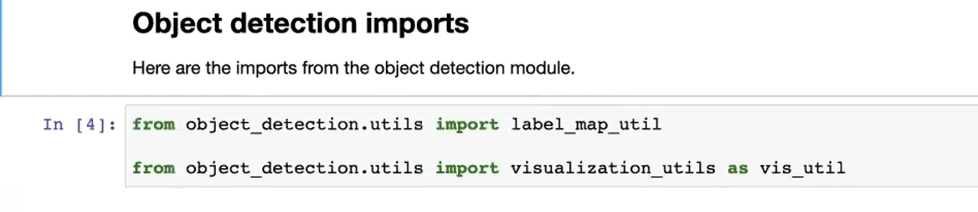

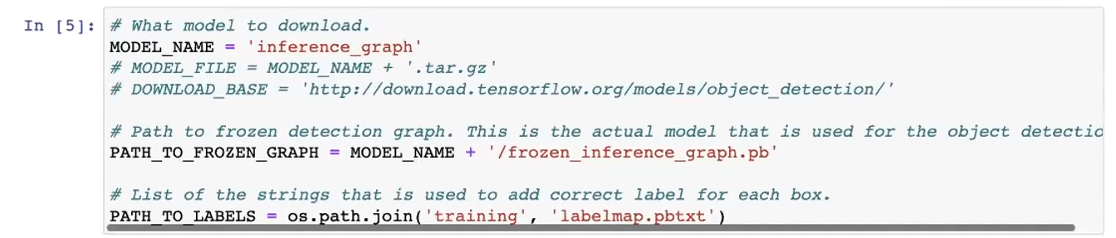

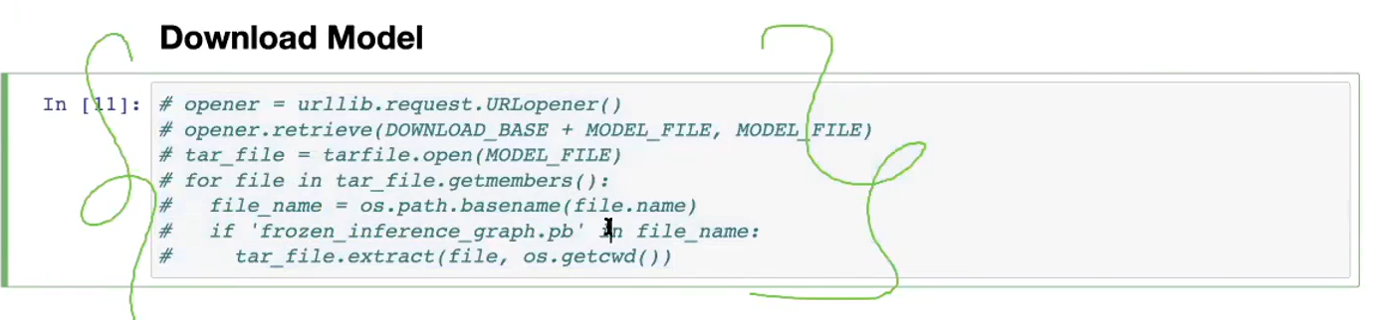

Create test_images folder in research folder.

Copy few images from research/test folder and paste in research/test_images and rename those images

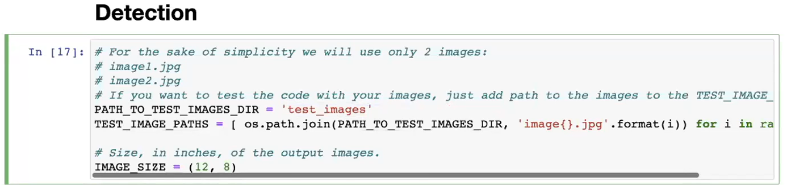

Made the above changes and executes all cell in notebook.

Share below two files for sharing the models:

* Research/inference_graph/frozen_inference_graph.pb
* Labelmap.pbtxt

**TF_Lite use only SSD model.**

**TF_Lite use for mobile devices(not for PC).**

**TFOD 2.x**

[models/object_detection_tutorial.ipynb at master · tensorflow/models (github.com)](https://github.com/tensorflow/models/blob/master/research/object_detection/colab_tutorials/object_detection_tutorial.ipynb)