Chapter I

Introduction

1. Background of Reinforcement Learning and Robotics
Introduction to Reinforcement Learning
Reinforcement Learning (RL) is a subfield of machine learning that focuses on how agents should take actions in an environment to maximize a cumulative reward. Unlike supervised learning, where the model is trained on labeled data, RL involves learning from interactions with the environment and receiving feedback through rewards or punishments. This trial-and-error approach allows RL to be particularly useful in settings where the ideal solution or behavior is not known in advance but can be learned over time.
The RL framework typically involves an agent, an environment, actions, states, and rewards. The agent interacts with the environment by performing actions, which lead to transitions between states. The agent receives a reward (or penalty) for its actions, which it uses to adjust its behavior and improve future decisions. The goal of the agent is to learn a policy, a mapping from states to actions, that maximizes its expected cumulative reward over time.
In robotics, RL plays a crucial role in enabling robots to perform complex tasks autonomously. Traditional robotics relied heavily on pre-programmed instructions, with little flexibility for handling unexpected scenarios. With the integration of RL, robots now have the ability to learn directly from experience, enabling them to adapt to new and dynamic environments without human intervention.

The Role of Reinforcement Learning in Robotics
Robotics involves designing machines that can perform a variety of tasks with a level of autonomy and intelligence. Early robotic systems were often rigid and incapable of adapting to new or unstructured environments. These limitations arose due to their reliance on hardcoded rules and pre-defined actions. As robotic applications began to demand more flexibility, researchers turned to machine learning, and specifically RL, to address these challenges.
In robotics, RL has been applied across a wide range of tasks, from simple ones like moving an arm to more complex ones such as autonomous navigation and object manipulation. RL provides the advantage of allowing robots to optimize their actions based on feedback from the environment rather than relying on explicit human programming. This self-learning ability is particularly beneficial in real-world scenarios where robots often encounter unpredictable variables.
For instance, in mobile robotics, RL has enabled robots to learn how to navigate complex environments such as indoor spaces or outdoor terrains. Autonomous vehicles are another prime example, where RL helps vehicles learn driving policies by interacting with dynamic environments like traffic, pedestrians, and road conditions.

Key Reinforcement Learning Algorithms in Robotics
Several RL algorithms have been developed and adapted for use in robotic systems.
Some of the key algorithms include:
- Q-learning: Q-learning is one of the simplest and most well-known RL algorithms. It is a model-free algorithm where the agent learns an optimal policy by updating a Q-value table, which stores the expected future rewards for each action taken in a given state. Although effective in discrete and small environments, Q-learning struggles in continuous and high-dimensional spaces typically encountered in robotics.
- Deep Q-Networks (DQN): DQNs combine Q-learning with deep learning techniques by utilizing deep neural networks to approximate Q-values. This approach allows RL agents to handle high-dimensional input spaces (such as images) by automatically learning feature representations, making it applicable for complex robotic tasks such as visual object recognition or robotic manipulation.
- Policy Gradient Methods: Unlike Q-learning, which focuses on learning value functions, policy gradient methods directly optimize the policy by adjusting the parameters of a policy network. These methods are often preferred in continuous action spaces and have been used in robotics for tasks like robotic arm manipulation and locomotion in complex environments.
- Actor-Critic Algorithms: Actor-Critic methods combine the benefits of value-based and policy-based approaches. The "actor" decides which action to take, while the "critic" evaluates how good the action is by estimating the value function. This approach has been widely used for tasks requiring both exploration and exploitation, such as dynamic balancing or autonomous driving.

Table 1: Key RL Algorithms and Their Use in Robotics
Algorithm | Type | Key Application in Robotics | Advantages | Challenges
Q-learning | Value-based | Used in discrete task environments, such as grid navigation and simple control | Simple and intuitive; Effective in small environments | Struggles with high-dimensional or continuous spaces
Deep Q-Networks (DQN) | Value-based | Robotic object manipulation and vision-based tasks | Handles high-dimensional input (images) | Requires large amounts of data and computation
Policy Gradient | Policy-based | Continuous control tasks, like robotic arm movements or legged locomotion | Direct optimization of policy in continuous spaces | Can have high variance and slow convergence
Actor-Critic | Hybrid | Autonomous driving, dynamic balancing robots | Combines advantages of both value-based and policy-based methods | Requires careful tuning of actor and critic models

Challenges in Applying RL to Robotics
Despite the successes, RL in robotics faces several challenges, primarily related to sample efficiency, generalization, and safety.
- Sample Efficiency: Traditional RL algorithms require vast amounts of data and experience to learn effective policies, which is impractical in robotics, especially in real-world applications. Robots must spend a significant amount of time interacting with their environment to gather enough data to perform tasks competently.
- Generalization: One of the major concerns with RL is its ability to generalize from one task to another. A robot trained in one environment may struggle to perform effectively in a new environment with different conditions. Achieving transfer learning, where a robot can apply knowledge learned in one setting to a different one, remains an ongoing research challenge.
- Safety: In real-world applications, such as industrial robots or autonomous vehicles, ensuring safety during the learning process is critical. RL agents often perform random actions during the exploration phase, which can lead to harmful or costly outcomes in environments where safety is a priority. Techniques for safe exploration in RL are therefore essential for practical deployment.

Graph 1: Learning Curve of an RL Agent in a Robotic Task
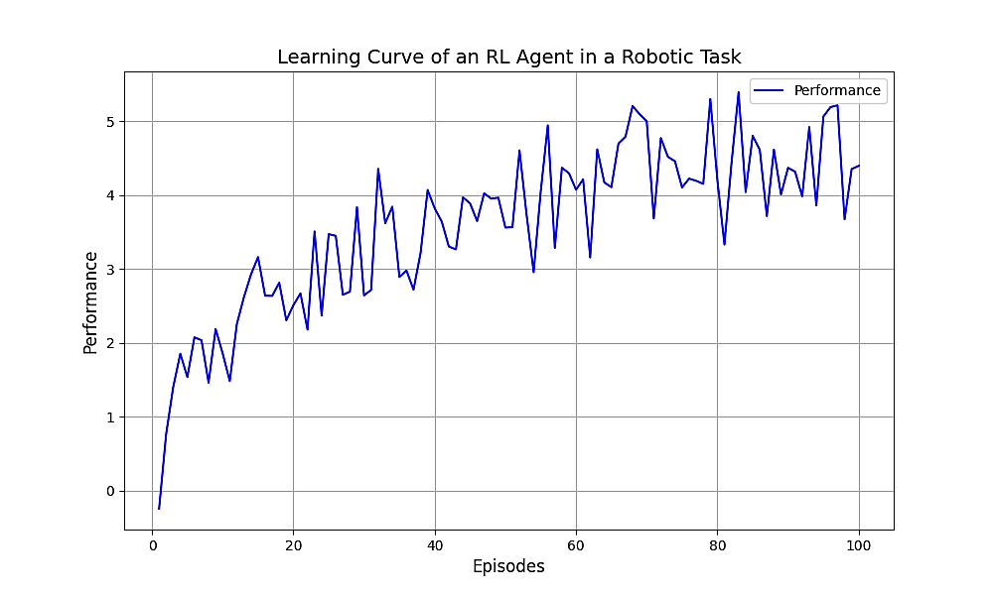
Applications of RL in Robotics
The combination of RL with robotics has led to numerous groundbreaking applications across industries.
Some prominent examples include:
- Autonomous Vehicles: Autonomous vehicles use RL to learn driving policies by interacting with simulated or real-world environments. RL allows vehicles to make complex decisions, such as avoiding obstacles, following traffic rules, and adapting to changing conditions. For example, Waymo and Tesla use deep RL techniques to train their self-driving systems.
- Robotic Manipulation: RL has been instrumental in robotic arms learning tasks such as grasping, picking and placing objects, and assembly. Robots can now learn these tasks by interacting with their environment, making them much more adaptable in settings like warehouses or factories.
- Human-Robot Interaction: In applications where robots work alongside humans, such as collaborative robotics in factories, RL can help robots learn how to assist humans in a safe and effective manner. The robot's ability to adapt to a human's actions in real time and improve collaboration efficiency is greatly enhanced through RL.

Takeaway Key:
- Reinforcement Learning enables robots to autonomously learn optimal behaviors through interaction with their environment.
- Key RL algorithms such as Q-learning, DQN, and Policy Gradient are fundamental in making robots capable of performing complex tasks.
- Challenges like sample efficiency, generalization, and safety must be overcome for RL to be successfully applied in real-world robotic applications.
- Applications of RL in robotics have revolutionized autonomous vehicles, robotic manipulation, and human-robot collaboration.

2. Motivation for the Study
The motivation for this research lies in the rapidly growing field of robotics, where autonomous systems are becoming increasingly essential in industries ranging from healthcare to manufacturing. The complexity of real-world environments presents significant challenges for robots, which must operate with flexibility, autonomy, and adapt to dynamic conditions. Reinforcement Learning (RL) has proven to be an effective tool in achieving this autonomy, but there remain significant hurdles in applying RL methods to robotics in a practical and scalable way.

Challenges in Traditional Robotics Systems
Traditionally, robots relied heavily on manual programming or rule-based systems, where each task or action had to be explicitly defined by a human operator. These systems performed well in highly structured environments with clear rules and limited variables. However, in real-world environments, robots encounter scenarios that are far more unpredictable and dynamic.
Some of the key limitations of traditional robotics systems include:
- Lack of Adaptability: Traditional systems struggle to adapt to new environments or tasks without manual reprogramming. For example, a robot trained to pick objects in one warehouse might fail to perform the same task in a different setting where object shapes or lighting conditions change.
- Limited Generalization: Rule-based systems often struggle to generalize from one task to another. For example, a robot trained to navigate a factory floor may not perform well if it is suddenly placed in a new environment with unfamiliar obstacles or layouts.
- Difficulty with Complex Decision-Making: Traditional systems often require explicit instructions for each decision. In more complex tasks, such as autonomous driving or surgical robots, the number of potential decisions and actions is too large for manual programming to handle effectively.
These limitations motivate the need for more intelligent, self-learning systems that can improve their performance autonomously over time. This is where RL becomes invaluable.

Why Reinforcement Learning?
Reinforcement Learning is a promising approach for addressing the limitations of traditional systems. Rather than relying on predefined rules, RL enables robots to learn from their interactions with the environment. Through trial and error, robots can discover optimal strategies for achieving their goals.
The key motivations for adopting RL in robotics are as follows:
- Autonomy: RL allows robots to operate autonomously without requiring explicit instructions for every action. The robot learns by interacting with its environment, adjusting its behavior based on feedback in the form of rewards or penalties. This capability is particularly useful for tasks that are difficult to program directly, such as navigation in complex, unknown environments.
- Adaptability: RL enables robots to adapt to changes in their environment. A robot using RL can learn to adjust its actions in response to new situations, making it far more flexible than traditional systems. For example, autonomous vehicles use RL to learn optimal driving strategies by interacting with real-world traffic conditions, road signs, and pedestrians.
- Improved Decision-Making: RL provides a framework for continuous improvement. Robots can improve their decision-making strategies over time, increasing efficiency and reducing the risk of failure. For instance, a robotic arm can learn how to optimize its movements over time to grasp objects more efficiently.
- Handling Uncertainty: Many real-world robotic tasks involve uncertainty—whether it’s uncertain sensor readings, unexpected obstacles, or unpredictable human behavior. RL’s ability to learn from feedback makes it particularly suited to environments that are uncertain and dynamic.

Recent Advancements in Reinforcement Learning
In recent years, RL has made significant strides, particularly with the introduction of Deep Reinforcement Learning (DRL). By combining RL with deep learning techniques, DRL has enabled agents to tackle tasks in complex environments with high-dimensional inputs, such as images or raw sensory data, making it a powerful tool for robotics.
- Deep Q-Networks (DQN): One of the most significant advancements, DQNs have demonstrated the ability to successfully train RL agents on tasks involving high-dimensional sensory input, like Atari games and robotic manipulation tasks. The application of DQNs has enabled robots to autonomously learn policies that were previously only feasible through manual programming.
- Proximal Policy Optimization (PPO) and Trust Region Policy Optimization (TRPO): These are state-of-the-art policy gradient methods that have proven effective in robotics, providing stable learning with high sample efficiency. They allow robots to learn complex continuous control tasks, such as walking and flying, with minimal human intervention.
- Safe Reinforcement Learning: As robots interact with real-world environments, safety becomes a critical concern. New research in safe exploration and safe RL ensures that robots can explore their environments without performing harmful actions, minimizing the risk of damaging the robot or its surroundings during the learning phase.

Graph 2: Advancement of RL Algorithms in Robotics
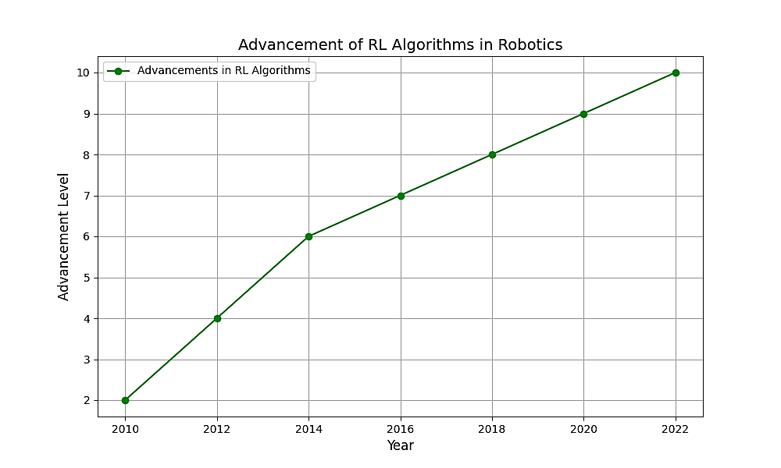

Takeaway Key:
- RL offers autonomous, adaptive, and flexible solutions to robotics, allowing robots to learn from experience rather than relying on predefined rules.
- Key advantages of RL include the ability to handle complex decision-making, generalize across tasks, and adapt to dynamic environments.
- Recent advancements, such as Deep Q-Networks (DQN) and Proximal Policy Optimization (PPO), have significantly improved the efficiency and effectiveness of RL in robotics.
- Safe RL techniques are addressing the critical challenge of ensuring robot safety during learning, enabling real-world deployment.

3. Research Objectives and Scope
Research Objectives
The primary objective of this research is to explore and develop advanced Reinforcement Learning (RL) algorithms that can be effectively applied in the domain of robotics and autonomous agents. Given the rapid advancement of both fields, there is a pressing need to address several key challenges related to the application of RL in real-world robotic tasks. The research will focus on improving the efficiency, safety, and adaptability of RL algorithms, thereby making them more suitable for practical use in robotics.
The specific research objectives for this study are as follows:
- Developing Efficient RL Algorithms for Robotics: One of the major challenges in applying RL to robotics is the sample efficiency. Traditional RL algorithms often require large amounts of data and time to achieve optimal performance. This objective aims to develop RL algorithms that are more sample-efficient, allowing robots to learn faster and perform tasks effectively with less training data.
- Ensuring Safe Exploration in RL: As RL agents learn by interacting with their environments, the risk of unsafe exploration is a critical issue, especially in robotics. The second objective of this research is to design safe exploration techniques, ensuring that robots do not perform harmful actions during the learning phase, which could lead to physical damage to the robot or its environment.
- Improving Generalization Across Tasks and Environments: Many RL algorithms fail to generalize effectively from one task to another, leading to poor performance when exposed to new or unfamiliar environments. This objective focuses on improving the generalization capability of RL algorithms, enabling robots to learn transferable skills and adapt to a variety of tasks without requiring complete retraining for each new scenario.
- Developing Real-World Applications of RL in Robotics: While RL has seen success in simulated environments, deploying RL in real-world robotics presents significant challenges. This objective aims to bridge the gap between simulation-based learning and real-world application, with a focus on integrating RL algorithms into practical robotic systems such as autonomous vehicles, robotic arms, and mobile robots.
- Evaluating the Performance and Effectiveness of the Proposed Algorithms: The final objective is to evaluate the effectiveness of the developed RL algorithms in real-world robotic applications. This will involve conducting comprehensive experiments, comparing the performance of the proposed RL methods against existing techniques, and demonstrating their practical benefits in real-world scenarios.

Scope of the Study
The scope of this research will focus on the application of Reinforcement Learning to robotics, specifically in the context of autonomous agents. The study will cover both theoretical developments in RL algorithms and practical implementation in real-world robotic systems.
- Task Focus: This research will focus primarily on tasks where RL has demonstrated potential for improving robotic performance, including autonomous navigation, object manipulation, and human-robot interaction. These tasks are chosen because they represent some of the most challenging problems in robotics, requiring robots to make complex decisions in dynamic and uncertain environments.
- Algorithm Development and Testing: The scope of the study includes the development of RL algorithms, with a particular emphasis on improving sample efficiency, safety, and generalization. The algorithms will be tested in both simulated environments (to allow for fast experimentation) and real-world robotic systems (to assess their practicality).
- Applications: This research will specifically focus on autonomous vehicles, robotic arms, and mobile robots. These areas are chosen because of their relevance to current advancements in robotics, where RL can significantly improve performance. The study will also explore how RL can contribute to the advancement of human-robot collaboration, where robots work alongside humans in shared spaces.
- Experimental Setup: A large part of this research will involve conducting experiments in both simulated and real-world settings. The experimental setup will involve the design and implementation of robotic systems equipped with RL algorithms, followed by detailed performance analysis. The study will focus on tasks such as navigation, object manipulation, and decision-making under uncertainty.
- Limitations: The study will focus on the application of RL algorithms in robotics and will not extend to other areas of AI or machine learning, such as supervised learning or natural language processing. The research will primarily concentrate on improving RL techniques in autonomous agents and robotic systems, with limited exploration into other domains.

Table 2: Research Objectives and Scope
Objective | Description
Developing Efficient RL Algorithms | Focus on improving sample efficiency and reducing data requirements for RL models in robotics.
Ensuring Safe Exploration | Develop safe RL techniques that prevent robots from performing harmful actions during learning.
Improving Generalization | Enhance the ability of RL models to generalize across different tasks and environments.
Developing Real-World Applications | Apply RL algorithms in real-world robotic systems such as autonomous vehicles and robotic arms.
Evaluating Performance and Effectiveness | Conduct experiments to compare the performance of proposed RL algorithms with existing methods.

Takeaway Key:
- Efficiency and safety are major challenges in RL for robotics, which this research aims to address.
- Key research objectives include improving sample efficiency, ensuring safe exploration, and enhancing generalization.
- The study will focus on autonomous navigation, object manipulation, and human-robot interaction tasks, with practical applications in autonomous vehicles and robotic arms.
- This research aims to bridge the gap between simulation-based learning and real-world applications, making RL more applicable in real-world robotic systems.

4. Significance of the Study
The significance of this study lies in its potential to enhance the capabilities of robotics through the integration of advanced Reinforcement Learning (RL) algorithms. As robotics continues to evolve, the demand for smarter, more adaptable, and autonomous systems has never been greater. This research aims to make substantial contributions to the field by improving the performance, safety, and efficiency of RL algorithms, thereby enabling robots to perform tasks in dynamic, unstructured environments.

Practical Applications and Industry Impact
The successful integration of RL algorithms into robotics will have far-reaching implications for various industries, revolutionizing how robots are used in real-world applications.
Some of the key areas where RL-based robotics can have a significant impact include:
- Autonomous Vehicles: The application of RL in autonomous vehicles, such as self-driving cars, is one of the most promising areas of research. RL allows vehicles to learn optimal driving policies based on real-time data from their surroundings, including traffic conditions, road signs, pedestrians, and other vehicles. By improving the decision-making abilities of autonomous vehicles, RL can enhance their ability to navigate safely and efficiently in complex, dynamic environments. As a result, RL can contribute to the widespread adoption of autonomous transportation, reducing human error and improving road safety.
- Industrial Automation: In industries like manufacturing, assembly, and logistics, robots equipped with RL algorithms can adapt to changing tasks and environments. For example, in warehouse automation, robots can learn how to navigate around obstacles, pick and place objects, and manage inventories with minimal human intervention. RL-based robotic arms can also optimize their movements to increase efficiency and precision, reducing downtime and improving overall productivity. The integration of RL in industrial automation can lead to cost savings, increased operational efficiency, and the ability to perform tasks that are too dangerous or complex for human workers.
- Healthcare and Medical Robotics: RL can be used in healthcare applications, such as robotic surgery, rehabilitation robots, and assistive robots for elderly care. By learning optimal surgical techniques or rehabilitation exercises, RL can enable robots to perform tasks with greater precision and adaptability. For example, a robotic surgery system could use RL to improve its performance over time, learning how to adjust its movements based on the patient's condition and minimizing the risk of complications. Additionally, RL can enable robots to assist elderly individuals by learning to recognize their needs and provide appropriate support, such as fetching objects, assisting with mobility, or monitoring health metrics.
- Human-Robot Collaboration: RL can enable robots to work alongside humans in collaborative environments, such as shared workspaces or homes. By learning to predict human actions and adapt their behavior accordingly, robots can assist in a wide range of tasks, from construction to healthcare. For instance, in a collaborative manufacturing environment, robots could use RL to learn how to coordinate their actions with human workers, improving productivity and safety. This human-robot collaboration has the potential to transform industries by enabling robots to perform complex, flexible tasks while working seamlessly with humans.

Theoretical Contributions
Beyond the practical applications, this research will contribute to the theoretical advancements of RL algorithms, particularly in the context of robotics. The study will explore new methods to overcome existing limitations in RL, such as sample inefficiency, safety concerns, and generalization issues.
Some of the key theoretical contributions include:
- Safe Exploration in RL: Safe exploration is a critical concern in RL, particularly in high-risk applications like robotics. This study will introduce techniques for ensuring that RL agents can explore their environments without performing dangerous or costly actions. By developing safety-conscious RL methods, this research will help prevent robots from causing harm to themselves or their environment during the learning phase.
- Improved Sample Efficiency: Traditional RL algorithms require a large number of interactions with the environment to learn effective policies. This research will explore techniques to improve sample efficiency, enabling robots to learn faster and with fewer interactions. Techniques like transfer learning, model-based RL, and hierarchical RL will be explored to reduce the need for extensive data and training time.
- Generalization across Tasks and Environments: One of the major challenges in RL is ensuring that learned policies can generalize across different tasks and environments. This study will contribute to the development of RL algorithms that are capable of transferring learned knowledge from one task or environment to another. By improving generalization, this research will make RL more practical and adaptable for real-world applications, where environments and tasks are constantly changing.
- Enhancement of RL Algorithms for Robotics: This research will push the boundaries of existing RL techniques by exploring how they can be optimized for the unique challenges presented by robotics. This includes improving how robots perceive and act in continuous, high-dimensional spaces and making decisions in real-time. The research will advance the theoretical understanding of how RL can be tailored to the complexities of robotic systems, improving both performance and reliability.

Social and Economic Impacts
The integration of RL in robotics can also have profound social and economic impacts. As robots become more autonomous, they can take on tasks that are too dangerous, repetitive, or strenuous for humans, improving the quality of life for workers and consumers alike. In addition, the widespread use of robots in industries such as healthcare, manufacturing, and transportation will drive economic growth by reducing operational costs, increasing productivity, and creating new job opportunities in fields related to robotics and AI. Furthermore, RL-based robots have the potential to enhance accessibility for individuals with disabilities by providing assistive devices that can adapt to their needs. This includes robotic exoskeletons, personal assistants, and other devices designed to improve mobility and quality of life.

Takeaway Key:
- The significance of RL in robotics extends far beyond theoretical advancements, with real-world applications in autonomous vehicles, industrial automation, healthcare, and human-robot collaboration.
- RL has the potential to improve safety, efficiency, and adaptability in robots, making them more capable of operating autonomously in dynamic, uncertain environments.
- Safe exploration and sample efficiency are critical areas of improvement in RL, which will be addressed in this study to ensure real-world applicability in robotics.
- Economic and social impacts include increased productivity, reduced risks in dangerous jobs, and enhanced accessibility for individuals with disabilities.

5. Structure of the Thesis
This section provides an overview of the organization and structure of the thesis. Each chapter builds upon the previous one to address the research objectives and present the findings in a coherent and logical sequence. Below is a brief description of each chapter:

Chapter 1: Introduction
As the first chapter of the thesis, the Introduction sets the stage for the research. It outlines the background of Reinforcement Learning (RL) and its applications in robotics, providing context for the need for more advanced RL algorithms. The motivation for the study is discussed, highlighting the challenges and gaps in current robotic systems that RL aims to address. The research objectives and scope of the study are clearly defined, along with the expected contributions of the research. Lastly, the significance of the study is emphasized, detailing the potential impacts on various industries and society as a whole.

Chapter 2: Literature Review
The Literature Review provides a comprehensive analysis of the existing body of research related to RL in robotics. It begins by reviewing the fundamental concepts of RL, including its core algorithms and theoretical foundations. The chapter then explores the application of RL in various domains of robotics, from autonomous navigation to object manipulation and human-robot collaboration. Key challenges in applying RL to robotics, such as sample efficiency, safety, and generalization, are discussed in detail. The chapter concludes with a review of recent advancements in RL algorithms and their potential to overcome these challenges.

Chapter 3: Research Methodology
This chapter outlines the research methodology used to achieve the objectives of the study. It begins by describing the experimental setup, including the choice of robotic systems, environments, and task definitions. The chapter details the RL algorithms that will be developed and tested, with a focus on improving sample efficiency, safety, and generalization. The methodology also includes the design of simulation experiments and the application of the algorithms to real-world robotic systems. The evaluation criteria for assessing the performance of the algorithms, such as task completion time, robustness, and safety, are also outlined.

Chapter 4: Algorithm Development and Experimentation
Chapter 4 presents the development of the RL algorithms that form the core of the research. The chapter begins by describing the design and architecture of the proposed algorithms, including modifications and innovations made to existing RL methods. The chapter then moves on to simulation experiments, where the algorithms are tested in controlled environments. The performance of the algorithms is compared with existing methods, and the results are analyzed. The chapter also includes a discussion of the challenges faced during the development and experimentation phases and how they were addressed.

Chapter 5: Real-World Applications and Testing
In this chapter, the focus shifts to the application of the developed RL algorithms in real-world robotic systems. The chapter begins by discussing the real-world tasks chosen for testing, such as autonomous navigation, object manipulation, and human-robot interaction. The performance of the RL algorithms is evaluated in these tasks, and comparisons are made with traditional robotic systems. The results are analyzed to assess how the algorithms perform in dynamic, unstructured environments. The chapter also explores the practical challenges encountered during real-world testing and their implications for future research.

Chapter 6: Results and Discussion
Chapter 6 presents the findings of the research, drawing from both the simulation experiments and real-world testing. The performance of the RL algorithms is thoroughly analyzed, with a focus on sample efficiency, generalization, and safety. The chapter compares the results with existing RL algorithms and discusses the strengths and weaknesses of the proposed methods. Additionally, the chapter highlights the implications of the findings for the future development of RL in robotics and suggests potential improvements for future work.

Chapter 7: Conclusion and Future Work
The final chapter concludes the thesis by summarizing the key findings and contributions of the research. The objectives of the study are revisited, and the extent to which they have been achieved is discussed. The chapter also provides a discussion of the limitations of the study and suggests directions for future research. Finally, the potential applications of the research in real-world robotic systems are explored, along with recommendations for improving RL algorithms for future use.

Appendices
The Appendices provide supplementary materials that support the main body of the thesis. This includes detailed mathematical derivations, code listings for the RL algorithms, experimental data, and additional charts or graphs. The appendices serve as a reference for readers who wish to explore the technical aspects of the research in more detail.

References
The References section lists all the sources cited throughout the thesis, following the APA referencing style. This includes books, journal articles, conference papers, and other relevant literature in the fields of Reinforcement Learning and Robotics.

Takeaway Key:
- Chapter 1 sets the context for the research, outlining the background, motivation, objectives, and significance.
- Chapter 2 reviews the existing literature on RL in robotics, identifying key challenges and advancements.
- Chapter 3 describes the methodology used to develop and test RL algorithms in robotics.
- Chapters 4 and 5 focus on algorithm development and real-world application, including testing and experimentation.
- Chapter 6 presents the results and discussion, analyzing the performance of the algorithms.
- Chapter 7 concludes the thesis, offering recommendations for future work and potential improvements in RL for robotics.

Chapter Conclusion
In Chapter 1: Introduction, the research journey into the application of Reinforcement Learning (RL) in robotics has been initiated. The chapter provided a comprehensive background on the concept of RL and its significance in enabling robots to perform complex tasks autonomously. The motivation for exploring RL within robotics was clearly outlined, focusing on the challenges faced by traditional robotic systems and the need for intelligent, adaptable, and self-learning systems. The research objectives and scope were defined, setting the direction for the study. These include developing more sample-efficient RL algorithms, ensuring safe exploration, and improving the generalization of RL models across tasks and environments. Additionally, the significance of this study in both practical applications and theoretical advancements was emphasized, showcasing the potential impact of RL on industries such as autonomous vehicles, industrial automation, healthcare, and human-robot collaboration. This chapter laid the foundation for understanding the role of RL in robotics and set the stage for further exploration in subsequent chapters, where the development and testing of RL algorithms will be discussed in detail.

