Capstone Project
What Drives Resale-Condo Prices in Tokyo? — Final Report
- Author: Sumit Mishra
- GitHub repository: https://github.com/Sumit-Misra/tokyo-condo-capstone-final
- Notebooks: 1. Cleaning, EDA & Statistics | 2. Modeling | 3. Evaluation & Findings

1. Problem Statement
Buying a resale condominium in Tokyo is one of the largest financial decisions many people make. However, determining whether a property is fairly priced can be difficult. Prices are influenced by several factors, including location, floor area, building age, distance to the nearest station and the timing of the sale. Property prices have also increased steadily since 2015, making it even harder for buyers to assess market value. In many cases, buyers rely on the selling agent's judgement, which may not provide an independent valuation.
Goal: Identify the key property characteristics that influence resale-condominium prices and develop a machine learning model that can estimate transaction prices accurately enough to help identify potentially over- or underpriced properties.
Challenges: The original dataset is in Japanese and contains several text-based fields that require processing before analysis. Property prices are heavily skewed and can vary by as much as seven times between locations. Prices also change over time, so the model must be evaluated on more recent transactions rather than using a random train/test split.
Potential Benefits: The analysis could help buyers make more informed decisions and negotiate with supporting evidence, help sellers set more realistic asking prices, and provide lenders and investors with a quick, consistent second opinion when assessing property values.
Change Since Module 16: The original proposal focused on forecasting payment-system failures using the PaySim synthetic payments dataset. However, PaySim does not contain a failure label and covers only around 30 days of simulated activity, making it unsuitable for the original objective. The project was therefore re-scoped to focus on Tokyo resale-condominium prices, using a real-world public dataset with a clearly defined prediction target.

2. Model Outcomes or Predictions
- Type of learning: Supervised learning — regression.
- Target variable: The transaction price in Japanese yen, transformed using log(price). This helps the model learn relative price differences and reduces the influence of a small number of very expensive properties.
- Expected output: An estimated market value for a condominium based on its location (municipality, district and nearest station), floor area, building age, layout, walking time to the station, building structure, zoning, renovation status and sale date. The estimated value can then be compared with the actual transaction price or asking price to identify potential valuation differences. Properties are classified as within ±20% of the estimate, more than 20% above it or more than 20% below it.
- Algorithms: The project uses supervised learning algorithms across several approaches, including linear models, distance-based methods, tree-based models and ensemble methods.

3. Data Acquisition
The project uses the Real Estate Transaction Price Information dataset for Used condominiums, etc., covering Tokyo from 2015 Q1 to 2026 Q1. It is published by Japan's Ministry of Land, Infrastructure, Transport and Tourism (MLIT) through the Real Estate Information Library. The original dataset contains 182,555 transactions across 21 columns, with records provided in Japanese.
This dataset is well suited to the project because it is an official public source, covers reported resale-condominium transactions in Tokyo over an eleven-year period, and includes many of the characteristics that influence property prices.
A second data source containing station passenger numbers, available through MLIT's National Land Numerical Information, was also considered. However, matching approximately 600 Japanese station names to the transaction dataset could not be completed within the available project time. This was left as a potential improvement for future work. Instead, the analysis used the detailed location fields already available in the dataset, including district and nearest station.

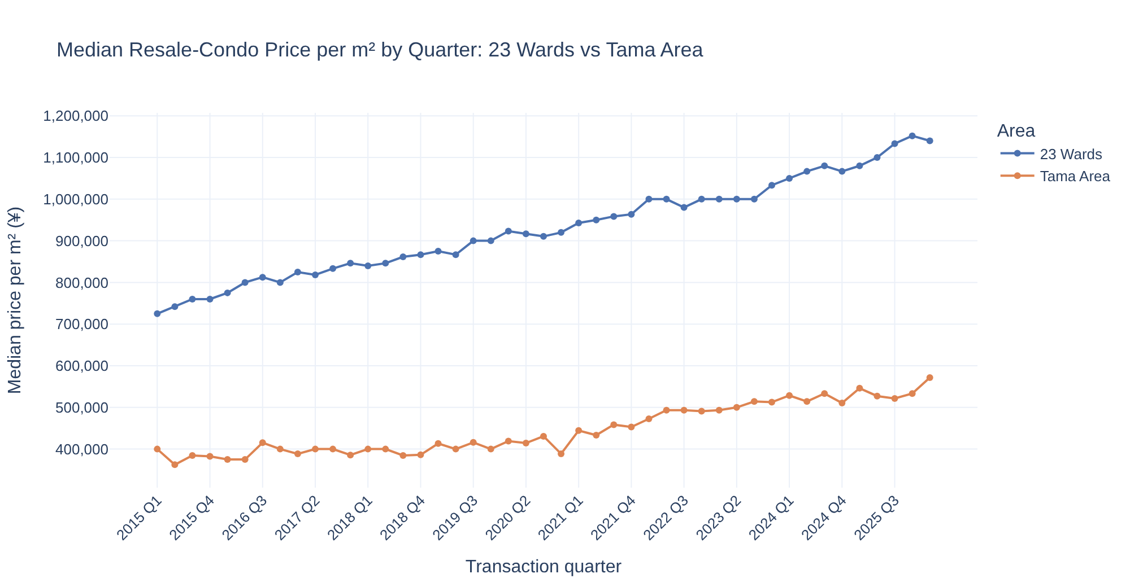
Figure 1. Median price per m² by quarter: +59% in the 23 wards and +33% in the Tama Area (2015 Q1 to 2025 Q4). The clear trend and location gap show the data's potential to explain prices.

4. Data Preprocessing / Preparation

a. Missing Values and Inconsistencies
Several preparation steps were required to make the original dataset suitable for analysis and modelling:
- Translated all Japanese column names and category values into English.
- Removed 1,282 non-market transactions, including auctions and related-party sales; 1,507 non-residential properties; 1,523 exact duplicates; and 93 records with missing station walking times.
- Converted text-based fields into numerical or structured values. This included walking-time ranges (for example, 30–60 min converted to 45 minutes), construction dates such as pre-war converted to 1945, layout codes such as 3LDK+S and transaction quarters.
- Filled missing construction years and zoning values using the median or typical value within the same district, falling back to the municipality where necessary. Room counts were estimated using properties of similar sizes, while missing categories were retained under an explicit Unknown label.
- Identified outliers using the IQR rule applied to log price per square metre within each municipality. This removed 4,405 transactions (2.5%), along with units larger than 300 m².
After these steps, the final dataset contained 173,745 transactions, retaining 95.2% of the original records.

b. Train/Test Split
A time-based split was used to evaluate how well the model could estimate prices for more recent transactions:
- Training set: 140,993 transactions from 2015–2023.
- Test set: 32,752 transactions from 2024–2026.
Property prices have increased over time, so a random split could allow information from later transactions to influence model training. A time-based split provides a more realistic evaluation by using historical transactions to predict prices in a later period.
Hyperparameters were tuned using four-fold TimeSeriesSplit cross-validation on the training data only. The test set was kept separate throughout model selection and tuning.

c. Analysis and Encoding
The following feature engineering and preprocessing steps were applied:
- Feature engineering: Created building age at the time of sale, price per square metre, log transaction price and a time index representing the number of quarters since 2015.
- Categorical encoding: Applied one-hot encoding to municipality, building structure, zoning, renovation status and recorded property use. District (1,198 distinct values) and nearest station (612 distinct values) were target-encoded with internal cross-fitting.
- Feature scaling: Applied scaling to the numerical features used by Linear Regression, Ridge, Lasso and KNN, where appropriate.
- Preprocessing pipelines: All preprocessing steps were included within scikit-learn Pipelines. This ensured that transformations were fitted separately within each training fold, helping prevent validation-data leakage during cross-validation.
Inferential statistical tests provided further support for the patterns identified during exploratory analysis:
- Location: Price differences across the wards were substantial, with a Kruskal–Wallis effect size of ε² = 0.31.
- Renovation: After controlling for building age, renovation was associated with a 15.8% higher price (95% CI: 15.5%–16.2%), despite appearing cheaper in the initial comparison.
- Property layout: The distribution of layouts differed between central and outer Tokyo, with a Cramér's V of 0.29.
- Station distance: Walking distance remained negatively associated with prices within the 23 wards (Spearman ρ = −0.24).

5. Modeling
The modelling process started with a Dummy Regressor that predicts the median training price, alongside the Linear Regression baseline established in Module 20.1. Seven model approaches were then trained and tuned using GridSearchCV, with MAPE as the primary scoring metric.
The models and their purpose were:
- Linear Regression with detailed location: Evaluated whether adding district and nearest-station information improved on the original baseline.
- Ridge and Lasso: Applied regularisation to manage correlated features, particularly floor area and number of rooms, which had a correlation of 0.84.
- Decision Tree: Tested whether a tree-based model could capture non-linear relationships, such as the price difference associated with longer station walking times.
- KNN: Estimated prices based on similar properties. A 40,000-row sample was used to keep training time manageable.
- Random Forest: Combined 100 decision trees to reduce prediction variance and capture more complex relationships.
- Gradient Boosting: Built trees sequentially, with each new tree working to correct errors made by the previous ones.
Market-trend adjustment
The initial Gradient Boosting model struggled to account for rising prices in the 2024–2026 test period. Tree-based models do not naturally extrapolate beyond the patterns observed during training, which resulted in underestimates of up to 17%.
To address this, a market-trend adjustment was applied to the tuned Gradient Boosting model. The estimated market trend of +1.24% per quarter (approximately 5% annually) was calculated using training data only. This trend was removed from the target before model training and added back to the predictions afterwards.

6. Model Evaluation
Evaluation Metric: Mean Absolute Percentage Error (MAPE) was used as the primary metric to evaluate prediction accuracy. Condominium prices in the dataset range from below ¥10 million to over ¥300 million, so measuring errors as percentages makes it easier to compare performance across properties at different price levels. It also provides a more practical way to interpret prediction errors in the context of property valuations.
Alongside MAPE, the evaluation included median absolute percentage error, the percentage of predictions within ±10% of the actual transaction price, Mean Absolute Error (MAE) and the coefficient of determination (R²).
All results reported below are based on the held-out 2024–2026 test set, which was not used during model training or hyperparameter tuning.

Model | Test MAPE | Median APE | Within ±10% | R² | CV MAPE
Gradient Boosting + market trend | 14.86% | 11.08% | 45.7% | 0.91 | 13.86%
Gradient Boosting | 16.37% | 13.42% | 37.6% | 0.89 | 14.17%
Random Forest | 18.48% | 15.27% | 33.1% | 0.86 | 16.18%
Linear Regression + location | 19.98% | 15.40% | 33.9% | 0.85 | 18.28%
Ridge | 19.98% | 15.39% | 33.9% | 0.85 | 18.28%
Lasso | 20.08% | 15.50% | 33.9% | 0.85 | 18.35%
Baseline: Linear Regression (20.1) | 20.52% | 15.80% | 33.5% | 0.84 | —
Decision Tree | 21.77% | 17.80% | 29.2% | 0.79 | 19.79%
KNN (40k sample) | 23.89% | 18.66% | 28.2% | 0.76 | 23.52%
Dummy (median price) | 53.43% | 38.78% | 13.0% | −0.10 | —

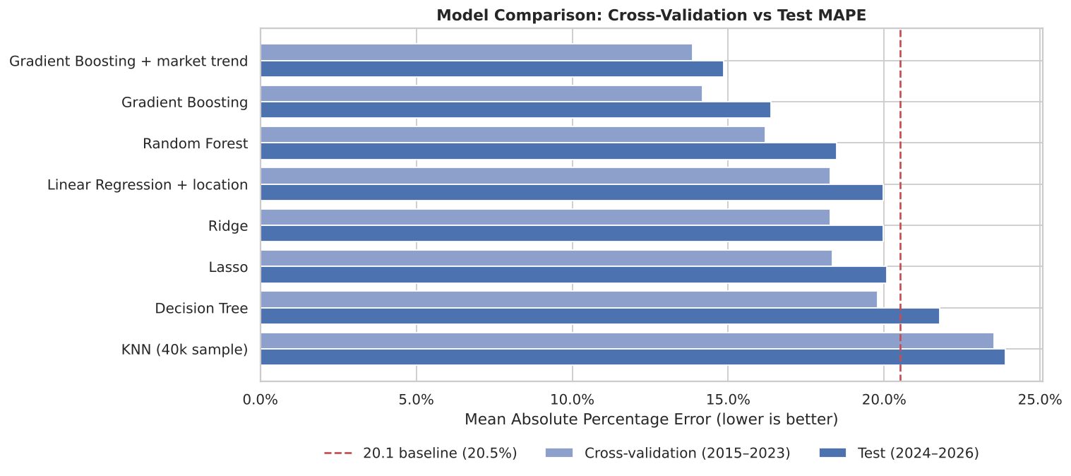
Figure 2. Cross-validation and test MAPE for each model; the dashed line is the Module 20.1 baseline.
Model Selection: Gradient Boosting with the market-trend adjustment was selected as the final model because it achieved the lowest error in both cross-validation (13.86%) and the held-out test set (14.86%). This represents an improvement of approximately 28% over the baseline. Tree-based ensemble methods performed better than linear models because they can capture more complex relationships between property characteristics, such as how the effect of building age on price varies between central and outer Tokyo. The difference between training MAPE (11.78%) and test MAPE (14.86%) indicates a moderate degree of overfitting, while showing that the model generalises reasonably well to unseen transactions.
Interpretation: Permutation importance identified floor area, building age and location (municipality, nearest station and district) as the main factors influencing the model's predictions. What-if analysis showed that estimated prices decreased by around 5% when walking distance increased from 1 to 10 minutes, and by approximately 15% at 15 minutes. A property's estimated value also decreased by around 21% as its building age increased from new to 10 years. The model performed best for mid-priced properties, with MAPE between 10.7% and 12.7%, and across the 23 wards, with MAPE of 14.2%. Prediction errors were higher in the Tama area (19.0%) and at the lower and upper ends of the price range.
Practical Use: When compared with the model's estimates, 75.3% of transactions from 2024–2026 were within ±20%. A further 14.0% sold for more than 20% above the estimated value, most commonly in Minato, Chuo and Chiyoda. Another 10.8% sold for more than 20% below the estimate, with the highest shares in Katsushika, Adachi and Edogawa. These differences can help identify transactions that may warrant closer review.
Limitations and Next Steps: The model is designed for ordinary residential properties, assumes that the market trend observed during 2015–2023 remains a useful guide, and does not account for factors such as floor level, property views or building condition. Future improvements could include adding station passenger data, expanding the hyperparameter search to include XGBoost and LightGBM, retraining the model quarterly and developing a simple web application that provides an estimated property-price range.

