## 5CS037 –

Concepts and Technologies of AI

**Assignment-02**

**Term-Paper (Report) on Ethics and AI.**

**Name: SUMIT SHAH**

**Group: L5CG17**

**Student ID: 2358830 (230083)**

**ACADEMIC TUTOR: NABIN ACHARYA**

**Module leader: SIMAN GIRI**

# ABSTRACT

This report is all about AI. The importance of AI. What AI has given us, how we have been developing AI, and how AI has been helping in the development of humankind. Different people have different opinions and views regarding AI. But we must see what true and real facts about AI are. AI is in the developing stage so it may have lots of problems for now, but all the problems and difficulties will be solved as time passes because AI has a great ability to learn itself with past experiences like human beings do. This report talks about the ethics of AI, its work, its social good, its initiatives, its generic framework, and its contribution to humankind in short. This report is not about only personal views but about the research based on facts and truth. What is right, what is wrong, and what we should do and not do for the development of AI?

Contents

ABSTRACT 1

ETHICS 3

Ethics of AI and Ethical AI 4

AI and Social Good: 5

Initiatives in the field of Ethical AI: 6

Conclusion: 9

Reference: 10

# 

# ETHICS

The word “ethics” is derived from the Latin word ethos (character), and the Latin word mores (customs). In simple language, ethics means how the person chooses to react with the person or own self or in any kind of situation or with another Person or condition or situation. Every one individual has their own ethics and values. The difference is some may have positive, and some have negative. Some have high ethics, and some have low ethics.

## Ethics of AI and Ethical AI

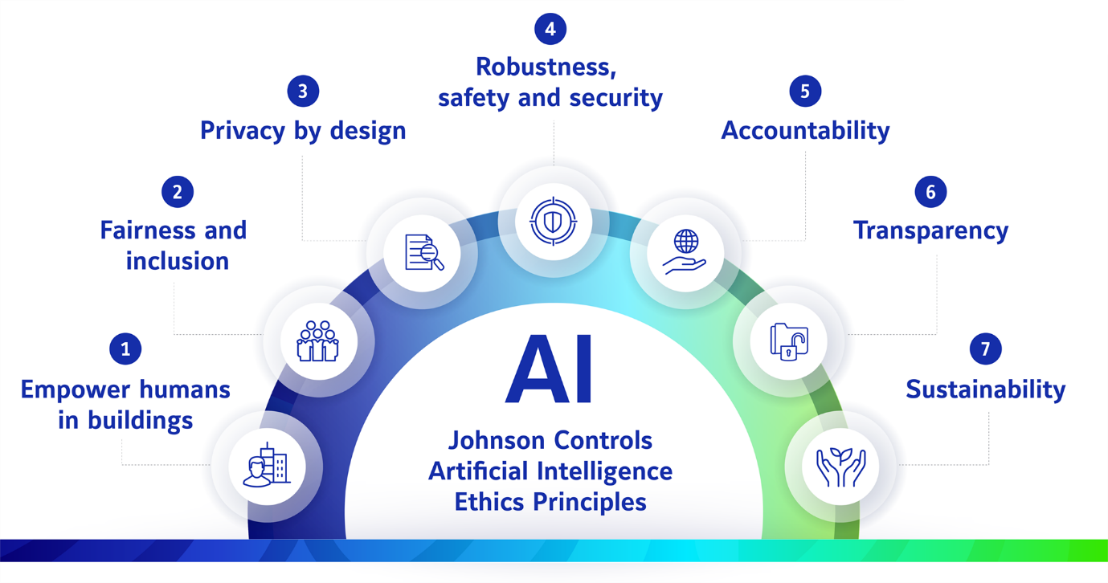

The main Ethics of AI is helping human begin to create and build new things for the betterment of human beings. AI should be fair and include all the inclusive functions that are needed for the human being Ai should be deign as the privacy of human being or user of the AI. Ai should be secured there should not be any kind of harm while using the AI The user should feel safe and secure while using AI. Ai should be transparent and there should not be hidden from users which may cause any kind of problem in the future. AI should be suitable not only for today and tomorrow but also for a long time. Ethical AI includes fairness, transparency, accountability, and respect for human values.

We should build ethical AI because AI is built for the betterment of humankind not the destruction of humankind. To increase the productivity and creativity of Human beings. Human beings should not take AI as an opponent but as a strong weapon for betterment.

## AI and Social Good:

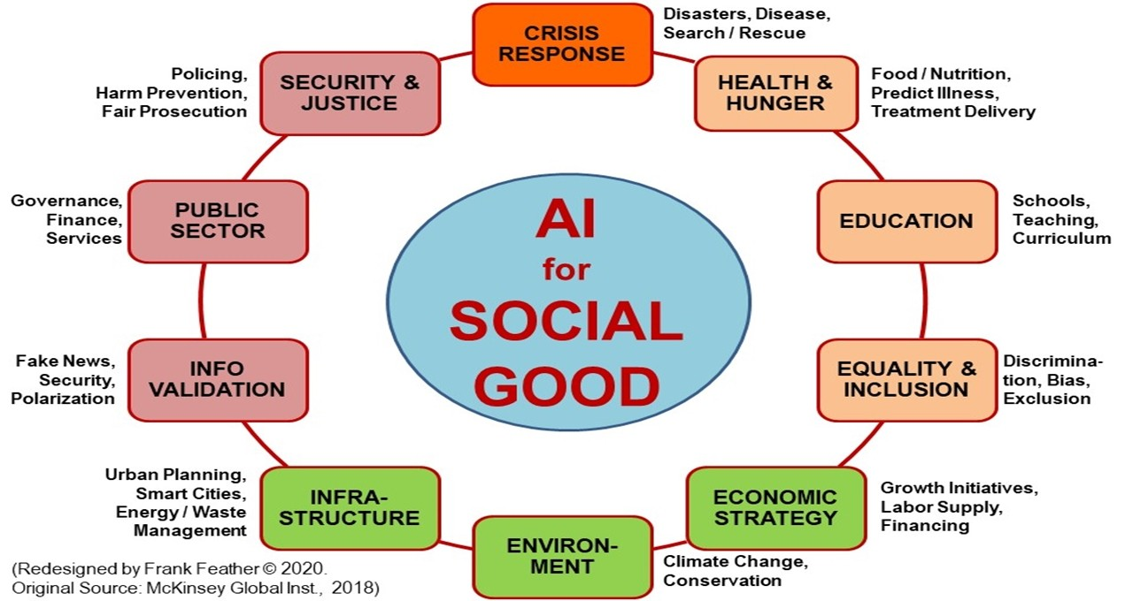

AI is very much used in the education sector both by learners and teachers. AI helps to boost productivity much more times than the usual form. AI helps teachers to teach and helps how to make students understand much more easily than by the self learns same by the learner they do not have to stop in one problem or stuck the problem they can easily solve and continue their learning.

AI Helps in Health sector. Ai helps to detect most of the diseases which we humans cannot easily detect through our self; the treatment can be done in time and can saves lots of life. AI is also being used in the production of medicine as per the specific disease need to be consumed by specific patient of specific disease.

AI helps in the prediction with the help of past data. AI is used to predict the future as per past experiences.

AI has been used in security purpose as well specially in sensitive places like Airport, hospital, bank and so on. AI helps to increase the security level to the next level. As AI has the ability to learn itself and make the system more and more secure as the time passes with the experiences.

AI has a great contribution to our society also. AI helps in the government sector to the private sector from the health sector to the education sector to the public sector.

# Initiatives in the field of Ethical AI:

Everyone is trying from their side to make AI better and better day by day not only from the personal level but also from the different law-making and implementing organization levels. UNESCO and European Commissions also work in partnership with ethical issues in AI such as bias and transparency.

High-Level Expert Group in AI (HLEG AI): This group helps to advise on policy and regulation Frameworks on AI.

The Algorithmic Decision-Making (ADM) Act: This group makes law in the US for certain companies to make algorithms in AI.

Centre for Data Ethics and Democracy: This organization advocates when there is a problem for AI and ethical use of data and algorithms.

These are just simple examples of who is working for the betterment and development of AI but directly or indirectly many organizations are working for the betterment and development of AI.

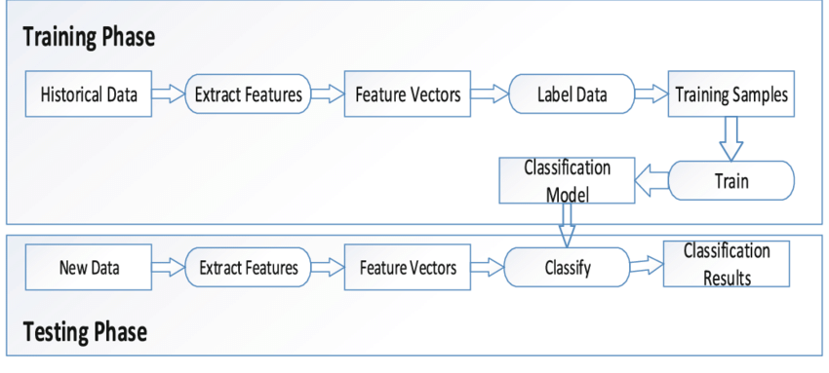

Generic Framework/Principle for the development and use of AI:

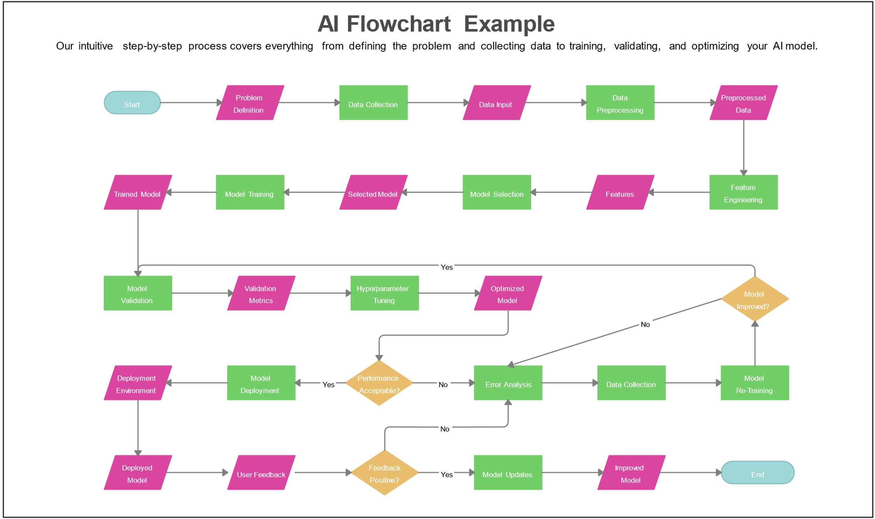

AI is all about data and Analysis. AI requires lots of historical data for certain results or outputs. It extracts certain features from the past data, some features of vectors, some label data, and training with some samples to train the certain model for the result or output of the data.

AI is not only used in one or two sectors but all the other sectors which we imagine. Whether it is from farming to rocket science, all of them use AI. In agriculture, AI is used to track the growth and development of crops and calculate the expected crops in certain time. AI use in animal husbandry is tracking the health condition of animals in their feeding and growth and development of animals for the commercial things. AI is used in driving autonomous vehicles which is also called auto pilot vehicle. Which doesn’t require any kind of driver and can drive its self-safer and secure way. AI is also used in the field of research to store old historical data and predict the result of what output can come from the experiment and research. AI not only deals with data but also AI is able to learn itself from past experience. AI is designed in such a way that it gets much better with the experience and day by day. And able to solve the problems in a much better way and effective way.

# Conclusion:

In nutshell, AI is very important for the development of humankind. It only doesn’t help us to solve our problems of ours, but it has ability learn itself with the past experience like human beings. Which makes it better. In the coming days AI will be better and will help us lose a lot in each and every sector. Human beings should not take AI as an opponent but as a companion. People believe that AI may take their jobs but in reality, AI will create more new types of job opportunity and help people to do their job much more effectively in less period of time. There are many laws, rules and regulations which provide difficulties in implementation of AI. That kind of law rules and regulation should be corrected as per the need and requirement of humankind. Everyone should help to make AI better and better to solve their problem in a more effective way.

# Reference:

arimetrics. (n.d.). *arimetrics*. Retrieved from  
What is black box algorithm: <https://www.arimetrics.com/en/digital-glossary/black-box-algorithm>  
  
  
Blackman, R. (2020, october 15). *Havard business  
review*. Retrieved from A Practical Guide to Building Ethical AI:  
<https://hbr.org/2020/10/a-practical-guide-to-building-ethical-ai>  
  
  
Chu, C. (2022, jan 18). *the conversation*.  
Retrieved from Artificial intelligence can discriminate on the basis of race  
and gender, and also age: <https://theconversation.com/artificial-intelligence-can-discriminate-on-the-basis-of-race-and-gender-and-also-age-173617>  
  
  
*coursera*.  
(2024, jan 5). Retrieved from AI Ethics: What It Is and Why It Matters:  
<https://www.coursera.org/articles/ai-ethics>  
  
  
europarl. (2023, 08 06). *EU AI Act: first  
regulation on artificial intelligence*. Retrieved from  
<https://www.europarl.europa.eu/news/en/headlines/society/20230601STO93804/eu-ai-act-first-regulation-on-artificial-intelligence>  
  
  
Kenton, W. (2023, june 29). *What Is a Black Box  
Model? Definition, Uses, and Examples*. Retrieved from investopedia:  
<https://www.investopedia.com/terms/b/blackbox.asp>  
  
  
Maker, P. J. (n.d.). *pursuit*. Retrieved from  
WHY DOES ARTIFICIAL INTELLIGENCE DISCRIMINATE?:  
<https://pursuit.unimelb.edu.au/articles/why-does-artificial-intelligence-discriminate>  
  
  
Omowole, A. (2021, july 19). *World Economic Forum*.  
Retrieved from Research shows AI is often biased. Here's how to make  
algorithms work for all of us:  
<https://weforum.org/agenda/2021/07/ai-machine-learning-bias-discrimination/>  
  
  
Purcell, B. (2020, april 13). *Five AI Principles  
To Put In Practice*. Retrieved from Forrester:  
<https://www.forrester.com/blogs/five-ai-principles-to-put-in-practice/#:~:text=In%20general%2C%20most%20entities%E2%80%99%20AI%20principles%20to%20develop,transparency%2C%20accountability%2C%20social%20benefit%2C%20and%20privacy%20and%20security>.  
  
  
Roe, D. (2021, june 25). *Why Ethical AI Won't  
Catch On Anytime Soon*. Retrieved from reworked:  
<https://www.reworked.co/information-management/why-ethical-ai-wont-catch-on-anytime-soon/>  
  
  
Suzman, M. (2023, may 21). *The first principles  
guiding our work with AI*. Retrieved from gates foundation:  
<https://www.gatesfoundation.org/ideas/articles/artificial-intelligence-ai-development-principles>  
  
  
Talagala, N. (2022, may 31). *forbes*. Retrieved  
from AI Ethics: What It Is And Why It Matters:  
<https://www.forbes.com/sites/nishatalagala/2022/05/31/ai-ethics-what-it-is-and-why-it-matters/?sh=1fb1b1723537>  
  
  
Velasquez, M. (2010, jan 1). *Markkula center*.  
Retrieved from Scu:  
<https://www.scu.edu/ethics/ethics-resources/ethical-decision-making/what-is-ethics/>

