ABSTRACT:

This report is all about AI. The importance of AI. What AI have given us, how we have been developing AI and how AI has been helping in the development of human kind. Different people have different opinion and views regarding AI. But we have to see what is true and real fact about the AI. AI is in developing stage so it may have lots of problem for now but all the problems and difficult will be solved as time pass because AI has great ability to learn itself with past experiences like human beings does. This report talk about ethics of AI , its work ,its social good, its initiatives , its generic framework and the contribution to human kind in short. This report is not about only personal view but about the research based on facts and truth. What is right, what is wrong and what should we do and not do for the development of AI.

ETHICS

The word “ethics” is derived from the Latin word ethos (character), and the Latin word mores (customs). In simple language, ethics means how the person chooses to react with the person or own self or in any kind of situation or with another Person or condition or situation. Every one individual have their own ethics and value. The difference is some may have positive and some have negative .Some have high ethics and some have low ethics.

Ethics of AI and Ethical AI

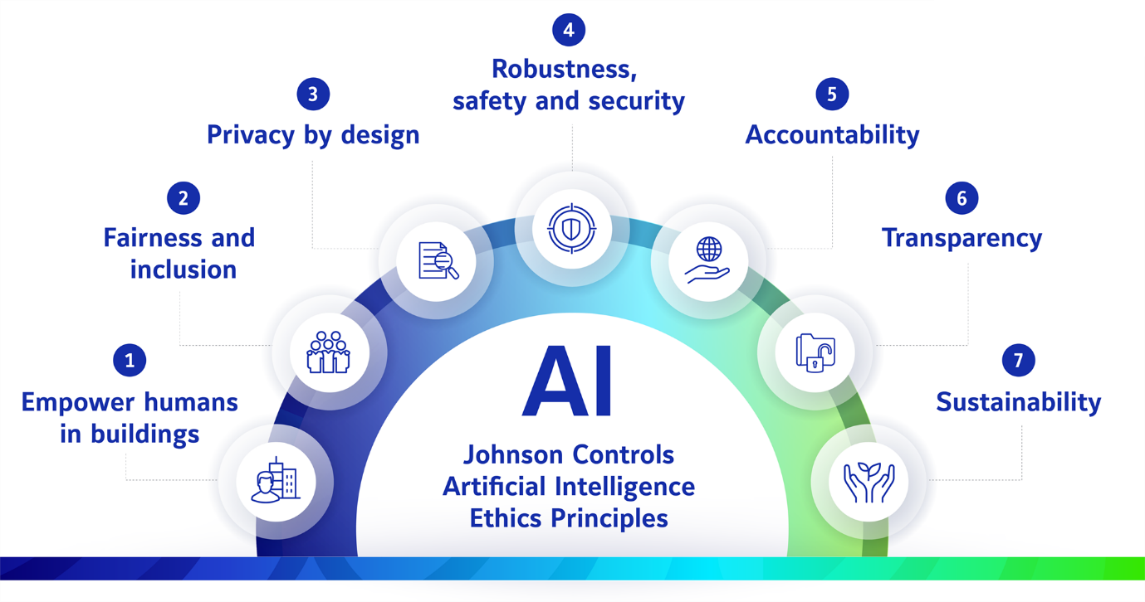

The main Ethics of AI is helping human begin to create and build new things for the betterment of human beings. AI should be fair and include all the inclusive function that are need for the human being Ai should be deign as the privacy of human being or user of the AI. Ai should be secured there should not be any kind of harm while using the AI The user should feel safe and secure while using AI. Ai should be transparent there should not be hide anything from users which may cause any kind of problem in the future. AI should be suitable not only for today and tomorrow but also for the long time. The Ethical AI includes fairness, transparency, accountability and respect for the human values.

We should build ethical AI because AI is built for the betterment of humankind not the destruction of humankind. To increase the productivity and creativity of Human beings. Human beings should not take AI as an opponent but as a strong weapon for betterment.

AI and Social Good:

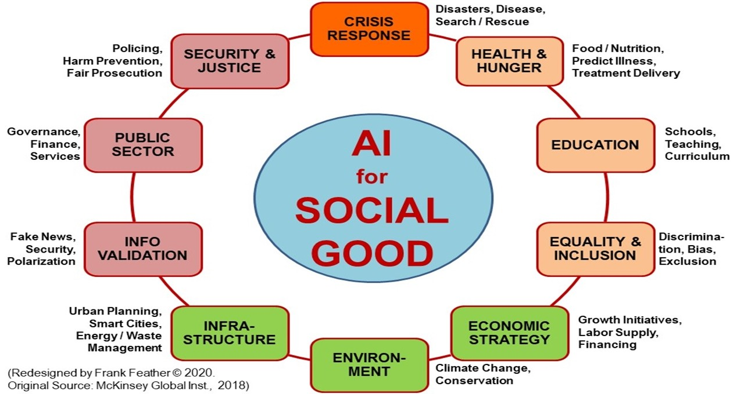

AI is very much use in education sector both by leaner and teacher. AI help to boost the productivity much more times than the usual form. AI helps teacher to teach and help how to make student understand much more easily than by the self learns same by the learner they do not have to stop in one problem or stuck the problem they can easily solve and continue their learning .

AI Helps in Health sector. Ai helps to detects most of the disease which we human cannot easily detect through our self, the treatment can be done in time and can saves lots of life. AI is also being used in the production of medicine as per the specific disease need to be consumed by specific patient of specific disease.

AI helps in the prediction with the help of past data. AI is used to predict the future as per the past experiences .

AI is been used in security purpose as well specially in sensitive places like Airport, hospital, bank and so on. AI helps to increase the security level to next level. As AI has ability to learn itself and make the system more and more secure as the time passes with the experieces.

AI has a great contribution to our society also. AI helps in the government sector to the private sector from the health sector to the education sector to the public sector.

Initiatives in the field of Ethical AI:

Everyone is trying from their side to make AI better and better day by day not only from the personal level but also from the different law-making and implementing organization levels. UNESCO and European Commissions also work in partnership with ethical issues in AI such as bias and transparency.

High-Level Expert Group in AI (HLEG AI): This group helps to advise on policy and regulation Frameworks on AI.

The Algorithmic Decision-Making (ADM) Act: This group makes law in the US for certain companies to make algorithms in AI.

Centre for Data Ethics and Democracy: This organization advocates when there is a problem for AI and ethical use of data and algorithms.

These are just simple examples of who is working for the betterment and development of AI but directly or indirectly many organizations are working for the betterment and development of AI.

Generic Framework/Principle for the development and use of AI:

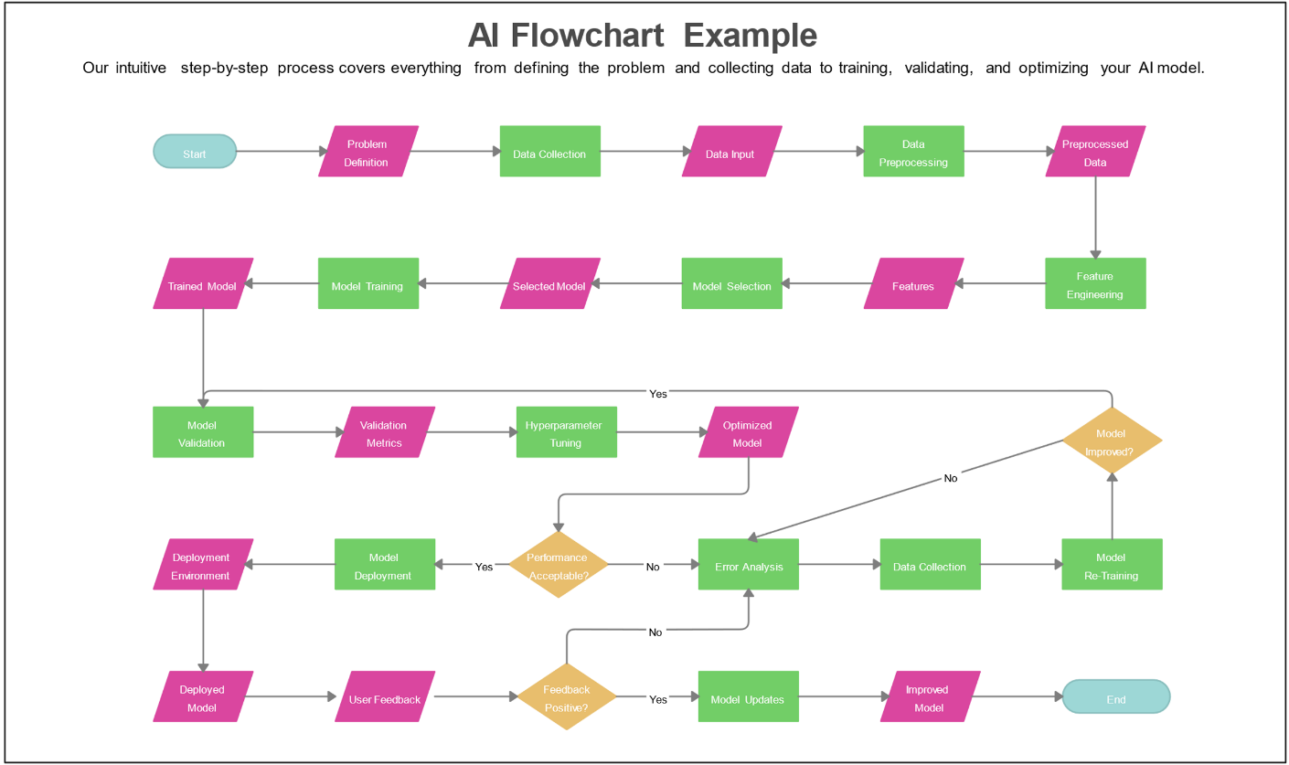

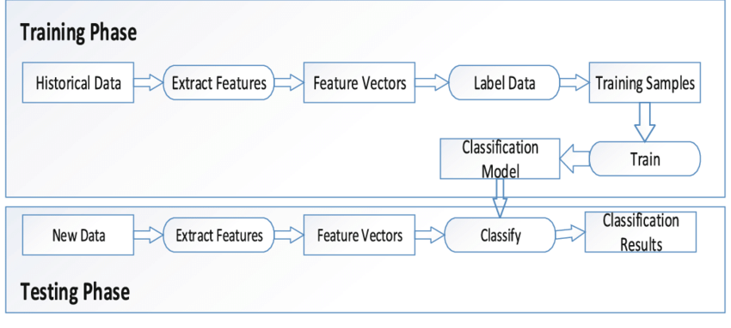

AI is all about data and Analysis. AI requires lots of historical data for certain results or outputs. It extracts certain features from the past data, some features of vectors, some label data, and training with some samples to train the certain model for the result or output of the data.

AI is not only used in one or two sectors but all the other sectors which we imagine. Whether it is from farming to rocket science, all of them use AI. In agriculture, AI is used to track the growth and development of crops and calculate the expected crops in certain time. AI use in animal husbandry is tracking the health condition of animals in their feeding and growth and development of animals for the commercial things. AI is used in driving the autonomous vehicle which is also called auto pilot vehicle. Which doesn’t required any kind of driver and can drive its self-safer and secure way. AI is also used in the field of research to store the old historical data and predict the result what output can come from the experiment and research. AI not only deal with data but also AI is able to learn itself from past experience. AI is deign in such a way that it get much better with the experience and day by day. And able to solve the problems much better way and effective way.

Conclusion:





AI is very much important for the development of human kind .It only don’t help us to solve the problems of ours but it have ability learn itself with the past experience like human beings .Which makes it more and more better. In coming day’s future AI will be better and will help we lot in each and every sector. Human being should not take AI as an opponent but as a companion. People believe that AI may take their jobs but in reality AI will create more new types of job opportunity and help people to do their job much more effectively in less period of time. There are many law rules and regulation which provide difficulties in implementation of AI. Those kind of law rules and regulation should be corrected as per the need and requirement of human kind. Everyone should help to make AI better and better to solve their problem in more effective way.