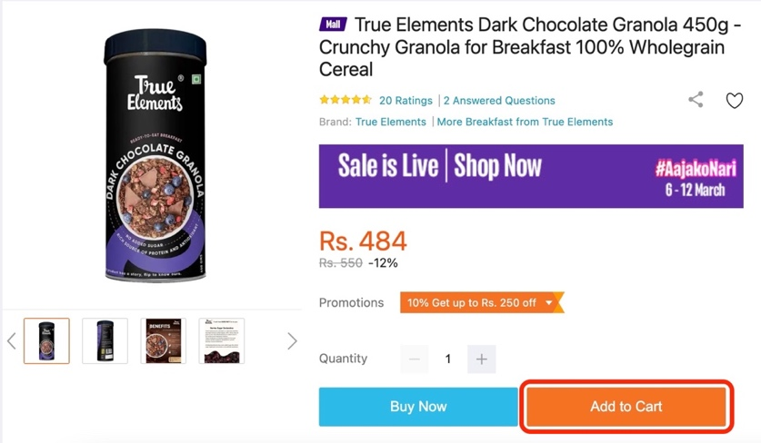

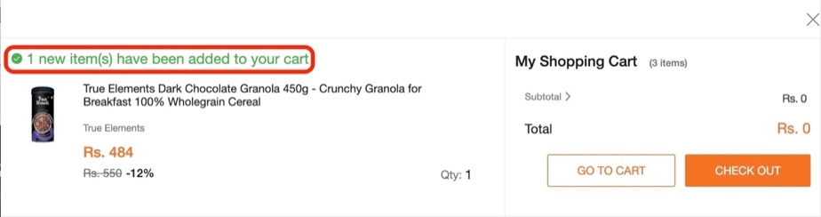

|  |  |  |
| --- | --- | --- |
| **Theories** | **Color** | **Applied** |
| **8 Golden Rule** |  | * Offer informative Feedback |
| **10 Usability Heuristics** |  | * Visibility of system status * Match between system and the real world |
| **Analysis:**  We can see that when we add an item to the cart, the system shows a pop-up informing the user about the completion of that particular task.  Similarly, the concept to “Add to Cart” was brought into the system to match with the real world. That phrase is used to relate the user’s physical shopping experience. | | |