Tutorial 3

1. **Impact of Accessibility**

* Empathy needs to be at the core of the design
* [When we design for disability, we all benefit | Elise Roy](https://youtu.be/g2m97gPI70I?t=248)

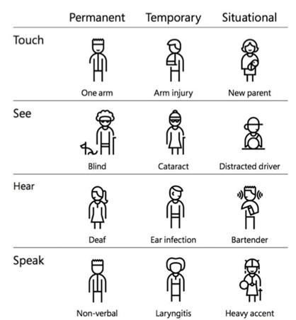

* How good design steps away from **Conventional Wisdom**
  + The Wright brothers were ridiculed when they first wanted to fly
  + Commercial airlines had already started in their lifetime
  + The first flight was in 1903
  + The first moon landing in 1969
  + 63 years and humanity evolved leaps and bounds because two brothers were able to question conventional wisdom
* The misconception that it is only for people with permanent disabilities
* One of the largest user groups. A report published by the United Nations in 2011 estimated **there were 1–1.3 billion people with disabilities in the world (as much as the population of China in 2014)**.
* Brand Positioning - An accessible design is more marketable and appreciated by the general public
  + <https://www.computerworld.com/article/2532690/target-agrees-to--6m-settlement-of-accessibility-lawsuit.html>

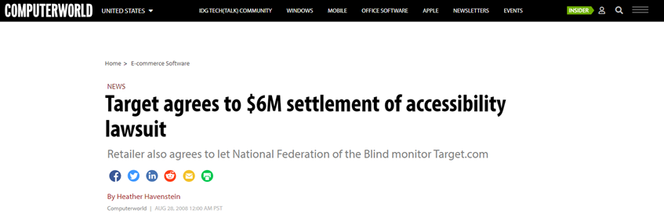

1. **Accessible design is better UX for everyone (Case Studies)**
   * Gaming Vlog
     + You run a gaming vlog
     + You use closed captions in your video to make it accessible for your deaf viewers
     + The text can be searched by the google engine and helps in your ranking
   * Restaurant
     + You run a restaurant
     + You want to make a website for your restaurant
     + You spent a lot of money to hire a designer and create a menu
     + You can either recreate the menu in code or upload JPEG
     + If you upload JPEG, you won’t serve visually impaired customers
     + The text can’t be searched and SEO ranking goes down
     + Your users can’t search for an item when they visit your website
2. **Alt Tags (Lecture Content)**
   * What are alt tags
   * Misuse of alt tags for SEO
   * When to skip alt tags
   * Longdesc in alt tag
3. **Accessibility of real-world websites and software**

* <https://blog.hubspot.com/website/accessible-website-examples>

1. **Accessibility options in famous mobile applications**

* <https://www.accessibilitychecker.org/guides/mobile-apps-accessibility/>

1. **Device accessibility options and a hands-on experience**
   * <https://www.microsoft.com/en-us/accessibility/features?activetab=pivot_1%3aprimaryr2>
   * <https://www.apple.com/newsroom/2022/05/apple-previews-innovative-accessibility-features/>

**Assignment Related**

1. **Address Task-1 if students have any questions or queries**
   1. 10 wireframes screen to include
   2. Literature Review ( 2 reference papers)
   3. Read more (Task 1 - Usability Report Guidelines ):

<https://drive.google.com/file/d/16lLHpn85DWJ6SEgGfreIXpBliWAVl4ab/view?usp=drivesdk>