# Section 1 (1 marks each)

1. What is the significance of Generalization in a UML diagram
   1. Specifies a inheritance relationship
   2. Specifies that two classes are linked to each other
   3. Specifies that the objects are related to each other
   4. Specifies that a class has multiple subclasses
2. What is the difference between private and protected access modifiers
   1. private: makes the member of the class accessible onto to the class itself and protected: makes the member of the class accessible to only itself and to its subclasses
   2. private: makes the members of the class accessible to all the other classes and protected: makes the members of the class accessible to only itself
   3. private: makes the members of the class accessible within a package and protected: makes the members of the class accessible to only files within the package
   4. private and protected both work similarly

# Section 2 (2 marks each)

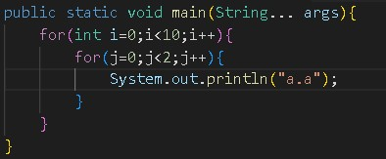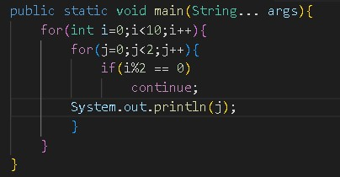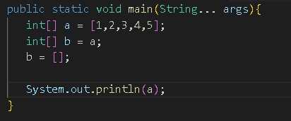

3. 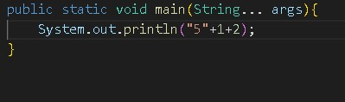

4.

5. 6.

# Section 3 (6 marks each)

1. Write a program to know if the sum of all the digits of the number is even or not. Your program should return true or false.

import java.util.Scanner;

public class Main {

    public static void main(String[] args) {

        // Get user input

        Scanner scanner = new Scanner(System.in);

        System.out.print("Enter a number: ");

        int number = scanner.nextInt();

        // Check if the sum of digits is even

        boolean isSumEven = isSumOfDigitsEven(number);

        // Display the result

        System.out.println("The sum of digits is even: " + isSumEven);

    }

    // Function to check if the sum of digits is even

    public static boolean isSumOfDigitsEven(int num) {

        int sum = 0;

        // Calculate the sum of digits

        while (num != 0) {

            int digit = num % 10;

            sum += digit;

            num /= 10;

        }

        // Check if the sum is even

        return sum % 2 == 0;

    }

}

1. Write a program to print a Diamond shape of a number, the number should be imputed as a user input.
2. import java.util.*;
3. public class Main {
4. public static void main(String[] args) {
5. Scanner sc = new Scanner(System.in);
6. int n;
7. System.out.println("Enter an odd number:");
8. n = sc.nextInt();
9. if (n % 2 != 0) {
10. // Call the diamond function only if n is an odd number
11. diamond(n);
12. } else {
13. System.out.println("Diamond cannot be created with the input number!");
14. }
15. sc.close();
16. }
17. public static void diamond(int n) {
18. // 1st half
19. for (int i = 1; i <= n; i++) {
20. // spaces
21. for (int j = 1; j <= n - i; j++) {
22. System.out.print(" ");
23. }
24. // stars
25. for (int j = 1; j <= 2 * i - 1; j++) {
26. System.out.print("*");
27. }
28. System.out.println();
29. }
30. // 2nd half
31. for (int i = n - 1; i >= 1; i--) {
32. // spaces
33. for (int j = 1; j <= n - i; j++) {
34. System.out.print(" ");
35. }
36. // stars
37. for (int j = 1; j <= 2 * i - 1; j++) {
38. System.out.print("*");
39. }
40. System.out.println();
41. }
42. }
43. }

# Section 4 (6 marks each)

1. What do you understand by encapsulation? Explain encapsulation with an example of implementing encapsulation on a relatable scenario.
2. What do you understand by abstraction? List out the difference between abstract classes and interfaces using a real life example, in what scenario would you use what.
3. What do you understand about a static method and an insatiable method? What are the advantages and disadvantages of using one over the other?

# Section 5 (10 marks)

1. Consider a scenario where you are asked to design a system for a school. The school will use the system to manage and record all the information of the students and the teachers. Justify how you will design and model the system and what features of OOP would you implement to design the system.