Course Management System

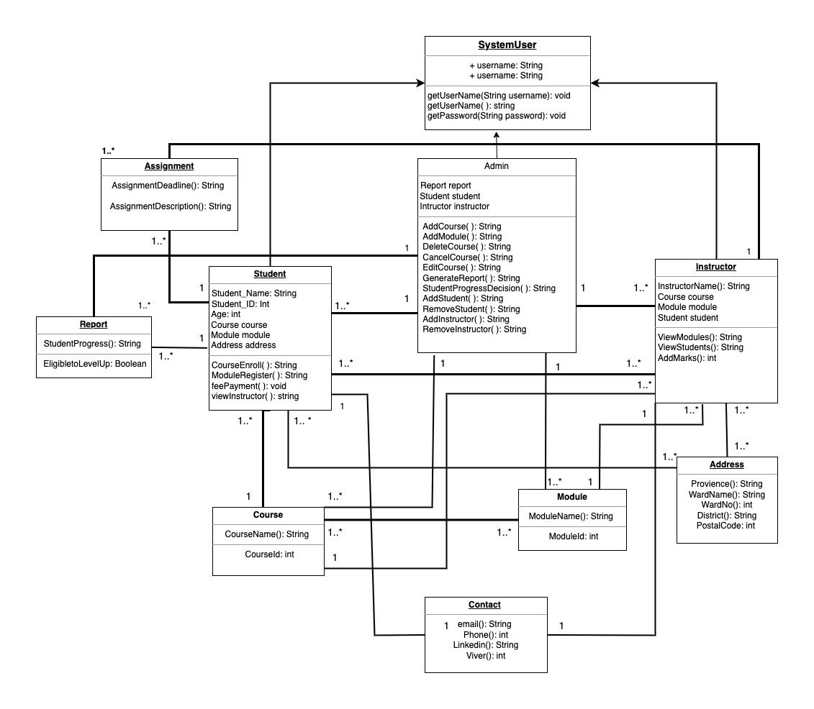

The diagram is a class diagram in the Unified Modeling Language (UML), and it shows the relationships between different classes in a system, including their attributes, methods, and associations. Here's what I have made from the diagram:

Classes:

System User: This class represents a user of the system. It has attributes like username and password.

Admin: This class represents an administrator of the system. It has methods like Add Course, AddModule, and GenerateReport.

Report: This class represents a report that can be generated by the system. It has attributes like student progress and course enrollment.

Student: This class represents a student who uses the system. It has attributes like name, ID, age, and address.

Instructor: This class represents an instructor who teaches courses in the system. It has attributes like name and contact information.

Course: This class represents a course that students can enroll in. It has attributes like a name and ID.

Module: This class represents a module within a course. It has attributes like a name and ID.

Address: This class represents the address of a student or instructor. It has attributes like province, district, and postal code.

Attributes:

Each class has attributes, which are essentially its properties. For example, the Student class has attributes like name, ID, age, and address.

Methods:

Classes also have methods, which are actions they can perform. For example, the Admin class has methods like AddCourse, AddModule, and GenerateReport.

Associations:

The lines between the classes represent associations. These show how the classes are related to each other. For example, the association between the Student and Course classes indicates that a student can enroll in a course.

A Student can enroll in one or more Courses.

A Course can have one or more Modules.

A Module belongs to one Course.

An Instructor can teach one or more Courses.

A Course can be taught by one or more Instructors.

A Student has one Address.

An Instructor has one Address.

Screenshot of databases:

