**Class Diagram:**

1. What is a class diagram, and what purpose does it serve in software design?
2. How do you represent a class in a class diagram?
3. What is an association in a class diagram, and how is it represented?
4. Describe the difference between an aggregation and a composition in class diagrams.
5. What does multiplicity represent in an association, and how is it expressed in a class diagram?
6. Describe the role of visibility modifiers (public, private, protected) in class diagrams.
7. Design a class diagram for a banking system, including classes like Account, Customer, and Transaction.

1. Create a class diagram for a school management system, including classes such as Student, Teacher, and Course.

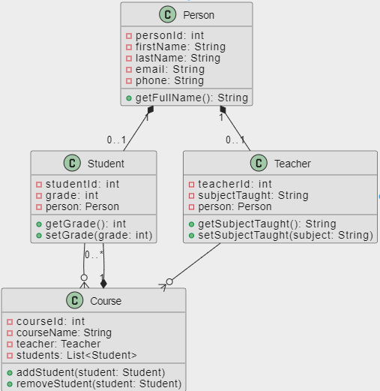

1. Design a class diagram for a hotel reservation system, including classes like Reservation, Room, and Guest.

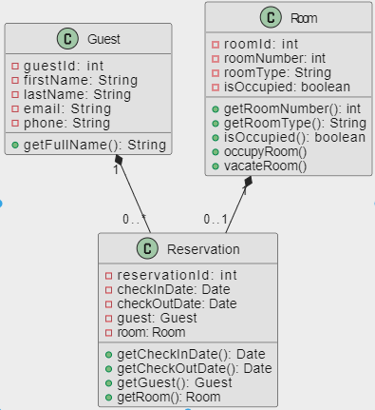

1. Design a class diagram for a university registration system, including classes like Student, Course, and Professor.

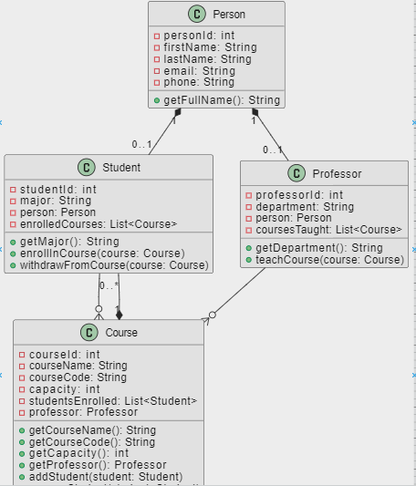

**Use Case Diagram:**

1. What is a use case diagram, and what is its primary purpose in system modeling?
2. Explain the key elements of a use case diagram and their roles (actors, use cases, system boundary).
3. Create a simple use case diagram for an online shopping system, including actors like Customer and use cases like Browse Products.
4. Design a use case diagram for an ATM system, including actors like Customer and use cases such as Withdraw Cash.
5. Discuss the purpose and use of the <<extends>> and <<includes>> relationships in use case diagrams. Provide examples.

**Sequence Diagram:**

1. What is a sequence diagram, and what is its primary purpose in system modeling?
2. Explain the key elements of a sequence diagram, including lifelines, messages, and activations.
3. Create a sequence diagram for a simple scenario where a customer places an order online.
4. Design a sequence diagram for a scenario where a customer withdraws cash from an ATM, including actors like Customer and objects like ATM.
5. Create a sequence diagram for a scenario involving a customer making a hotel reservation online, including actors like Customer and objects like Reservation.