**Abstraction**

1. Design a class diagram for a banking system, including classes like Account, Customer, and Bank.

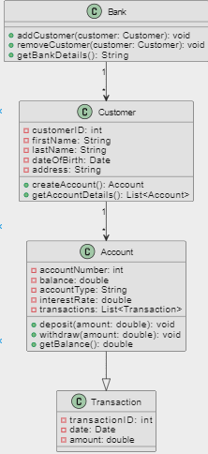

1. Create a class diagram for a school management system, including classes such as Student, Teacher, and Course.

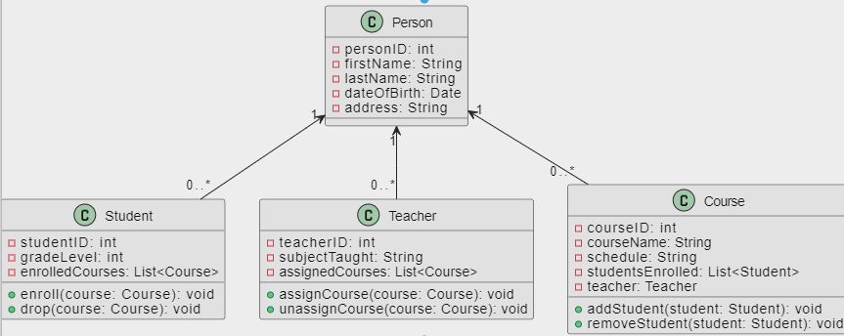

1. Design a class diagram for a hotel reservation system, including classes like Reservation, Room, and Guest.

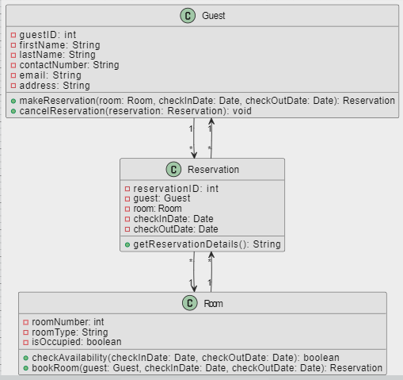

1. Design a class diagram for a university registration system, including classes like Student, Course, and Professor.

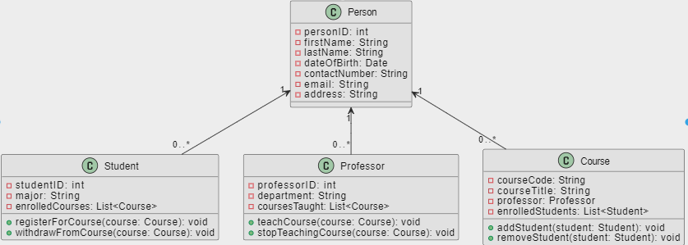

**Use case diagram**

1. Create a simple use case diagram for an online shopping system, including actors like Customer and use cases like Browse Products.

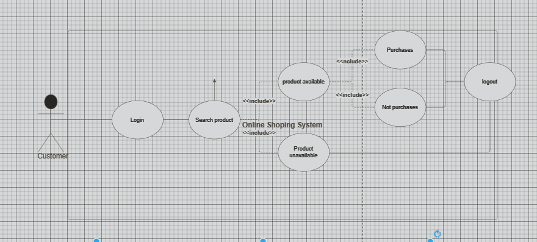

1. Design a use case diagram for an ATM system, including actors like Customer and use cases such as Withdraw Cash.

**Sequence diagram**

1. Create a sequence diagram for a simple scenario where a customer places an order online.

1. Design a sequence diagram for a scenario where a customer withdraws cash from an ATM, including actors like Customer and objects like ATM.

