**Looping:**

1. Write a Java program that uses a "for" loop to print the numbers from 1 to 10.

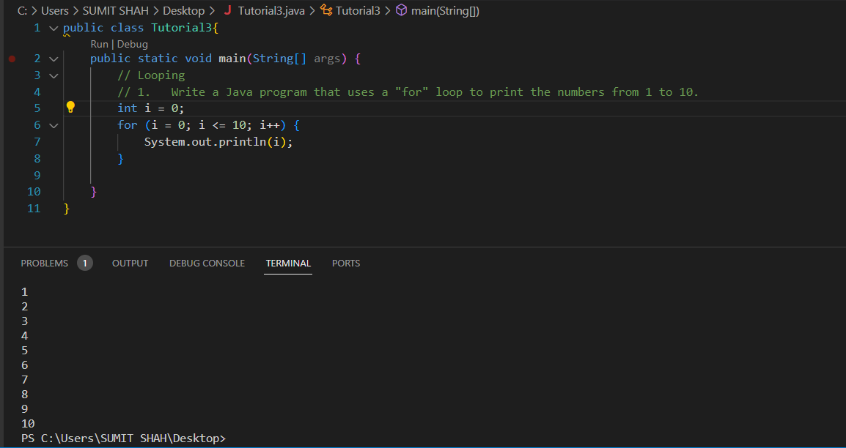

1. Implement a Java program that utilizes a "while" loop to find the factorial of a given number.

1. Create a Java program using a "do-while" loop to repeatedly ask the user for input until they enter a specific value (e.g., 0).

1. Write a Java program that demonstrates the use of nested loops to print a pattern, such as a pyramid of stars.

**Arrays:**

1. Develop a Java program that declares and initializes an array of integers. Print the elements of the array in reverse order.

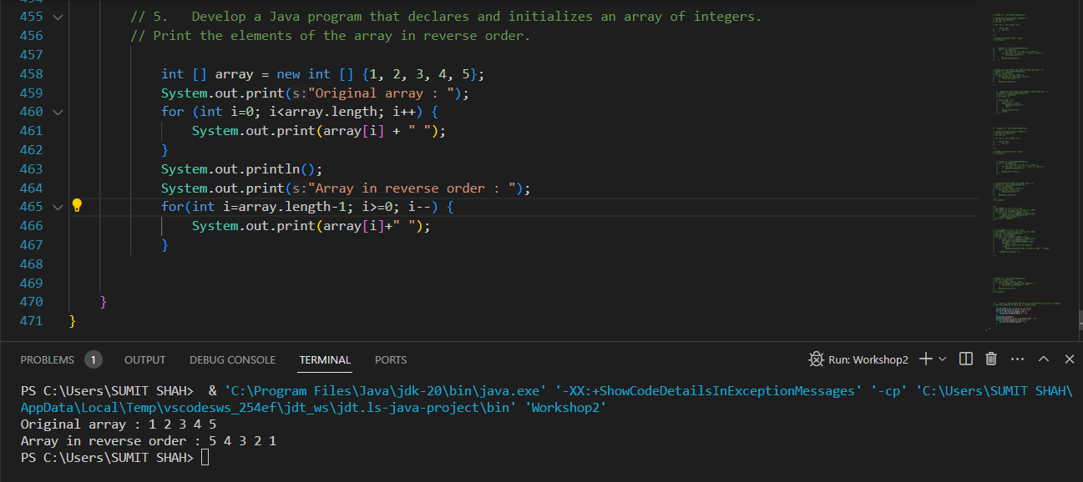

1. Implement a Java program that finds the sum and average of elements in an array of floating-point numbers.

1. Write a Java program that checks if a given element is present in an array of strings. If present, print its index; otherwise, print a message indicating its absence.
2. Create a Java program that sorts an array of integers in ascending order using the bubble sort algorithm. A screen shot of a computer program

   Description automatically generated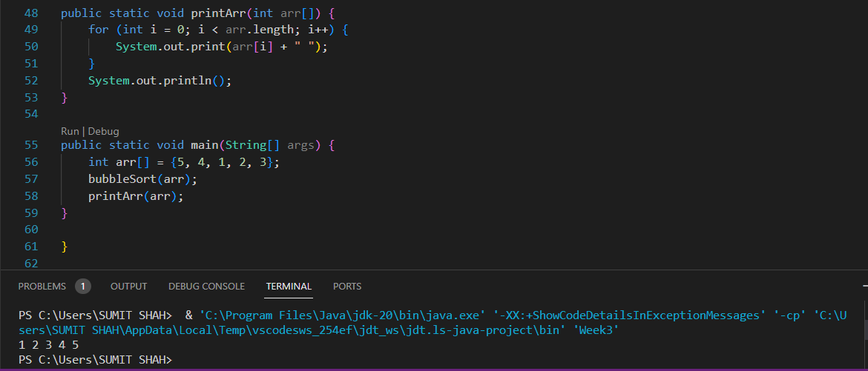

**Enhanced For Loop:**

1. Develop a Java program that uses the enhanced for loop to iterate through an array of characters and count the number of vowels.

1. Write a Java program that uses the enhanced for loop to find the maximum value in an array of doubles.

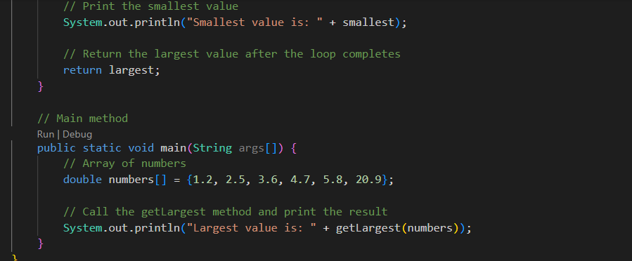

1. Implement a Java program that initializes a 2D array and uses an enhanced for loop to calculate the sum of all elements.

1. Create a Java program that utilizes the enhanced for loop to concatenate all strings in an array and print the result. A screen shot of a computer program

   Description automatically generated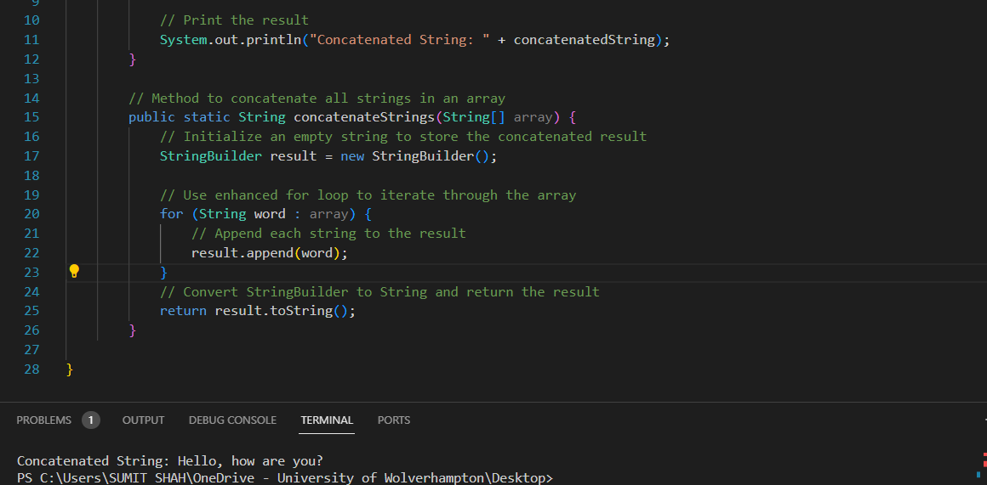

|  |  |  |  |  |
| --- | --- | --- | --- | --- |
| a[0][0] | a[0][1] |  |  |  |
|  |  |  |  |  |
|  |  |  |  |  |
|  |  |  |  |  |
|  |  |  |  |  |