Software Project Management Plan (SPMP)

Introduction
This section of the SPMP provides a comprehensive overview of the Smart Roommate & Flatmate Finder project. It highlights the core idea, goals, and significance of the system, offering a clear understanding of what the project aims to achieve and how it aligns with user needs. The section also outlines the key functionalities, target users, and technological foundation of the application. Overall, it serves as a concise summary that sets the stage for the detailed planning and execution strategies described in the following sections

Objective
Many individuals relocating struggle to find suitable roommates. They eventually end up sharing their space with such people who may not have the same principles. Hence, we design a user-friendly web-app/app backed up with ML model which allow users to find the perfect roommate/flatmate.

Major functionalities

User Profiles & Onboarding
Create detailed user profiles with personal information, lifestyle habits, budget, and location preferences.

Smart Roommate & Flat Matching
ML-powered recommendation engine suggests compatible roommates/flatmates based on lifestyle, budget, and preferences.
Users can filter matches manually (location, budget range, occupation, etc.).

Property & Room Listings
Users can list available flats/rooms with details (rent, amenities, location, rules) according to their needs.

Trust & Verification System
Identity verification via government ID or email/phone validation.
Reviews and ratings for roommates and landlords after stay duration.

Performance issues
- Scalability: The ML model and database must handle large volumes of users and listings efficiently.
- Real-time Updates: Flat/room availability and messages should update without noticeable lag.

Management and Technical constraints
- Time Constraint: Development must be completed within the planned project timeline (3 months).
- Budget Constraint: Limited budget for hosting, third-party APIs, and ML infrastructure.
- Resource Constraint: Small development team with specific roles (frontend, backend, ML).
- Technical Constraints:
  - Deployment limited to free hosting services (not enterprise cloud like AWS unless free credits available).
  - ML model trained on survey-collected data rather than large-scale real datasets.
  - App primarily developed as a prototype (core features only, not full scalability).

Project Estimates

Historical Data Used
The estimation process is based on data and observations from previous academic software development projects of similar scale and complexity, typically involving web-based platforms developed using open-source technologies. These projects averaged around 4,000–6,000 lines of code (LOC) with a development duration of approximately 10–12 weeks under a small team setup. Such data provides a realistic baseline for estimating the size, effort, and cost of this project.

Estimation Techniques Used
The Basic COCOMO (Constructive Cost Model) is employed to estimate the project’s effort, cost, and duration, with size measured in Lines of Code (LOC). The system is categorized as an Organic Project, considering the small team size, familiar technology stack, and moderate complexity.
For resource and staffing estimations, Putnam–Norden Rayleigh curve is used to model the variation of staffing levels over time, ensuring optimal manpower allocation across different phases of the project.

Estimates

Size Estimate
Module / Component | Approx LOC
Frontend (basic UI forms) | 500–800
Backend (API, DB handling) | 1300-1500
User authentication + profile | 600-800
Data preprocessing (smoothing, cleaning) | 150–250
Clustering algorithm (e.g., K-Means) | 200–300
Matching logic (recommendations) | 400-600
Error handling + validations | 1000-1200
Misc (config, helpers, testing) | 200–300

Based on project scope and functionality, the estimated size is approximately 5,000 LOC, covering frontend, backend, and machine learning integration.

Effort and Time Estimation (COCOMO Basic Model)
For an Organic type project:
$$E=a×(KLOC)^{b}=2.4×(5)^{1.05}=12.6\text{ person-months (approx.)} \\ D=c×(E)^{d}=2.5×(12.6)^{0.38}=6.5\text{ months (approx.)}$$
Thus, the estimated development effort is about 12.6 person-months, and the schedule duration is roughly 6–7 months for a full-scale deployment. For the current prototype, the timeline will be adjusted to around 3 months within the academic schedule.

Resource Estimation
Considering student-level development, the project will require:
- Team Composition: 1 Project Lead, 2 Developers, 1 Designer/Tester.
- Hardware resources: 3 personal systems, internet access.
- Software Resources:
  - Development Tools: VS Code, GitHub, PostgreSQL, Python, Node.js, and React.
  - Database: MySQL/PostgreSQL (free).
  - Hosting: Firebase/Render/Heroku free tier.
  - ML Libraries: scikit-learn, TensorFlow/PyTorch (open-source).

Cost Estimation
The total project cost includes both human resource expenses and operational costs such as hosting, domain, and other minor expenditures.
Using the Basic COCOMO model, the total estimated effort is 12.6 person-months. Assuming an average monthly stipend/salary of ₹8,000 per developer, the total human resource cost is calculated as:

$$\text{Total Salary Cost}=12.6\text{ person-months}×\text{₹}8,000=\text{₹}1,00,800$$
Additional costs are summarized below:
Item | Estimated Cost (INR) | Remarks
Domain Purchase (.com/.in) | ₹1,000 – ₹1,500 per annum | For official web presence
Hosting and Cloud Services | ₹3,000 – ₹4,000 per annum | Paid usage after free-tier limits
Software Licenses / Tools | ₹2,000 per annum | Includes premium APIs or design tools
Marketing & Awareness | ₹2,500 per annum | For promotions and outreach
Hardware / PC Setup | ₹1,30,000 | Four mid-range developer PCs
Miscellaneous Expenses | ₹3,000 per annum | Internet, testing devices, maintenance
Total Estimated Project Cost: ≈ ₹1,40,000 – ₹1,50,000

Staffing Level Estimation (Norden’s Work)
According to Norden’s staffing model, manpower requirement follows a Rayleigh distribution:
- Staffing rises gradually during design and coding phases, peaking at mid-development.
- It then tapers during testing and integration.
For this project, maximum staffing (3–4 members) will occur in the middle phase, followed by reduced involvement (1–2 members) during testing and documentation.

Schedule

Work Breakdown Structure
The project is divided into the following phases and sub-tasks:

Requirement Analysis (2 weeks)
- A1) Collect problem requirements. (1 week)
- A2) Define functional and non-functional requirements. (1.5 week)
- A3) Finalize tech stack. (0.5 week)

Design (2 weeks)
- B1) UI/UX wireframe. (1.5 week)
- B2) Database schema design. (1 week)
- B3) ML model architecture design. (1.5 week)

Implementation (6 weeks)
- C1) Frontend development (web/app interface). (1.5 week)
- C2) Backend development (APIs, authentication, database). (1.5 week)
- C3) ML model development (data preprocessing, training, integration). (3 week)

Testing (2 weeks)
- D1) Unit testing (frontend, backend, ML components). (1 week)
- D2) Integration testing (system as a whole). (0.5 week)
- D3) Bug fixing. (1 week)

Deployment & Documentation (2 weeks)
- E1) Hosting on free-tier cloud (Firebase/Heroku/Render). (.75 week)
- E2) Preparing user manual and project report. (1.5 week)

Task Network Representation
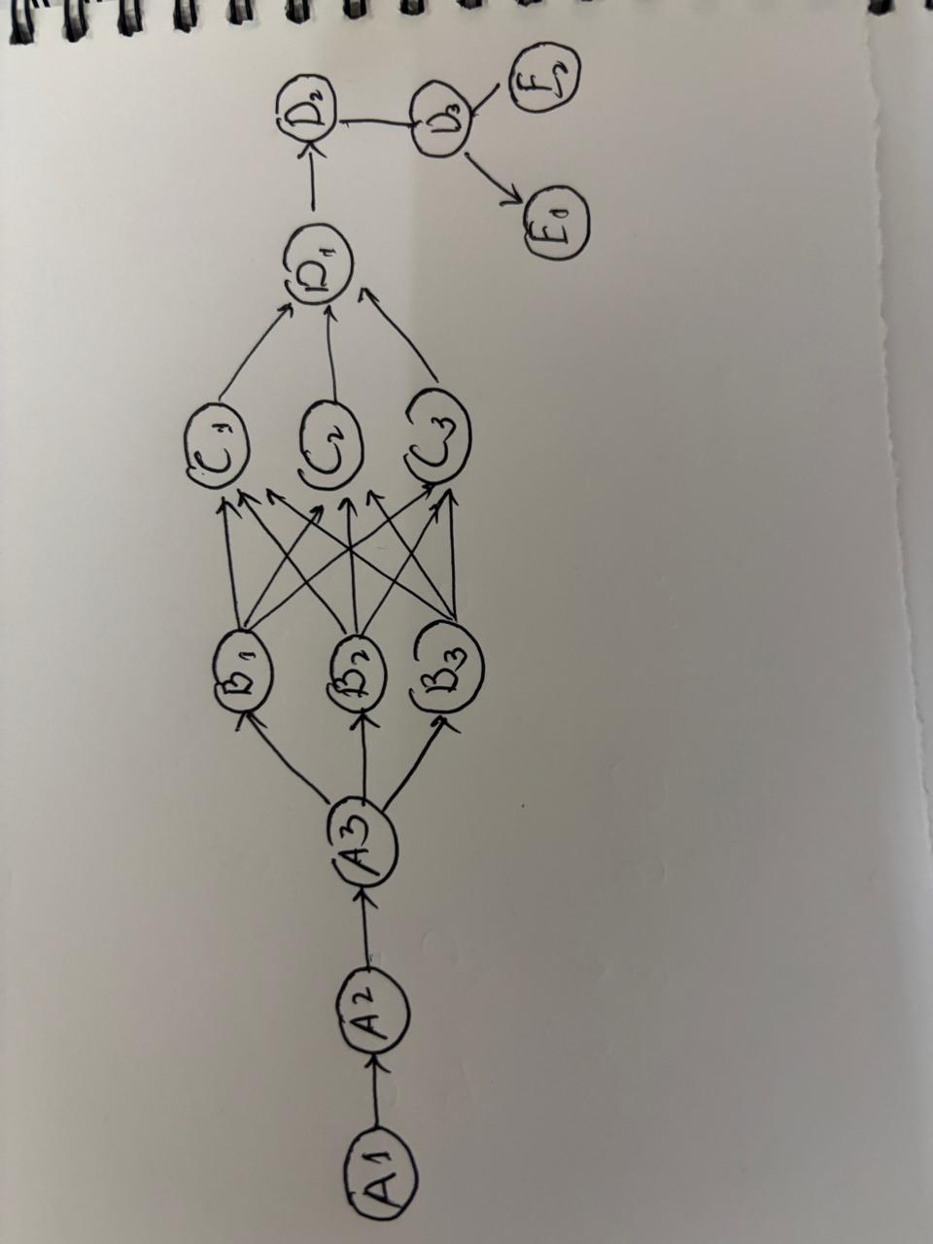
Critical Path: A1->A2->A3->B1->C3->D1->D2->D3->E2

3.3Gantt Chart
  - 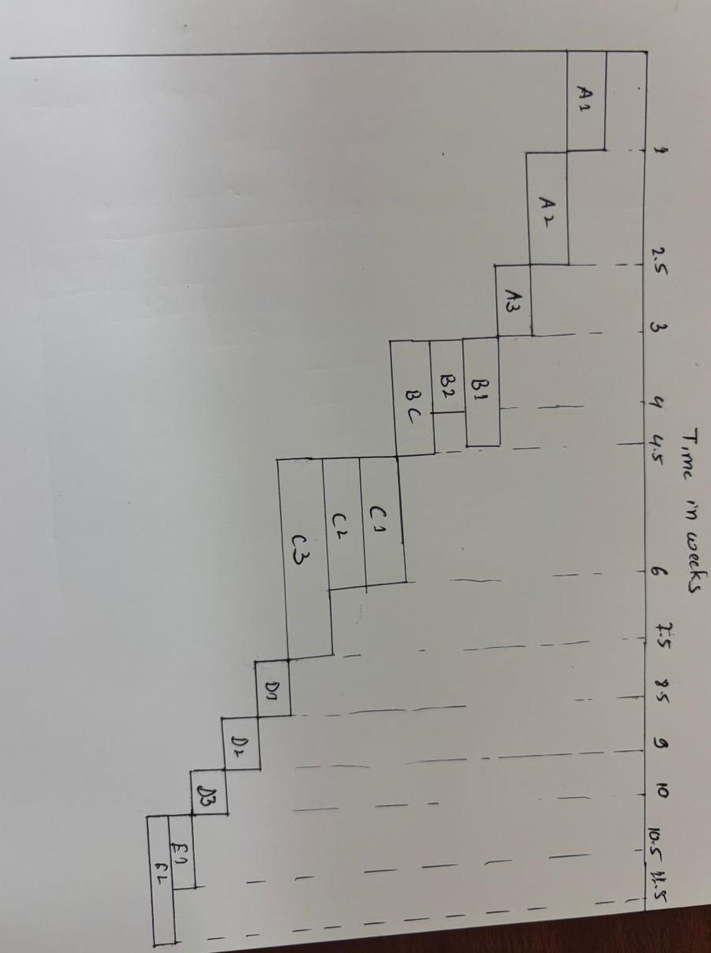

Project Resources

People
The project is managed by a small, cross-functional team of four: Frontend Developer, Backend Developer for API/database handling, and ML Engineer for the recommendation algorithm.

Hardware
Due to budget constraints, development relies on personal machines and free-tier cloud services like Heroku for production hosting and data storage (e.g., PostgreSQL).

Software
  - Development Tools: VS Code, GitHub, PostgreSQL, Python, Node.js, and React.
  - Database: MySQL/PostgreSQL (free).
  - Hosting: Firebase/Render/Heroku free tier.
  - ML Libraries: scikit-learn, TensorFlow/PyTorch (open-source).

Special Resources
The project will utilize free, open-source tools (scikit-learn, React, GitHub) and free-tier third-party APIs for streamlined authentication and basic mapping/location services.

Staff Organisation

5.1 Team Structure
The team uses a Democratic Structure, where Decisions are made collectively by the team, with leadership often rotating among members.

5.2 Management Reporting
The team conducts short daily stand-ups to identify roadblocks, and collectively decides a formal weekly report on progress and high-priority risks.

Risk Management

Risk identification and mitigation

Technical risks
Risk | Description | Possible Mitigation
ML Model Inaccuracy | The recommendation engine may produce poor matches due to limited or noisy survey data. | Collect cleaner data, test multiple algorithms (K-Means, cosine similarity), fine-tune model iteratively.
Integration Complexity | Integrating frontend, backend, and ML services may cause compatibility issues. | Define clear API contracts early, use consistent JSON formats, test integrations incrementally.
Data Privacy & Security | Sensitive user info (habits, contact) may be exposed if not secured properly. | Encrypt credentials, use HTTPS, restrict access using role-based authentication.

Project Risk
Risk | Description | Possible Mitigation
Time Overrun | Development may exceed 3-month schedule due to feature creep or debugging. | Set clear milestones; prioritize core features; follow weekly progress reviews.
Skill Gap | Team members may lack advanced ML or full-stack expertise. | Assign tasks based on strengths; encourage quick learning via tutorials/documentation.
Coordination Challenges | Miscommunication in the small team may cause version conflicts or duplicated effort. | Use GitHub branches and pull requests; hold short daily/weekly stand-ups.

Business Risk
Risk | Description | Possible Mitigation
B1. Low User Adoption | Students may prefer informal platforms (WhatsApp, Facebook groups). | Conduct campus campaigns; highlight app’s smart matching advantage.
B2. Fake or Misleading Profiles | Users might give false info affecting reliability. | Add college email verification, reporting system, and post-stay rating system.
B3. Privacy Concerns | Users may hesitate to share lifestyle or personal details. | Allow optional profile visibility; anonymize sensitive data.

Risk Estimation and Analysis

- Category | - Risk | - Probability (P) | - Impact (I) | - Risk Exposure (P×I) | - Level
- Technical | - ML Model Inaccuracy | - 0.7 | - 8 | - 5.6 | - High
 | - Integration Complexity | - 0.6 | - 7 | - 4.2 | - Medium
 | - Data Privacy & Security Issues | - 0.5 | - 9 | - 4.5 | - High
- Project | - Time Overrun | - 0.7 | - 8 | - 5.6 | - High
 | - Skill Gap | - 0.6 | - 7 | - 4.2 | - Medium
 | - Coordination Challenges | - 0.5 | - 6 | - 3.0 | - Medium
- Business | - Low User Adoption | - 0.6 | - 9 | - 5.4 | - High
 | - Fake/Misleading Profiles | - 0.8 | - 8 | - 6.4 | - Very High
 | - Privacy Concerns | - 0.5 | - 7 | - 3.5 | - Medium

Project Tracking and Control Plan

Metrics Used to Be Tracked
- Progress Metrics: Tasks completed vs. planned tasks (per phase).
- Effort Metrics: Actual hours spent vs. estimated effort.
- Defect Metrics: Number of bugs identified, resolved, and pending.
- Schedule Metrics: Deviation from planned timeline (in weeks/days).
- Code Quality Metrics: LOC, code review comments, and test coverage.

Tracking Plan and Control
- Weekly progress meetings to assess milestones and update schedules.
- All issues and changes tracked via GitHub Issues and version commits.
- Major deviations (delay >1 week or critical bugs) reviewed by the full team for corrective actions.
- Faculty guide notified of major progress summaries at the end of each phase.

8. Miscellaneous Plans

Process Tailoring
The project follows an iterative waterfall approach, slightly tailored to allow parallel ML model and backend development. Documentation and testing occur after each major milestone.

Quality Assurance Plan
- Code reviews after each sprint.
- Functional testing for every new feature before merging.
- Use of linters and formatters for consistent code quality.

Configuration Management Plan
- Version control managed via Git and GitHub.
- Main branch remains stable; development occurs in feature branches.
- Regular backups maintained on cloud repositories.

Validation and Verification
- Verification: Internal testing ensures each module meets design specifications.
- Validation: End-to-end testing verifies system meets user expectations through demo sessions.

System Testing Plan
- Includes unit, integration, and acceptance testing.
- Testing performed on both web and backend modules using real and dummy data.

Delivery, Installation, and Maintenance Plan
- Final prototype deployed on Firebase/Heroku free tier.
- Installation via web link (no local setup required).
- Maintenance involves bug fixes and minor updates based on feedback post-deployment.

