QUEUELESS: SMART QUEUE MANAGEMENT SYSTEM

A REPORT
Submitted by
AMEY KUMAR (T052)
SUMIT (T053)
of
BACHELOR OF TECHNOLOGY
IN
COMPUTER ENGINEERING
Subject: MAD | Submitted to: Dr. Preetjot Kaur

DEPARTMENT OF COMPUTER SCIENCE AND ENGINEERING
SCHOOL OF TECHNOLOGY MANAGEMENT AND ENGINEERING, CHANDIGARH

TABLE OF CONTENTS
CHAPTER NO. TITLE PAGE NO.
1. INTRODUCTION 1
1.1 GENERAL 1
1.2 PROBLEM STATEMENT 1
1.3 USER NEEDS 1
1.4 OBJECTIVES 2
1.5 SCOPE AND FEATURES 2
2. LITERATURE REVIEW 3
2.1 GENERAL 3
2.2 EXISTING QUEUE MANAGEMENT APPROACHES 3
2.3 GAP AND PROPOSED APPROACH 3
3. TOOLS AND TECHNOLOGIES 4
3.1 GENERAL 4
3.2 DEVELOPMENT ENVIRONMENT AND PERMISSIONS 4
3.3 COMPONENTS AND LIBRARIES 4
4. SYSTEM DESIGN 5
4.1 ARCHITECTURE 5
4.2 PROJECT STRUCTURE 5
4.3 CLASS DESCRIPTIONS 6
4.4 SCREEN NAVIGATION 7
4.5 DATABASE DESIGN 8
5. IMPLEMENTATION 9
5.1 PRIORITY AGING ALGORITHM 9
5.2 SECURITY 9
5.3 SELF-LEARNING: NEW CONCEPTS ADDED 10
5.4 MATERIAL DESIGN AND PLAY STORE READINESS 10
6. TESTING AND RESULTS 11
6.1 UNIT TESTING 11
6.2 MANUAL TESTING 11
6.3 APPLICATION SCREENSHOTS 11
13
7. CONCLUSION AND FUTURE SCOPE 14
7.1 LIMITATIONS 14
7.2 FUTURE SCOPE 14
7.3 CONCLUSION 14
REFERENCES 16

1. INTRODUCTION

1.1 GENERAL
QueueLess is an Android application that replaces physical waiting lines with digital tokens. A user selects a service (for example a hospital OPD, a bank counter or a college office), receives a token with a QR code, and can see the live position in the queue and the estimated waiting time. An administrator controls the queue from a dashboard and calls the next token. The app orders tokens with a priority algorithm that serves emergencies and senior citizens first, and it adds an "aging" rule so that no token waits forever.
The app is written in Java in Android Studio. It uses SQLite for local storage, RecyclerView and Fragments for the interface, Google Maps and Location services for the service map, the ZXing library for QR codes, and Android notifications for status alerts. The project contains 12 Activities, 4 Fragments, 3 Adapters, 4 model classes and a layer of helper classes, and it includes 17 unit tests.
Queues are part of everyday life at hospitals, banks, government counters and campus offices. A mobile app is a suitable solution because almost everyone already carries a phone, and a phone can show a token, a position and a notification at the same time. This report describes the design, implementation and testing of the app as part of the MAD course.

1.2 PROBLEM STATEMENT
People who use service counters face four recurring problems:
- Physical queues take time and space, and people wait without knowing when their turn will come.
- Paper tokens are easily lost, and manual calling is error-prone.
- Urgent cases such as emergencies and senior citizens are not handled in a consistent, fair way.
- Staff have no live view of who is waiting and no quick way to manage the order.
The problem to solve is how to let users take a token digitally, track their turn remotely, and let staff run the queue fairly from one screen.

1.3 USER NEEDS
- Know my position and expected waiting time.
- Fair priority for senior citizens and emergencies.
- Get an alert when my turn arrives.
- For staff: an easy way to call the next person and to manage services.

1.4 OBJECTIVES
- Build an Android app where users register, log in and generate tokens for a chosen service.
- Order the queue with a fair priority algorithm that includes aging.
- Provide QR codes for tokens and a scanner for service and token QR codes.
- Show live position and estimated waiting time.
- Give administrators a dashboard to call, serve, complete, skip or cancel tokens and to manage services.
- Notify the user when the status of a token changes.
- Follow Material design and keep the app ready for Play Store packaging.

1.5 SCOPE AND FEATURES

1.5.1 User features
- Register and log in with email and password. Choose the role User or Admin at registration.
- Search the list of services and pick one.
- Generate a token by choosing a category (General, Appointment, Senior Citizen or Emergency) and a date.
- Open a token to see its QR code, queue position and estimated time.
- See all active tokens in the Queue tab, and cancel a token before it is called.
- Scan a service QR code to generate a token, or a token QR code to open it.
- View the map of service locations with the distance from the user.
- View the history of actions on tokens, and read the queue rules.

1.5.2 Admin features
- See the live list of waiting and serving tokens.
- Call the next token, chosen by the priority algorithm.
- Change a token to Serving, Completed, Skipped or Cancelled.
- Add, edit, activate, deactivate or delete services.

2. LITERATURE REVIEW

2.1 GENERAL
Queue management is a common topic in service system design. The aim of any queue management method is to reduce waiting, treat customers fairly and give the service provider a clear view of demand. Existing methods can be grouped by how much technology they use.

2.2 EXISTING QUEUE MANAGEMENT APPROACHES
- Manual lines and paper tokens. These need no technology, but the user must stay on the premises, tokens can be lost, and there is no live information about the waiting time.
- Token dispensers with display boards. These remove paper handling and call numbers on a screen, but they need hardware at every location and the user still has to wait inside.
- SMS or web-based booking. These let a user reserve a slot remotely, but they often treat all users alike and give limited help to urgent cases.
- Mobile queue apps. These let a user take a token and track the turn from a phone. Their quality depends on how fairly the queue is ordered and how easily staff can control it.
[Add here: 3 to 5 research papers, articles or existing apps that you studied, written as short paragraphs with Harvard-style citations that also appear in the References.]

2.3 GAP AND PROPOSED APPROACH
QueueLess combines the useful parts of these approaches in one app. It gives the user a digital token with a QR code and live position, it orders the queue by category with an aging rule so that low-priority tokens are not starved, and it gives the administrator a single dashboard to run the queue and manage services. All data is stored on the device, which keeps the app simple to run and test as a course project.

3. TOOLS AND TECHNOLOGIES

3.1 GENERAL
The app uses the standard Android toolchain and a small set of libraries. Each component was chosen because it directly supports a feature of the app.

3.2 DEVELOPMENT ENVIRONMENT AND PERMISSIONS
- Language and IDE: Java in Android Studio, with XML layouts and the Gradle build system.
- SDK levels: compileSdk 34, targetSdk 34 and minSdk 24.
- Application id: com.queueless.app, version 1.0 (version code 1).
- Permissions declared in the manifest: Camera (QR scanning), Fine and Coarse Location (map and distance), Post Notifications (status alerts), Internet and Network State (Google Maps). Camera, location and notification permissions are requested at run time.

3.3 COMPONENTS AND LIBRARIES
Table 3.1: Components and libraries used
Component | Purpose in the app
Activities (12) | One class for each screen
Fragments (4) and BottomNavigationView | Home, Queue, Map and Profile tabs inside MainActivity
RecyclerView and Adapters (3) | Lists of services, tokens and history
SQLite (SQLiteOpenHelper) | Local database with four tables
SharedPreferences | Login session and notification setting
Google Maps SDK and Fused Location Provider | Service map and the position of the user
ZXing (core and zxing-android-embedded) | Generating and scanning QR codes
Notifications | Status alerts and the Android 13 permission request
Material Components, CardView, ConstraintLayout | Look and layout of the screens
ExecutorService and Handler | Background work for login and database seeding
JUnit, Robolectric, Mockito, Espresso | Unit and UI testing

4. SYSTEM DESIGN

4.1 ARCHITECTURE
The code is organised in layers, and each layer lives in its own package under com.queueless.app.
- UI layer: activities (12), fragments (4), adapters (3) and XML layouts (20).
- Logic layer: QueueScheduler (queue algorithm) and LocalAuthManager (registration and login).
- Utility layer: PreferenceUtils, QrCodeUtils, NotificationHelper and AssetReader.
- Data layer: DatabaseHelper, which wraps the SQLite database queueless.db.
- Models: User, Token, ServiceModel and QueueHistory, which carry data between all layers.
Higher layers call the layers below them. Screens never write SQL themselves; they call DatabaseHelper.
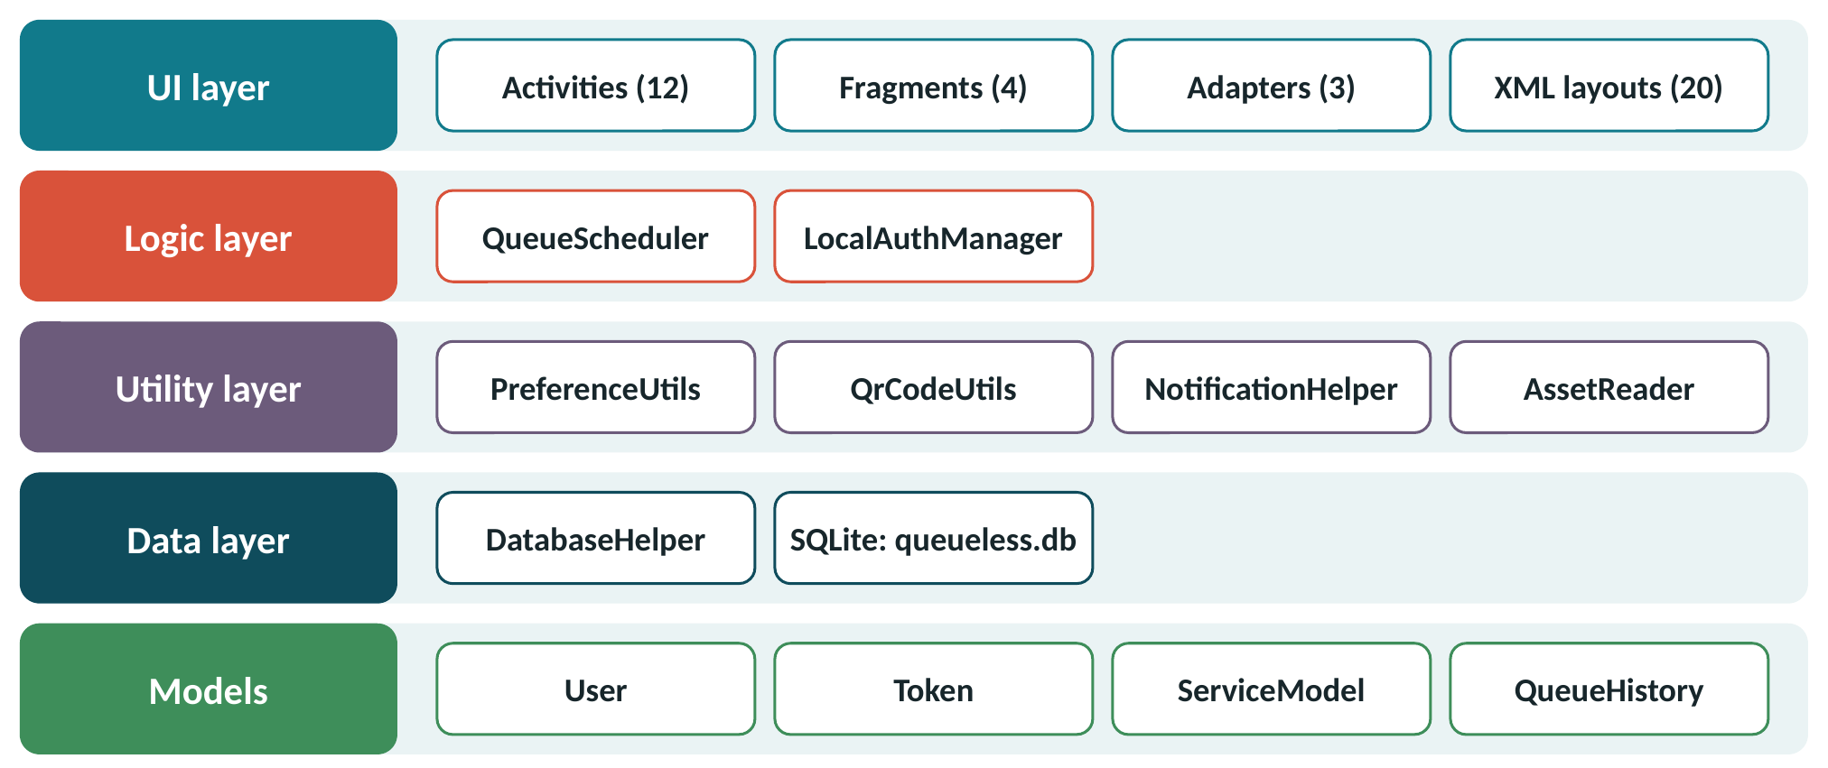
Figure 4.1: Layered architecture of QueueLess

4.2 PROJECT STRUCTURE
- activities: SplashActivity, LoginActivity, RegisterActivity, MainActivity, ServiceSelectionActivity, GenerateTokenActivity, TokenDetailActivity, TokenHistoryActivity, QRScannerActivity, QueueRulesActivity, AdminDashboardActivity, ManageServicesActivity.
- fragments: HomeFragment, QueueFragment, MapFragment, ProfileFragment.
- adapters: ServiceAdapter, TokenAdapter, QueueHistoryAdapter.
- models: User, ServiceModel, Token, QueueHistory.
- database: DatabaseHelper. auth: LocalAuthManager. algorithm: QueueScheduler.
- utils: PreferenceUtils, QrCodeUtils, NotificationHelper, AssetReader.
- assets: services.csv (initial services) and queue_rules.txt (queue rules shown in the app).
- res: layouts, vector icons, drawables, themes and strings.

4.3 CLASS DESCRIPTIONS

4.3.1 Main classes
- DatabaseHelper extends SQLiteOpenHelper. It is a singleton and the only class that touches the database. It creates the four tables, migrates the database from version 1 to 2, seeds services from services.csv, and offers insert, read, update and delete methods for users, services, tokens and history.
- LocalAuthManager handles registration and login on a background thread. It generates a salt, hashes the password with PBKDF2, stores the hash through DatabaseHelper, and returns the result through an AuthCallback interface on the main thread.
- QueueScheduler contains static methods for base priority, effective priority with aging, sorting the queue, choosing the next token, queue position and estimated waiting time.
- PreferenceUtils stores the logged-in user, the role and the notification setting in SharedPreferences.
- QrCodeUtils builds the JSON payload stored in a token QR code, draws the QR bitmap with ZXing and parses a scanned payload.
- NotificationHelper creates the notification channel, asks for the notification permission on Android 13 and above, and posts a notification when a token status changes.
- AssetReader reads text and CSV files from the assets folder.

4.3.2 How the classes connect
- SplashActivity seeds services through DatabaseHelper on a background thread, then uses PreferenceUtils to decide between LoginActivity, MainActivity and AdminDashboardActivity.
- LoginActivity and RegisterActivity call LocalAuthManager, which uses DatabaseHelper. On success they save the user with PreferenceUtils.
- MainActivity hosts HomeFragment, QueueFragment, MapFragment and ProfileFragment using a BottomNavigationView and the FragmentManager.
- GenerateTokenActivity reads the chosen service from DatabaseHelper, gets the base priority from QueueScheduler, builds the token number and saves the token with DatabaseHelper.
- TokenDetailActivity loads the token, shows its position and estimated time through QueueScheduler, and draws the QR code with QrCodeUtils.
- AdminDashboardActivity loads active tokens, chooses the next token with QueueScheduler, updates the status through DatabaseHelper and notifies the user through NotificationHelper.
- TokenAdapter calls QueueScheduler to show the position and estimated time on each token card.
- DatabaseHelper uses AssetReader to read services.csv when it seeds the services table.
Screens pass data to each other through Intent extras, such as service_id for GenerateTokenActivity and the token id for TokenDetailActivity.
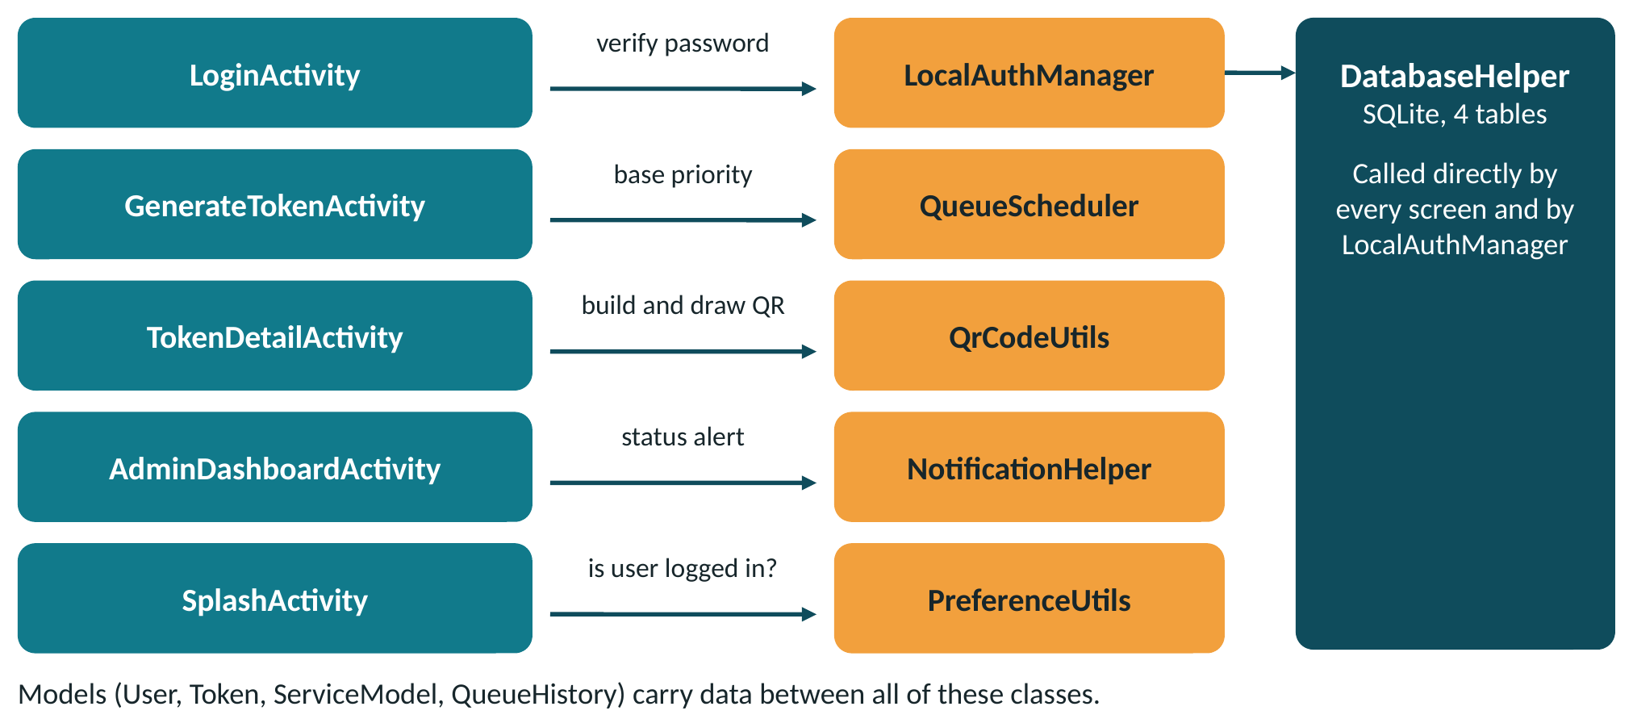
Figure 4.2: Connections between the important classes

4.4 SCREEN NAVIGATION
- SplashActivity is the launcher. A user who is not logged in goes to LoginActivity, which links to RegisterActivity. A logged-in user goes to MainActivity, and an admin goes to AdminDashboardActivity.
- From the Home tab the user opens ServiceSelectionActivity, then GenerateTokenActivity, which opens TokenDetailActivity after the token is created.
- The Queue tab opens TokenDetailActivity for any active token.
- QRScannerActivity opens GenerateTokenActivity for a service QR code and TokenDetailActivity for a token QR code.
- The Profile tab opens TokenHistoryActivity and QueueRulesActivity, and the Admin panel for admins. Logging out returns to LoginActivity.
- AdminDashboardActivity opens ManageServicesActivity and the scanner.
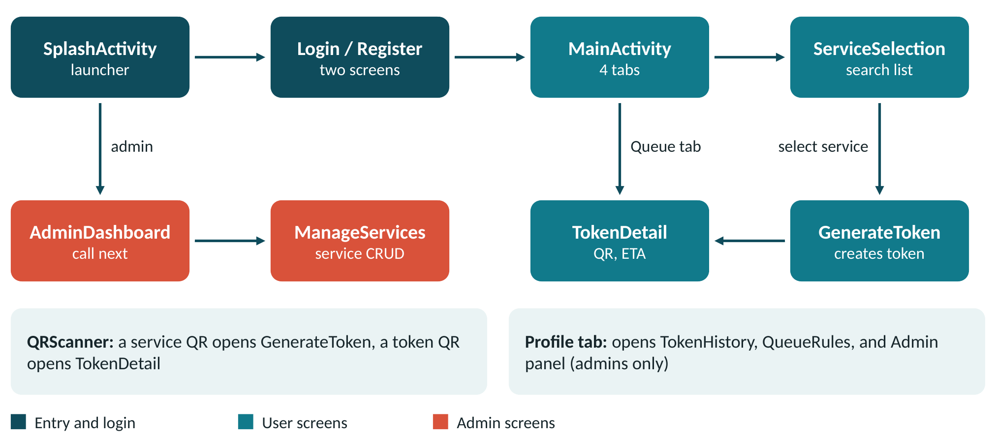
Figure 4.3: Screen navigation flow

4.5 DATABASE DESIGN
The database is queueless.db (SQLite, version 2) with four tables, shown in Table 4.1. The tables are linked by user_id, service_id and token_id. These are logical links; no foreign key constraints are declared, and the tokens table keeps its own copy of the service name and department.
Table 4.1: Tables of the database
Table | Main columns
users | id (primary key), name, email, phone, role, created time, password hash, password salt
services | id (primary key), service name, department, average time in minutes, location, status (ACTIVE or INACTIVE)
tokens | id (primary key), token number, user id, user name and phone, service id, service name and department, priority category, base and effective priority, status, appointment date, arrival time, estimated time, served time, notes
queue_history | id (auto increment), token id, user id, service id, service name, action type, action timestamp, notes

Important behaviour of the database class:
- onCreate creates the tables and an index on the email column, and seeds the initial services.
- onUpgrade moves version 1 to version 2 by adding the password hash and salt columns, so existing data is kept.
- Every query uses placeholders, which prevents SQL injection.
- Inserting a token also writes a CREATED record to queue_history. Every status change writes another history record.
- A token number has the form TKN-serviceId-sequence, for example TKN-101-003. The sequence is the count of tokens for that service and date plus one.

5. IMPLEMENTATION

5.1 PRIORITY AGING ALGORITHM
Each token has a base priority that depends on its category:
- Emergency: 4
- Senior Citizen or Special Assistance: 3
- Appointment: 2
- General: 1
To avoid starvation of low-priority tokens, the effective priority grows with waiting time:
Effective priority = base priority + floor(minutes waited / 5)
The queue is sorted by effective priority, highest first. If two tokens have the same effective priority, the token that arrived earlier is served first. The next token is the first token of this sorted list of WAITING tokens.
Example: a General token (base 1) that has waited 15 minutes has effective priority 1 + 3 = 4. This equals a new Emergency token, and because it arrived earlier it is called first.
Queue position is the place of the token in the sorted list of waiting tokens of the same service. The estimated waiting time is the number of people ahead of the token multiplied by the average service time of that service.
Token status life cycle: WAITING, then SERVING, then COMPLETED. A token can also become SKIPPED (admin) or CANCELLED (user or admin).

5.2 SECURITY
- Passwords are never stored in plain text. LocalAuthManager creates a random 16-byte salt and hashes the password with PBKDF2 (HMAC-SHA1, 10,000 iterations, 256-bit key).
- Login compares hashes with a constant-time comparison.
- Registration runs inside a database transaction and rejects an email that already has an account. Email matching is case-insensitive.
- Database queries use parameter placeholders instead of string concatenation.
- Camera, location and notification permissions are declared in the manifest and requested at run time.

5.3 SELF-LEARNING: NEW CONCEPTS ADDED
The following concepts go beyond the basic course material and each one is used by a real feature of the app.
- QR code generation and scanning with the ZXing library, used for token QR codes and service QR codes.
- Google Maps SDK and Fused Location Provider, used to show service markers and the distance from the user.
- Secure authentication with salted PBKDF2 hashing and constant-time comparison.
- A custom priority aging scheduler, written and unit tested for this project.
- Notification channels and the Android 13 notification permission.
- SQLite schema migration (onUpgrade) and background threads with ExecutorService.

5.4 MATERIAL DESIGN AND PLAY STORE READINESS
Material design is followed through the Material Components DayNight theme, a bottom navigation bar with four tabs, card-based lists, rounded buttons, priority badges, vector icons for all actions, and a dedicated splash theme and launcher icon.
Play Store basics already in place: a unique application id (com.queueless.app), a version code and version name, target SDK 34, minimum SDK 24, and declared permissions with run-time prompts for camera, location and notifications.
Still needed before publishing: a signed release bundle, a privacy policy, a Maps API key restricted to the app, and the store listing assets (icon, screenshots and description).

6. TESTING AND RESULTS

6.1 UNIT TESTING
The project has 17 unit tests in four test classes, summarised in Table 6.1. The tests use JUnit 4, Robolectric (to run Android code on the JVM) and Mockito. Espresso is included for instrumented UI tests.
Table 6.1: Unit tests
Test class | Tests | What is checked
QueueSchedulerTest | 7 | Base priority, aging, sorting, next token, position and estimated time
DatabaseHelperTest | 5 | Insert, read and update of users, services and tokens
QrCodeUtilsTest | 3 | Building and parsing the QR payload
AssetReaderTest | 2 | Reading text and CSV files

[Figure 6.1: Paste the screenshot of the test results from Android Studio here.]

6.2 MANUAL TESTING
The following flow was used to test the whole app: register as a user, pick a service, generate tokens in different categories, open a token to check the QR code, position and estimated time, log in as admin, call the next token, mark it Serving and Completed, and check that the user receives a notification and that the history is updated.

6.3 APPLICATION SCREENSHOTS
Paste screenshot here |  | Paste screenshot here
Figure 6.2: Login screen |  | Figure 6.3: Register screen

Paste screenshot here |  | Paste screenshot here
Figure 6.4: Home tab with the service list |  | Figure 6.5: Generate token screen

Paste screenshot here |  | Paste screenshot here
Figure 6.6: Token detail with QR code |  | Figure 6.7: Queue tab

Paste screenshot here |  | Paste screenshot here
Figure 6.8: Map tab |  | Figure 6.9: Admin dashboard

7. CONCLUSION AND FUTURE SCOPE

7.1 LIMITATIONS
- All data is stored on the device, so tokens are not shared between phones.
- Notifications are local; there are no SMS or push messages.
- Most database reads run on the main thread, which is fine for small data but should move to background threads for large data.
- The map uses fixed sample coordinates for services.

7.2 FUTURE SCOPE
- A cloud backend so that users and admins share one live queue across devices.
- SMS and push notifications.
- Admin analytics such as average waiting time per service.
- Publishing on the Play Store after the release steps in Section 5.4.

7.3 CONCLUSION
QueueLess shows that a mobile app can make queues fairer and easier to manage. Users take tokens from their phone, see their position and get alerted, and administrators run the queue from one dashboard. The layered design keeps the screens, the logic and the data separate, the priority aging algorithm keeps the order fair, and the unit tests check the important logic. The project covers the full cycle of designing, implementing and evaluating a workable Android application.

REFERENCES
- Android Developers (n.d.) ‘Activities’, Android Developers Documentation. Available at: https://developer.android.com/guide/components/activities.
- Android Developers (n.d.) ‘Fragments’, Android Developers Documentation. Available at: https://developer.android.com/guide/fragments.
- Android Developers (n.d.) ‘Notifications overview’, Android Developers Documentation. Available at: https://developer.android.com/develop/ui/views/notifications.
- Android Developers (n.d.) ‘Save data using SQLite’, Android Developers Documentation. Available at: https://developer.android.com/training/data-storage/sqlite.
- Google (n.d.) ‘Maps SDK for Android’, Google Maps Platform Documentation. Available at: https://developers.google.com/maps/documentation/android-sdk.
- JourneyApps (n.d.) ‘zxing-android-embedded’, GitHub. Available at: https://github.com/journeyapps/zxing-android-embedded.
- JUnit (n.d.) ‘JUnit 4’. Available at: https://junit.org/junit4/.
- Material Design (n.d.) ‘Material Design 3’. Available at: https://m3.material.io/.
- Mockito (n.d.) ‘Mockito framework site’. Available at: https://site.mockito.org/.
- Moriarty, K., Kaliski, B. and Rusch, A. (2017) ‘PKCS #5: Password-Based Cryptography Specification Version 2.1’, RFC 8018, Internet Engineering Task Force. Available at: https://www.rfc-editor.org/rfc/rfc8018.
- Robolectric (n.d.) ‘Robolectric’. Available at: https://robolectric.org/.
- ZXing (n.d.) ‘ZXing (Zebra Crossing) barcode scanning library’, GitHub. Available at: https://github.com/zxing/zxing.

