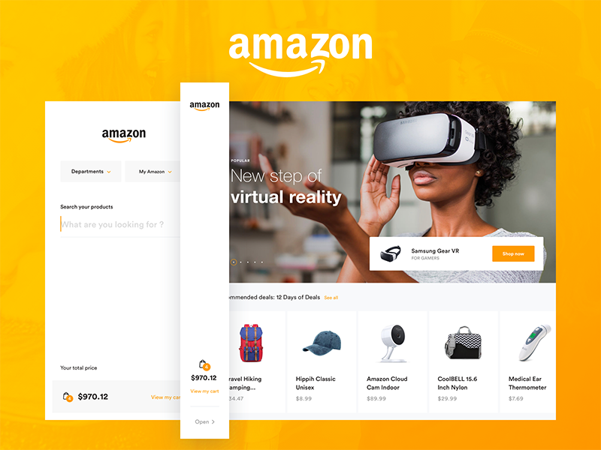

Project Name : Amazon

Sumit Mahajan

**Edureka Presents**

Overview

Amazon India launched its operations in June 2013. The company soon launched its website Amazon.in which is offering customers a wide variety of choices in apparel, groceries, household items, books, movies, television shows and almost everything that a person requires. On the very first day of its operations, the company received more than 10,000 orders. Amazon India is a subsidiary of US-based e-commerce giant Amazon Inc.

The parent company Amazon was founded by [**Jeff Bezos**](https://en.wikipedia.org/wiki/Jeff_Bezos) in 1994. The company wanted to explore other countries for sales increment and the growth of the company.

**Goals**

1. Login Page

2. Product Categary Page

3. Profile Page

4. Payment Page

5. The website also contain search bar , wish list and bag icons

**History**

[Amazon](https://interestingengineering.com/jeff-bezos-reveals-the-number-of-amazon-prime-members-exceeded-100-million), or more correctly Amazon.com, was first incorporated by Jeff Bezos in July of 2005. At the time, he was a Wall Street hedge fund executive.

Amazon was [originally to be called Cadabra](https://www.businessinsider.com/amazon-jeff-bezos-chose-company-name-2018-5) (from Abracadabra). But Bezos' lawyer advised him that the reference to magic might be a bit too obscure.

Also, when people heard the name on the phone, they all too often heard "[Cadaver](https://youtu.be/StaMb1iwPNE)" instead — not ideal.

So, Bezos and his then-wife MacKenzie Tuttle started to register some domain names for their potential new venture.

Bezos soon [registered the domain names](https://www.businessinsider.com/amazon-jeff-bezos-chose-company-name-2018-5) Awake.com, Browse.com, and Bookmall.com. He also registered the domain name [Relentless.com](http://relentless.com/) and kept it. In fact, if you type that into your browser today, you'll be redirected to Amazon.com.

He contended from the company's very beginnings that Amazon was not just an online retailer selling consumer products. Bezos envisaged the company being a technology company at heart whose real business was to simplify online transactions for its customers.

**Technologies used in Amazon**

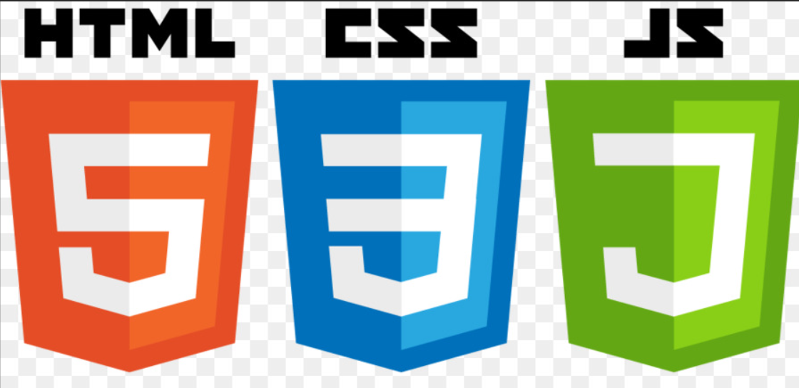Front-End:

1. Html
2. CSS
3. BootStrap
4. Java Script

Thanking you and regards

Sumit Mahajan

(edureka student)

