**RESUME** 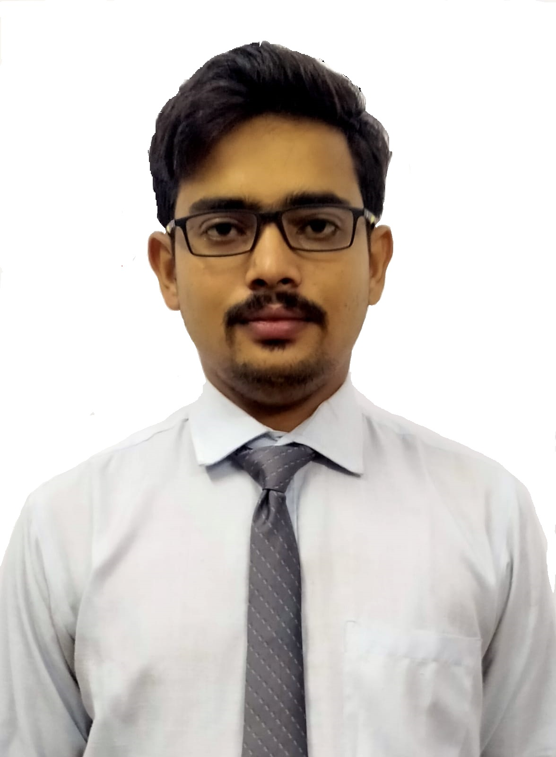

**PERSONAL DETAILS**

**Name:-** Sumit Kumar

**Email- ID:-** sumitmintu12@gmail.com

**LinkedIn ID :-** https://www.linkedin.com/in/sumit-kumar-a0556617b

**Mobile No.:-** +919109273944

**D.O.B:-** 12/09/1998

**CAREER OBJECTIVE**

To evolve into a capable professional by being associated with a company that will challenge me to push my boundaries and allow me to use my education and skills in a way that is mutually beneficial for my employer and me and achieve a sustainable growth in life.

**EDUCATION QUALIFICATION**

**A) B.TECH [Electronics and Communication Engineering ]**

|  |  |  |  |
| --- | --- | --- | --- |
| **Session** | **University** | **Institution** | **CGPA** |
| 2018-2022 | RGPV, Bhopal | Indira Gandhi Govt. Engineering College, Sagar,Madhya Pradesh | **7.20/10** |

**B) HSC**

|  |  |  |  |  |
| --- | --- | --- | --- | --- |
| **Degree** | **Board** | **School** | **Year of**  **Passing** | **CGPA** |
| 12th | Bihar School Examination Board, Patna | K.M.Y.J.K.B.V. College KamalaBari Jaynagar Madhubani Bihar. | 2017 | **61.20%** |

**C) SSC**

|  |  |  |  |  |
| --- | --- | --- | --- | --- |
| **Degree** | **Board** | **School** | **Year of**  **Passing** | **CGPA** |
| 10th | CBSE | Sri Rani Saraswati Vidya Mandir Araria Bihar | 2014 | **10/10** |

**SKILLS & KNOWLEDGE**

**∙ Programming languages:** Python, Numpy,Pandas,Maplotlib,Machine Learning,SQL

C,HTML ,CSS ,JS

**∙ Operating Systems:** Windows

**∙ Tools & Environments**: Pycharm, Jupyter notebook, Intellij IDE ,VS-code,ServiceNow

**PROJECT**

**Pharmacy Management System**

This project is all about Pharmacy Management System, in the system we save the information about the medicine with the help of some basic GUI technology like Tkinter, Python and Mysql.

**Airline Reservation System**

This project is all about how to book airline tickets and reserve yourself in the system for ticket booking, and demonstrate a real-world airlines tickets booking system with the help of some basic web technology like HTML, CSS, and JavaScript(for API calls) and Bootstrap.

**CERTIFICATION**

∙ Basic of Python Programming

∙ Basic Machine Learning (INTERSHALA)

**KEY SKILL**

∙ Strong data analysis, interpretation and problem-solving skills

∙∙Willingness to accept challenges along with the ability to work under pressure. ∙∙Goal oriented and motivated individual along with the ability to work independently.

∙∙Ability to develop quality assessment strategies and plans and implement them successfully.

∙ Good leadership and communication skills

**LANGUAGES**

∙ English

∙ Hindi

**EXTRACURRICULAR ACTIVITIES**

∙ Basic Scouts course in Bharat Scout and Guides ,Bihar .

∙ First position in ULJHAN SULJHAN in college fest.

**ACHIEVEMENTS**

∙ Selected for University State Level Softball Championship, 2019-2020.

∙ Select for School State Level Vedik Mathematics Championship 2013-2014