Steps for Installation of java and Android Studio.

Step 1:

Install JDK.  
link https://www.oracle.com/technetwork/java/javase/downloads/index.html

Download JDK and install in windows 64 bit or 32 bit.

Double click on step and you can see below screen just press next.

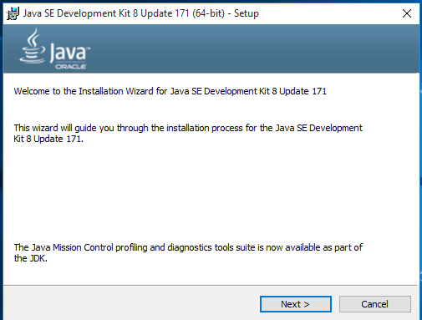

After click on next we can see below screen and press next.

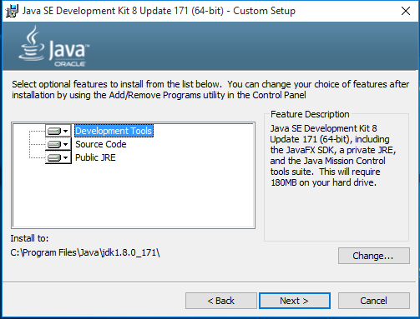

On next click setup download some file online we need to wait for some time and after completed the download we can see below screen.

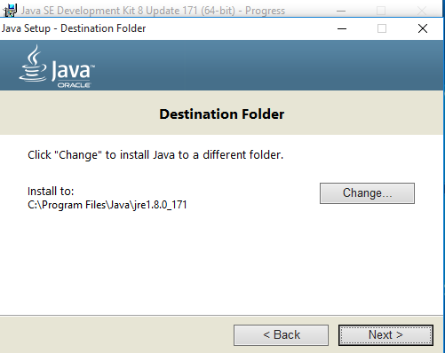

This screen asking for a path we can direct click on next button path auto get by setup and click on next button. It can some time setup download some dependence or file.

After complete download we can see below screen into this click on close.

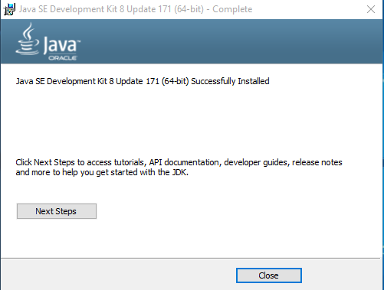

Step 2:

After success fully installed JDK than we need to set java path in Windows System.

First go to My Computer(THIS PC) and right click on that and select property option.

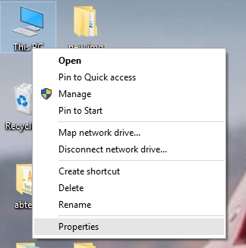

Now, go to the left panel of window and click on “Advance System Settings” option.

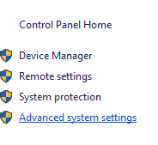

After click on option we can see below screen.

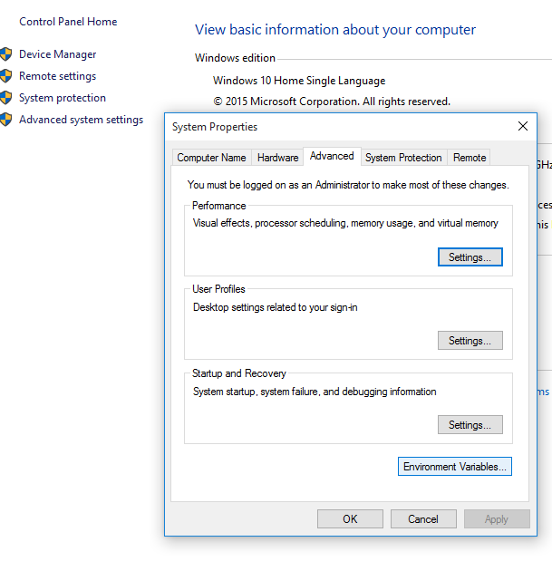

Using above screen short we can see the Environment variable button click on that.

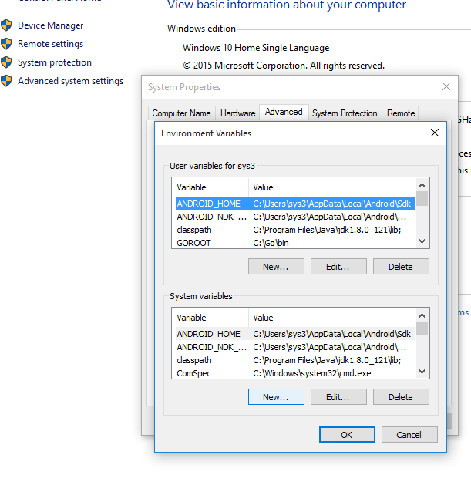

After click we can see the above screen and now we need to create two system variable. Click on new option. After that we can see below Dialog box.

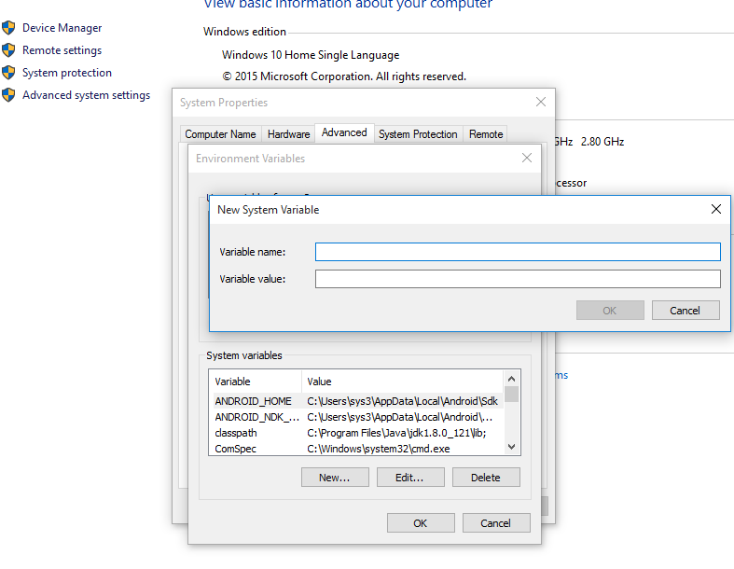

We can see two edit box. One for variable name and second for variable value.

Variable name = path

Variable value = C:\Program Files\Java\jdk1.8.0_121\bin

Like below screen shot.

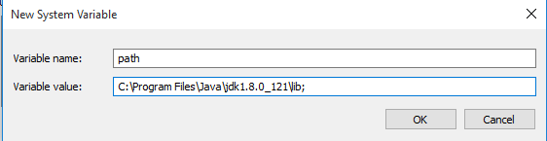

Now create second variable click on new again and set.

Variable name = classpath

Variable value = C:\Program Files\Java\jdk1.8.0_121\lib

Like below screen shot.

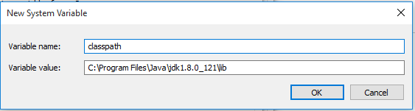

Step 3:

After set java path we can check java installation completed or not.

using below method we can check.

Open CMD and run “java” and “javac” command and you can see below output.

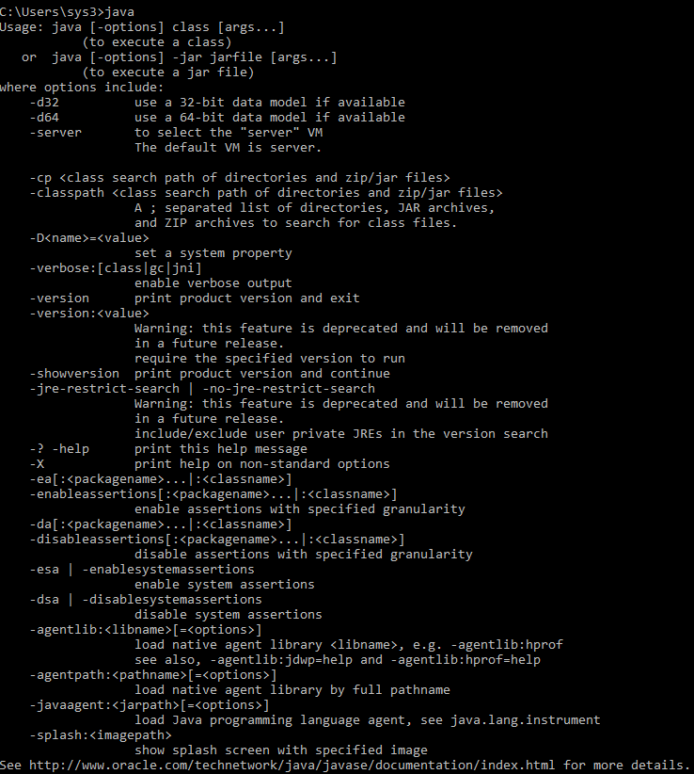If any

problem with installation cmd show message javac command not found.

Step 4:

Now Download android studio from below url.

Link: <https://developer.android.com/studio/>

Install Android Studio.

Below are screen short of steps.

Double click on exe file of android and set up ask for permission provide yes and after that you can see below screen shot.

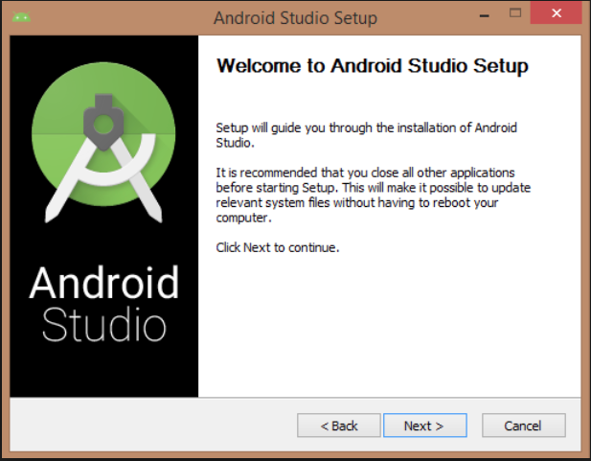

Click on next step. After that we can see the next dialog it’s ask for download android component.

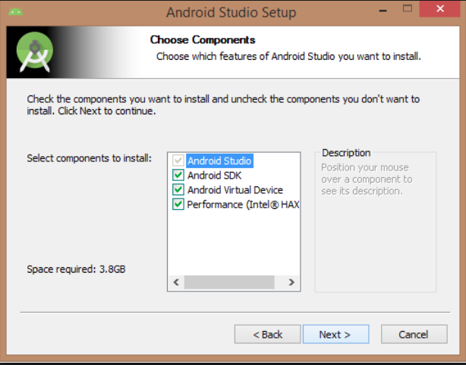

Check the all three check box and click on next button and next button ask for term and condition just click on agree button.

After that we can see the new dialog box. This dialog fox show the path of JDK or android SDK.

If path not available than we need to set path otherwise just click on next button.

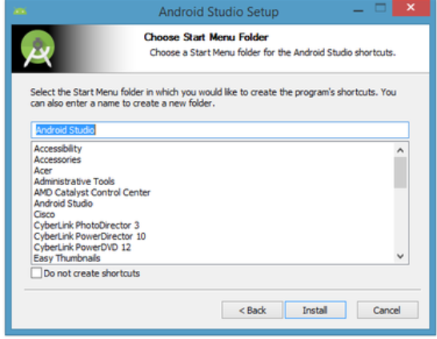

After that we can see above screen we just need to click on Install button it can download around 2gb or more files or android Studio. After download we can see below screen.

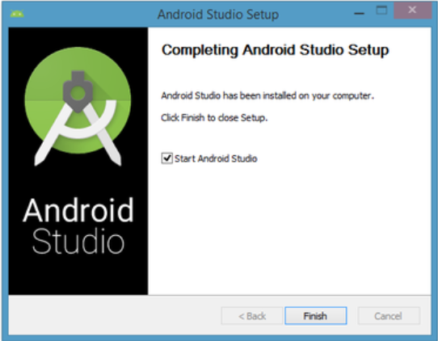

Click on finish and set up open the android studio.

Android studio starting screen like below.



After that we can see below screen for open our android project.

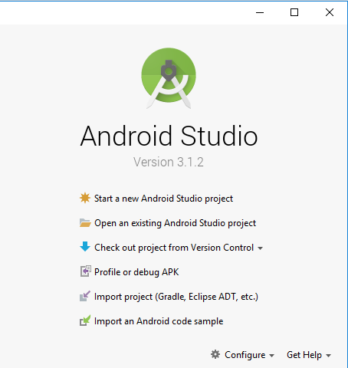

We can open android project using above screen second option.

Click on Open an existing Android Studio project.

After that select the destination our android project folder.

After some time android studio open your project.