DIPLOMA FINAL-YEAR INTERNSHIP
COMPANY RESEARCH REPORT

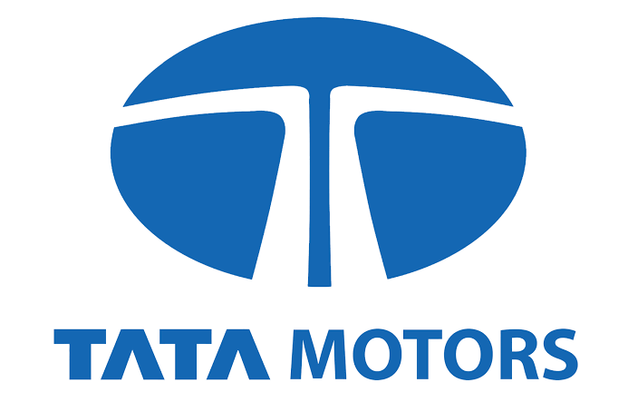
TATA MOTORS LIMITED
A Study of Company Development, Automotive Products,
Research and Development, and Manufacturing Methodologies

Submitted by | Nachiket L Karoshi
Diploma / Department | Diploma in Electronics and Communication Engineering
Institution | KLE Society's C B Kolli Polytechnic, Haveri
Internship organisation | Tata Motors Limited
Academic year | 2026–2027
Submission date | 14 October 2026

Submitted in partial fulfilment of the requirements for the Diploma final-year internship.

Certificate / Declaration
I hereby declare that this company research report entitled "Tata Motors Limited — Company Research Report" is prepared by me, Nachiket L Karoshi, as part of the final-year diploma internship requirement. The information is compiled from publicly available sources with appropriate acknowledgement.
Place: Haveri
Date: 14 October 2026
Signature of student: _______________________
Name: Nachiket L Karoshi

Table of Contents
Executive Summary
1. Introduction
2. About Tata Motors
3. Company Overview (segments, achievements, R&D, sustainability)
4. History and Development of Tata Motors
5. Manufacturing Methodology Used by Tata Motors
6. Products Manufactured by Tata Motors
7. Challenges and Future Opportunities
8. Research Methodology
9. Conclusion
References

Executive Summary
Tata Motors Limited is the Tata Group's flagship automotive company and one of India's largest vehicle manufacturers. This report presents a complete study of its history, business segments, products, manufacturing systems, research areas, challenges, and internship relevance for a Diploma in Electronics and Communication Engineering.
According to public disclosures for FY2024–25, Tata Motors strengthened its position in commercial vehicles, recorded strong SUV growth in passenger vehicles, and maintained leadership in passenger electric vehicles. Milestones include over 6 million cumulative passenger vehicle sales, more than 200,000 cumulative EV sales, expansion at Sanand, and progress on a new manufacturing facility in Tamil Nadu. The company's multi-powertrain approach (petrol, diesel, CNG, electric, and alternate fuels) supports India's goals for safer, cleaner mobility.
India's passenger vehicle industry crossed record volumes in FY25, with SUVs accounting for a large share of customer demand. Tata Motors responded with a refreshed portfolio, higher safety positioning, and growth in CNG and electric powertrains. On the commercial side, the company continued to focus on fleet uptime, total cost of ownership, and digital services for logistics customers. This combination of scale, engineering depth, and brand trust makes Tata Motors a significant case study for diploma-level industrial research.
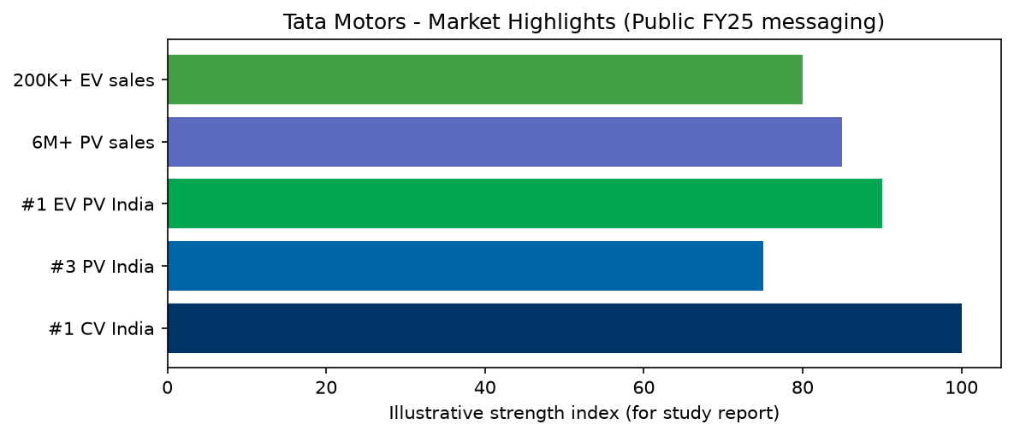
Figure ES-1: Market position highlights (FY25 public messaging)

1. Introduction
The automobile industry is one of the most important sectors of the Indian economy. It contributes to industrial development, employment generation, technological innovation, infrastructure development, and international trade. Within this industry, Tata Motors has established itself as a major automobile manufacturer with a strong presence in passenger vehicles, commercial vehicles, electric mobility, and vehicle engineering.
Tata Motors was established in 1945 as Tata Engineering and Locomotive Company Limited (TELCO). Initially, the company focused on manufacturing locomotives and engineering products. Over time, it expanded into commercial vehicles, passenger cars, sports utility vehicles (SUVs), buses, and electric vehicles. The company has contributed significantly to the development of the Indian automobile industry by introducing indigenous vehicle designs, expanding manufacturing capabilities, improving vehicle safety, and investing in sustainable mobility.
This research report examines Tata Motors' background, organisational development, products, manufacturing processes, achievements, business progress, and recent developments. It also studies the manufacturing methodologies used in automobile production and the importance of continuous improvement in maintaining quality, productivity, and customer satisfaction.
The Indian automotive sector is linked to steel, plastics, electronics, tyres, and logistics industries. Policy emphasis on emission norms (BS VI), vehicle safety, and electric mobility has accelerated product development cycles. Tata Motors has adapted through platform strategies (such as multi-powertrain architectures), localised supply chains, and investment in vehicle electronics—areas directly relevant to Electronics and Communication Engineering students seeking industrial exposure.
2. About Tata Motors
Tata Motors is a well-known automotive manufacturer associated with the Tata Group. Its operations cover the design, development, manufacturing, marketing, and servicing of a wide range of vehicles.
The company serves individual customers, businesses, logistics operators, public transport organisations, and industrial customers. Its vehicles are used for personal transportation, goods transportation, passenger transport, construction, mining, defence-related mobility, and specialised commercial applications.
Tata Motors has invested in research and development, vehicle electrification, connected technologies, safety engineering, and advanced manufacturing systems. It is widely recognised for building vehicles that balance affordability with improving safety and technology.
The Tata Group, founded in 1868, operates across multiple sectors including steel, IT, hospitality, and aviation. Tata Motors benefits from group-level values emphasising ethics, community impact, and long-term nation building. The company's passenger and commercial businesses support millions of customers—from rural last-mile entrepreneurs using Ace mini-trucks to urban families choosing SUVs with higher safety ratings. After-sales service networks and spare-parts availability are important parts of the business model, especially for commercial fleet operators.
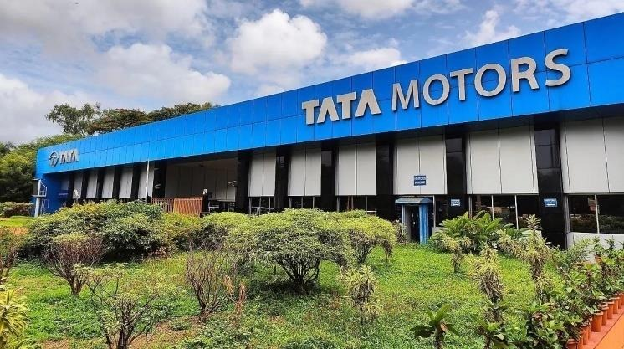
Figure 1: Tata Motors facility (reference image)
3. Company Overview
Tata Motors operates in a highly competitive industry where product quality, pricing, design, safety, technology, fuel efficiency, and after-sales service influence customer decisions. Its business is organised around major automotive segments reported publicly for the Tata Motors Group: Tata Commercial Vehicles (CV), Tata Passenger Vehicles (PV), electric mobility, and Jaguar Land Rover (JLR).
Effective 1 October 2025, a composite scheme of arrangement (approved by the National Company Law Tribunal) demerged commercial vehicles from passenger vehicles (including electric passenger mobility) to allow sharper focus and strategy execution in each business.
Tata Motors competes with domestic and global OEMs in India. Success depends on product freshness, financing options, dealer experience, and perceived reliability. The company has invested in design studios, crash-test capability, connected-car features, and EV charging partnerships. Public investor materials describe Tata CV as a profit-leading commercial business in many periods, Tata PV as a top-three passenger OEM, and Tata EV as the leading passenger electric brand in India by volume in several reporting quarters.
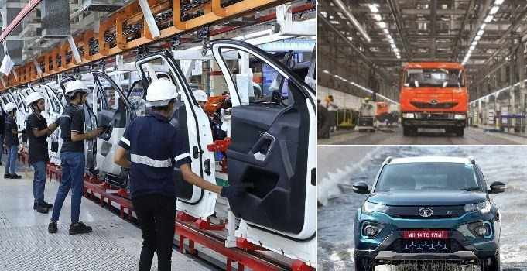
Figure 2: Manufacturing and product operations
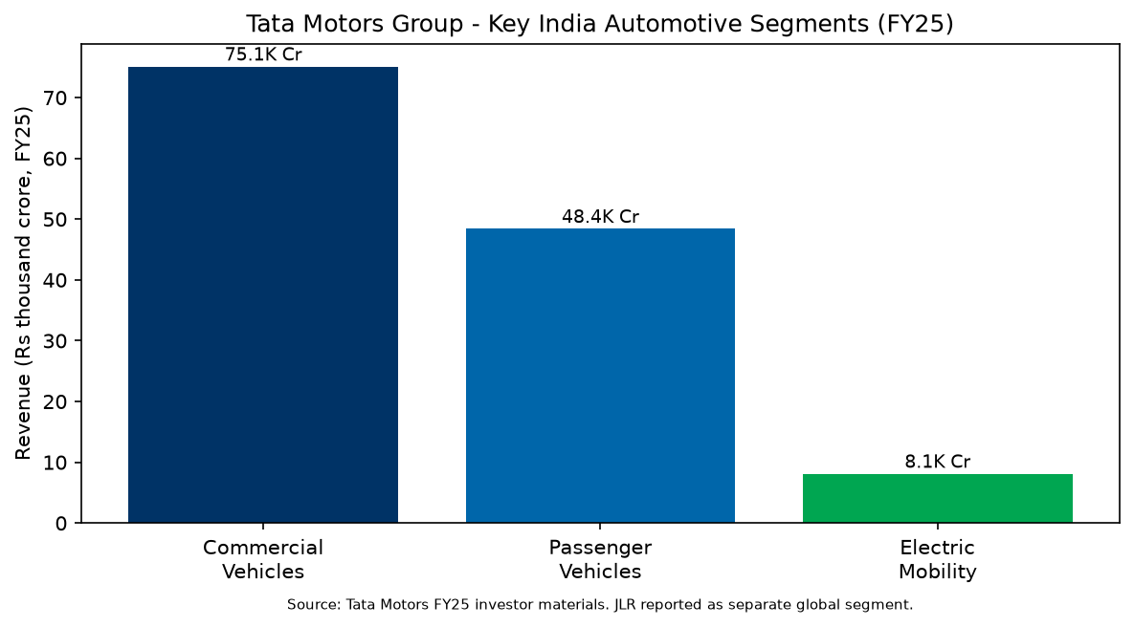
Figure 3: Major business segments (illustrative)
3.1 Tata Commercial Vehicles (CV)
Tata Commercial Vehicles serves construction, mining, e-commerce logistics, agriculture, and long-haul freight. Product lines span small commercial vehicles (SCV) for intra-city delivery, light and medium trucks for regional distribution, and heavy trucks for bulk cargo. Buses connect towns, factories, and schools. Service networks and financing partnerships influence fleet purchase decisions as much as upfront vehicle price.
- Trucks (light, medium, heavy), tippers, and specialised haulage vehicles.
- Buses and staff carriers for public transport and institutions.
- Small commercial vehicles and pickups (Ace, Intra families).
- Electric commercial mobility including Ace EV and e-bus solutions.
- Market leadership in Indian CV with focus on uptime and total cost of ownership.
3.2 Tata Passenger Vehicles (PV)
Tata Passenger Vehicles targets first-time buyers, young families, and SUV-oriented customers. The portfolio uses shared platforms to improve development speed while offering distinct designs. Safety marketing (including independent crash-test results on selected models) has become a differentiator. Retail experience, digital configurators, and test-drive programmes support conversion in competitive metro and tier-2 markets.
- Hatchbacks and sedans: Tiago, Altroz, Tigor.
- SUVs and crossovers: Punch, Nexon, Harrier, Safari, Curvv.
- Multi-powertrain strategy: petrol, diesel, CNG, and electric where offered.
- Safety and design are key brand pillars (including NCAP-focused marketing).
3.3 Electric Mobility
Tata's electric mobility strategy includes passenger EVs, fleet solutions, and charging ecosystem partnerships. ZIPTRON and acti.ev branding communicate technology generations to customers. Range anxiety, charging time, and battery warranty terms remain key purchase factors; the company addresses them through product updates and service packages. Commercial EV buses support state transport undertakings and smart-city projects.
- Passenger EV leadership in India with Nexon EV, Tiago EV, Punch EV, and related platforms.
- ZIPTRON and acti.ev technology for range, safety, and charging ecosystem.
- Commercial electric buses and smart-city mobility solutions.
3.4 Jaguar Land Rover (JLR)
Acquired in 2008, Jaguar Land Rover is Tata Motors' global premium automotive business with luxury brands, advanced engineering, and manufacturing primarily in the United Kingdom and other international locations.
3.5 Achievements and business progress (FY2024–25)
Public reports for the financial year 2024–25 highlight several achievements for Tata Motors' automotive businesses. The passenger vehicle business crossed 6 million cumulative sales, reflecting decades of customer adoption across economic cycles. The electric vehicle business surpassed 200,000 cumulative EV sales, with Tata EVs collectively travelling billions of kilometres and contributing to lower tailpipe emissions in Indian cities.
The company increased the share of CNG and electric vehicles within its passenger portfolio, supporting customers who want lower running costs or cleaner powertrains. Product launches and refreshes—including SUVs and technologies such as turbocharged CNG—helped maintain competitiveness. Commercial vehicle operations focused on market share, dealer profitability, and electric buses for urban transport. Manufacturing investments included scaling Sanand and commencing work on a new Tamil Nadu facility to support future volume.
3.6 Research, development and innovation
Research and development at Tata Motors spans vehicle platforms, powertrains, materials, electronics, and digital features. Engineers work on crash safety, noise-vibration-harshness (NVH), aerodynamics, thermal management, and durability testing. Electric vehicle R&D includes battery chemistry partnerships, battery management software, motor control, and charging communication standards.
Connected vehicle programmes add telematics, remote diagnostics, and over-the-air updates where supported. Commercial vehicle R&D addresses payload efficiency, fuel economy, driver comfort, and fleet telematics. Jaguar Land Rover contributes premium automotive technology and global homologation experience. For diploma students, R&D is visible not only in laboratories but also through pilot builds, prototype testing, and collaboration between design, manufacturing, and quality teams.
3.7 Sustainability and future mobility
Sustainability is a strategic theme for Tata Motors. The company promotes safer vehicles (including higher safety ratings on selected passenger models), cleaner powertrains (CNG, EV, and research into hydrogen internal combustion for commercial applications), and responsible manufacturing (energy use, waste, water, and emissions at plants).
Electric buses and passenger EVs support urban air-quality goals. Battery lifecycle management—including recycling and second-life applications—is an emerging focus across the industry. Tata Motors communicates progress through integrated reporting aligned with environmental, social, and governance (ESG) expectations of investors and regulators.
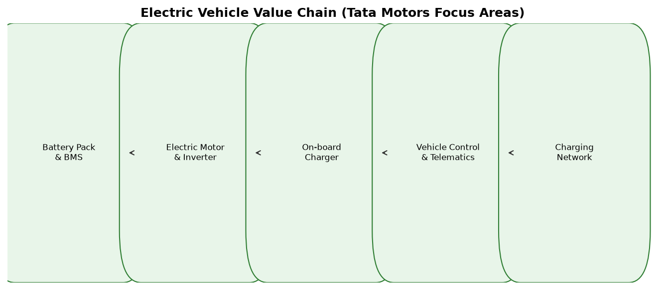
Figure 4: Electric mobility value chain
3.8 Core strengths
- Strong brand trust associated with the Tata Group.
- Wide portfolio covering passenger, commercial, and electric segments.
- Extensive manufacturing and service footprint across India.
- Growing capability in EVs and alternative fuels.
- International presence and technology access through Jaguar Land Rover.
Basic company profile
Particular | Details
Company name | Tata Motors Limited
Established | 1945
Original name | Tata Engineering and Locomotive Company (TELCO)
Founder / group | Founded under the leadership of the Tata Group
Industry | Automotive manufacturing
Headquarters | Mumbai, Maharashtra, India
Parent group | Tata Group
Main products | Cars, SUVs, trucks, buses, electric vehicles and mobility solutions
Major markets | India and selected international markets
Key focus areas | Quality, safety, innovation, sustainability and customer satisfaction

4. History and Development of Tata Motors
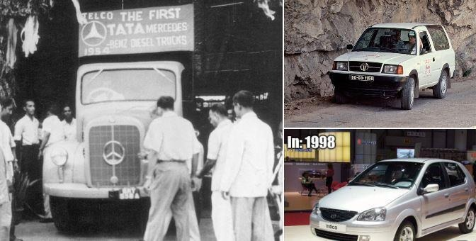 | 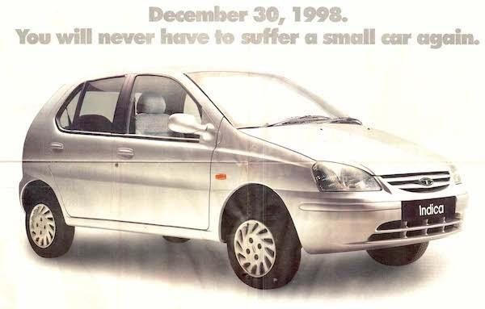

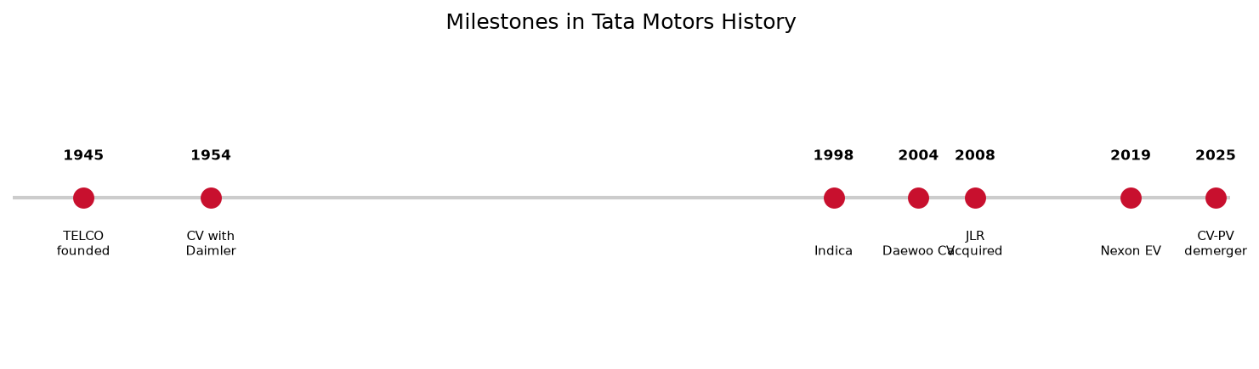
Figure 5: Historical milestone timeline
4.1 Early foundation: 1945
Tata Motors was established in 1945 as Tata Engineering and Locomotive Company Limited. Its initial activities were associated with locomotives and engineering products, building industrial capability for later vehicle manufacturing. Post-independence industrial growth in India created demand for domestic commercial transport and engineering goods, which shaped the company's early priorities.
4.2 Entry into commercial vehicles: 1950s
The company entered the commercial vehicle sector through collaboration with Daimler-Benz of Germany (1954), beginning organised truck manufacturing in India. This partnership transferred know-how for chassis, engines, and assembly methods. Commercial vehicles later became the backbone of Tata Motors' revenue and brand recognition among fleet operators.
4.3 Expansion into passenger vehicles
Passenger vehicles helped the company move beyond commercial transport. The Tata Sierra (1991) signalled SUV ambition, while the Tata Indica (1998) became a milestone as an indigenously developed passenger car. Indica demonstrated that India could design and engineer a full passenger car platform, strengthening confidence in local R&D.
4.4 International expansion: 2000s
In 2004, Tata Motors acquired Daewoo Commercial Vehicle Company in South Korea, gaining international CV presence. In 2008, it acquired Jaguar Land Rover from Ford Motor Company—a landmark deal adding luxury brands, global distribution, and advanced powertrain and aluminium-body expertise. JLR remains a distinct premium automotive business within the group.
4.5 Development of modern vehicles
Subsequent launches focused on styling, fuel efficiency, safety, comfort, and technology. IMPACT design language shaped Tiago and Tigor; SUVs such as Nexon, Harrier, Safari, and Punch targeted India's shift toward higher seating position and road presence. Tata Ace (2005) created the mini-truck category for entrepreneurs; Ultra and Prima strengthened structured logistics.
4.6 Electric mobility and digital manufacturing
Tata Motors invested in battery-electric vehicles, ZIPTRON powertrain (2019 Nexon EV), acti.ev platforms, charging partnerships, and connected features. FY2024–25 reporting highlights higher CNG+EV mix, hydrogen ICE truck demonstration, Sanand ramp-up, Tamil Nadu plant groundwork, and use of automation and data analytics in manufacturing.

5. Manufacturing Methodology Used by Tata Motors
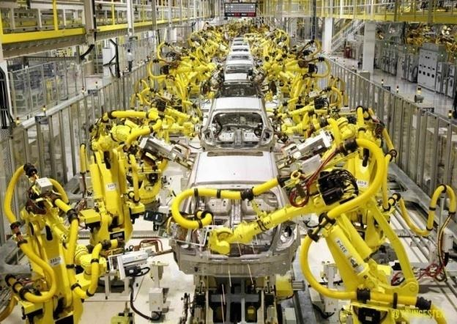 | 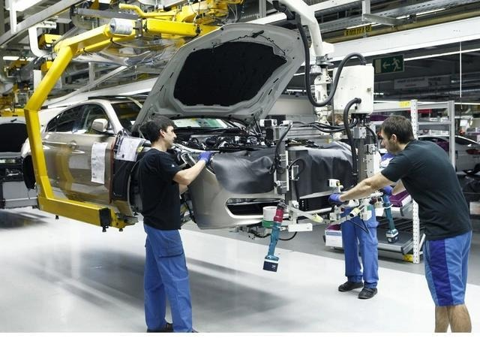

Automobile manufacturing involves multiple coordinated activities, from product design and raw material procurement to assembly, inspection, and delivery. Tata Motors' exact procedures vary by plant, product, and production line. The following methodologies describe established automotive manufacturing practices relevant to its operations; they should not be interpreted as a verified list of systems used identically at every Tata Motors facility.
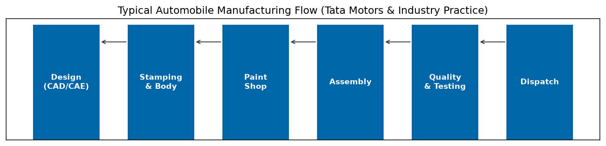
Figure 6: Typical automobile manufacturing flow
5.1 Lean manufacturing
Lean manufacturing aims to reduce waste and improve the flow of materials and work.
- Eliminating unnecessary movement and waiting time.
- Reducing excess inventory.
- Improving workstation organisation.
- Simplifying manufacturing processes.
- Reducing defects and rework.
- Improving productivity without compromising quality.
5.2 Just-in-Time (JIT) production
Just-in-Time production supplies materials and components when required by the production process.
- Requires reliable suppliers and accurate production schedules.
- Needs coordination between purchasing, stores, and assembly.
5.3 Kaizen and continuous improvement
Kaizen focuses on continuous, incremental improvement in safety, quality, productivity, and workflow.
5.4 Total Quality Management (TQM)
TQM emphasises quality across the entire organisation—not only at final inspection.
- Establishing quality standards.
- Training employees in correct procedures.
- Monitoring production defects.
- Investigating root causes of failures.
5.5 Automation and robotics
Automation improves precision, repeatability, and productivity in welding, painting, and assembly operations.
5.6 Computer-Aided Design and Manufacturing
CAD supports digital vehicle design; CAM supports planning and execution of manufacturing operations.
5.7 Supply chain management
Automobile manufacturing depends on suppliers of steel, tyres, electronics, batteries, glass, and seats.
- Supplier evaluation and purchasing.
- Inventory planning and incoming inspection.
- Production scheduling and logistics coordination.
5.8 Safety and environmental management
Plants manage occupational safety, energy, emissions, waste, water, and chemical handling.
- Machine guarding and safety training.
- Energy monitoring and waste segregation.
- Wastewater treatment and environmental compliance.
5.9 Electric vehicle manufacturing
EV production shares body, paint, and assembly processes with conventional vehicles but adds:
- Battery pack assembly and thermal management.
- High-voltage components and electrical safety protocols.
- Electric motors and power electronics integration.
5.10 Quality inspection and testing
Before dispatch, manufacturers conduct multiple inspections and tests:
- Body and paint inspection; dimensional checks.
- Electrical system and powertrain testing.
- Brake, steering, leak, and end-of-line functional tests.
- Road testing or prescribed vehicle checks.

6. Products Manufactured by Tata Motors
Tata Motors has developed a wide range of vehicles for individual customers, businesses, and public transport operators. The portfolio is summarised in the table below and illustrated with representative product categories.
Segment | Category | Examples
Passenger | Hatch / sedan | Tiago, Altroz, Tigor
Passenger | SUV / crossover | Punch, Nexon, Harrier, Safari, Curvv
Commercial | SCV / LCV / M&HCV | Ace, Intra, Ultra, Prima, Signa
Commercial | Buses | Starbus, electric buses
Electric | Passenger & CV EV | Nexon EV, Tiago EV, Punch EV, Ace EV

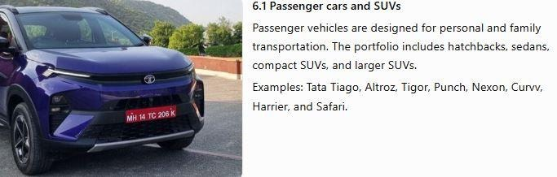 | 6.1 Passenger cars and SUVs  Passenger vehicles are designed for personal and family transportation. Tata Motors offers hatchbacks, sedans, and SUVs with emphasis on safety, comfort, and fuel-efficient or electric powertrains. Representative models include Tiago, Altroz, Tigor, Punch, Nexon, Harrier, Safari, and Curvv. Features often include touchscreen infotainment, connected services, multiple airbags on selected variants, and choice of petrol, diesel, CNG, or electric powertrains depending on model.

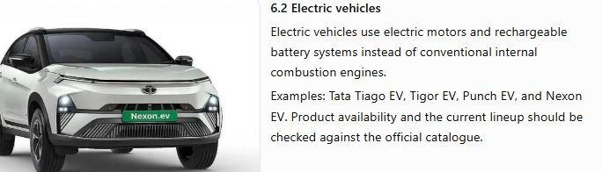 | 6.2 Electric vehicles  Electric vehicles use electric motors and rechargeable battery packs instead of conventional fuel tanks and exhaust systems. Tata Motors leads India's passenger EV segment by volume in many reporting periods, with Nexon EV, Tiago EV, Punch EV, and Tigor EV. Customers evaluate range, charging time, battery warranty, and resale value; the company addresses these through ZIPTRON technology updates and service programmes.

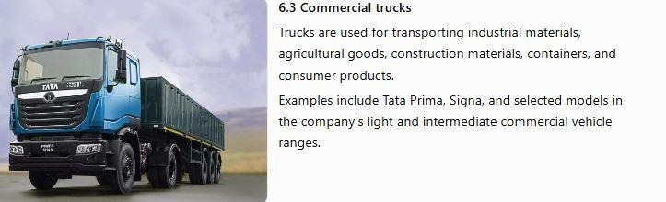 | 6.3 Commercial trucks  Trucks support industrial, agricultural, and logistics transport. Tata Motors manufactures light, medium, and heavy commercial vehicles including Ace, Intra, Ultra, Signa, and Prima families for varied payload and distance requirements.

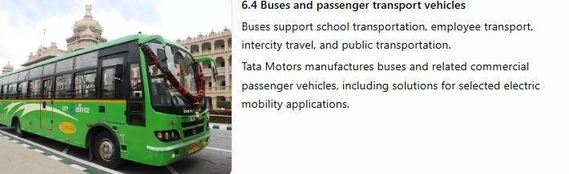 | 6.4 Buses and passenger transport vehicles  Buses are used for city service, school transport, staff carriers, and intercity travel. Tata Motors supplies conventional and electric bus solutions for public transport operators and smart-city mobility programmes.

6.5 Research, Development and Electronics (ECE relevance)
Modern automobiles are complex electro-mechanical systems. Electronics and Communication Engineering plays an important role in automotive R&D and production quality at Tata Motors. A single vehicle may contain dozens of electronic control units coordinating engine or motor torque, braking, lighting, climate control, instrument cluster, infotainment, and safety features.
Key domains include engine control units (ECU), body control modules, infotainment and telematics, ADAS sensors, battery management systems (BMS) in EVs, wiring harnesses, in-vehicle networks (CAN, LIN, Ethernet in newer architectures), and over-the-air software updates. Poor harness routing or weak earthing can cause intermittent faults; therefore production plants enforce standard work instructions, torque tools, and electrical tests.
During authorised plant visits or internships, diploma students may observe trim-and-chassis (TCF) processes, harness routing, earthing safety checks, ECU flashing, heating-element quality, connector inspection, PLC-based automation, robotic welding cells, and end-of-line electrical testing—especially at passenger vehicle plants such as Pune and manufacturing locations such as Sanand and Jamshedpur. Documenting these observations with diagrams and safety rules strengthens the college internship report.
- Embedded controllers (ECU, BCM, BMS) and firmware flashing procedures.
- Sensors for speed, temperature, pressure, and advanced driver assistance on higher trims.
- Wiring harness routing, clipping, continuity, and high-voltage isolation on EV lines.
- In-vehicle networks: CAN, LIN, and Ethernet-based architectures in newer vehicles.
- Production testers, oscilloscopes, and automated end-of-line electrical checks.
- PLC and robot integration in body shop and paint shop automation.
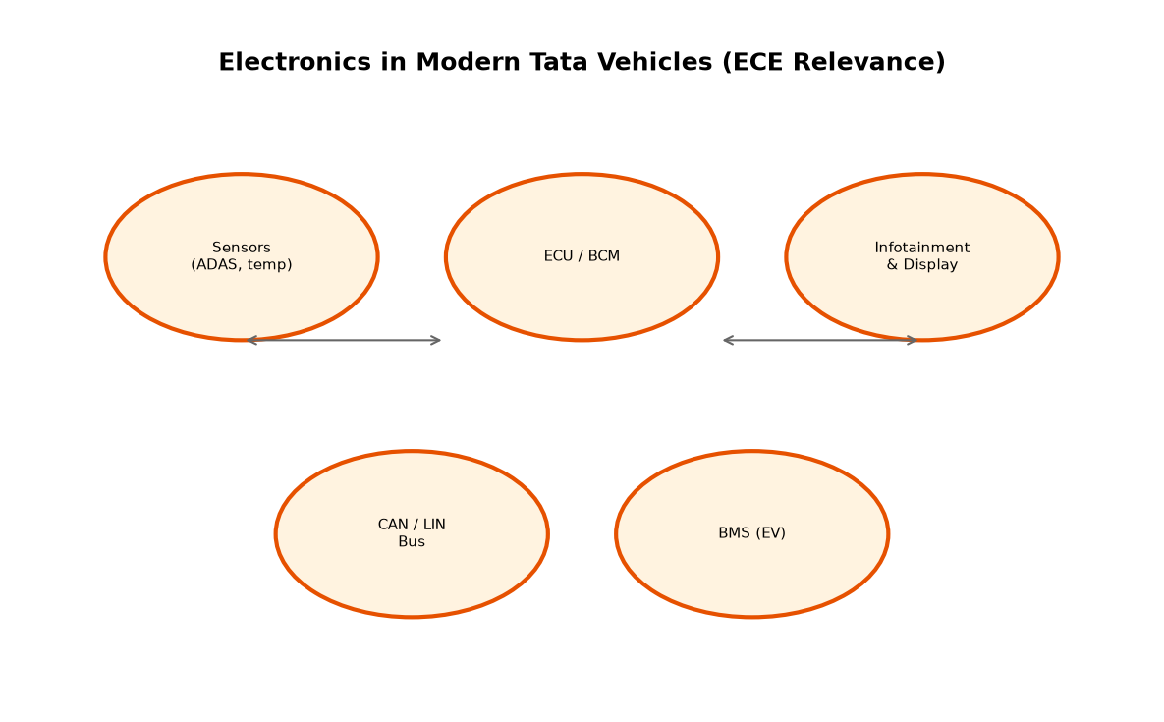
Figure 7: Electronics integration in vehicles
6.6 Manufacturing plants in India
Tata Motors operates major manufacturing and assembly facilities in India including Pune (passenger vehicles), Jamshedpur and Lucknow (commercial vehicles), Sanand (passenger and EV-related capacity), and Dharwad. Plants are organised into shops: press shop (stamping panels), body shop (welding and framing), paint shop (corrosion protection and aesthetics), engine or battery assembly (where applicable), trim and final assembly, and vehicle testing.
Material flow uses conveyors, AGVs, and kitting stations aligned with takt time. Quality gates stop defects from propagating downstream. Environmental controls in paint shops and strict high-voltage procedures in EV lines protect workers and product integrity. Capacity expansions—such as Sanand scale-up and the Tamil Nadu greenfield—support new models and export ambitions.
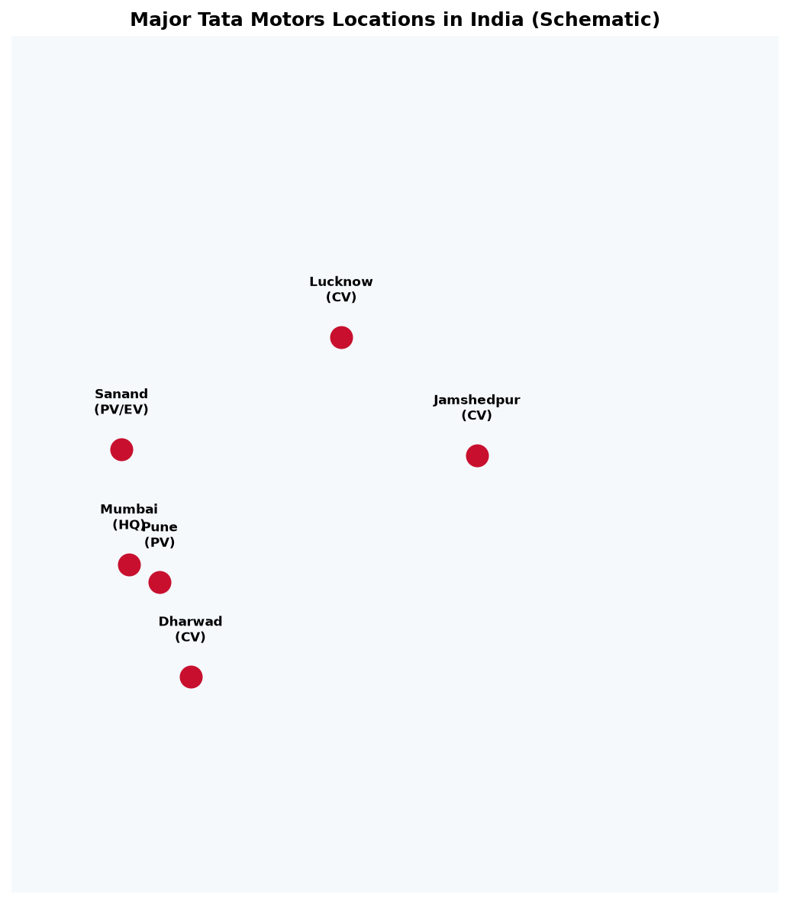
Figure 8: Major locations in India (schematic)
6.7 Internship and student programmes
Tata Motors offers structured engagement with students through campus programmes, internships, and graduate engineer trainee (GET) pathways. The company's careers portal describes induction, domain training, and exposure to real business problems under experienced mentors. Manufacturing internships may cover production planning, quality audits, lean projects, and shop-floor problem solving.
For Electronics and Communication Engineering, value lies in understanding how design intent becomes a reliable vehicle: wiring diagrams, connector torque specs, ECU calibration, test limits, and traceability records. Students should approach internships with safety discipline, curiosity about cross-functional workflows, and willingness to document observations for college reports. Institutes typically coordinate visits through formal MoUs with company HR or training departments.
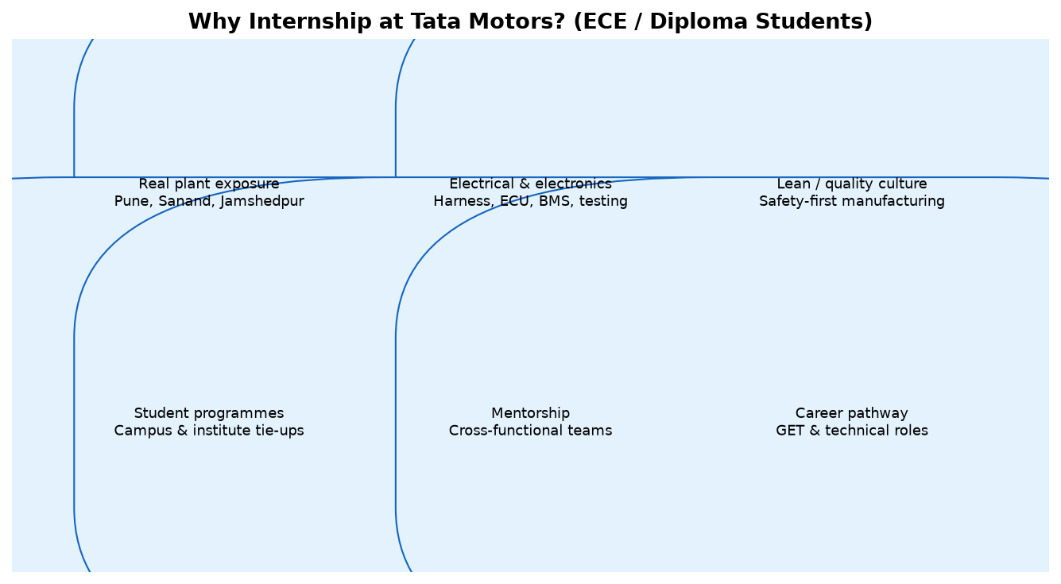
Figure 9: Internship learning areas for diploma students

7. Challenges and Future Opportunities
Tata Motors operates in an industry affected by intense competition, changing customer preferences, raw material costs, supply chain risks, technology transitions, and environmental regulations. New technologies create opportunities but require investment in engineering, testing, production equipment, and workforce skills.
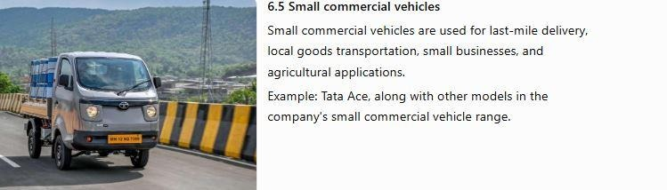
Figure 3: Future mobility and innovation
- Competition and pricing: Manufacturers must balance product features, affordability, quality, and profitability.
- Supply chain resilience: Component shortages or delayed deliveries can interrupt production.
- Quality and reliability: Defects can increase rework, warranty costs, and customer dissatisfaction.
- Electrification: Battery cost, charging infrastructure, range, resale value, and customer confidence influence EV adoption.
- Sustainability and compliance: Manufacturers must respond to changing safety, emission, and environmental requirements.
- Future opportunities: Further R&D, process digitalisation, improved energy efficiency, battery recycling, and data-driven quality improvement.
8. Research Methodology
This report uses a descriptive, document-based research approach. It organises publicly available company information and general automotive manufacturing knowledge to understand Tata Motors' development, products, R&D areas, manufacturing methodologies, and challenges.
- Secondary data: Official company information, annual reports, investor materials, product catalogues, government publications, and reputable automotive industry sources.
- Primary data (if collected): Direct observation, authorised employee interviews, permitted document review, or discussions during an industrial visit.
- Data analysis: Historical analysis for company development; descriptive analysis for products and processes; thematic analysis for quality, manufacturing, sustainability, and challenges.
- Verification: Compare information across sources; record publication dates and financial year for quantitative claims.
- Limitations: Public sources may not disclose confidential plant procedures, detailed production data, or team-level R&D work.
9. Conclusion
Tata Motors has grown from a locomotive and engineering company into a diversified automotive group with leadership in Indian commercial vehicles, a strong passenger vehicle portfolio, market-leading electric mobility initiatives, and a global premium business through Jaguar Land Rover.
Its manufacturing philosophy combines lean production, quality systems, automation, supply chain coordination, and increasing digitalisation. Product development increasingly blends mechanical engineering with software, electronics, and connectivity—exactly the intersection where diploma ECE students can contribute and learn.
Completing this company research report supports internship readiness: it builds vocabulary for interviews, explains business segments recruiters expect candidates to know, and connects classroom topics (digital electronics, microcontrollers, communication protocols) to shop-floor reality. Tata Motors remains a strong reference organisation for students who want to serve India's industrial growth while building a technical career in automotive or allied industries.
References
[1] Tata Motors Limited, Integrated Annual Report 2024–25.
[2] Tata Motors Limited, Q4 FY25 Investor Presentation and press releases.
[3] Tata Motors Limited, Corporate website — www.tatamotors.com
[4] Tata Motors Careers, Student Programmes — joinus.tatamotors.com
[5] Government of India automotive sector publications (industry context).

