

DIPLOMA FINAL-YEAR INTERNSHIP
COMPANY RESEARCH REPORT
TATA MOTORS LIMITED
A Study of Company Development, Automotive Products,
Research and Development, and Manufacturing Methodologies

Submitted by: Nachiket L Karoshi
Diploma / Department: Diploma in Electronics and Communication Engineering
Institution: KLE Society's C B Kolli Polytechnic, Haveri
Internship organisation: Tata Motors Limited
Academic year: 2026–2027
Submission date: 14 October 2026

Submitted in partial fulfilment of the requirements for the Diploma final-year internship.

Certificate / Declaration
I hereby declare that this company research report entitled "Tata Motors Limited — Company Research Report" is prepared by me, Nachiket L Karoshi, as part of the final-year diploma internship requirement. The information is compiled from publicly available sources and general industrial knowledge. I have not copied any material without appropriate acknowledgement.
Place: Haveri
Date: 14 October 2026
Signature of student: _______________________
Name: Nachiket L Karoshi

Table of Contents
1. Introduction
2. About Tata Motors
3. Company Overview
4. History and Development of Tata Motors
5. Manufacturing Methodology Used by Tata Motors
6. Products Manufactured by Tata Motors
7. Challenges and Future Opportunities
8. Research Methodology
9. Conclusion
10. References

1. Introduction
The automobile industry is one of the most important sectors of the Indian economy. It contributes to industrial development, employment generation, technological innovation, infrastructure development, and international trade. Within this industry, Tata Motors has established itself as a major automobile manufacturer with a strong presence in passenger vehicles, commercial vehicles, electric mobility, and premium international brands.
Tata Motors was established in 1945 as Tata Engineering and Locomotive Company Limited (TELCO). Initially, the company focused on locomotives and engineering products. Over time, it expanded into commercial vehicles, passenger cars, sport utility vehicles (SUVs), buses, and electric vehicles. The company has contributed significantly to the development of the Indian automobile industry through indigenous vehicle design, expanded manufacturing capabilities, improved vehicle safety, and investment in sustainable mobility.
This research report examines Tata Motors' background, organisational development, business segments, products, manufacturing processes, research and development areas, achievements, and recent developments. For a diploma student in Electronics and Communication Engineering, the report also highlights how electronic systems, sensors, control units, and connectivity are integrated into modern vehicles.
2. About Tata Motors
Tata Motors is a leading automotive manufacturer associated with the Tata Group, one of India's largest and most respected business conglomerates. Its operations cover the design, development, manufacturing, marketing, and servicing of a wide range of vehicles.
The company serves individual customers, businesses, logistics operators, public transport organisations, and industrial customers. Its vehicles are used for personal transportation, goods transportation, passenger transport, construction, mining, defence-related mobility, and specialised commercial applications.
Tata Motors invests in research and development, vehicle electrification, connected technologies, safety engineering, and advanced manufacturing systems. Public company materials describe a multi-segment automotive business with strong positions in commercial vehicles and a growing passenger vehicle and electric mobility portfolio, alongside the international Jaguar Land Rover (JLR) business.
Company name | Tata Motors Limited (group; segment structure evolved in FY25–26)
Established | 1945
Original name | Tata Engineering and Locomotive Company (TELCO)
Industry | Automotive manufacturing
Headquarters | Mumbai, Maharashtra, India
Parent group | Tata Group
Main products | Cars, SUVs, trucks, buses, vans, electric vehicles, mobility solutions
Major markets | India and selected international markets
Core focus | Quality, safety, innovation, sustainability, customer satisfaction
3. Company Overview
Tata Motors operates in a highly competitive industry where product quality, pricing, design, safety, technology, fuel efficiency, and after-sales service influence customer decisions. According to Tata Motors' integrated annual report and investor presentations for FY2024–25, the group's automotive business is organised around major reportable segments including Tata Commercial Vehicles (Tata CV), Tata Passenger Vehicles (Tata PV), electric mobility, and Jaguar Land Rover (JLR).
Effective 1 October 2025, the company implemented a composite scheme of arrangement approved by the National Company Law Tribunal to demerge commercial vehicles from passenger vehicles (including electric passenger mobility), creating focused listed entities for sharper strategy execution. Students should refer to the latest annual report for the exact legal entity names after demerger.
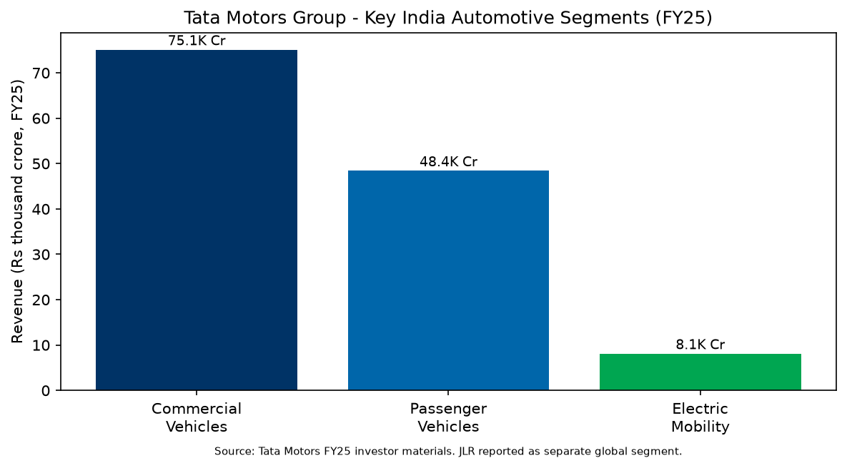
Figure 1: Illustrative revenue scale by segment (FY25 public disclosures)
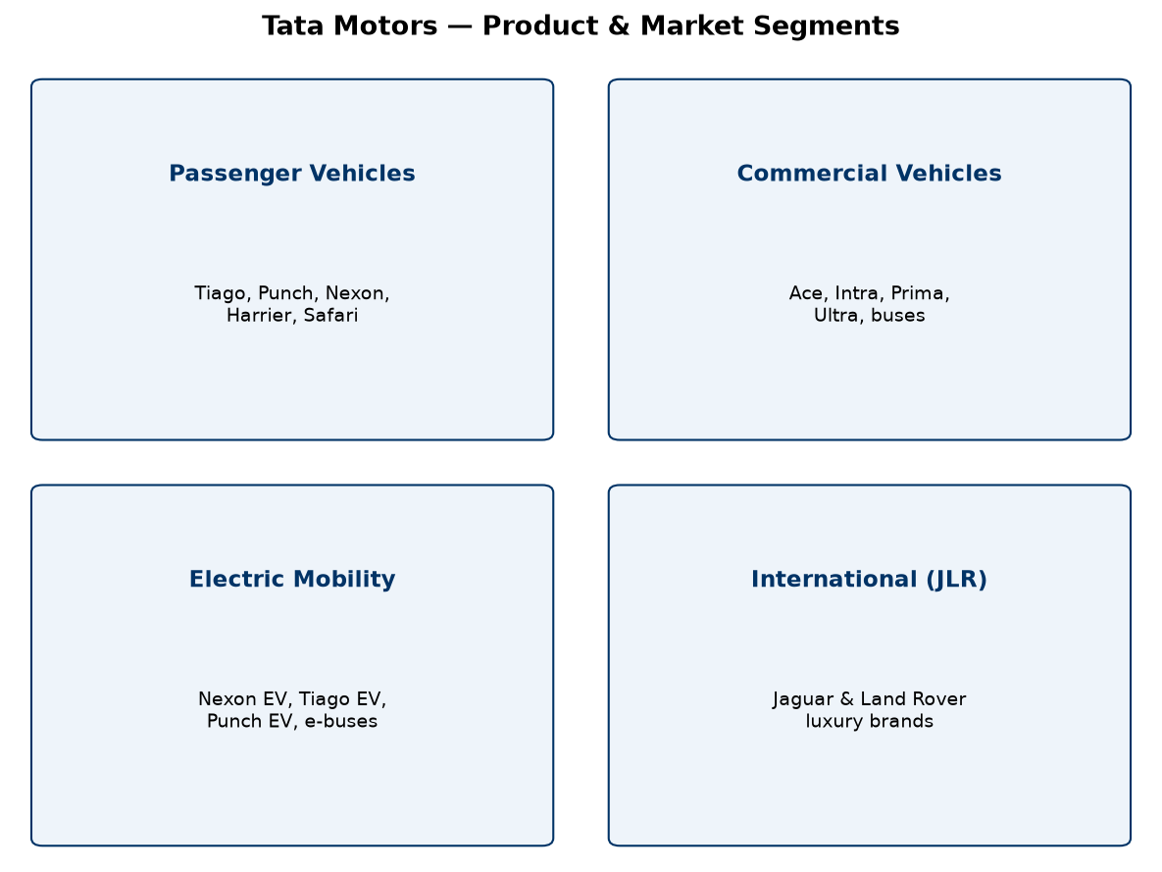
Figure 2: Product and market segments
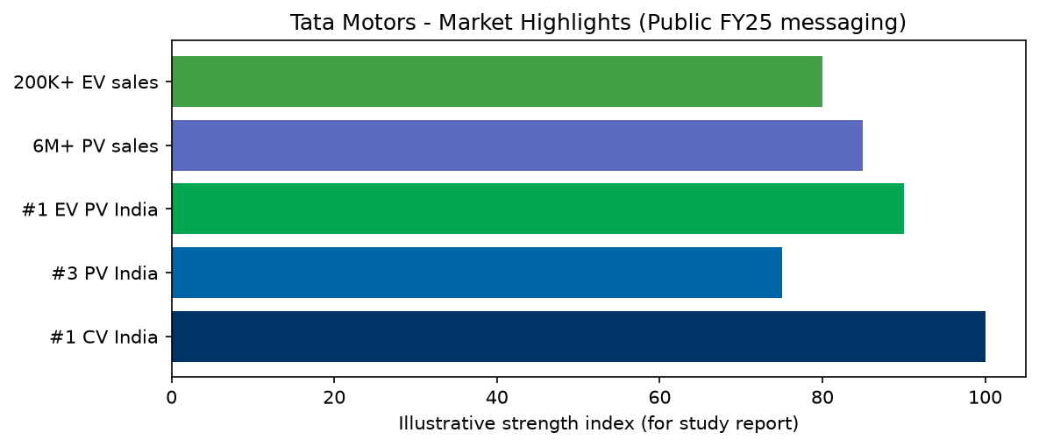
Figure 3: Market position highlights (public FY25 disclosures)
3.1 Tata Commercial Vehicles (CV)
- Trucks (light, medium, and heavy), tippers, tractors, and specialised haulage vehicles.
- Buses and staff carriers for public transport, schools, and institutions.
- Small commercial vehicles and pickups such as the Tata Ace and Intra families.
- Electric commercial mobility including Ace EV and electric bus solutions for smart cities.
- India market leadership in commercial vehicles; focus on uptime, total cost of ownership, and fleet solutions.
3.2 Tata Passenger Vehicles (PV)
- Hatchbacks and compact cars (e.g., Tiago, Altroz).
- SUVs and crossovers (e.g., Punch, Nexon, Harrier, Safari).
- Multi-powertrain strategy: petrol, diesel, CNG, and electric variants where offered.
- Strong SUV portfolio aligned with Indian market preference; safety ratings (NCAP) used as a brand pillar.
3.3 Electric Mobility
- Tata Passenger Electric Mobility leads India's passenger EV market with a majority share in many periods.
- Models include Nexon EV, Tiago EV, Punch EV, and upcoming platforms.
- Ecosystem work includes charging partnerships, battery technology, and software-defined features.
- Commercial EV includes electric buses with large fleet kilometres operated in Indian cities.
3.4 Jaguar Land Rover (JLR)
Acquired in 2008, JLR represents Tata Motors' global premium automotive business with luxury brands Jaguar and Land Rover, advanced engineering, and export-oriented manufacturing in the United Kingdom and other locations.
4. History and Development of Tata Motors
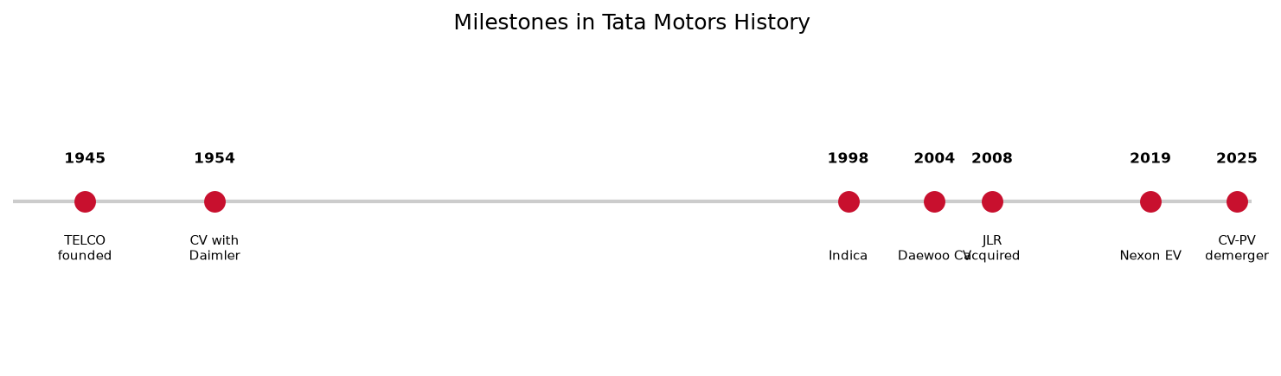
Figure 4: Key milestones in Tata Motors history
1945 — Tata Engineering and Locomotive Company (TELCO) founded; early focus on locomotives and engineering.
1950s — Entry into commercial vehicles through collaboration with Daimler-Benz.
1998 — Launch of Tata Indica, an important indigenous passenger car milestone.
2004 — Acquisition of Daewoo Commercial Vehicle Company (South Korea), expanding international CV footprint.
2008 — Acquisition of Jaguar Land Rover, transforming global brand and technology access.
2010s–2020s — Modern PV lineup (Tiago, Nexon, Harrier, Punch), safety focus, and rapid EV scaling.
2025 — Business demerger separating CV and PV strategies; continued investment in EV, CNG, and digital manufacturing.
5. Manufacturing Methodology Used by Tata Motors
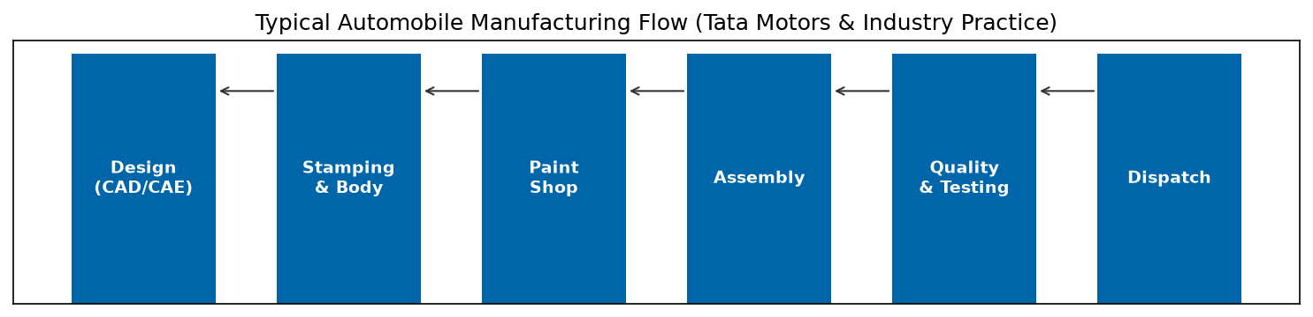
Figure 5: Typical vehicle manufacturing flow
Automobile manufacturing involves coordinated activities from product design and procurement to assembly, inspection, and delivery. Tata Motors uses established automotive practices; exact procedures vary by plant and product line. The following describes widely used methodologies relevant to Tata Motors and the industry.
5.1 Lean manufacturing
Reduces waste and improves material flow through elimination of unnecessary movement, excess inventory, and rework while improving productivity and quality.
5.2 Just-in-Time (JIT) production
Supplies components when needed on the line, requiring reliable suppliers and accurate scheduling.
5.3 Kaizen and continuous improvement
Employees and supervisors identify problems and implement incremental improvements in safety, quality, and workflow.
5.4 Total Quality Management (TQM)
Quality is built across design, production, and service—not only at final inspection.
5.5 Automation, robotics, CAD/CAM
Robots improve precision in welding and handling; CAD/CAM supports digital design and manufacturing planning.
5.6 Supply chain and vendor management
Steel, tyres, electronics, batteries, and assemblies are sourced from a large vendor network with incoming quality checks.
5.7 Safety and environmental management
Plants manage occupational safety, energy, emissions, wastewater, and statutory environmental compliance.
5.8 Electric vehicle manufacturing
Adds high-voltage battery assembly, thermal management, power electronics, and strict electrical safety protocols.
5.9 Quality inspection and testing
Includes body and paint checks, electrical tests, powertrain checks, brake/steering inspection, leak tests, and road tests as applicable.
6. Products Manufactured by Tata Motors
Tata Motors manufactures a wide portfolio for personal mobility, logistics, and public transport. Representative families are summarised below (model lists change with product lifecycle).
Segment | Category | Examples
Passenger | Hatch / sedan | Tiago, Altroz, Tigor
Passenger | SUV / crossover | Punch, Nexon, Harrier, Safari, Curvv
Commercial | SCV / LCV / M&HCV | Ace, Intra, Ultra, Prima, Signa
Commercial | Buses & mobility | Starbus, electric buses, staff carriers
Electric | Passenger & CV EV | Nexon EV, Tiago EV, Punch EV, Ace EV
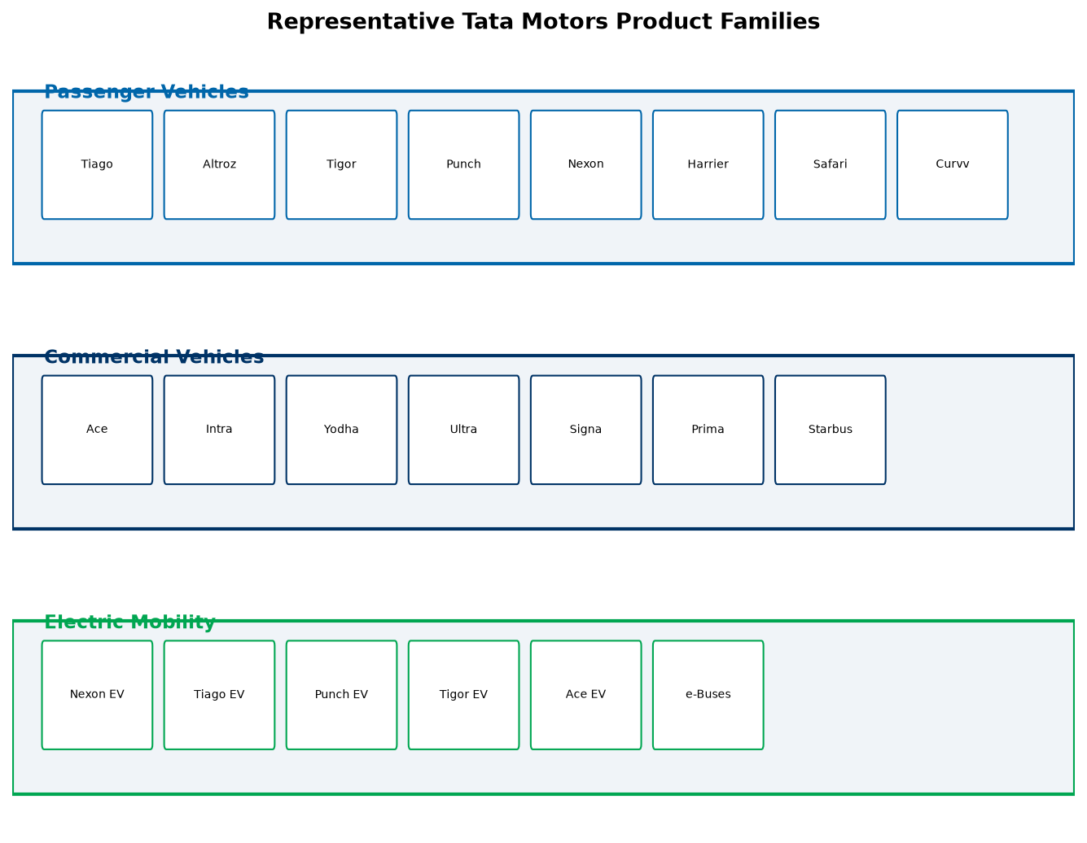
Figure 6: Representative product families across segments
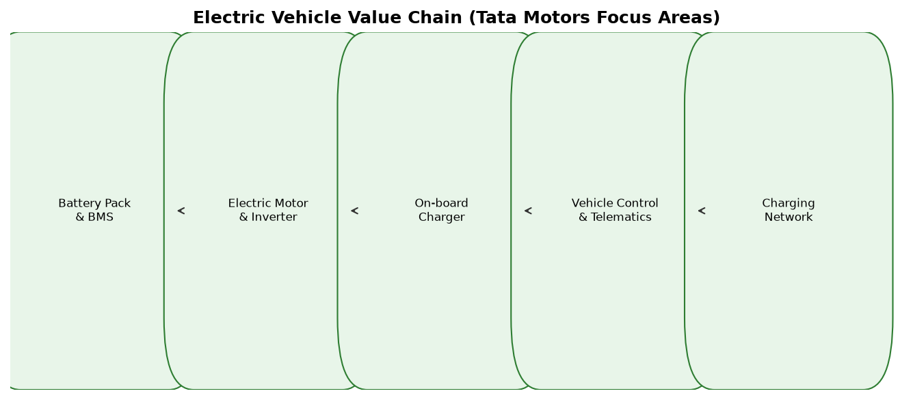
Figure 7: Electric mobility value chain
6.1 Research, Development and Electronics (ECE relevance)
Modern automobiles are complex electro-mechanical systems. Electronics and Communication Engineering plays a critical role in automotive R&D and production quality.
Key electronic domains in Tata Motors vehicles include engine control units (ECU), body control modules, infotainment and telematics, advanced driver assistance sensors, battery management systems (BMS) in EVs, wiring harnesses, communication buses (CAN, LIN, Ethernet in newer architectures), and over-the-air (OTA) software updates in connected cars.
Manufacturing and quality teams use electronic test equipment for functional verification, diagnostics, and traceability. Diploma interns in electronics may observe PLC-based automation, robotic cells, end-of-line electrical checks, and instrumentation in paint and assembly shops during authorised plant visits.
- Embedded systems: microcontrollers in ECUs and BMS.
- Sensors: speed, temperature, pressure, radar/camera for ADAS on higher trims.
- Communication: in-vehicle networks linking sensors, displays, and control units.
- Power electronics: inverters and converters in electric powertrains.
- Quality electronics: test jigs, oscilloscopes, and automated diagnostic stations.
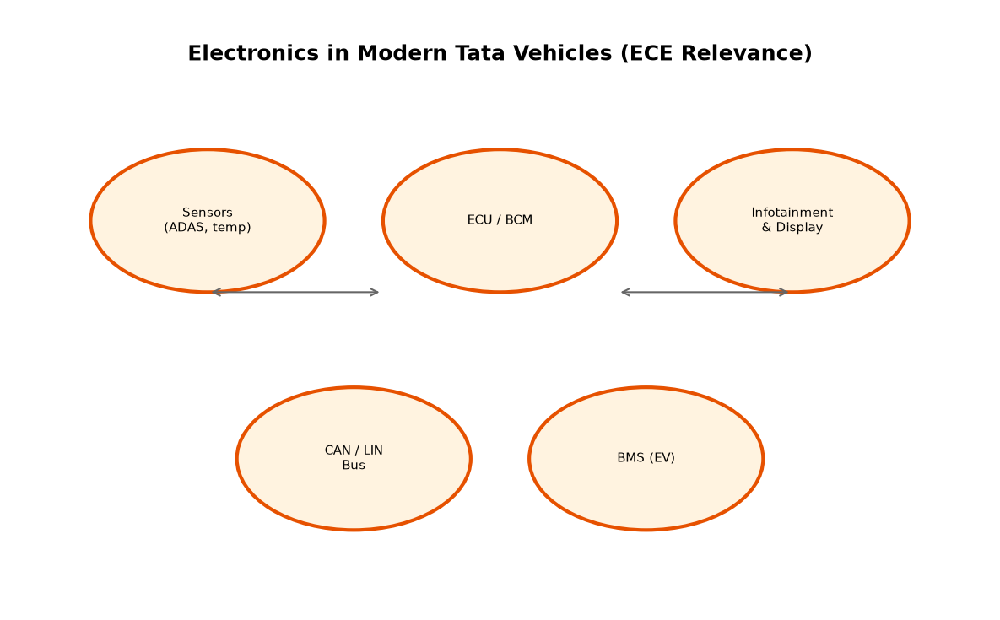
Figure 8: Electronics integration in modern vehicles (ECE perspective)
6.2 Manufacturing Plants and Operations in India
Tata Motors operates multiple manufacturing and assembly facilities in India. Major locations include Pune (passenger vehicles), Jamshedpur and Lucknow (commercial vehicles), Sanand (passenger and EV-related capacity), and Dharwad among others. Plants integrate stamping, body shop, paint shop, engine or powertrain assembly (where applicable), final assembly, and quality gates. Capacity and product mix are updated over time as new models launch.
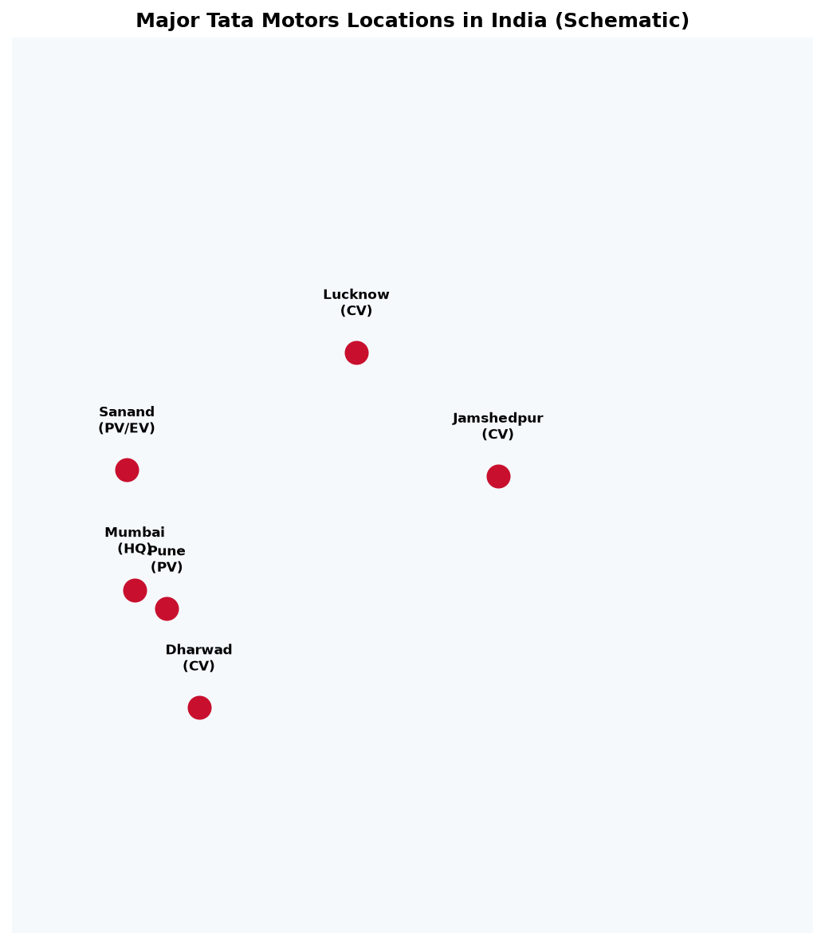
Figure 9: Major Tata Motors locations in India (schematic)
7. Challenges and Future Opportunities
- Competition and pricing pressure across CV and PV segments.
- Supply chain resilience for semiconductors, batteries, and specialised components.
- Quality and reliability expectations from customers and regulators.
- Accelerating electrification, charging infrastructure, and battery cost reduction.
- Sustainability, carbon footprint, and compliance with emission and safety norms.
- Opportunities in connected vehicles, software-defined features, hydrogen/fuel-cell research, and export growth.
8. Research Methodology
This report uses a descriptive, document-based research approach. Publicly available company information and general automotive manufacturing knowledge are organised to explain Tata Motors' development, segments, products, R&D areas, manufacturing methodologies, and challenges.
- Secondary data: Tata Motors website, integrated annual report FY2024–25, investor presentations, product catalogues, and reputable industry publications.
- Primary data (if collected during internship): authorised plant visit notes, supervised discussions, and observation logs—include only with official permission.
- Analysis: historical timeline, segment-wise description, and thematic grouping (quality, manufacturing, sustainability, electronics).
- Verification: cross-check figures with source publication dates and financial year labels.
- Limitations: confidential plant procedures and unreleased R&D details are not available in public sources.
9. Conclusion
Tata Motors has grown from a locomotive and engineering company into a diversified automotive group with leadership in Indian commercial vehicles, a strong passenger vehicle portfolio, market-leading electric mobility initiatives, and a global premium business through Jaguar Land Rover. Its manufacturing philosophy combines lean production, quality systems, automation, and supply chain coordination. For diploma students, studying Tata Motors provides practical insight into how large-scale manufacturing, electronics integration, and innovation align with national industrial growth and sustainable mobility goals.
10. References
[1] Tata Motors Limited, Integrated Annual Report 2024–25.
[2] Tata Motors Limited, Q4 FY25 Investor Presentation and press releases.
[3] Tata Motors Limited, Corporate website — www.tatamotors.com (company profile, products, sustainability).
[4] Government of India, automotive industry reports and policy documents (for sector context).
[5] Textbooks on automobile engineering and manufacturing technology (for general methodology terms).

