**Term Project**

Transaction :

|  |  |  |  |  |
| --- | --- | --- | --- | --- |
| Attribute | Description | Key Type/  Constraint | Data Type | Field length |
| transID | ID of Transaction | PK | Varchar2 | 10 |
| transDate | Date of Transaction | NOT NULL | Date | - |
| transType | Type of transaction (Deposit/Withdrawal) | CK | Char | 1 |
| transAmount | Transaction Amount | - | Decimal | (10,2) |

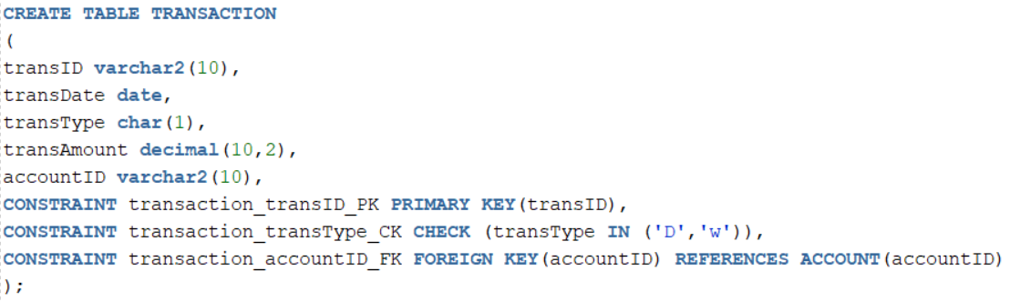

Customer:

|  |  |  |  |  |
| --- | --- | --- | --- | --- |
| Attribute | Description | Key Type/  Constraint | Data Type | Field length |
| custID | ID of Customer | PK | Varchar2 | 10 |
| fullName | Customer Full Name | NOT NULL | Varchar2 | 25 |
| billAddress | Bill Address | NOT NULL | Varchar2 | 50 |
| Phone | Phone number | CK | Number | 10 |

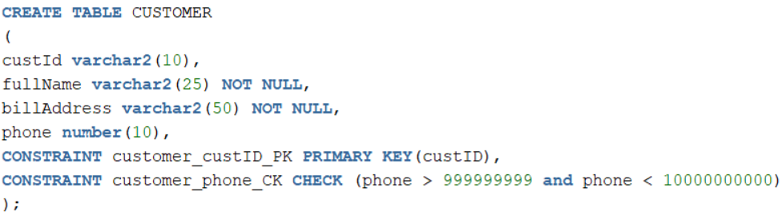

Account:

|  |  |  |  |  |
| --- | --- | --- | --- | --- |
| Attribute | Description | Key Type/  Constraint | Data Type | Field length |
| accountID | ID of account | PK | Varchar2 | 10 |
| creditLimit | Limit of credit card | NOT NULL | decimal | (10,2) |
| dateOpened | Date of opening of account | - | date | - |

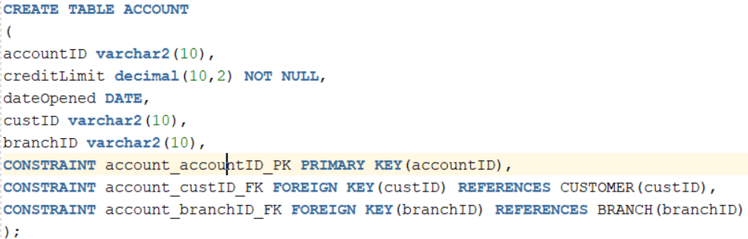

Branch

|  |  |  |  |  |
| --- | --- | --- | --- | --- |
| Attribute | Description | Key Type/  Constraint | Data Type | Field length |
| branchID | ID of branch | PK | Varchar2 | 10 |
| managerName | Name of manager | NOT NULL | Varchar2 | - |
| branchLocation | Location of branch | NOT NULL | Varchar2 | 10 |
| MainPhone | Main Phone number | NOT NULL | number | 10 |

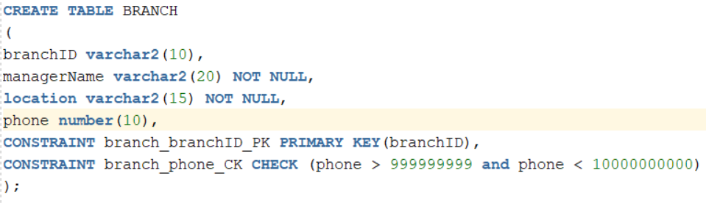

Savings Account:

|  |  |  |  |  |
| --- | --- | --- | --- | --- |
| Attribute | Description | Key Type/  Constraint | Data Type | Filed length |
| accountID | ID of account | PK,FK | Varchar2 | 10 |
| balance | Balance left | NOT NULL | decimal | (10,2) |
| interestRate | Rate of interest | - | decimal | (4,2) |

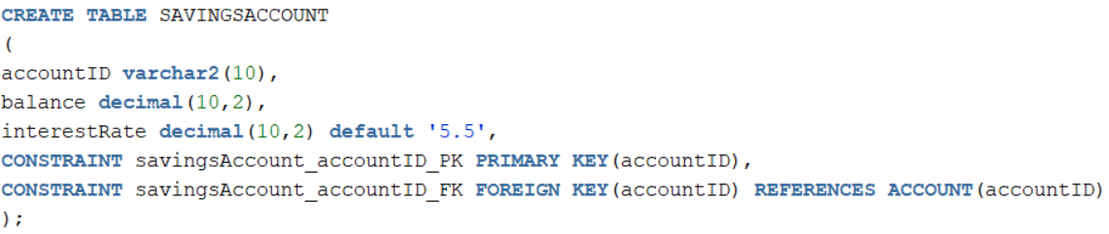

Checking Account:

|  |  |  |  |  |
| --- | --- | --- | --- | --- |
| Attribute | Description | Key Type/  Constraint | Data Type | Filed length |
| accountID | ID of account | PK,FK | Varchar2 | 10 |
| balance | balance | NOT NULL | Decimal | (10,2) |
| transType | Type of Account (Deposit/Withdrawal) | CK | Char | 1 |

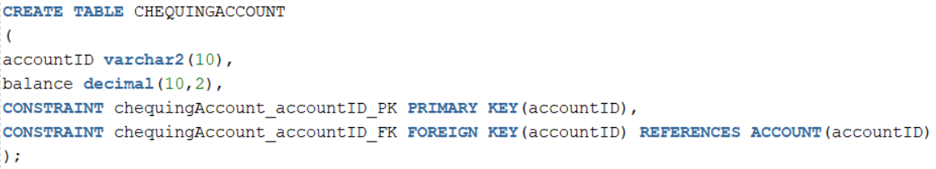

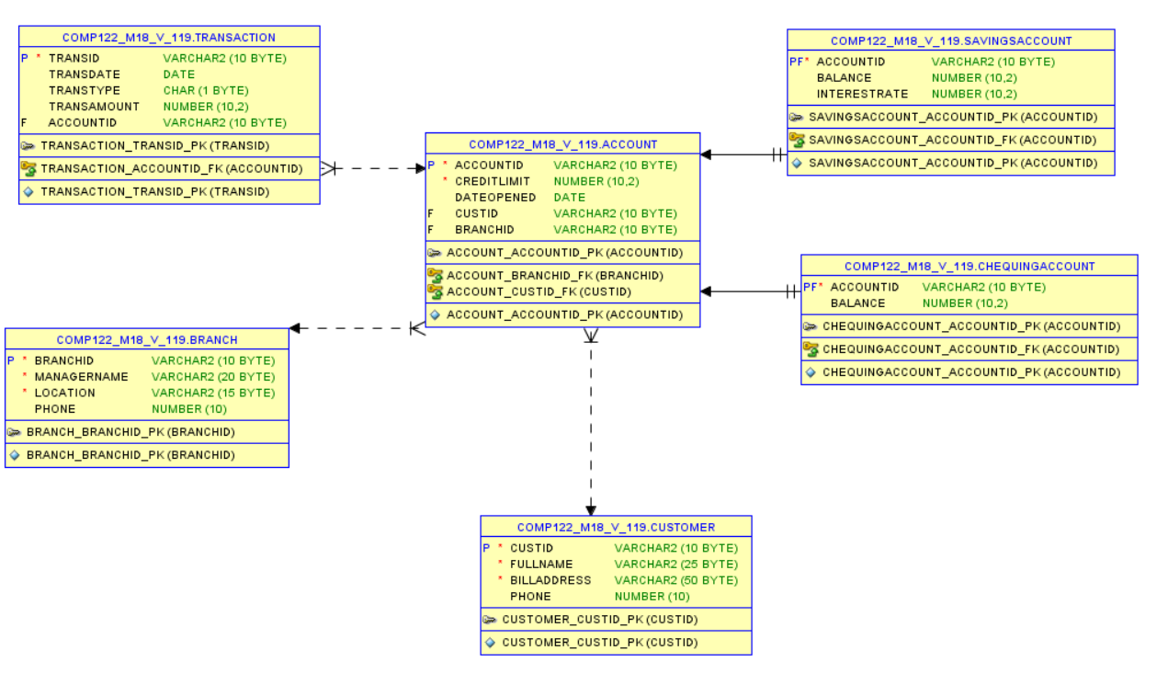

JOIN QUERIES:

All the queries show linking of tables with each other

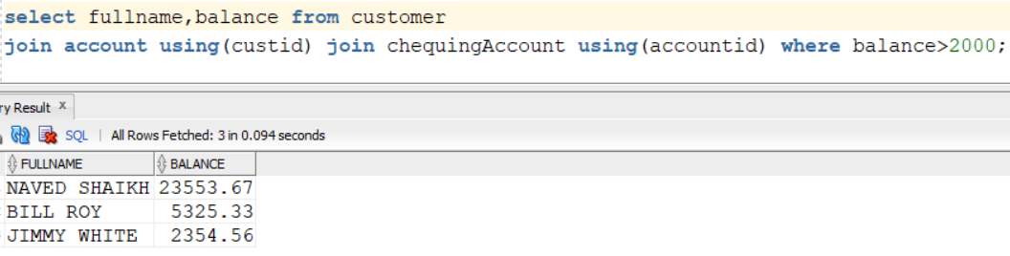

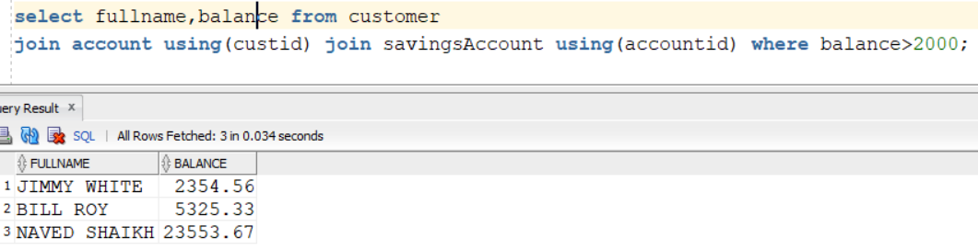

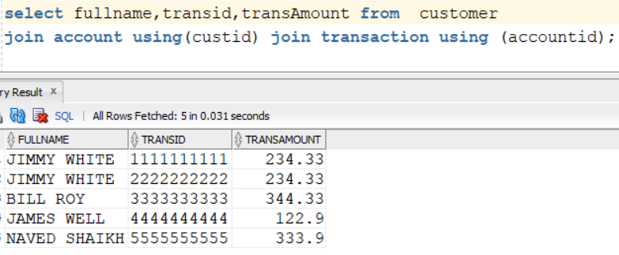

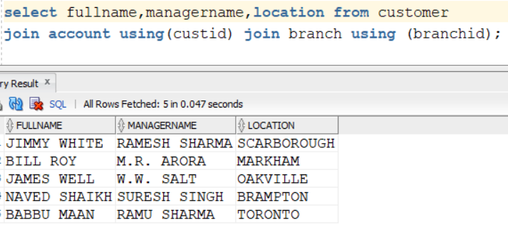

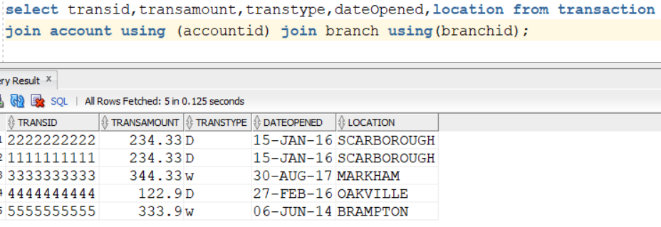

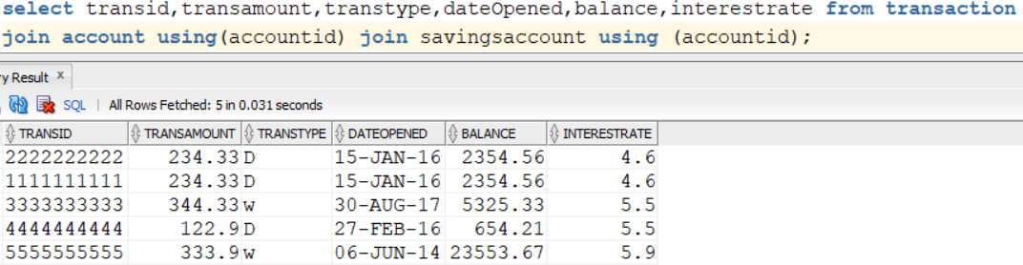

AGGREGATE FUNCTION QUERIES:

Select maximum, minimum and average of balance from savings account.

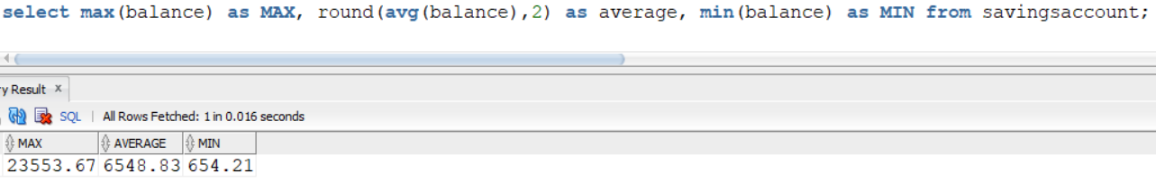

Display accounted, average of balance and group by accountID.

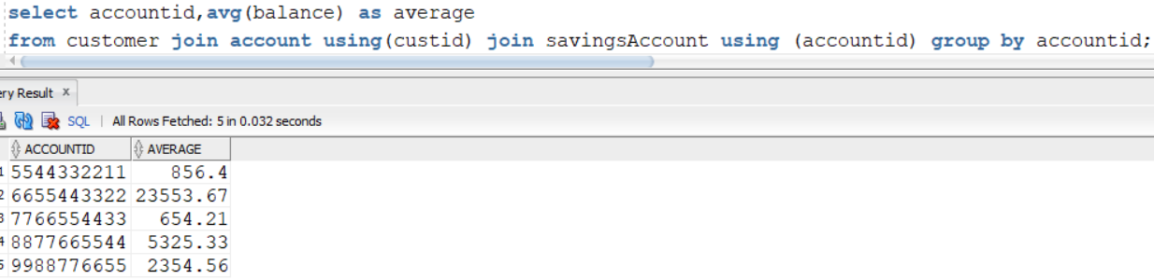

Display number of accounted, balance from savings account, group by balance

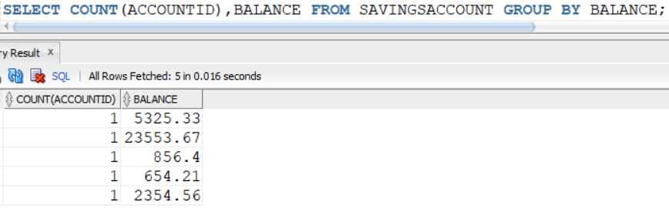

Display balance average, minimum balance and maximum balance and branchID, group by branchID.

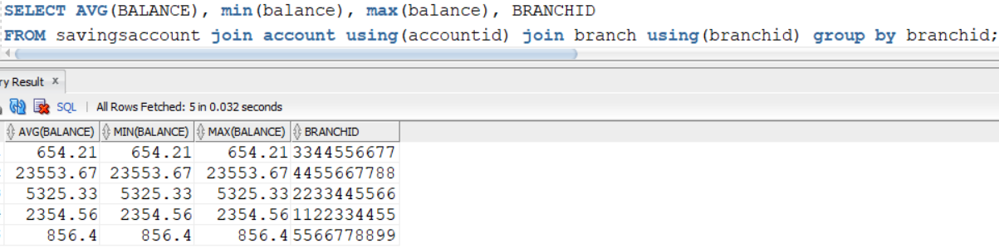

Display name of the customer whose address starts from “12”.

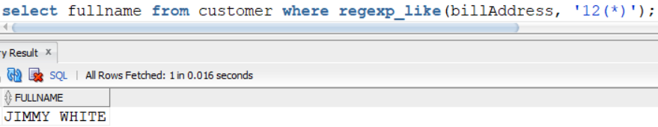

Display name and address of customer whose customer id> 1515151515.

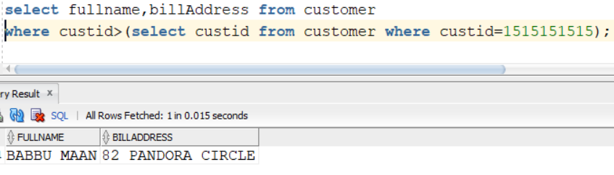

Display id and minimum balance from chequing account who have balance>2500, group by ID.

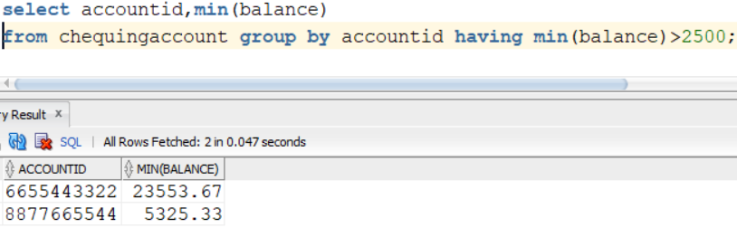

Use regexp to replace “pandora circle” in the billing address “82 Pandora circle” to “82 Hello street”

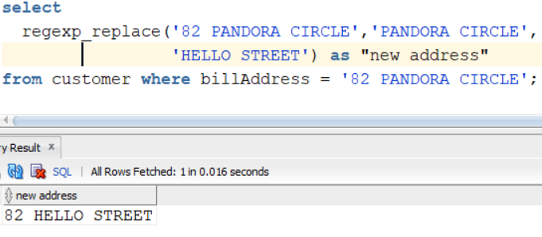

Display name, ID, balance of customer whose balance in savings account is greater than 2500.

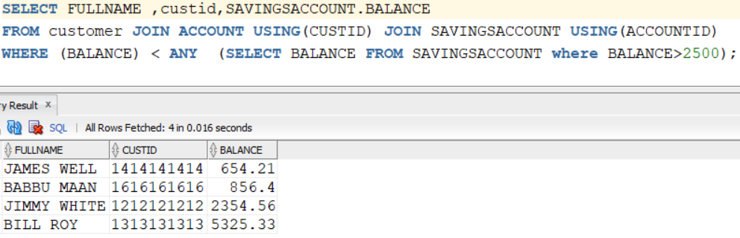

Group Members:

Rishav Mahajan (300988104)

Keshav Anand Singh (300988081)

Sumit Mittal (300980027)